I AM: I Am The Gate
Senior Pastor Daniel Ho

Very truly I tell you Pharisees, anyone who does not enter the sheep pen by the gate, but climbs in by some other way, is a thief and a robber. The one who enters by the gate is the shepherd of the sheep. The gatekeeper opens the gate for him, and the sheep listen to his voice. He calls his own sheep by name and leads them out. When he has brought out all his own, he goes on ahead of them, and his sheep follow him because they know his voice. But they will never follow a stranger; in fact, they will run away from him because they do not recognize a stranger’s voice.” Jesus used this figure of speech, but the Pharisees did not understand what he was telling them.7 Therefore Jesus said again, “Very truly I tell you, I am the gate for the sheep. All who have come before me are thieves and robbers, but the sheep have not listened to them. I am the gate; whoever enters through me will be saved. They will come in and go out, and find pasture. The thief comes only to steal and kill and destroy; I have come that they may have life, and have it to the full. (John 10:1-10)

Introduction
Many tend to limit God by a name. Some are trying to change the name of “Allah” to “Yahweh” in the Malay bible. “Yahweh is just another name for God. Our God does not have a name. God is known as the “I am”.

The phrase I am
- Implies deity /divinity
Moses said to God, “Suppose I go to the Israelites and say to them, ‘The God of your fathers has sent me to you,’ and they ask me, ‘What is his name?’ Then what shall I tell them?” God said to Moses, “I am who I am. This is what you are to say to the Israelites: ‘I am has sent me to you. (Exodus 3: 13, 14)
- Jesus uses it on himself
“Very truly I tell you,” Jesus answered, “before Abraham was born, I am!” (John 8:58)

When Jesus says “I Am”, He implies many things. Today we look at “I am the gate”

I am the gate represents:

A Passage Way That Is Right
“Very truly I tell you Pharisees, anyone who does not enter the sheep pen by the gate, but climbs in by some other way, is a thief and a robber. (John 10:1, 7)
There was a man sent from God whose name was John. He came as a witness to testify concerning that light, so that through him all might believe. (John 1:6-7)
Jesus offers the way in and out. The way to God is to make sure that our walk with Him is right. This can be done by answering two simple questions about your life. In Pastor Daniel’s office room, there is a place for chats, work and counselling. When counselling, Pastor Daniel will ask two questions:
- How is your walk with God?
- How is your quiet time?
It has been found that missionaries fall back because they do not spend their time with God consistently. Life with God has to always be consistent.

A Protection that is Secure
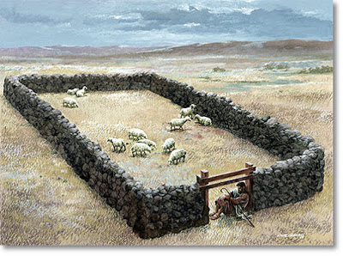
I am the gate; whoever enters through me will be saved. They will come in and go out, and find pasture. (John 10:9)
My Father, who has given them to me, is greater than all; no one can snatch them out of my Father’s hand. (John 10:29)

The gate not only represents the right way of passage but also offers protection from harm. Christians are natural ghostbusters. We have Jesus in us and we do not have to fear about any harm or attack from the evil one.

A Person

Jesus has a name. He is a person who came to the world through Mary. An angel came to Joseph in a dream telling him not to quietly divorce Mary and affirm that the child is from God. This is why he is without sin.

A name symbolizes the
- Person
- Character
- Function
- Hope and Vision

Jesus is the True Shepherd
The one who enters by the gate is the shepherd of the sheep. The gatekeeper opens the gate for him, and the sheep listen to his voice. He calls his own sheep by name and leads them out. (John 10:2-3)

He knows our name and sees us through our personal struggles. The sheep only responds to the moves and the call of the shepherd. The shepherd knows every one of his sheep. This shows that you are valued.
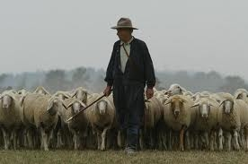

Jesus is the legitimate leader

When he has brought out all his own, he goes on ahead of them, and his sheep follow him because they know his voice. But they will never follow a stranger; in fact, they will run away from him because they do not recognize a stranger’s voice. (John 10:4-5)

The Lord is my shepherd, I lack nothing. He makes me lie down in green pastures, he leads me beside quiet waters, he refreshes my soul. He guides me along the right paths for his name’s sake. (Psalm 23: 1-3)

During the Full Gospel Businessmen’s Fellowship (FGBF) in Jakarta, one of the governors shared about how hard it was to be an exemplary leader. He followed God just like Daniel did. Other leaders were trying to find fault with him but could not. He was pressured to resign because he wasn’t corrupt. He has received death threats countless times. Some of his family members shunned him because he refused to show partiality when it came to jobs and scholarships, yet he still presses on because he knew his calling in life.

Jesus is the Eternal Saviour

I am the gate; whoever enters through me will be saved. They will come in and go out, and find pasture. (John 10:9)

I give them eternal life, and they shall never perish; no one will snatch them out of my hand. (John 10:28)

Therefore, there is now no condemnation for those who are in Christ Jesus, because through Christ Jesus the law of the Spirit who gives life has set you[a] free from the law of sin and death. (Romans 8:1-2)

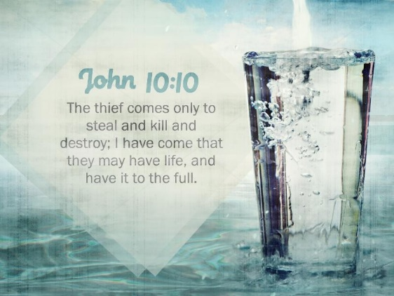
Jesus came to give us eternal life. All of us want to have years added to our life. When Isaiah prophesied that king Hezekiah was about to die, he repented and 15 years was added to his life. We need to exercise regularly and eat moderately for a healthy life.

Jesus is the abundant life giver

The thief comes only to steal and kill and destroy; I have come that they may have life, and have it to the full. (John 10:10)

We need to put Jesus at the centre of our life because he gives an abundantly. We must share the love of Christ to others regularly with others.

Conclusion
Pastor Daniel often encourages people to share Christ to a number of people per year. Keep a number and pray for the people and the opportunities God has put in your heart to win people for Christ. If one shares to one person every year and this keeps on multiplying; it will only take 33 years for the whole world to accept Christ.
Sermon summary contributed by Abbey Thangiah
Prayer Points contributed by Michelle Wong

SERMON: I Am the Gate
Pray:
- The people of God will set aside time to read His Word daily in order to be able to live a wholesome life.
- God’s people to remember that Jesus is the gate that provides us with right, secure and wholesome living.
- We must come and hear the message during celebration in order to get a clear understanding of the message.
- People of God will be bold, courageous and stand firm in our calling; thrusting God to lead us in His direction.
“May the Lord direct your heart to the love of God and to the steadfastness of Christ”
(2Thessalonians 3:5)

MINISTRIES and EVENTS: W2W Encounter
26 – 28 November 2016
Pray:
- God will convict the hearts of the women to have the desire to seek Him and His purpose for them.
- God will raise up the younger women to be bold and step up to be involved in W2W ministry.
- God will enable the Men to bless this event by encouraging their wives, sisters and mothers to sign up for the event.
- God will instil the spirit of team unity and humility, compassion and love for a special encounter with the Lord through fasting and prayer for those involved to facilitate the event.
For the Lord gives wisdom; from his mouth come knowledge and understanding. (Proverbs 2:6)

MALAYSIA MY NATION: FEDERAL GOVERNMENT
Execution of projects allocation funds. Penang Flood Mitigation Funds.
Pray:
- God will put the right people in charge of the project allocation funds to enable productive and beneficial use of all funds.
- People of God will pray for the immediate release of funds to enable work to be carried out to solve the flood problem.
- People of God will pray for the leadership of the Federal government and State government to be able to work hand in hand for the benefit of the people.
I urge, then, first of all, that petitions, prayers, intercession and thanksgiving be made for all people- for kings and all those in authority, that we may live peaceful and quiet lives in all godliness and holiness.(1 Timothy2 :1-2)

- A TRANSFORMED WORLD: YEMEN
Pray:
- God to raise up a leader who will reconcile the divided factions in bringing peace and stability to the nation.
- God’s strength, comfort and protection upon those who have lost loved ones due to the violence.
- People of God will return and create an ongoing presence of Christ’ church in Yemen through comfort and protection for the injured.
- God to open the eyes of those who live in darkness to see the light through dreams, visions and hearing from the Holy Spirit.
Rejoice always, pray continually, give thanks in all circumstances; for this is God’s will for you in Christ Jesus (1Thessalonians 5:16-18)

