**I am the True Vine (John 15:1-17)**

***Senior Pastor Chris Kam***

“I am the true vine, and my Father is the gardener. He cuts off every branch in me that bears no fruit, while every branch that does bear fruit he prunes so that it will be even more fruitful. You are already clean because of the word I have spoken to you. Remain in me, as I also remain in you. No branch can bear fruit by itself; it must remain in the vine. Neither can you bear fruit unless you remain in me.

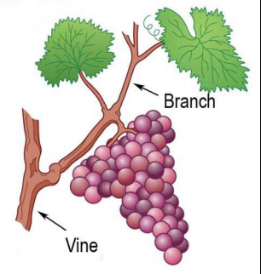

“I am the vine; you are the branches. If you remain in me and I in you, you will bear much fruit; apart from me you can do nothing. If you do not remain in me, you are like a branch that is thrown away an wither; such branches are picked up, thrown into the fire and burned. If you remain in me and my words remain in you, ask whatever you wish, and it will be done for you. This is to my Father’s glory, that you bear much fruit, showing yourselves to be my disciples.

As the Father has loved me, so I have loved you. Now remain in my love. If you keep my commands, you will remain in my love, just as I have kept my Father’s commands and remain in his love. I have told you this so that my joy may be in you and that your joy may be complete. My command is this: Love each other as I have loved you. Greater love has no one than this: to lay down one’s life for one’s friends. You are my friends if you do what I command. I no longer call you servants, because a servant does not know his master’s business. Instead, I have called you friends, for everything that I learned from my Father I have made known to you. You did not choose me, but I chose you and appointed you so that you might go and bear fruit - fruit that will last - and so that whatever you ask in my name, the Father will give you. This is my command: Love each other. (John 15:1-17)

# Introduction

This was during the time after the Last Supper and before Jesus was about to be arrested. As he and his disciples were on the way to the garden of Gethsemane on the slope of the Mount of Olive, Jesus took the opportunity to share the parable of the true vine as they passed a grapevine.

“I am the true Vine, my Father is the Gardener and you are the branches” (John 15:1, 5a)

As a gardener, we want our plants to bear fruit. If you are a branch, you must bear fruit. When we are fruitful in our lives, we bring delight to ourselves and to the people around us.



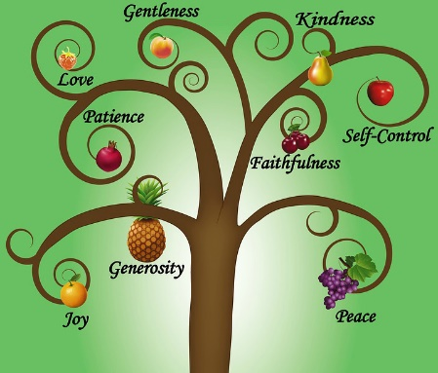

What kind of fruits are there?

* of our offspring - our children.
* of our labour - results of our hard work, profit
* of repentance - a 180° turn from our sins to be a better person.
* of good works - what we do for our community, bless the poor.
* of the spirit. (Galatians 5:22-23)
* of our lips - what we say, righteousness.
* of salvation / of the gospel.

# **Big Idea: Remain Plugged In! If you are lifeless, apply CPR**

# He Cuts

He cuts off every branch in me that bears no fruit (John 15:2a)

To stay healthy, the dying or diseased branch must be cut off as it could become harmful and dangerous to ourselves and other people. God is doing us a favour by cutting off these branches. It may be painful, but necessary.

What are some areas of our lives that God wants to cut off? There are 3 categories:

1. Rejections in our life - fear (of trusting people), shame, loneliness, sadness, a sense of failure.
2. Baggage - heavy things we carry causing us the inability to run – un-forgiveness, pride, anger, are easily offended.
3. Bondages - things that tie us up - idolatry, occult, generational sins, sexual sins, substance addictions (drugs, alcohol), gambling, smoking and pornography.

The danger is that when God wants to cut, many of us refuse to allow him to do so.

# He Prunes

“He cuts off every branch in me that bears no fruit, while every branch that does bear fruit he prunes so that it will be even more fruitful.” (John 15:2)

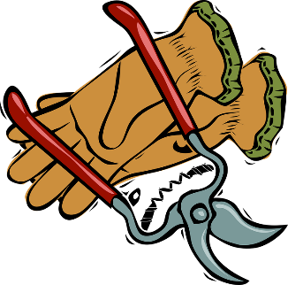Why do gardeners prune their plants?

* To allocate more nutrients to the rest of the plant and to area of new growth.
* To remove dead areas.
* To reshape the plant to be more beautiful.
* To produce a denser, bushier appearance.

Why does God prune us?

* To be more focused - he prunes away our dreams or wants that may be unnecessary.
* To teach us a life of surrender - that we will give up and die to our own dreams, so that in return God will give us bigger dreams.

Remember, there are many good things in our lives, but it may not be the best.

* Allow better use of our gifts and talents as God directs us to new things
* Trim away the rough edges of our lives - He may put difficult people or circumstances in our lives.
* He prunes our character

Do not go places where your talents and gifting take you but where your character cannot sustain you.

God is not in a hurry to change us. He will take his time (to cut and to prune). In doing so, he builds our characters so that we can be strong enough to handle our successes and take us all the way.

# He Remains

If you remain in me and I in you, you will bear much fruit; apart from me you can do nothing.” (John 15:5b)

We need to make the choice whether to remain in God or not. When we sin, we are independent from God. We run our own lives and will achieve nothing in the end. Similar to lessons we learned from the book of Joshua, “Without God, we cannot.” “Follow me, you win; Leave me, you lose.” and “Obedience brings blessings; Disobedience brings curses.”

How then do we remain in Him?

* Obey his commands

“If you keep my commands, you will remain in my love, just as I have kept my Father’s commands and remain in his love.” (John 15:10)

* Love each other as He has loved you.

“My command if this: Love each other as I have loved you. Greater love has no one than this: to lay down one’s life for one’s friends.” (John 15:12, 13)

“Love the Lord your God with all your heart and with all your soul and with all your strength and with all your mind”; and, “Love your neighbour as yourself” (Luke 10:27)

# Conclusion

“If you remain in me and my words remain in you, ask whatever you wish, and it will be give you.” (John 15:7)

There are 2 types of people in the world - the charges and the dischargers.

The chargers are people we will love to meet and have great conversations with. They inspire us.

The dischargers are people who makes us feel tired and uncomfortable and we want to avoid them.

To be chargers, we should start by being fruitful. To be fruitful, allow God to apply CPR in our lives.

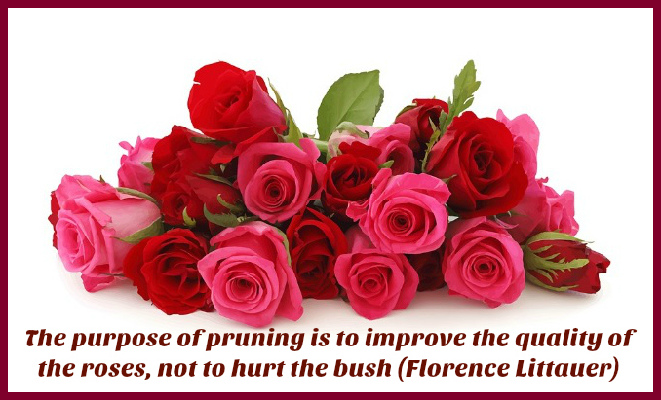

Sermon summary contributed by WendyML.

Prayer pointers contributed by Loong.



SERMON: I am the True Vine

**Pray:**

* The Holy Spirit to reveal to us the areas of our lives that are lifeless.
* God will cut away areas of our lives that are not bearing fruit.
* God will prune us so we can grow to be healthy and strong, and bear much fruit.
* We will remain in God by obeying Him and loving one another.
* The Word of God will be real in our lives.
* We will always remember Jesus who is I AM.

***I am the vine; you are the branches. If a man remains in me and I in him, he will bear much fruit; apart from me you can do nothing. (John 15:5)***

**MINISTRIES & EVENTS: Choices**

*DUMC is running a Christmas production called Choices on 16 and 17 Dec, starting at 8:00 pm on both nights.*

**Pray:**

* Practices will go smoothly to ensure a stellar performance by all involved, including the performers, the choir, the sound engineers, artists, stage hands, etc.
* Members will invite their friends to the 2 performances.
* Many will come to see the performance.
* Those who do not know Jesus will get the message and make a commitment to receive Jesus.
* Those who know Jesus will remember the reason Jesus came and live an even more purposeful life.

***For to us a child is born, to us a son is given, and the government will be on his shoulders. And he will be called Wonderful Counselor, Mighty God, Everlasting Father, Prince of Peace (Isaiah 9:6)***

MALAYSIA MY NATION: The Plight of the Natives

*Laws are enacted to protect the rights of the natives. However, for the Red Indians in America, the Aborigines and Torres Strait Islanders in Australia, and the many native tribes in Malaysia, their land rights seem to be not in existence. Their land is being taken away systematically in the name of development. Their culture and dignity are being eroded indiscriminately.*

**Pray:**

* The authorities will respect the natives’ right to their own land and habitat.
* The natives will not be neglected as lower class citizens.
* Resources will be allocated fairly to the natives, including the area of education, utilities, facilities and other forms of amenities.
* More concerted efforts to help the natives catch up so they can contribute to the nation’s growth.
* Law and enforcements to prevent abuse of the natives.
* People in the land will be treated fairly.

***So Peter opened his mouth and said: “Truly I understand that God shows no partiality.” (Acts 10:34, ESV)***

* **A TRANSFORMED WORLD: The Plight of the Rohingyas**

*Rohingyas are oppressed and abused in their own nation of Myanmar. There are reports of murder, rape and ethnic cleansing. There are an estimated 45,000 Rohingya refugees in Malaysia.*

**Pray:**

* International pressure and intervention will continue until the oppression and abuse cease.
* The Myanmar government will take this seriously and take actions to right the wrong against the Rohingyas.
* Rohingyas will be accorded rights as normal citizens.
* Refugees overseas will get a chance to start a new live.
* Refugees will receive the help they need.

***He defends the cause of the fatherless and the widow, and loves the foreigner residing among you, giving them food and clothing. (Deuteronomy 10:18, 19)***