Servers and Senders (2 Corinthians 5:14)
Pastor Bill Wilson
For the love of Christ constraineth us; because we thus judge, that if one died for
all, then were all dead: (2 Corinthians 5:14)

Introduction - the 100-degree water.
At 100 degrees Celsius, the fire, the source of heat of the boiling water, has come in contact with the water just enough to bring a change to the state of the water. It totally changes the water. Same chemical composition, same in nature. Just a drastic change in its form due to the effect of the fire. It becomes almost unrecognizable.
Are we ready for that change?
We always say that we want change. But we want comfortable change. Sometimes, God’s change can make us uncomfortable.
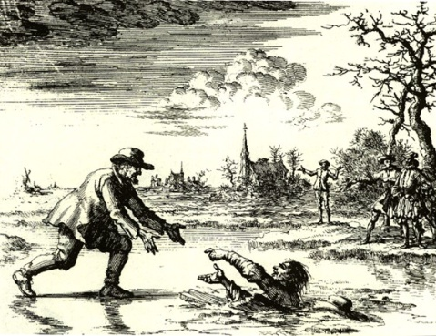
1. The Story of Dirk Willems
Dirk Willems was an outspoken Dutch Christian, martyred in May 1569. He was known for escaping from prison, turning around to rescue his pursuer, who had fallen through thin ice while chasing Willems, to then be recaptured, tortured and killed for his faith. While at the stake, just moments from being tortured and burnt, witnesses from the crowd asked him why he did what he did. Why did he rescue this man who was going to take him to his death?
His answer was simple. “It was a reflex.”
Question: What then makes the difference between Christians and non-Christians, is it their reflex? Without having to pray, without having to think twice, we act in a way that God told us to do.
When it is a reflex, you don’t have a choice.
2. The Love of Christ Constrains Us
“The love of Christ constrains us.” (2 Corinthians 5:13)

Constrains (NIV “compels”) comes from the Greek word “sunecho”.
Every time the word “constrains” was used by Paul, it meant 3 different things at the same time. These 3 definitions are a primary, secondary, and a tertiary definition.
1. The love of Christ forces motion. It moves and pushes us towards something. It’s like we have no choice but to do it.
2. The love of Christ keeps us away from something (the enemy). It stops us from doing what the enemy wants us to do.
3. The love of Christ keeps you in it (the ministry / the church / the Word). It gives us all we need to keep us doing what we are doing.

3. The Plug and the Power Source
To have this Love, we have to be connected to the power source, God. To be close does not count. Close is not good enough. Not 1 cm away, not 1 mm away. An example of this is electricity or a battery pack. When the plug connects with the source, something has to happen. It does not have a choice. To be in it, to be connected, is what it is. Once we are connected to God, we don’t have an option.
When connection happens, something happens.
Conclusion
The love of Christ constrains us. The love of Christ causes something to happen. Do we truly understand what Christ did on the cross for us?
Once person can make a difference.
Pastor Bill Wilson was abandoned by his mother as a child. A man by the name of Dave Rudenis stopped and helped Pastor Bill. Today the ministry, Metro World Child, which Pastor Bill founded, reaches over 150,000 children every week around the world in missions. This all was possible because one man stopped to help one boy.
Sermon summary contributed by Phoebe Leong.
Prayer points contributed by Abbey Thangiah.

SERMON: Servers and Senders
Pray:
- People will share their testimonies and be sensitive to share Christ.
- People will be out there to make a difference.
- Christians will have that one moment in life where they “get it” and it will move them to do Gods work.
- That the love of Christ will push us towards something, keep us away from the enemy and keep us in the ministry.
For Christ’s love compels us, because we are convinced that one died for all, and therefore all died. (2 Corinthians 5:14)

MINISTRIES & EVENTS: Church Prayer Meetings
Pray:
- People of God will seek Him in corporate prayer.
- People will place importance on prayer as much or even more than they do to work or other worldly matters.
- DUMC will receive words and direction from God during these prayer meetings.
- The church will learn to fast and depend wholly on God.
Do not be anxious about anything, but in every situation, by prayer and petition, with thanksgiving, present your requests to God. And the peace of God, which transcends all understanding, will guard your hearts and your minds in Christ Jesus. (Philippians 4:6-7)

MALAYSIA MY NATION: ISIS (Islamic State) is finding new ways of reaching out through the Internet, experts are warning Malaysians of the threat of "self-radicalised" lone wolves. They note that Malaysian IS members are asking their countrymen to fight alongside IS in the wake of the terrorist group's "recognition" of the southern Philippines-based Abu Sayyaf as part of the Islamic State "caliphate".
Pray:
- God will protect the churches and the rest of Malaysia from ISIS threats.
- The country will take terrorism measures seriously and will put counter measures in place to stop ISIS from spreading.
- Citizens will see through their ploy and not fall for it.
- The church will never cease praying for peace in the nation during good times.
- The church will play an active role in combating terrorism.
God is our refuge and strength, an ever-present help in trouble. Therefore, we will not fear, though the earth give way and the mountains fall into the heart of the sea (Psalm 46:1-2)

- A TRANSFORMED WORLD: RIO OLYMPICS 2016
Pray:
- The world will come together in unity and steadfastness.
- Athletes will compete fairly and not take drugs.
- For the world to come together more often and participate in healthy activities to promote world peace.
- The church will use this as an opportunity to volunteer and share the gospel.
- Protection from acts of violence, robbery, theft and unsanitary conditions during the Olympics.
I appeal to you, brothers, by the name of our Lord Jesus Christ, that all of you agree, and that there be no divisions among you, but that you be united in the same mind and the same judgment. (1 Corinthians 1:10)

