A Three-Part Series on the Book of Joshua: Legacy Makers – What will you leave behind? Part One
SBJ7: Involve God in your Decisions
(Joshua 9: 1-6; 14-21)
Senior Pastor Daniel Ho

Now when all the kings west of the Jordan heard about these things—the kings in the hill country, in the western foothills, and along the entire coast of the Mediterranean Sea as far as Lebanon (the kings of the Hittites, Amorites, Canaanites, Perizzites, Hivites and Jebusites) - they came together to wage war against Joshua and Israel. However, when the people of Gibeon heard what Joshua had done to Jericho and Ai, they resorted to a ruse: They went as a delegation whose donkeys were loaded with worn-out sacks and old wineskins, cracked and mended. They put worn and patched sandals on their feet and wore old clothes. All the bread of their food supply was dry and mouldy. Then they went to Joshua in the camp at Gilgal and said to him and the Israelites, “We have come from a distant country; make a treaty with us.” (Joshua 9: 1-6)

The Israelites sampled their provisions but did not inquire of the Lord. Then Joshua made a treaty of peace with them to let them live, and the leaders of the assembly ratified it by oath. Three days after they made the treaty with the Gibeonites, the Israelites heard that they were neighbours, living near them. So the Israelites set out and on the third day came to their cities: Gibeon, Kephirah, Beeroth and Kiriath Jearim. But the Israelites did not attack them, because the leaders of the assembly had sworn an oath to them by the Lord, the God of Israel. The whole assembly grumbled against the leaders, but all the leaders answered, “We have given them our oath by the Lord, the God of Israel, and we cannot touch them now. This is what we will do to them: We will let them live, so that God’s wrath will not fall on us for breaking the oath we swore to them.” They continued, “Let them live, but let them be woodcutters and water carriers in the service of the whole assembly.” So the leaders’ promise to them was kept. (Joshua 9: 14-21)

Introduction
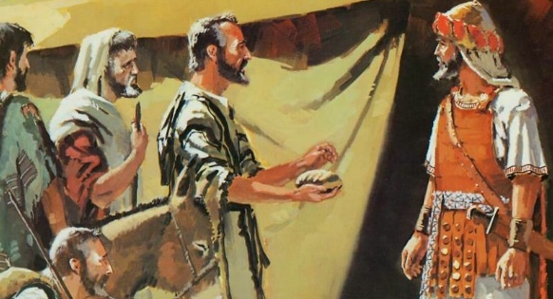
One of the legacies we can leave behind is through making wise decisions in our daily lives by involving God. So how do we make decisions that are good and honouring to God? Often times, people struggle to identify what exactly is the will of God. Even outstanding leaders like Joshua could make wrong decisions because he did not ask the Lord and acted too quick to come into a conclusion (Joshua 9:14-15). Pastor Daniel shared the different kinds of decisions we make and how God lead us in decision making that would bear fruit.

There are FOUR different levels of decisions that we have to make all the time:

The Background
The River Jordan had been dried up and the cities of Jericho and Ai taken (Joshua 3 and 4, 6 and 8). All the Kings west if the Jordan were filled with fear (Joshua 5:1). Yet they still came and attacked Joshua and God’s people (Joshua 9:1,2).
But the Gibeonites knew better and tricked Joshua and the leaders for them to live in their midst (Joshua 9:3-6).

The Mistake
The Israelites sampled their provisions but did not inquire of the Lord. Then Joshua made a treaty of peace with them to let them live, and the leaders of the assembly ratified it by oath. (Joshua 9:14,15)

They did not inquire from the Lord in their decision-making.

How do we make decisions that are good and God-honouring?

Through Prayer and Seeking the Face of God
You, God, are my God, earnestly I seek you; I thirst for you, my whole being longs for you, in a dry and parched land where there is no water. I have seen you in the sanctuary and beheld your power and your glory. (Psalm 63:1-2)

Our God is a God of revelation. When we seek after Him, He will reveal Himself. That is why our prayers should always be personal and specific so that He can reveal to us the specific answer to lead us and guide us in our decision making.

Through The Word of God
For the word of God is alive and active. Sharper than any double-edged sword, it penetrates even to dividing soul and spirit, joints and marrow; it judges the thoughts and attitudes of the heart. Nothing in all creation is hidden from God’s sight. Everything is uncovered and laid bare before the eyes of him to whom we must give account. (Hebrews 4: 12-13)

As we read the Word of God, it will expose our motivation, intention and desires. God would give us either confirmation or conviction through His Word. If it is something not right, He will correct us so we will not make hasty or self-centred decisions.

Through the Voice of God or the Impression He Puts on Our Heart
The Lord came and stood there, calling as at the other times, “Samuel! Samuel!” Then Samuel said, “Speak, for your servant is listening.” (1 Samuel 3:10)

God called Samuel three times and yet Samuel was not aware. He was blessed because Eli was there to remind him that it was God whom had called him. Have we missed God’s voice and calling because we were too busy with our own lives? We need to be in close relationship with God to be sensitive to His voice. Eli could not recognize it was God who was calling Samuel. Sometimes we can be so professional in our Christianity we become disconnected with God. It has become a religion instead of a relationship. Sometimes God speaks through His mighty voice and sometimes He could put an impression on our heart. It could be a prompting that we sense so clearly that God is trying to give us a confirmation, reminder or conviction.

When God calls a person by name twice, it was a significant life-changing event to a person. We read this happening to Abraham and Moses in the Old Testament, and Saul (Paul) and Peter in the New Testament.

Through Circumstances or Events That God Orchestrates
Paul and his companions travelled throughout the region of Phrygia and Galatia, having been kept by the Holy Spirit from preaching the word in the province of Asia. When they came to the border of Mysia, they tried to enter Bithynia, but the Spirit of Jesus would not allow them to. So they passed by Mysia and went down to Troas. During the night Paul had a vision of a man of Macedonia standing and begging him, “Come over to Macedonia and help us.” After Paul had seen the vision, we got ready at once to leave for Macedonia, concluding that God had called us to preach the gospel to them. (Acts 16:6-10)

God can open and shut doors. Sometimes we may be anticipating a deal or job offer that we wanted so badly, we even went through all the stages and thought we would really get it but in the end we did not get it and we felt upset. But fret not! God allows this to happen because He has a better place for us. He shuts the door because He has another better door prepared for us to enter the promise land.

Through His Creation or People around Us
Look at the birds of the air; they do not sow or reap or store away in barns, and yet your heavenly Father feeds them. Are you not much more valuable than they? Can any one of you by worrying add a single hour to your life? And why do you worry about clothes? See how the flowers of the field grow. They do not labour or spin. Yet I tell you that not even Solomon in all his splendour was dressed like one of these. If that is how God clothes the grass of the field, which is here today and tomorrow is thrown into the fire, will he not much more clothe you—you of little faith? So do not worry, saying, ‘What shall we eat?’ or ‘What shall we drink?’ or ‘What shall we wear?’ For the pagans run after all these things, and your heavenly Father knows that you need them. (Matthew 6: 26-32)

The best way God leads us to making wise decisions is through the life of Jesus. He also shows us through the people and even other creations around us. God asked us to look at the birds in the air, the grass of the field and assured us not to worry. Trust God, look to Him, and when the time comes, the Lord will provide.

By Seeking the Wisdom of One or More Spiritually Mature, Wise and Discerning People
There are plenty of spiritual leaders that we can seek advice from like pastors, cell group leaders, etc. We do not have to struggle on our own but get help and counsel from the wise and experienced people that God has placed around us for our good.

Conclusion
What is God’s purpose in helping our decision making?
These are the nations the Lord left to test all those Israelites who had not experienced any of the wars in Canaan (he did this only to teach warfare to the descendants of the Israelites who had not had previous battle experience): the five rulers of the Philistines, all the Canaanites, the Sidonians, and the Hivites living in the Lebanon mountains from Mount Baal Hermon to Lebo Hamath. They were left to test the Israelites to see whether they would obey the Lord’s commands, which he had given their ancestors through Moses. (Judges 3:1-4)

God put the foreign forces there to teach the descendant of Israel warfare. He was teaching them not just the principles but gave them practice. The ultimate purpose of God is to teach us faithfulness. This springs forth fruitfulness in our lives and for the glory of His kingdom. As we are faithful in little things, God will entrust us with bigger things. Pastor Daniel ended the sermon by reminding us to always guard our hearts with the 6Ps: Power, Position, Pride, Passion, Purse and Practice (especially later in life). We must always be vigilant, watchful, accountable and transparent in all that we do. We cannot assume that we will always be fruitful.
Sermon summary contributed by Phoebe Wong.
Prayer points contributed by Abbey Thangiah.

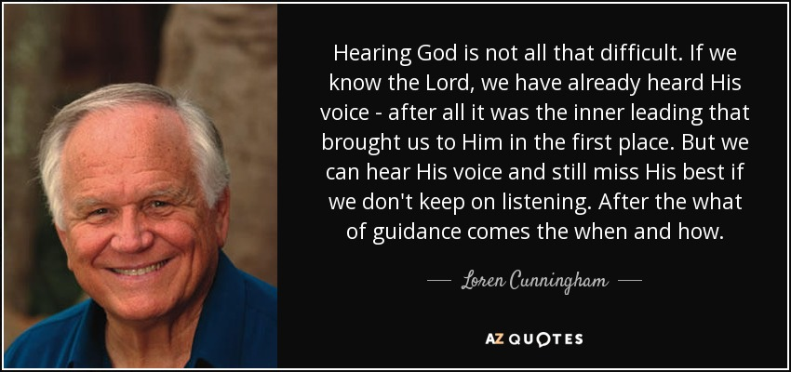

SERMON: Involve God in your Decisions
Pray:
- People will involve God in making decisions regardless how big or small.
- People will seek the will of God through prayer.
- Christians will accept consequences when God closes the door because another door will open for better things.
- People will accept advice from godly people as people are around for our good.
- That we will be faithful in little things and decisions.
They answered Joshua, “Your servants were clearly told how the Lord your God had commanded his servant Moses to give you the whole land and to wipe out all its inhabitants from before you. So we feared for our lives because of you, and that is why we did this. We are now in your hands. Do to us whatever seems good and right to you.” (Joshua 9:24, 25)

MINISTRIES & EVENTS: Alpha
Pray:
- Pastors and volunteers will continue to serve God despite repeatedly doing Alpha.
- God will reveal to us who to invite to join Alpha.
- DUMC members will also consider attending Alpha as a refresher or serving in the Alpha Team.
- God will start preparing the hearts of the non-believers to attend alpha despite all the distractions that will occur.
I will give them a heart to know me, that I am the Lord. They will be my people, and I will be their God, for they will return to me with all their heart. (Jeremiah 24:7)

MALAYSIA MY NATION: ZIKA
New Zika cases will continue to emerge, said Health Minister Datuk Seri Dr S. Subramaniam. He, however, said it was possible there were other infected people in the community who are potential sources of infection. "We are in the process of tracing the movement of this last patient over the past few weeks. We will intensify vector control activities in these areas," he said. Dr Subramanian said the Health Ministry was of the view that the patient's death was not directly related to Zika. (thestar.com.my)
Pray:
- God will protect and heal the nation from this virus.
- Malaysians will be vigilant in cleaning and making their neighbourhoods mosquito free.
- That Christians will not live in fear but turn to God for hope.
- That the families of those affected with the virus will be comforted.
He himself bore our sins” in his body on the cross, so that we might die to sins and live for righteousness; “by his wounds you have been healed.” (1 Peter 2:24)

- A TRANSFORMED WORLD: Terrorism
DAVAO, Philippines (Reuters) - Philippines' President Rodrigo Duterte declared on Saturday a nationwide "state of lawlessness" after a bombing police believe was orchestrated by Muslim militants killed 14 people in his home city during his weekend visit there.
Pray:
- The world will not pin terrorism to a specific group of people but recognize that this has become a global issue.
- The initiatives of President Duterte to combat corruption and terrorism will be taken positively.
- People of different faiths will take this opportunity to promote peace and harmony within the nation.
- People will take terrorism seriously and not just leave things to the government.
God is our refuge and strength, an ever-present help in trouble. Therefore we will not fear, though the earth give way and the mountains fall into the heart of the sea (Psalm 46:1-2)

