SBJ9: Give Me My Mountain (Joshua 14:6-15)
Datuk Dr Denison Jayasooria

Now the people of Judah approached Joshua at Gilgal, and Caleb son of Jephunneh the Kenizzite said to him, “You know what the Lord said to Moses the man of God at Kadesh Barnea about you and me. I was forty years old when Moses the servant of the Lord sent me from Kadesh Barnea to explore the land. And I brought him back a report according to my convictions, but my fellow Israelites who went up with me made the hearts of the people melt in fear. I, however, followed the Lord my God wholeheartedly. So on that day Moses swore to me, ‘The land on which your feet have walked will be your inheritance and that of your children forever, because you have followed the Lord my God wholeheartedly.’ (Joshua 14:6-9)

Introduction
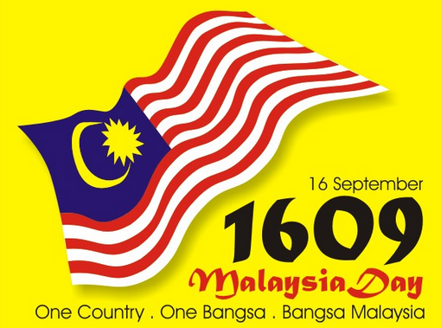
Our reflections for 2016 Malaysia Day is centred on this theme of possessing the Promised Land. The theme of the Promised Land is a very important dimension of the salvation history. Even to this day there are issues contesting the occupation of Jewish lands, similar to how the lands of the Malaysian indigenous peoples are being contested by the government of the day and the peoples around the lands.

Let’s first look at the key theme we can gather from the passage, and how we can apply it into the Malaysian context.

Key Themes
The nation of Israel had finally entered the Promised Land and it is now being allocated to the 12 tribes of Israel for them to conquer and occupy. Caleb the Kenizzite from the tribe of Judah finally stakes his claim of inheritance of land for him and his descendants – and asks for Hebron.

Inheritance
Now these are the areas the Israelites received as an inheritance in the land of Canaan, which Eleazar the priest, Joshua son of Nun and the heads of the tribal clans of Israel allotted to them. (Joshua 14:1)
Inheritance is a key biblical theme especially inherited promised from God to Abraham and his descendants. In the context of this passage, the promise was a literal occupation of the land (Genesis 12:2&7). For many Christians, inheritance could also be viewed spiritually in terms of inheriting the new Jerusalem (Romans 4:13-16). However the emphasis for this message is on possessing the land.

The righteous will inherit the land and dwell in it forever. (Psalm 37:29)

The Orang Asli have been disposed of their lands, inherited from generation to generation. They may have a greater claim on those lands, however as they do not possess land grants, the state does not recognise their stake on the lands.

Caleb’s Claim – A Bold Claim
‘So on that day Moses swore to me, ‘The land on which your feet have walked will be your inheritance and that of your children forever, because you have followed the Lord my God wholeheartedly.’ (Joshua 14:9)

Caleb had faith in God that the impossible can be achieved if we trust the strength of the Lord and demonstrated it when he went up to the Israelites and urged them to take possession of the Promised Land (Numbers 13:26-33). For his optimism in God, Caleb was promised an inheritance for “the land he set his feet on, because he followed the Lord wholeheartedly” (Deuteronomy 1:36). However, he had to wait until he was 85 years old before he could make his rightful claim for land on the basis of his faith and the confidence he showed 45 years before.

During that 45 years of living in the wilderness, after witnessing the death of his entire generation, and finally coming out of the exile, it is important to note that Caleb did nothing to forfeit his inheritance from God. He kept the faith in God that the impossible can be achieved if we trust in the strength of the Lord.

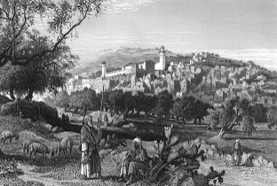
Hebron: The City of the Friend of God
Then Joshua blessed Caleb son of Jephunneh and gave him Hebron as his inheritance. (Joshua 14:13)

Caleb asks for Hebron, the best piece of real estate in the land of Canaan. Hebron is one of the highest locations in Canaan, at 3050 feet above sea level and 32 kilometres from Jerusalem. It was also a place associated with the patriarchs. This is where Abraham lived, and where Abraham, Isaac and Jacob and their wives, were buried (Genesis 23:19, 49:29-33). The name "Hebron" means "fellowship." It was the place where Abraham built his altar, and where much of the Abrahamic covenant was given - the promise of the Land and descendants. So it evoked very important memories in the minds of God's people at that time. It was the best; there was no other place like it in Canaan.
Fun fact: Hebron was also where King David was anointed (2 Samuel 5:3).

It is also worthwhile to note that at the time Caleb was staking his inheritance claim, Anakites – the terrible giants, occupied Hebron. However Caleb said to Joshua, “I am still as strong today as the day Moses sent me out; I’m just as vigorous to go out to battle now as I was then. Now give me this hill country that the Lord promised me that day. You yourself heard then that the Anakites were there and their cities were large and fortified, but, the Lord helping me, I will drive them out just as he said.” (Joshua 14:11-12)

Application

Land matters had always been the bone of contention amongst people. Up to today both Israel and Palestinians are contesting the Jewish lands, just as the indigenous peoples in both the Peninsula and Borneo are fighting to stake their claim on their inherited lands without government grants. It is interesting to note that more than 60% of Christians in Malaysia are from the indigenous groups. These are our Bahasa-speaking, poor and systematically displaced brothers and sisters.

Datuk Dr Denison shares 3 real life experiences on land matters among the Malaysian indigenous people and helps us draw relevance as to how we as Christians can pray and support them.

Community-based Conservation

Dr Paul Porodong, an environmental anthropologist from the Rungus tribe, shares his experience of the community-based conservation of Bukit Gumantong, which is surrounded by the 13 Rungus Christian villages in Kudat, Sabah. The forest and hill area was originally under the purview of the Ministry of Natural Resources and Environment, however this responsibility to manage and conserve the area was handed back to the Rungus community.

Conservation may have been an unintended outcome of the Rungus cultural practices, however conservation is a Christian mission agenda as being stewards of God’s creation which has been entrusted to us. We need to instill the love for the environment and our forests among our younger generations.

Land Inquiry Report of SUHAKAM (2013)

The 2013 Land Inquiry Report of SUHAKAM gives details on the 892 complaints received on land encroachments. Although the Federal government has set up a taskforce and Cabinet Committee, there has been no tangible results and very little is being done at this point in time.

We as fellow citizens of Malaysia share the responsibility to be in solidarity alongside the indigenous peoples for a time such as this – to advocate for their rightful ownership of their lands. We can pray for the people on land-related matters. We can also help them by volunteering in social and public advocacy, including providing legal assistance to the indigenous peoples.

Organic Farming Project

Kon Onn Sien - a lawyer turned community development worker turned social entrepreneur through Yayasan Kajian dan Pembangunan Masyarakat (YKPM) – tells his story of working with 12 Jakun Christian families in developing an organic farm in Ulu Gumum, Pahang. The project empowers the community through discipleship and agricultural competencies. It also enables profit sharing through the market chain by taking away the middleman.

This shows that we as Christians can become social investors and enablers. We minimize the dangers of complacency in the form of government handouts, by empowering communities to create wealth for the common good of the country.

Conclusion
Land as an inheritance challenges us to pray, give, volunteer or work full-time alongside the most needy communities in Malaysia. Working with the indigenous people of Malaysia on this matter is part of the Great Commandment (Love God and Love Your neighbour - Mark 12:28-31) and the Great Commission (make disciples - Matthew 28:16-20). Let’s learn to be like Caleb – to be positive and ever persevering in the faith – because this is a long-drawn process.

Take that first step by joining the “Give Them Their Land” workshop on 24 September 2016, 9.00am to 12.30pm. You can sign up at bit.ly/cnbm_land and find out more at http://www.facebook.com/citizensnetworkMY

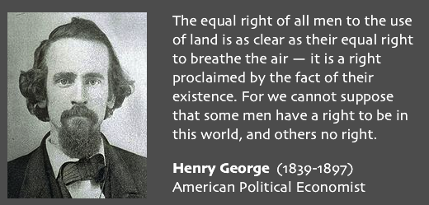

Sermon summary contributed by Adeliyn Lim.
Prayer items by Prudence Tay

SERMON: Give Me My Mountain
Pray:
- We will be stand up together with our ‘orang asli’ brothers and sisters to fight for their rights, especially in the area of land.
- We will give of our resources to help indigenous people of Malaysia in whatever way possible.
- God to continue to give strength and perseverance to all who are working with the indigenous people of Malaysia.
- The administration will view seriously the issue of land encroachment and take actions to fix it.
For there will never cease to be poor in the land. Therefore I command you, ‘You shall open wide your hand to your brother, to the needy and to the poor, in your land.’ (Deuteronomy 15:11)

MINISTRIES &EVENTS: Mission Candidate’s Preparation Program 1 (MCPP1)
On September 24th – 25nd.
Pray:
- Those who have signed up will go with an open heart.
- God’s anointing upon the facilitators to impart a heart for missions.
- God to deposit a passion for missions into the hearts of the participants and a country and people group for them to reach out to.
- Journey mercies for both participants and facilitators as the travel.
Then Jesus came to them and said, “All authority in heaven and on earth has been given to me. Therefore go and make disciples of all nations, baptizing them in the name of the Father and of the Son and of the Holy Spirit, and teaching them to obey everything I have commanded you. And surely I am with you always, to the very end of the age.” (Matthew 28:18-20)

MALAYSIA MY NATION: Kidnapping in Sabah
TAWAU: Three Filipino fishermen were kidnapped by seven armed men in the waters off Pulau Pom-Pom, Semporna last Saturday. One of them had had contacted his employer to relay a two million pesos (RM180,000) ransom demand for their release.
Pray:
- Peace for the families of the fishermen during this time.
- The police will be successful in getting the fishermen safely released.
- God’s protection for the people in that region of Sabah.
- The Filipino government will actively hunt and put a stop to the activities of these rebels.
May the LORD answer you when you are in distress; may the name of the God of Jacob protect you. (Psalm 20:1)

- A TRANSFORMED WORLD: North Korea Nuclear test
(CNN)- North Korea said it hit the button on its fifth and potentially most powerful nuclear test. They are claiming to have successfully detonated a nuclear warhead that could be mounted on ballistic rockets. State media said the test would enable North Korea to produce "a variety of smaller, lighter and diversified nuclear warheads of higher strike power." World leaders condemned the test, saying it was a clear violation of UN Security Council resolutions.
Pray:
- Peace to reign in that region and North Korea will keep to UN Security Council resolutions.
- People will be calm over the situation.
- South Korea and USA will ‘keep their distance’ even as they increase their presence in that area.
- For peace and a clear mind to all leaders and governments in that area and to the UN Security Council.
- God’s intervention in this situation and touch the hearts of the leaders of North Korea.
Do not repay anyone evil for evil. Be careful to do what is right in the eyes of everyone. If it is possible, as far as it depends on you, live at peace with everyone. Do not take revenge, my dear friends, but leave room for God’s wrath, for it is written: “It is mine to avenge; I will repay,” says the Lord. (Romans 12:17-21)

