SBJ11: Choose For Yourself This Day (Joshua 24:1-33)
Senior Pastor Chris Kam

Introduction
In this context, Joshua, who had been faithfully leading the Israelites as they take over the Promised Land, is now old and well advanced in years, and had assembled all the tribes of Israel at Shechem in order to renew the covenant of the people to the Lord.

The Big Idea: Without God, we cannot. Without us, God will not.

Without God, we cannot.

Then Joshua assembled all the tribes of Israel at Shechem. He summoned the elders, leaders, judges and officials of Israel, and they presented themselves before God. Joshua said to all the people, “This is what the Lord, the God of Israel, says: ‘Long ago your ancestors, including Terah the father of Abraham and Nahor, lived beyond the Euphrates River and worshiped other gods. But I took your father Abraham from the land beyond the Euphrates and led him throughout Canaan and gave him many descendants. I gave him Isaac, and to Isaac I gave Jacob and Esau. I assigned the hill country of Seir to Esau, but Jacob and his family went down to Egypt. “‘Then I sent Moses and Aaron, and I afflicted the Egyptians by what I did there, and I brought you out. When I brought your people out of Egypt, you came to the sea, and the Egyptians pursued them with chariots and horsemen as far as the Red Sea. But they cried to the Lord for help, and he put darkness between you and the Egyptians; he brought the sea over them and covered them. You saw with your own eyes what I did to the Egyptians. Then you lived in the wilderness for a long time. “‘I brought you to the land of the Amorites who lived east of the Jordan. They fought against you, but I gave them into your hands. I destroyed them from before you, and you took possession of their land. When Balak son of Zippor, the king of Moab, prepared to fight against Israel, he sent for Balaam son of Beor to put a curse on you. But I would not listen to Balaam, so he blessed you again and again, and I delivered you out of his hand. “‘Then you crossed the Jordan and came to Jericho. The citizens of Jericho fought against you, as did also the Amorites, Perizzites, Canaanites, Hittites, Girgashites, Hivites and Jebusites, but I gave them into your hands. I sent the hornet ahead of you, which drove them out before you—also the two Amorite kings. You did not do it with your own sword and bow. So I gave you a land on which you did not toil and cities you did not build; and you live in them and eat from vineyards and olive groves that you did not plant.’ (Joshua 24:1-13)

Joshua reminded the people that without God, they cannot. Trying too hard does not get you anywhere. You have to rely on God, and depend completely on Him.
God did all this:
I took, I led, I gave, I assigned, I sent, I afflicted, I did, I brought, I destroyed, I delivered.
God’s Word to the people:
Follow me, you win. Leave me, you lose. Obedience brings blessings. Disobedience brings curses.
You may say to yourself, “My power and the strength of my hands have produced this wealth for me.” But remember the Lord your God, for it is he who gives you the ability to produce wealth, and so confirms his covenant, which he swore to your ancestors, as it is today. (Deuteronomy 8:17-18)

Without us, God will not.

“Now fear the Lord and serve him with all faithfulness. Throw away the gods your ancestors worshiped beyond the Euphrates River and in Egypt, and serve the Lord. But if serving the Lord seems undesirable to you, then choose for yourselves this day whom you will serve, whether the gods your ancestors served beyond the Euphrates, or the gods of the Amorites, in whose land you are living. But as for me and my household, we will serve the Lord.” (Joshua 24:14-15)

There has to be a fear of God in us. The number one problem in our country today is that people do not fear God, and that is why there is a lot of crime and corruption. People do not fear eternal judgement.

Joshua challenged the Israelites to discard their idols. He reminded us not only of the faithfulness of God, but also of our responsibility to God. Without God, the Israelites cannot enter the Promised Land, but they had to start walking and moving. Although God will provide, you need to work. God wants everyone to be saved, but you must share the Gospel. God is looking for willing hearts.

The posture of our hearts as we choose to serve God should be to fear the Lord and serve Him with all faithfulness.

“No one can serve two masters. Either you will hate the one and love the other, or you will be devoted to the one and despise the other. You cannot serve both God and money.” (Matthew 6:24)

Either God is your master or you are the master of your own life. However, no one can truly be the master of their own life. They are actually slaves, living in constant anxiety and fear. God is all-sufficient and does need anything. He only asks us to serve for our own good.

Why does God want us to serve?

Express our faith in practical action

“If you love me, keep my commands.” (John 14:15)

If you love Jesus, then you will obey His commands.

Faith becomes real when lives are transformed. When you see a need, meet it. When you see a hurt, heal it. Radical serving is led by the Holy Spirit, involving the usage of spiritual gifts. If you think you cannot do it, you will not serve, and therefore you will not discover your spiritual gifts.

Going to church and cell group is not part of serving. It is a duty. Leading the Word or leading worship regularly in cell group is part of serving. The key is regularity.

Grow through serving

When you avail yourself to serve, you will discover your spiritual gifts.

There are three types of people in the church:

Takers – They come only to take but do not give or serve
Clubbers – They come to church just to enjoy themselves and have a good time
Givers – They give and serve faithfully and regularly in church

There is nothing wrong to enjoy church, but you will only grow if you serve. You encounter God when you serve God.

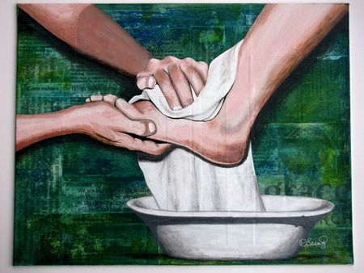
Model a lifestyle of service and servanthood (make disciples)

Jesus came “not to be served but to serve, and to give His life as a ransom for many.” (Matthew 20:28)

Every Christian has to model after Jesus to serve. Parents need to model a lifestyle of servanthood to their children. Effective ministry comes through years of serving.

God sees and rewards our labour of love.

God is not unjust; he will not forget your work and the love you have shown him as you have helped his people and continue to help them. (Hebrews 6:10)

God watches what we do. God sees what you are doing even when people do not see. God rewards us for our faithfulness, not for how many things we do. At the end of it all, we want to hear God say, “Well done, good and faithful servant.”

Conclusion
Before we start serving God, we need to deal with the idols in our lives. Joshua knew that the people needed to deal with the idols in their lives before they start serving God. They needed to be committed to the Lord and serve out of a genuinely sincere heart. Or else, they will be susceptible to the danger of falling away from the Lord. This was proven when, by the next generation, the people has fallen away from the Lord due to the sin of idolatry.

We need to ensure that the posture of our hearts is made right in our relationship with God as we serve Him, which is to fear Him and serve Him with all faithfulness. We have to rely and depend on God, partnering with Him in His work in our lives and the world.

Sermon summary contributed by Anthea Tan.
Prayer items by Ngui Yuen Loong.

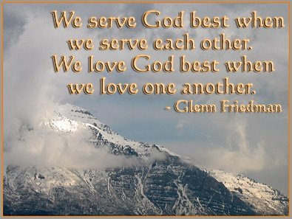

SERMON: What will you leave behind
Pray:
- As Christians, we will make a deliberate decision to follow God.
- We will allow our faith to manifest in works in practical ways.
- We will be willing to serve so we can grow.
- We will serve God as a family.
- We will get involve in disciple-making.
But if serving the Lord seems undesirable to you, then choose for yourselves this day whom you will serve, whether the gods your ancestors served beyond the Euphrates, or the gods of the Amorites, in whose land you are living. But as for me and my household, we will serve the Lord.” (Joshua 24:15)

MINISTRIES & EVENTS: Chosen: A Men’s Conference
Themed “Become the man that God has chosen you to be”, the Chosen Conference will be held in the Dream Centre from 20/10/2016 to 22/10/2016.
Pray:
- Men from within DUMC and from outside will sign up and attend the conference.
- God to anoint the speakers Patrick Morley and Senior Pastor Chris Kam.
- The conference will make a strong impact to the participants that will bring about positive effects on their families, churches and workplace.
- Churches will recognize the importance of men’s ministry and put stronger emphasis on it.
Be watchful, stand firm in the faith, act like men, be strong. Let all that you do be done in love. (1 Corinthians 16:13, 14, ESV)

MALAYSIA MY NATION: Zika Virus
Pray:
- The local authorities will keep tab on the latest development and respond swiftly.
- The public will be aware of the threat and not take it lightly.
- The public will co-operate by cleaning up their areas to prevent the breeding of mosquitoes.
- Working together, we will be able to contain the spread of Zika Virus in Malaysia.
He sent out his word and healed them; he rescued them from the grave. (Psalm 107:20)

- A TRANSFORMED WORLD: US Presidential Election
Americans will vote on Super Tuesday (08/11/2016) to elect their 45th President.
Pray:
- Campaigns and debates in days leading to election days will reveal much about the two candidates so the voters know who they are voting for.
- The winning candidate will commit to serve justly in one of the most powerful position in the world.
- The next President will also seriously look into the problems faced by the citizens and find ways to resolves them.
- The next President will put first the interest of the Americans and to a larger extent, the world before his / her own interest.
When the righteous thrive, the people rejoice; when the wicked rule, the people groan. (Proverbs 29:2)

