FORWARD2017
STEP OUT: Love God, Serve People & Make Disciples (Luke 10:25-37)
Senior Pastor Chris Kam

On one occasion an expert in the law stood up to test Jesus. “Teacher,” he asked, “what must I do to inherit eternal life?” “What is written in the Law?” he replied. “How do you read it?” He answered, “‘Love the Lord your God with all your heart and with all your soul and with all your strength and with all your mind’; and, ‘Love your neighbour as yourself.’” “You have answered correctly,” Jesus replied. “Do this and you will live.” But he wanted to justify himself, so he asked Jesus, “And who is my neighbour?” In reply Jesus said: “A man was going down from Jerusalem to Jericho, when he was attacked by robbers. They stripped him of his clothes, beat him and went away, leaving him half dead. A priest happened to be going down the same road, and when he saw the man, he passed by on the other side. So too, a Levite, when he came to the place and saw him, passed by on the other side. But a Samaritan, as he travelled, came where the man was; and when he saw him, he took pity on him. He went to him and bandaged his wounds, pouring on oil and wine. Then he put the man on his own donkey, brought him to an inn and took care of him. The next day he took out two denarii and gave them to the innkeeper. ‘Look after him,’ he said, ‘and when I return, I will reimburse you for any extra expense you may have.’ “Which of these three do you think was a neighbour to the man who fell into the hands of robbers?” The expert in the law replied, “The one who had mercy on him.” Jesus told him, “Go and do likewise.” (Luke 10:25-37)

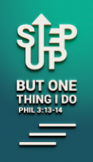
Introduction
The theme of Last Year was to Step Up. Taking from Philippians 3:13-14, we are to:
- Forgetting what is behind;
- Forging toward what is ahead; and
- Focusing on the Call.
Brothers and sisters, I do not consider myself yet to have taken hold of it. But one thing I do: Forgetting what is behind and straining toward what is ahead, I press on toward the goal to win the prize for which God has called me heavenward in Christ Jesus. (Philippians 3:13-14)

For the first time in the history of DUMC, the transition of Senior Pastor took place in 2016. Pastor Chris obeyed and stepped up, and he prays that everyone will do the same too. Last year, many people came to accept the baptism of the Holy Spirit. Ever since, many things started to change. We started seeing cell groups reaching out to the communities, many members coming to pray during the zone prayers, and just a few weeks ago, thousands of people came to know the Lord during Myanmar congregation’s Christmas celebration. This year, we are asking for, “More, Lord!”

Upon stepping up, God had given us the visions and steps of the first four years through Pastor Chris:
- First year: STEP UP
  - We are to step up in our life, and allow God to do things through us.
- Second year: STEP OUT
  - After stepping up, we are to step out. Every blessing that we receive must go out.
- Third year: STEP IN
  - After stepping up and out, we are called to step into whatever places God bring us to.
- Fourth year: STEP FORWARD
  - Ultimately, we are to forward blessings to the community. It is also a call to the church.

All the above are based on the great commandment and great commission:
Love the Lord your God with all your heart and with all your soul and with all your mind (Matthew 22:37)

Therefore go and make disciples of all nations, baptizing them in the name of the Father and of the Son and of the Holy Spirit, and teaching them to obey everything I have commanded you. And surely I am with you always, to the very end of the age.” (Matthew 28:19-20)

Big Idea: Love GOD, serve people, make disciples (Luke 10:27)

The big idea: Love, serve, make disciples- is the calling of DUMC.

Love God
He answered, “‘Love the Lord your God with all your heart and with all your soul and with all your strength and with all your mind’; and, ‘Love your neighbour as yourself.’” “You have answered correctly,” (Luke 10:27)

“The kingdom of heaven is like treasure hidden in a field. When a man found it, he hid it again, and then in his joy went and sold all he had and bought that field. “Again, the kingdom of heaven is like a merchant looking for fine pearls. When he found one of great value, he went away and sold everything he had and bought it. Matthew 13:44-46

When we say we love God, are we willing to give up everything and follow Him? The first thing is that we must obey Him. Obedience is when we do something that we do not feel like doing, but because God said so, so we do it willingly and we want to do it. The Bible says Christ’s love compels us. When we love God, we obey Him wholeheartedly.

During the Christmas celebration weekend, Pastor Chris shared about how Jesus turned water to wine upon the exhibit of faith and trust (John 2:1-10). The water only turned to wine when the servant was taking it to the master of banquet. The following week, Pastor Chris preached about the 10 men with leprosy. They were healed when they obeyed Jesus and went to the priest. They were healed because of their faith in Jesus (Luke 17:11-19). God will do the miracles when we obey.

Part of loving is sacrifice, sacrificing for something even better. Jesus sacrificed everything for us. In Malaysia, we may not fully understand this, because life is good here. There are countries where people die because they are Christians. Do we love God enough to give up our life? When we love God, we should want God to be a part of our lives every day. Loving God is not just about how we feel about God, but obedience. How do I get Him to be involved in my life everyday? When we love God, God’s presence will be upon us, and our life will be amazing. All these, start with loving God deeply.

Serve People
“Love your neighbour as yourself.” (Luke 10:27b)
We are servants of God, we are called to serve.
In the Bible, 'Love' is an action word. Thus the word 'Serve' is a good description for 'Love'.

Based on the parable of the Good Samaritan, there are three ways of looking at people:
- Robbers - Take things that don’t belong to them.
- Religious people - Ignore people who are in need.
- Good Samaritan - Helped the Jew (Jews rejected Samaritan who were labelled as half breed, not pure Jews).
We want to be like the Good Samaritan. We want to serve people irrespective of who they are.

Make Disciples
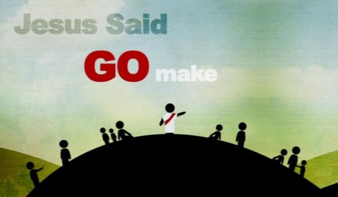
Then Jesus came to them and said, “All authority in heaven and on earth has been given to me. Therefore go and make disciples of all nations, baptizing them in the name of the Father and of the Son and of the Holy Spirit, and teaching them to obey everything I have commanded you. And surely I am with you always, to the very end of the age.” (Matthew 28:18-20)

God said to go and make disciples, not believers. It is more than just believing. Even the devil believes. We need to be disciples and to disciple others. We need to 'pass on' our faith to new believers.

This is going to be a church of disciples. It is going to be an exciting year in an exciting church.

Conclusion
We are to love God and love people, serve people and always remember to be kind to others, and make disciples of all nations. All these are the calling of our church based of the Great Commandment and Great Commission.

What is the Holy Spirit saying to you?
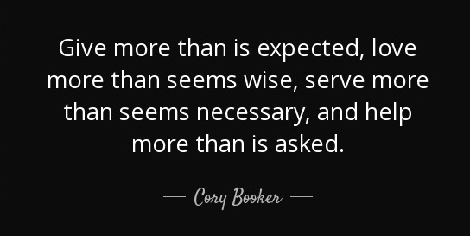
Sermon summary contributed by Chrisandra Wong
Prayer points contributed by Wendy ML
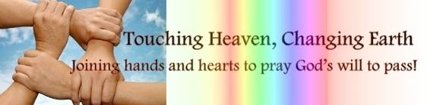

SERMON: FORWARD2017 - Step Out
Pray:
- That we will follow the great commandment and great commission - Love God, Serve People & Make Disciples.
- We will obey Him because we want to and not because we have to.
- We will be willing to sacrifice and give up everything for Him.
- We will involve the Holy Spirit in our lives every day, and look to God even when things are going well in our lives.
- We will be like the Good Samaritan man, helping others in need; to have a heart for other people.
- We will prepare ourselves that we may multiply and make disciples of others.
He answered,” ‘Love the Lord your God with all your heart and with all your soul and with all your strength and with all your mind’; and, ‘Love your neighbour as yourself.’” (Luke 10:27, NIV)

MINISTRIES & EVENTS: 37th ANNIVERSARY & GIFT WEEKEND
DUMC’s annual anniversary weekend will be held on 14 and 15 Jan 2017. It is a time set aside every year, to celebrate by giving to the Lord in gratitude and thanksgiving, and by giving generously and cheerfully.
Pray:
- We will praise God and be thankful for His provision and love in all areas of our lives.
- We will be obedient and faithful in contributing the amount that God may have prompted or stirred in their hearts.
- Preparation for the event will be smooth, no hiccups and the money collected will be safe from harm.
- That the amount collected will bear fruit in the many organizations and lives that are set to benefit from the giving.
Remember this: Whoever sows sparingly will also reap sparingly, and whoever sows generously will also reap generously. Each of you should give what you have decided in your heart to give, not reluctantly or under compulsion, for God loves a cheerful giver. And God is able to bless you abundantly, so that in all things at all times, having all that you need, you will abound in every good work. (2 Corinthians 9:6-8)

MALAYSIA MY NATION: Floods in the East Coast & Sabah
Floods are back on the East Coast as well as Sabah and Sarawak due to incessant rain and waters that have overflowed banks causing water levels to rise in villages and rivers, to dangerous points. Even as the new term starts, some schools had to be closed and families evacuate from their homes.
Pray:
- The relevant authorities and agencies will be able to handle the crisis at hand effectively.
- People will rise up and step out to help those who are in need, be it in donating cash, clothes, food, medical supplies, or even a helping hand to rebuild houses and infrastructure or cleaning up the beaches and its surroundings.
- Thefts and looting of empty homes evacuated during the flood will be thwarted.
- That God will comfort all who are affected by the flood. Pray for His healing hands upon those who are sick.
- That the flood will continue to recede so that people may return and rebuild their homes and resume their normal lives.
And do not forget to do good and to share with others, for with such sacrifices, God is pleased. (Hebrews 13:16, NIV)

A TRANSFORMED WORLD: Drying taps in Damascus, Syria
While we have floods here, Damascus, Syria on the other hand is facing an acute water crisis. In the past two weeks. Taps have run dry. The government and the rebels blame each other for damaging infrastructure near the springs outside the capital (Wadi Barada & Ain al-Fija) and thus halting the flow of clean water. Approximately 5.5 million people are affected.

Pray:
- Regardless what the cause is, that the water infrastructure and pumping facilities will be inspected and fixed immediately.
- In the meantime, water will continue to flow smoothly to the wells and that there will be sufficient water to be rationed to the people.
- Prices of drinking water will not be overly priced so as not to add to families’ financial strain.
- Against water-borne diseases as clean water is scarce, particularly towards young children and the elderly.
- That the ceasefire agreement between the government and the rebels will be upheld.
Consider the blameless, observe the upright; a future awaits those who seek peace. (Psalms 37:37)

