Back to Basics of Being a Born-Again Christian: The Lordship of Christ and you (Hebrews 5:11-6:2; Philippians 2:8-11)
Pastor Alex Tan

We have much to say about this, but it is hard to make it clear to you because you no longer try to understand. In fact, though by this time you ought to be teachers, you need someone to teach you the elementary truths of God’s word all over again. You need milk, not solid food! Anyone who lives on milk, being still an infant, is not acquainted with the teaching about righteousness. But solid food is for the mature, who by constant use have trained themselves to distinguish good from evil. Therefore let us move beyond the elementary teachings about Christ and be taken forward to maturity, not laying again the foundation of repentance from acts that lead to death, and of faith in God, instruction about cleansing rites, the laying on of hands, the resurrection of the dead, and eternal judgment. (Hebrews 5:11-6:2)

And being found in appearance as a man, he humbled himself by becoming obedient to death— even death on a cross! Therefore God exalted him to the highest place and gave him the name that is above every name, that at the name of Jesus every knee should bow, in heaven and on earth and under the earth, and every tongue acknowledge that Jesus Christ is Lord, to the glory of God the Father. (Philippians 2:8-11)

Introduction
Our core habits do not make us more Christlike. These core habits form a platform and reminder of how we can live and build a Biblical culture of serving others. It is important that we return to the fundamentals of our faith. How much have we changed in our lives towards Christlikeness? Are we better people? There are some areas that we change and some areas that we remain stubborn. How have we been transformed by the grace of God? Let it not just be a concept or a catchphrase that we memorise. Just like babies, it is good to go back and revisit the fundamentals of our faith in this 6-week sermon series.
1. Understand
We have much to say about this, but it is hard to make it clear to you because you no longer try to understand. (Hebrews 5:11)

We may need to be taught the elementary truths all over again. The word understand is important because we may have understood in a certain way when we learnt it as new believers but if we do not have the right understanding, this may lead to wrong beliefs and wrong actions. It is important to understand well.

2. Maturity
Therefore let us move beyond the elementary teachings about Christ and be taken forward to maturity, not laying again the foundation of repentance from acts that lead to death, and of faith in God (Hebrews 6:1)

There has to be a change that takes place in our lives. Hence we need to go back to basics. To mature well is to believe rightly. To believe rightly is to understand rightly. If you know it well, pass it on. Belief has to be personal so you can be sure of your faith and salvation.

The BIG idea: The Lordship of Christ grants you and me the privilege of surrender.

It is not burdensome to surrender to a God who is of supreme worth and value.

Lordship. He is.
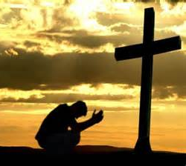
You cannot make Jesus Lord more than He already is. Regardless of how we see Him or embrace Him yet or whether we make Him Lord, you cannot make Him any less Lord than He already is. Calling Him Lord cannot make Him anymore Lord than He is already Lord. He is Lord of all regardless of whether we acknowledge His Lordship.

that at the name of Jesus every knee should bow,
in heaven and on earth and under the earth,
and every tongue acknowledge that Jesus Christ is Lord,
to the glory of God the Father. (Philippians 2:10, 11):

Bow
Bowing is a posture of surrender, humility and submission to someone who is greater, supreme and whom we should honour. He is the God; not just one god among many other gods. It is one thing to bow because we are forced to, due to a tradition or due to peer pressure. It is another thing to bow because of the untold magnificence, beauty and glory of God.

And being found in appearance as a man, he humbled himself by becoming obedient to death— even death on a cross! Therefore God exalted him to the highest place and gave him the name that is above every name,
(Philippians 2:8-9)

Jesus humbled Himself to serve others. That is the beauty of it – that God is great, supreme and unmatched because of how He has humbled himself. It is an irony that Lordship demands a certain response that is not forced. Beautiful surrender to God comes out of our willingness and desire to do so because of His beauty and majesty of our marvellous God.

The Son is the radiance of God’s glory and the exact representation of his being, sustaining all things by his powerful word. (Hebrews 1:3a)

This God is not far away. He can be known. You can have a conversation with Him. This God is a God whom you can be intimate with. Yet He is radiant because He is humble. We cannot help but honour the Lord when we recognise His supremacy in a world that fights for our attention. We tend to enthrone ourselves more than the God whom we should honour and give due reverence and glory. Therefore it is beautiful to hang around someone who is humble. Our hearts are so prone to entertain pride while humility is beautiful. We see that humility in Christ. When we see and recognise His Lordship and greatness, we marvel at that. We also marvel at the beauty of nature such as the Northern Lights and marvel at the God of creation. This God has created us, called us by name and knows the number of hairs on our head. How can we not bow and worship this God?

Worship = worth-ship

We need to embrace the worthiness of God. We may have elevated ourselves more than God who should be the God over our lives. How can we not respond to this beautiful Saviour who is our creator and the creator of the Universe?

Lordship. We give.
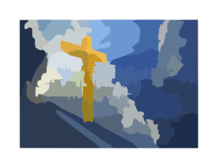
We know this God, Jesus, who died for us in such love and pursuit. You can give Him ownership of your life more than you already do. We struggle with sin and make bad choices in life. Not every part of us seems to be surrendered to God. You can and want to give Him ownership. You want to yield your heart to God. This should not be forced.

I have been crucified with Christ and I no longer live, but Christ lives in me. The life I now live in the body, I live by faith in the Son of God, who loved me and gave himself for me. (Galatians 2:20)

How many of us can say “it is no longer I who lives”? We tend to creep off the altar of sacrifice. We end up still being selfish, self-centred and proud. How do we react when things happen in life?

We can even choose to do whatever our sinful nature desires by twisting Scripture and truth saying that God and people should accept us as we are (our true selves). However, Jesus came to save you from your true self. If we do not recognize that, we see no need to change. We can demand to be accepted and loved anyway. We put ourselves on a pedestal and have a hard time crawling off the altar. We should not want our true selves. We should want Christ in us, the hope of glory – that makes all the difference. God blesses us with strengths, talents and abilities to use for His glory but we should not remain who we are. In our faith journey, there are still things we need to die to. He has come to save us from ourselves.

Surrender is a giving in to… and not just a matter of giving up.

The Christian life is not just about obeying rules. Surrender should be joyful. We should live an abundant life in Christ in a way that is honouring to Him. Surrender is giving in to the God who loves you and gave Himself for you. This God who is marvellous, magnificent and humble to reach out to be with you.

Conclusion

Surrender is a privilege. We need to lay our lives down. Some of us need to surrender our pain and give in to Jesus. Do not carry the pain with you but surrender and give in to this God who cares for you, loves you and pursues you.

He is Lord. You cannot make Jesus Lord more than He already is. We need to recognise and live out His Lordship in our lives. When we begin to know this God, who He is and how He would go all out for our highest good because He is good, we live for His highest good and glory. We also get to know what hurts Him and what conflicts or sins would offend God. That is a change of perspective of how we see this God of with and value that would change our lives and our minds. We have to walk away from sin in repentance because of we live for His highest good and because of what God has done for us.

We can give Him ownership of our lives more than we already do. How have you surrendered and yielded in this God who is interested in you? He is not a God who is far away but a God who is interested in having a relationship with you. Some of us may be pursuing eternal life but what about pursuing eternal love? We need to have a relationship with God and not just for the benefits of what we can get. Why did Jesus come to Earth? Most of us would answer that “He came to die for my sin to save me so that I can have eternal life”. Many times we have an anthropocentric view of this God – it is about me. Jesus actually came to do the will of the Father. The Lord has to change our thinking to have a theocentric (God-centred) view as we read Scripture and posture our hearts towards this God we call Lord.

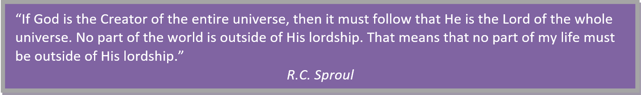

Sermon summary contributed by Zhenli
Prayer points contributed by May Ng

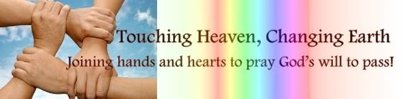

SERMON: The Lordship of Christ and You
Pray:
- Conviction that Jesus Christ is Lord over every aspect of our lives.
- A posture of surrendering to the Lord in all that we do.
- A worshipping posture that acknowledges Jesus Christ is Lord and not just for worshipping’s sake.
- Trust Jesus with all our hearts no matter the circumstances.
- Humility in all our hearts in seeking the Lord
Therefore do not be foolish, but understand what the Lord’s will is. (Ephesians 5:17)

MINISTRIES & EVENTS: LEAD2017
The LEAD Conference this year will be held 1-3 June at the Dream Centre.
Pray:
- More volunteers to encourage people to sign up for the conference.
- Servers, speakers and delegates to be in good health.
- Wisdom and outpouring of the Holy Spirit on the task force in the planning.
- More people to sign up as compared to previous years.
- Sound preparation by the speakers to prepare their sharing.
- All participants will come away refreshed at the end of the conference.
“And the things you have heard me say in the presence of many witnesses, entrust to reliable people who will also be qualified to teach others.” (2 Timothy 2:2)

MALAYSIA MY NATION: Youths in Malaysia
There have been numerous news reports on the youths in Malaysia recently, from the ‘basikal nyamuk’ phenomenon and the rise in numbers of teenage pregnancies, resulting in the dumping of babies.
Pray:
- Godly parents to educate their children.
- Wisdom on parents, teachers and authorities to exercise the necessary authority on the youths.
- Discipline among the youths especially when it comes to utilising their free time and idle resources.
- God’s love to be poured out on the youths.
- Jesus Christ to be revealed especially to the youths, believing that God has a plan and purpose for their lives.
How can a young person stay on the path of purity? By living according to Your word. (Psalm 119:9)

- A TRANSFORMED WORLD: The death of Kim Jong-Nam
Pray:
- For clarity and transparency in the investigations.
- Righteousness and justice to be upheld especially amongst the accused, witnesses and the perpetrators.
- Peace and harmony between the countries concerned especially North Korea and Malaysia.
- God’s will to be done in what has taken place and it will not escalate into a further conflict.
- The truth and righteousness of Jesus Christ to be revealed in the midst.
When justice is done, it brings joy to the righteous but terror to evildoers. (Proverbs 21:15)

