Back to Basics of Being a Born-Again Christian: Sin, repentance and you (2 Corinthians 7:8-11)
Pastor Mike Ngui

Even if I caused you sorrow by my letter, I do not regret it. Though I did regret it—I see that my letter hurt you, but only for a little while— 9 yet now I am happy, not because you were made sorry, but because your sorrow led you to repentance. For you became sorrowful as God intended and so were not harmed in any way by us. Godly sorrow brings repentance that leads to salvation and leaves no regret, but worldly sorrow brings death. See what this godly sorrow has produced in you: what earnestness, what eagerness to clear yourselves, what indignation, what alarm, what longing, what concern, what readiness to see justice done. At every point you have proved yourselves to be innocent in this matter. (2 Corinthians 7:8-11)

Introduction
The Corinthian church are already believers, yet there is still a need for them to repent. This is the same for us.

The BIG idea: Repentance is a daily discipline to change toward Christlikeness from the inside out.

Sin is the great spoiler
The acts of the flesh are obvious: sexual immorality, impurity and debauchery; idolatry and witchcraft; hatred, discord, jealousy, fits of rage, selfish ambition, dissensions, factions and envy; drunkenness, orgies, and the like. I warn you, as I did before, that those who live like this will not inherit the kingdom of God. (Galatians 5:19-21)

Someone puts it this way:

If life is a machine, sin is the bad gear that makes the machine malfunction. If life is a country, sin is like a terrorist group causing terror and destruction in a country. If life is a family, then sin is like a feud between family members. If life is a body, then sin is like untreated cancer. If life is like a river, then sin is like industrial pollutants which kill all the fish. If life is a garden, then sin is like an army of snails or slugs that eat up all your plants. If life is a computer, sin is like a virus or Trojan that destroys your hard drive and steals your data.

Sin comes when we take a perfectly natural desire or longing or ambition and try desperately to fulfil it without God. Not only is it sin, it is a perverse distortion of the image of the Creator in us. All these good things, and all our security, are rightly found only and completely in Him.

– Augustine, The Confessions of Saint Augustine

Repent in heart and mind
We need to yield to what God is doing in our hearts and lives. We need to ditch the unbiblical idea that God is a spoilsport and does not want us to enjoy the pleasures of life. It is only when we choose to deal with and eradicate sin from our lives that we can truly enjoy life to the fullest, for sin is absolutely destructive.

We need an inward change of how we view:
- God
- Sin
- Ourselves
This can only happen when we allow God to change us inwardly. Dealing with outward behaviour is not enough, it will be like going against a boat’s autopilot that was programmed to go against the direction you want it to go. This is similar to us trying to change based on will power alone. Our autopilot is similar to our values and beliefs which needs to be reprogrammed for us to experience real, lasting change.

Do not conform to the pattern of this world, but be transformed by the renewing of your mind. Then you will be able to test and approve what God’s will is—his good, pleasing and perfect will. (Romans 12:2)

You cannot change your behaviour by sheer willpower alone. You need to change your values and beliefs for there to be genuine transformation. Changing your willpower alone only leads to short-term change.

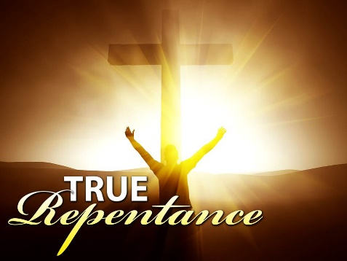
Repentance is birthed from worship. One turns away from sin because he wants to run toward God. It is to decide that God is better than sin. Christian repentance comes not from seeing ourselves, but seeing God. Christian repentance comes when we are drawn away from sin, and drawn towards God. It is a declaration of dependence and submission to God. Worship powers repentance. Repentance is the by-product of worship. It is God’s love that undergirds his call for us to repent. It is God’s love that empowers our desire to repent.

How do we repent? By allowing God to change our perspective, the way we interpret life, to change our value systems, to reprogram our autopilot. That requires the power of the Word of God. It is God’s Word that changes us.

We have to read the Bible thoroughly and comprehensively, instead of reading only to your own advantage or benefit, picking and choosing what we want to hear. It is important to study God’s Word with other people, because they can challenge and help you re-evaluate the way you read the Bible. Allow the Holy Spirit to challenge the way you think. That is how you are reprogrammed, that is how you change your autopilot.

Repent in hands and feet

Their deeds are evil deeds, and acts of violence are in their hands. Their feet rush into sin; they are swift to shed innocent blood. The Bible refers to hands and feet as what we do. It is an externalization of what is inside. (Isaiah 59:6b-7a)
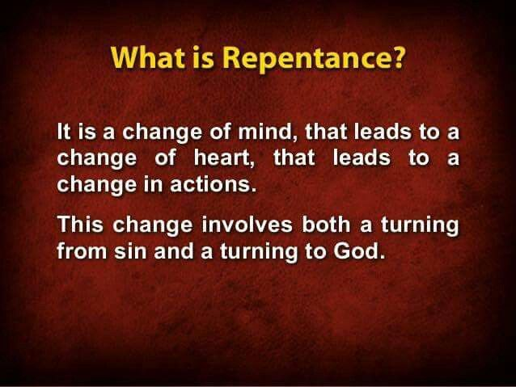
The Bible refers to hands and feet as what we do. It is an externalization of what is inside of us. If inside of us is rage, what comes out are words of anger.

Repentance is viewed in changed behaviour. Your lifestyle, your attitude, your choices and your decisions will change. True repentance is expressed both internally and outwardly. We need to be deliberate in changing our habits.

Unless we have a specific strategy to overcome and change our habits, we are not going to change. Paul always emphasizes the importance of working from the inside out. It begins with a changed mind and heart, which is then translated into changed behaviour. True repentance is hard work.

So how do we repent? We can start by telling a Christian brother or sister about it. The Bible says that we are to confess our sins to one another. We need to cultivate a repenting community, where everyone recognizes that they are sinners in need of repentance, where no one thinks they are better than the other.

Therefore confess your sins to each other and pray for each other so that you may be healed. (James 5:16a)

Failing is not in never falling down, but in failing to rise after falling. Sometimes you need to make amends, to recompense, to make retribution, to admit your wrongdoing and to say that you are sorry.

If we are sinners in recovery, we need to recognize that our battle with sin will continue until the day we die.

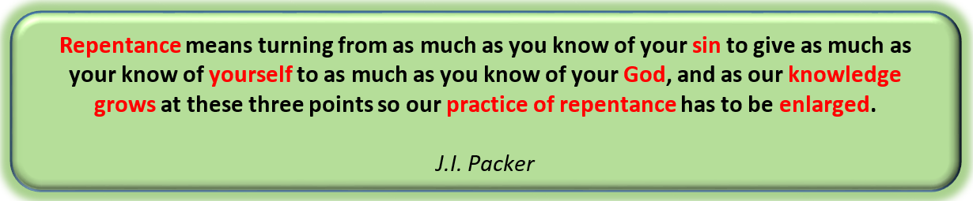

Sermon summary contributed by Anthea
Prayer points contributed by Michelle

SERMON: Back to Basics: Sin, Repentance and You

Pray:
- The people of God will recognise that we are sinful in nature and need to deliberately repent by turning to God seeking His Word.
- God’s people will intentionally respond to God’s call to repent and draw near to Him to change us.
- We must turn to God and set our heart and mind right to allow God’s Word to change us inwardly.
- People of God to obey Him by taking steps to deal with our sinful ways and respond to change by seeking to confess our sin to another.
Do not conform to the pattern of this world, but be transformed by the renewing of your mind. Then you will be able to test and approve what God’s will is – his good, pleasing and perfect will. (Romans12:2)

MINISTRIES & EVENTS: Unreached People Group: Penan, Sarawak
19 - 24 March 2017
Pray:
- Holy Spirit will prepare the hearts of the Unreached People to receive the Good News of God.
- God will give them the understanding of the Truth and know the freedom they receive in Christ.
- Penan Christians will be the salt and light in the community bringing light to those in darkness.
- God’s empowerment and wisdom upon the mission team members as they share the Good News.
- Cooperation, unity and smooth collaboration between mission team members and local pastor.
“May the Lord direct your heart to the love of God and to the steadfastness of Christ”
(2Thessalonians 3:5)

- MALAYSIA MY NATION: Future of Malaysia - GE14
The Election Commission - SPR
Pray:
- People of God will pray for protection and wisdom upon those involve in voter registration to be convicted in honesty and trustworthy in recording the voters’ registration.
- All eligible to be voters will be convicted in their hearts to step up and register themselves and those registered to ensure that their voting stations and names are still in the website.
- God’s protection and deliverance upon the Election Commission to keep all records of registered voters safe.
- God’s authority will prevail in all preparation for the coming GE in our country and we are thankful for all His grace and mercies.
I urge, then, first of all, that petitions, prayers, intercession and thanksgiving be made for all people- for kings and all those in authority, that we may live peaceful and quiet lives in all godliness and holiness. (1 Timothy2 :1-2)

- A TRANSFORMED WORLD: Africa: Starvation in Somalia, Kenya, Yemen, South Sudan
Pray:

- For God to protect His people in Africa who are showing the Love of Christ to those from the darkness.
- God’s people will be convicted to provide aid to the African people amidst time of unrest and starvation.
- God’s authority to be upon the UN to take steps to enforce security aid to the displaced people.
- The starving Africans will be open to the Gospel shared by the people of God.

And my God will meet all your needs according to the riches of His glory in Christ Jesus.
(Phillipians 4:19)

