Proclaim 2016
Living in His Presence with Thanksgiving (Luke 17:1-19)
Senior Pastor Chris Kam
Now on his way to Jerusalem, Jesus travelled along the border between Samaria and Galilee. As he was going into a village, ten men who had leprosy met him. They stood at a distance and called out in a loud voice, “Jesus, Master, have pity on us!” When he saw them, he said, “Go, show yourselves to the priests.” And as they went, they were cleansed. One of them, when he saw he was healed, came back, praising God in a loud voice. He threw himself at Jesus’ feet and thanked him—and he was a Samaritan. Jesus asked, “Were not all ten cleansed? Where are the other nine? Has no one returned to give praise to God except this foreigner?” Then he said to him, “Rise and go; your faith has made you well.” (Luke 17:11-19)

Introduction
We need to remember annually what we are thankful for. We need to develop a lifestyle of thanksgiving because this pleases God. You read in the Bible, that complaining people frustrated God and often made Him angry.

If a white sheet of paper is presented to you, with a black dot in the middle, what do you see? When we focus on the black dot, the black dot seems to become bigger and bigger until you do not see the white of the paper. We forget there are many good things in our lives and focus only on the bad things (the black dot) and the black dot becomes bigger and bigger.

Why do we need to be thankful?

Rejoice always, pray continually, give thanks in all circumstances; for this is God’s will for you in Christ Jesus. (1 Thessalonians 5:16-18)

About midnight Paul and Silas were praying and singing hymns to God, and the other prisoners were listening to them. Suddenly there was such a violent earthquake that the foundations of the prison were shaken. At once all the prison doors flew open, and everyone’s chains came loose.
(Acts 16:25-26)

When Paul and Silas were in jail, they were praying and singing and the prison doors were opened. They were praying, singing and thanking God and they were out of the prison.

Devote yourselves to prayer, being watchful and thankful. (Colossians 4:2)

Yet you are enthroned as the Holy One; you are the praise of Israel. (Psalm 22:3 NIV 1984)
“Yet you are holy, enthroned on the praises of Israel.” (Psalm 22:3 NRSV)

Big Idea:

Thanksgiving invites His Presence into our lives

If we want to see things happening in church, we need to have God’s presence in our lives. We need to become people who are thankful.

Obedience that leads to Miracles
As he was going into a village, ten men who had leprosy met him. They stood at a distance and called out in a loud voice, “Jesus, Master, have pity on us!” When he saw them, he said, “Go, show yourselves to the priests.” And as they went, they were cleansed. (Luke 17:12-14)

Why did Jesus ask them to show themselves to the priest? If lepers were miraculously healed in those days, they needed to go to the priest to be checked and certified that they were no longer lepers, pronounced clean, leave the leper community and able to go back to society. Only the priest could proclaim that they are healed.

These lepers were told to go to the priest even before they were healed. This was similar to the servants who were told to show the water that had turned into wine to the master even before the water had been turned to wine. This is the matter and method of Jesus. He wants us to exercise faith and begin walking. If you want to grow in faith, listen to what the Holy Spirit is telling you to do. Walk even if you have questions and miracles will happen.

Will you walk this journey of faith with God?

When Moses stretched out his hands, the sea parted. When fighting with the Amalekites, Moses was told that he should lift up his hands and the battle would be won. When his hands went down, they started losing the battle. Aaron and Hur saw that and propped Moses’ hands up. Joshua was told to cross the river with the ark carried by the priests. They had to step into the water before the water stopped flowing. Naaman the commander of the Syrian king, went to seek healing and was told to dip himself seven times in a muddy river. One of his servants encouraged him to do it despite his initial reluctance and when Naaman came out of the river he was healed of leprosy.

In Matthew 12, Jesus told the man with the shrivelled hand to stretch out his hand. A shrivelled hand cannot be moved but when the mas decided to do as he was told, his hand was healed. In the story of the five loaves and two fish, Jesus told his disciples to distribute the food to the crowd before the food was multiplied and at the end of the day there was more than the original amount left.

As we learn to hear the Holy Spirit, He will tell us to do certain things. We may think that we are unable to do it or it may sound impossible but it is not about us, it is about God.

Now on his way to Jerusalem, Jesus travelled along the border between Samaria and Galilee. As he was going into a village, ten men who had leprosy met him. They stood at a distance and called out in a loud voice, “Jesus, Master, have pity on us!” When he saw them, he said, “Go, show yourselves to the priests.” And as they went, they were cleansed. One of them, when he saw he was healed, came back, praising God in a loud voice. He threw himself at Jesus’ feet and thanked him—and he was a Samaritan. Jesus asked, “Were not all ten cleansed? Where are the other nine? Has no one returned to give praise to God except this foreigner?” Then he said to him, “Rise and go; your faith has made you well.” (Luke 17:11-19)

“If your brother or sister sins against you, rebuke them; and if they repent, forgive them. Even if they sin against you seven times in a day and seven times come back to you saying ‘I repent,’ you must forgive them.” The apostles said to the Lord, “Increase our faith!” He replied, “If you have faith as small as a mustard seed, you can say to this mulberry tree, ‘Be uprooted and planted in the sea,’ and it will obey you. (Luke 17:3-6)
Here, you do not need faith to forgive someone, you need obedience. In the same way, if we want to see a miracle happen in our lives, God may be saying, “Obey!”

When people struggle in life, they come for prayer and expect everything to be fine. We need to realise it is not about having more faith in that sense, it is about obedience. If you want a breakthrough in your life, obedience is the key.

Miracles that lead to Thanksgiving
One of them, when he saw he was healed, came back, praising God in a loud voice. (Luke 17:15)
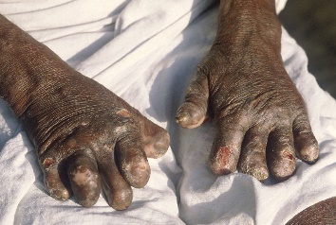
Lepers were not allowed to live with their families and had to warn people as they walk around so that people do not go near them. They were broken and rejected people. They would lose their fingers and toes (or digits) due to the lack of sensation to pain. In India, Dr Paul Brand gave cats to the people with leprosy to keep rats away from them so that they would not be bitten by the rats and lose their digits.

Generally we are not very thankful people and we need to be reminded over and over again to be thankful. Only one out of ten lepers, who were healed came back to thank Jesus. We need to learn to be grateful and thankful people.

What can we be thankful for? We can be thankful that we can end 2016 and go into 2017. We can be thankful for many things including provision in our lives. In this way, the black dot will become smaller and smaller.

The miracle of our lives is the miracle of salvation. When God begins to transform people, that change, is a miracle in itself. God has given us a new life and we need to be thankful to Jesus for that.

Thanksgiving that leads to Worship
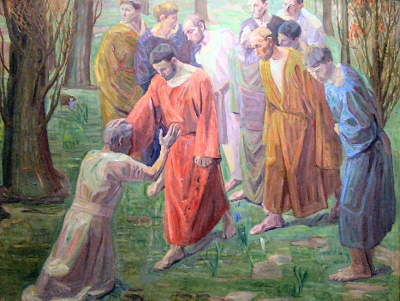
One of them, when he saw he was healed, came back, praising God in a loud voice. He threw himself at Jesus’ feet and thanked him—and he was a Samaritan. (Luke 17:15-16)

We may not know the extent we have been blessed. Here, this man is demonstrative. Expressing thanksgiving is a learned behaviour. We need to learn to give more to God in our worship and expression to God.

7 Hebrew words in the Old Testament described different ways of showing gratitude to God.
- Barak: To kneel or bow in thanksgiving.
I will extol the Lord at all times; his praise will always be on my lips. (Psalm 34:1)
- Halal: To make a show or rave about, giving thanks by being clamorously foolish – hallelujah.
You who fear the Lord, praise him! All you descendants of Jacob, honour him! Revere him, all you descendants of Israel! (Psalm 22:23)
- Shabach: To give thanks in a loud tone or to shout to the Lord.
One generation commends your works to another; they tell of your mighty acts. (Psalm 145:4)
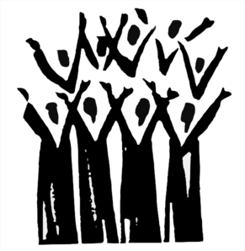
- Todah: A thanksgiving choir of worshippers.
I will praise God’s name in song and glorify him with thanksgiving. (Psalm 69:30)
- Yadah: To give thanks with extended or lifted hands.
Therefore I will praise you, Lord, among the nations; I will sing the praises of your name. (Psalm 18:49)
- Tehillah: To sing a spontaneous song of thanksgiving and praise to God out of an overflowing heart.
I will extol the Lord at all times; his praise will always be on my lips. (Psalm 34:1)
- Zamar: To give thanks with a musical instrument.
I will praise you with the harp for your faithfulness, my God; I will sing praise to you with the lyre, Holy One of Israel. (Psalm 71:22)
We need to be more exuberant in our worship to God, including dancing before the Lord.

Conclusion
Enter his gates with thanksgiving [todah] and his courts with praise [tehillah]; give thanks [yadah] to him and praise [barak] his name. (Psalm 100:4)
4 postures of gratitude in this verse
- A thanksgiving choir (todah)
- Spontaneous singing (tehillah)
- By lifting your hands (yadah)
- Bow before (barak)
Jesus asked, “Were not all ten cleansed? Where are the other nine? Has no one returned to give praise to God except this foreigner?” Then he said to him, “Rise and go; your faith has made you well.” (Luke 17:11-19)

Obedience Miracles Thanksgiving Worship God’s Presence

Obey the Lord, be thankful in all circumstances and miracles will begin to take place in your life when you step out in faith.

Sermon summary contributed by Zhenli
Prayer points contributed by Michelle and Zhenli
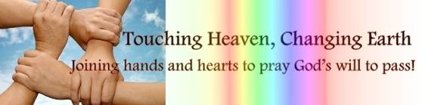

SERMON: Living in His Presence with Thanksgiving
Pray:
- We will remember God’s goodness and give thanks to God regularly for His blessings.
- We will see our circumstances with eyes of faith and have hope in the midst of storms.
- We will seek God, listen to the Holy Spirit and obey the Lord.
- We will worship exuberantly and with abundance.
But Samuel replied: “Does the Lord delight in burnt offerings and sacrifices as much as in obeying the Lord? To obey is better than sacrifice, and to heed is better than the fat of rams. (1 Samuel 15:22)

MINISTRIES & EVENTS: 14-Day Fast & Prayer
9 - 22 January 2017
Pray:
- God will convict the hearts of all followers of Jesus to have the desire to seek Him and His purpose for them through fasting and prayer.
- God will inspire more people of God step up in prayer and fasting during this season and lead them in His purpose for them.
- God will enable us to be obedient to His calling through this 14day prayer event.
- God will bless the leaders in their various ministries with wisdom, knowledge and understanding to do His Will.
For the Lord gives wisdom; from his mouth come knowledge and understanding. (Proverbs2:6)

MALAYSIA MY NATION: Future of Malaysia
GE14 and the People.
Pray:
- The people of God will pray for this nation, government and rules.
- Righteous men and women to be put in places of authority.
- Reconciliation among all leaders irrespective of race or religion for the good of the country in preparation of the coming GE14.
- The leadership of the churches to work towards the issue of taxation from religious bodies in the country.
- The rakyat will make wise decisions during the time of election.
- God’s authority will prevail in all circumstances which arise in our country and we are thankful for all His grace and mercies
I urge, then, first of all, that petitions, prayers, intercession and thanksgiving be made for all people- for kings and all those in authority, that we may live peaceful and quiet lives in all godliness and holiness.(1 Timothy2 :1-2)

- A TRANSFORMED WORLD: Turkey
An armed attack in an Istanbul nightclub left at least 35 dead on New Year’s Eve.
Pray:
- God to protect the people in Turkey who are showing the Love of Christ to those from the darkness.
- God’s strength, comfort and protection upon those who have lost loved ones due to the violence.
- The authorities and the people will have the ability to counter the terrorism through alertness and unity.
- God to open the eyes of those who live in darkness to see the light through dreams, visions and hearing from the Holy Spirit.
But you Lord, are a shield around me, my glory the One who lifts my head high. (Psalm 3:3)

