The Four Things Needed To Love People:
Value People (Matthew 4:18-22; Luke 19:1-10)
Senior Pastor Chris Kam

As Jesus was walking beside the Sea of Galilee, he saw two brothers; Simon called Peter and his brother Andrew. They were casting a net into the lake, for they were fishermen. “Come, follow me,” Jesus said, “and I will send you out to fish for people.” At once they left their nets and followed him. Going on from there, he saw two other brothers, James son of Zebedee and his brother John. They were in a boat with their father Zebedee, preparing their nets. Jesus called them, and immediately they left the boat and their father and followed him. (Matthew 19:1-10)

Introduction
Søren Kierkegaard, a 19th century philosopher from Denmark, once told a parable about two thieves who broke into a jewellery store, but instead of stealing the jewels they simply switched the price tags. They put high-priced tags on cheap jewellery and low-priced tags on valuable gems. For several weeks no one noticed. People bought cheap jewellery for exorbitant prices and rare jewels for spare change. In the same way, people subjected to the notion of value on others. They affect individuals through the words that they say and the amount of time spent in a meaningful way with the individual.

Kierkegaard’s point is pretty obvious: we have difficulty discerning between what is valuable and what is of little worth. But in God’s eyes, we are of equal worth and worthy by His grace to be saved.

“But you will receive power when the Holy Spirit comes on you; and you will be my witnesses in Jerusalem, and in all Judea and Samaria, and to the ends of the earth.” (Acts 1:8)
The Big Idea for the message this week is:
Evangelism starts with valuing people as Jesus values them.

Over the course of the next 4 weeks, the church will discuss Four Things Needed To Love People (Value, Connect, Serve and Influence People) as a sermon series. This series is a process of witnessing that we can practise and hopefully becomes a lifestyle for us.

“Come, follow me,” Jesus said, “and I will send you out to fish for people.” (Matthew 4:19)

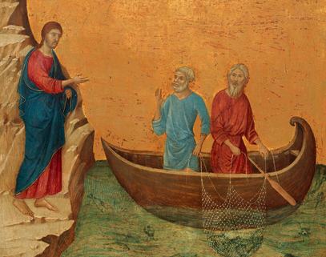
Follow Me” Thoughts

Jesus is looking for people to follow Him
When Jesus travelled around teaching, He did so without bias. Peter, Andrew, John and James were just humble fishermen, and are at the lower rungs of the community. When He called, the brothers drop their livelihoods and followed Jesus.

He find people in their environment
Jesus did not sit on a cushy chair waiting for people to come to him. He loves us so much that He came down to Earth as just a man.
For Peter, Andrew, John and James, Jesus went to where they were.

His words “follow me” are the greatest leadership words ever uttered
Jesus calls us to follow Him. Such a simple phrase, but the message is so clear and powerful. Everyone look up to leaders. People will naturally follow you if you are genuinely interested in them. On the flip side, people can smell you a mile away if you are not being genuine.
Following His words, the apostles’ urge for followers to follow them just as they strive to follow Jesus’ examples.
“Follow my example, as I follow the example of Christ.” (1 Corinthians 11:1)
“Therefore I urge you to imitate me.” (1 Corinthians 4:16)

Follow me means

Jesus will be your example

Read the Bible. See how He interacts and engages with the communities around Him.

Jesus will be with you
“But very truly I tell you, it is for your good that I am going away. Unless I go away, the Advocate will not come to you; but if I go, I will send him to you.” (John 16:7)

Jesus will help you discover significance

The fishermen were willing to leave everything – family, livelihoods – when Jesus called them to follow Him. They knew how Jesus treated them with value, where their communities did not.

Three questions followers need to ask their leaders:

1. Do you care for me?

2. Can you help me?

3. Can I trust in you?

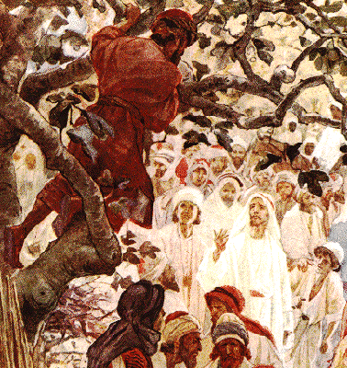
Zacchaeus

Let’s consider the story of Zacchaeus (Luke 19:1-10). He was a short guy. He was the chief tax collector for the Romans in Jericho, and was treated as scum by the Jewish people. On top of that, he was a man who extorts money from his own people, the Jews. But he had wanted to see Jesus the wandering rabbi so much that he climbed to tree just to see Him. Imagine Zacchaeus’s elation, that ‘when Jesus reached the spot, he looked up and said to him, “Zacchaeus, come down immediately. I must stay at your house today.” So he came down at once and welcomed him gladly.’ (Luke 19:5-6)

What did Jesus do?

Jesus valued Zacchaeus more than Zacchaeus valued himself
The word ‘gladly’ in original Greek is “chairōn” literally meant “rejoicing”. Zacchaeus was excited about Jesus staying over because for once he was given value by a fellow Jew who was a rabbi!

Jesus valued Zacchaeus more than others valued Zacchaeus
The crowds muttered and complained that Jesus was eating in the house of a sinner. But because Jesus valued Zacchaeus by spending time with him and his friends, Zacchaeus changed from a greedy man, to a generous man (Luke 19:8)

Three things Jesus did with Zacchaeus that made all the difference:
- Listen
- Linger
- Lend a hand

Conclusion
We are to be good witnesses about God to the world: we need first partner with the Holy Spirit, and give value to the people around us - the way God values each and every one of us.

Sermon summary contributed by Adeliyn Lim
Prayer points contributed by Michelle Wong
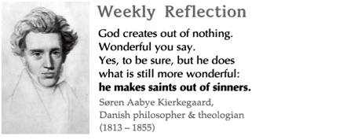

SERMON: The four things needed to love people:
Value People
Pray:
- All the people of God will respond to Jesus’ call to follow Him and minister to people in their own environment.
- God’s people will focus on Jesus as the only example as He helps them discover their significance as they walk with Him.
- We must pray that Jesus will use us to value others more than themselves by practising the fruit of the spirit in order to touch their lives.
- People of God will continue to pray and build one another up in the Spirit to enable them to move in the power of the Holy Spirit.
“Come, follow me,” Jesus said, “and I will make you fishers of men.” (Mathew 4:19)

MINISTRIES & EVENTS: MISSIONS PRAYER MEETING
Missions candidates 2 JULY 2016 & 6 AUGUST 2016
Pray:
- God’s protection will be on His chosen people in countries where sharing His Word is prohibited.
- God will convict the hearts of the chosen ones to reach out to those ready for His kingdom and bring them to salvation with the wisdom of God.
- God will enable the prayer intercessors to come for the morning prayer to pray for new missionaries and mission fields.
- God will instil the spirit of unity & raise up committed leaders to avail themselves for the mission field.
Be strong and courageous. Do not be afraid or terrified because of them, for the Lord your God goes with you; He will never leave you nor forsake you. (Deuteronomy 31:6)

MALAYSIA MY NATION: CHURCH IN MALAYSIA
- PERSONAL HOLINESS AND REVIVAL
Pray:
- God will convict the hearts of all believers in Malaysia of their sin in their own personal life and to repent and seek personal holiness in His presence.
- People of God will pray for His Kingdom to be done now at a time without any fear as they take up the cross to follow Jesus.
- People of God will fast and pray for God’s Hand to protect the rights of each citizen for freedom of religion in our country.
- God will convict the hearts of the church to engage in events to communicate valuing others in the community.
“I will give them an undivided heart and put a new spirit in them; I will remove from them their heart of stone and give them a heart of flesh.”(Ezekiel 11:19)

- A TRANSFORMED WORLD: BELGIUM
Anti-Terrorism Operations
Pray:
- For the Police force in Belgium to have a breakthrough in their investigations on the bombing in Brussels.
- The people in Belgium to be convicted in their hearts and be brave to come forward to assist the Police in their investigations.
- God’s protection on the families of all who are carrying out investigations on anti-terrorism in Belgium.
- People of God to reach out to help the families of victims of the bombing in Brussels.
- God to open the eyes of those who live in darkness to see the light through the work done by God’s people.
The light shines in the darkness, and the darkness has not overcome it. (John 1:5)

