The Four Things Needed To Love People:
Influence People (Matthew 5:13-16)
Founding Senior Pastor Dr Daniel Ho

“You are the salt of the earth. But if the salt loses its saltiness, how can it be made salty again? It is no longer good for anything, except to be thrown out and trampled underfoot. “You are the light of the world. A town built on a hill cannot be hidden. Neither do people light a lamp and put it under a bowl. Instead they put it on its stand, and it gives light to everyone in the house. In the same way, let your light shine before others, that they may see your good deeds and glorify your Father in heaven. (Matthew 5:13-16)

Introduction
Coming to the end on the series of “The Four Things Needed To Love People”, this week, Pastor Daniel spoke about loving people through influencing them.
Most of us know of God’s greatest command – Love God, love people. How do we put “Love God, love people” into action? What does it look like in your family, office, school, community, and church? Ultimately, we ask, how does Jesus demonstrate love to people and how can we follow Him to do likewise.
(http://dumc.my/whats-up/latestsermons/)

The four things needed to love people:

Value People
Why?
It is the fundamental of a human being, as every human being is created in the image of God. As such, we ought to show respect and honour to ALL types of people, regardless of gender, social status, skin colour, etc. Every one of us is important because we are made in His image, therefore we should be treated with respect, dignity, value and honour.

Connect with people
Why?
God makes human beings for relationships, and we long for such connections. We connect, reach out and make friends with people. Therefore, in DUMC, we make people feel at home at all times.

Serve people
Why?
Jesus Christ is our great example, for He has shown us the heart of a servant. He has come to serve and not to be served.
For even the Son of Man did not come to be served, but to serve, and to give his life as a ransom for many.” (Mark 10:45)

Influence people
Our goal: Influence people for good, towards God and for His glory.

Influencing people for good:

Salt & light
MALAYSIA NEEDS US
We must never forget that we are the salt and the light of the world (Matthew 5:13-16). In the context of this nation, we are the salt and the light of Malaysia. During this time of crisis, many have given up and have decided to seek for greener pasture overseas. However, we, as Christians, as salt and light, should react differently in response to the outcry of our nation. God has given us the unique privilege of changing our nation.

Instead of giving up and leaving our motherland, we should instead stop the rot and expose wrongdoings. We should influence people towards truth, justice and righteousness:

Righteousness and justice are the foundation of your throne (Psalm 89:14a)

“WE ARE A CHRISTIAN COMPANY”
Pastor Daniel shared about a company in Singapore in which he visited to deliver a talk about leadership. Pastor Daniel claimed that it is the only company, which he knows of, declared publicly that they are a Christian company. Pastor Daniel commended and affirmed them of their faith. Such a company is not just a great company, but a company rose by God to influence and impact the great market place.

ROTTEN APPLES
Pastor Daniel met a man who was once hurt by Christians, and offered apology on behalf of whoever hurt him. In response, he offensively rejected Pastor Daniel’s offer by telling him, “It is none of your business!” Without giving up, Pastor Daniel continued to influence him for good. This gentleman is now worshipping in DUMC, and had forgotten that he had once said that phrase to Pastor Daniel! The moral of this testimony is, do not judge an apple tree based on just one or a few rotten apples.

FLAVOURS & COLOURS
As God’s chosen people, we are to add flavours and colours to people’s life. Reading from The Message (MSG), the passage on Salt and Light may provide us with a fresh perspective of its context:
“Let me tell you why you are here. You’re here to be salt-seasoning that brings out the God-flavours of this earth. If you lose your saltiness, how will people taste godliness? You’ve lost your usefulness and will end up in the garbage. Here’s another way to put it: You’re here to be light, bringing out the God-colours in the world. God is not a secret to be kept. We’re going public with this, as public as a city on a hill. If I make you light-bearers, you don’t think I’m going to hide you under a bucket, do you? I’m putting you on a light stand. Now that I’ve put you there on a hilltop, on a light stand—shine! Keep open house; be generous with your lives. By opening up to others, you’ll prompt people to open up with God, this generous Father in heaven. (Matthew 5:13-16, MSG)

In short, we are to give good taste and to brighten up people’s lives.

Influencing people towards God and for His glory:

Pray and be empowered
As Christians, we can (and should) pray and be empowered by the Holy Spirit. Therefore, pray specifically- for people and for our influences on them toward God and for His glory.
But you will receive power when the Holy Spirit comes on you; and you will be my witnesses in Jerusalem, and in all Judea and Samaria, and to the ends of the earth.” (Acts 1:8)

Be intentional and take initiative
Take initiatives intentionally!
Be very careful, then, how you live—not as unwise but as wise (Ephesians 5:15)
Pastor Daniel shared two of his encounters when he intentionally took initiatives in reaching out to the pre-believers:

- He always made an effort to meet new people in our church cafeteria. Recently, he met Vincent, who was having lunch in church cafeteria. He talked to Vincent and gave his call card. Pastor Daniel has never ceased to pray for him since then.

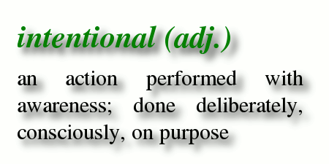
- On another occasion, he came across a man and his wife in church. Seeing the wife as someone unfamiliar, Pastor Daniel spoke to them and had instantly led the wife to Christ.

Why are there lives that are more fruitful that ours? Usually, they are those that are well lived, fruitful, purposeful, passionate and intentional. Being intentional also symbolizes the powerful fruit-bearing Christians.

Still other seed fell on good soil, where it produced a crop—a hundred, sixty or thirty times what was sown. (Matthew 13:8)

Turn every occasion into an opportunity to share Jesus
Once day, Pastor Daniel was driving around with Aunty Doris, and saw a funeral ceremony in a housing estate. Letting out a disappointed sigh, he commented to Aunty Doris that it is upsetting to see another life lost to Christ-less eternity. He then prayed to God to burden him with greater urgency in sharing the Gospel of Jesus Christ. That is what Jesus came for-
For God so loved the world that he gave his one and only Son, that whoever believes in him shall not perish but have eternal life. (John 3:16)

making the most of every opportunity, because the days are evil. Therefore do not be foolish, but understand what the Lord’s will is. (Ephesians 5:16-17)

The Lord is not slow in keeping his promise, as some understand slowness. Instead he is patient with you, not wanting anyone to perish, but everyone to come to repentance. (2 Peter 3:9)

Offer the invitation/challenge and trusting the Holy Spirit for the outcome
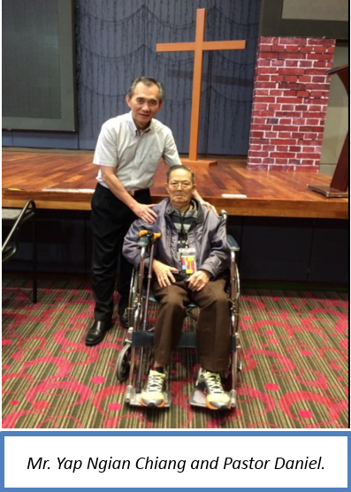
Be thick skinned for Jesus! It is crucial to share the Gospel of Christ; it is even more important to extend the invitation to accept Jesus and trusting God for the outcome! It is okay to be rejected, as Jesus was rejected too. Pastor Daniel was very honest when he told the congregation, that out of the many successful stories he shared about people whom he reached out to, there were many rejection stories that he did not share! As children of God, we press on albeit the rejection we may be facing.

Entrusting the Holy Spirit for the outcome of His work and for His glory, Pastor Daniel embraced the challenge of delivering the Gospel and leading an elderly man in his wheelchair through sinner’s prayer in Teochew dialect! Not intimidated by the language barrier and fear of rejection (This man is in his 90s, and had rejected the same invitation from his daughter many times. His daughter has been praying for him for many years), Pastor Daniel fully trusted that God is in charged. It was truly a joy when the man responded to the divine invitation almost instantly!

Discipleship
The discipleship process must begin for the person who comes to faith in Christ and he / she will increasingly then live for God and His glory.
The next morning, during breakfast, our 92-year-old brother Yap was seen beaming with joy in his smiling face. Pastor Daniel told his daughter Lina to keep follow up with him, and he will increasingly live for God and His Glory.

Conclusion
How can we not share Jesus? And how do we do it? Through our goal in loving people through:
- Influencing people for good
  - Always remember that we are the salt that brings flavours and light that brings God-colours to the world we live in.
- Influencing people towards God and for His glory
- Pray and be empowered; Be intentional and take initiatives; Turn every occasion into an opportunity to share Christ; Offer invitation; and Continue discipleship.

Sermon Summary contributed by Chrisandra Wong

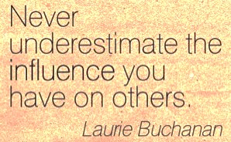
Prayer points contributed by Ngui Yuen Loong

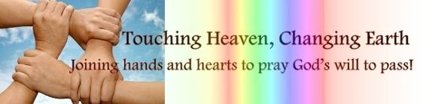

SERMON: Influence People
Pray:
- We will always remember that we are the salt and light.
- We will do our part to stop the decay of society and point people towards truth, justice and righteousness.
- We will be able to brighten up the lives of others.
- We will constantly pray and be empowered and we will be intentional and take initiative to influence the people in our sphere of influence.
- We will grab ever opportunity to share the Gospel and challenge others to trust in Jesus.
“You are the salt of the earth. But if the salt loses its saltiness, how can it be made salty again? It is no longer good for anything, except to be thrown out and trampled underfoot. “You are the light of the world. A town built on a hill cannot be hidden. Neither do people light a lamp and put it under a bowl. Instead they put it on its stand, and it gives light to everyone in the house. In the same way, let your light shine before others, that they may see your good deeds and glorify your Father in heaven. (Matthew 5:13-16)

MINISTRIES & EVENTS: 3-day Fast and Prayer
DUMC will have a 3-day fast and prayer from 12/07/2016 (Tue) to 14/07/2016 (Thu)
Pray:
- Church members will look forward to this and make preparation to attend the morning prayer.
- As we fast and pray, we will be sensitive to the voice of God.
- As we gather for corporate prayer, we will hear from God.
- We will encourage one another with our presence and prayer support.
- As we pray, we become more united and we change the spiritual atmosphere of the church.
You will seek me and find me when you seek me with all your heart. (Jeremiah 29:13)
MALAYSIA MY NATION: Crime
With the first officially recorded ISIS attack on the shore of Malaysia, several murders in populated places, the safety of the citizens is a grave concern.
Pray:
- The authorities, local council and the local community will work closely hand-in-hand to prevent crime.
- As a community, everyone will watch each other’s back in the neighbourhood.
- Children and adults will observe safety precautions lest they become victims of crime.
- Our communities will once again become safe.
- Citizens will have integrity and work hard to earn a living instead of turning into crimes and other unscrupulous means.
- Criminals will be arrested and justly judged and fairly punished to deter future crimes.
I will say of the Lord, “He is my refuge and my fortress, my God, in whom I trust.”. (Psalm 91:2)

- A TRANSFORMED WORLD: #BlackLivesMatter
Black Lives Matter is a movement created in 2012 following the acquittal of George Zimmerman, who shot dead Trayvon Martin. It campaigns against violence towards black people.
Pray:
- The administration will acknowledge there is a problem and handle it seriously.
- This problem will be tackled with a holistic manner from education to enforcement.
- The people will change their mind set towards people of a different ethnic group. They will learn to respect one another as fellow human beings.
- Stereotyping any individuals based on their ethnic groups, beliefs, social status, gender, etc. will not be tolerated.
- Everyone will be treated with respect and dignity.
Make the Master proud of you by being good citizens. Respect the authorities, whatever their level; they are God’s emissaries for keeping order. It is God’s will that by doing good, you might cure the ignorance of the fools who think you’re a danger to society. Exercise your freedom by serving God, not by breaking the rules. Treat everyone you meet with dignity. Love your spiritual family. Revere God. Respect the government. (1 Peter 2: 13-17, The Message, emphasis is from the editor.)

