Anticipate The Holy Spirit (Acts 1)
Senior Pastor Chris Kam

In my former book, Theophilus, I wrote about all that Jesus began to do and to teach until the day he was taken up to heaven, after giving instructions through the Holy Spirit to the apostles he had chosen. After his suffering, he presented himself to them and gave many convincing proofs that he was alive. He appeared to them over a period of forty days and spoke about the kingdom of God. On one occasion, while he was eating with them, he gave them this command: “Do not leave Jerusalem, but wait for the gift my Father promised, which you have heard me speak about. For John baptized with water, but in a few days you will be baptized with the Holy Spirit.” Then they gathered around him and asked him, “Lord, are you at this time going to restore the kingdom to Israel?” He said to them: “It is not for you to know the times or dates the Father has set by his own authority. But you will receive power when the Holy Spirit comes on you; and you will be my witnesses in Jerusalem, and in all Judea and Samaria, and to the ends of the earth.” After he said this, he was taken up before their very eyes, and a cloud hid him from their sight. They were looking intently up into the sky as he was going, when suddenly two men dressed in white stood beside them. “Men of Galilee,” they said, “why do you stand here looking into the sky? This same Jesus, who has been taken from you into heaven, will come back in the same way you have seen him go into heaven.” (Acts 1:1-11)

This weekend is Pentecost weekend. ‘Pentecost’ actually means ‘fifty’. Pentecost is a celebration of the harvest by the Jews, and over time, it became the celebration of the giving of the Law. The church will prosper when we move by the power of the Holy Spirit. Your life will prosper not when you move by your own ability, but by the power of the Holy Spirit.

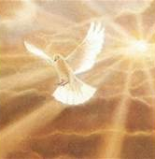
The Great Commission
Therefore go and make disciples of all nations, baptizing them in the name of the Father and of the Son and of the Holy Spirit, and teaching them to obey everything I have commanded you. And surely I am with you always, to the very end of the age.” (Matthew 28: 19-20)

Jesus is seated at the right hand of God. He is interceding for us right now. Jesus needs to go away so that He can send the Holy Spirit to be with us. He is always with us because the Holy Spirit is here.

On one occasion, while he was eating with them, he gave them this command: “Do not leave Jerusalem, but wait for the gift my Father promised, which you have heard me speak about. For John baptized with water, but in a few days you will be baptized with the Holy Spirit.” (Acts 1: 4-5)

Jesus told His disciples to wait, not to run out before the giving of the Holy Spirit.

Then they gathered around him and asked him, “Lord, are you at this time going to restore the kingdom to Israel?” He said to them: “It is not for you to know the times or dates the Father has set by his own authority. But you will receive power when the Holy Spirit comes on you; and you will be my witnesses in Jerusalem, and in all Judea and Samaria, and to the ends of the earth.” (Acts 1: 6-8)

Jesus went away and gave us the Holy Spirit so that we have power. We need power in our lives. We need power so that we can be witnesses. Witnessing is not about using our intellect, but about drawing on the power of God. Have we learnt to receive the power? It is about looking at every person and see that Jesus gave His life for that person.
“Men of Galilee,” they said, “why do you stand here looking into the sky? This same Jesus, who has been taken from you into heaven, will come back in the same way you have seen him go into heaven.” (Acts 1:11)

BIG IDEA
It is God’s plan all along. This was what Israel was supposed to be anticipating. This is what the Church is to experience.

INTENDED OUTCOME
Desire to welcome the Spirit of God. Appreciate the significance of the outpouring of or baptism in the Holy Spirit.

There are different kinds of baptism mentioned in the Bible.

Salvation Baptism – The Holy Spirit baptizes us in Jesus

The moment we say ‘I believe in Jesus’, the Holy Spirit baptizes us in Jesus.

For we were all baptized by one Spirit so as to form one body—whether Jews or Gentiles, slave or free—and we were all given the one Spirit to drink. (1 Corinthians 4: 12:13)
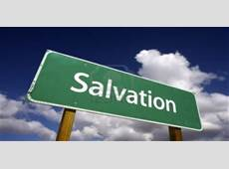
The moment we believe in Jesus, the Holy Spirit takes us and baptizes us into the body of Christ. The moment we become a Christian, we have the Holy Spirit in us. This is the indwelling of the Holy Spirit in our lives.

And you also were included in Christ when you heard the message of truth, the gospel of your salvation. When you believed, you were marked in him with a seal, the promised Holy Spirit, who is a deposit guaranteeing our inheritance until the redemption of those who are God’s possession—to the praise of his glory. (Ephesians 1: 13-14)

Again Jesus said, “Peace be with you! As the Father has sent me, I am sending you.” And with that he breathed on them and said, “Receive the Holy Spirit. (John 20: 21-22)

In this first baptism, God marked us with a seal when we received Christ.

Water Baptism – The disciples baptize us in water

Therefore go and make disciples of all nations, baptizing them in the name of the Father and of the Son and of the Holy Spirit, (Matthew 28:19)

Baptism is an outward expression of our inner reality, the first baptism where we are saved. The inner reality is our sins have all been washed away. By His grace we are completely set free. It is a matter of obedience by getting water baptized. When we are baptized, we die to our rights. Jesus Himself was baptized to fulfil all righteousness, even though there was no need to, but He set an example for us. Even Jesus needed the Holy Spirit to empower Him in the next three (3) years of His ministry.

Spirit Baptism – Jesus baptizes us in the Holy Spirit (in or with)

“I baptize you with water for repentance. But after me comes one who is more powerful than I, whose sandals I am not worthy to carry. He will baptize you with the Holy Spirit and fire. (Matthew 3:11)

When the apostles in Jerusalem heard that Samaria had accepted the word of God, they sent Peter and John to Samaria. When they arrived, they prayed for the new believers there that they might receive the Holy Spirit, because the Holy Spirit had not yet come on any of them; they had simply been baptized in the name of the Lord Jesus. Then Peter and John placed their hands on them, and they received the Holy Spirit. (Acts 8: 14-17) 5 years after Pentecost

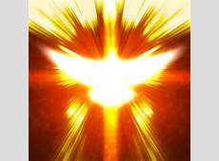
While Peter was still speaking these words, the Holy Spirit came on all who heard the message. The circumcised believers who had come with Peter were astonished that the gift of the Holy Spirit had been poured out even on Gentiles. For they heard them speaking in tongues and praising God. (Acts 10: 44-46)

Paul said, “John’s baptism was a baptism of repentance. He told the people to believe in the one coming after him, that is, in Jesus.” On hearing this, they were baptized in the name of the Lord Jesus. When Paul placed his hands on them, the Holy Spirit came on them, and they spoke in tongues and prophesied. There were about twelve men in all. (Acts 19: 4-7) 25 years after Pentecost

Summary

There are three baptisms: salvation, water, Spirit. In the Tabernacle, there is the Holy of Holies. Once a year, the high priest will go into the Holy of Holies, which require adequate preparation. There are three things needed: altar, where an animal is sacrificed, as blood is needed to atone for man’s sins; basin, to signify water, to cleanse us from all our sins, a symbolic way of saying we are clean; oil, with which the high priest is anointed, and only then do the high priest go into the Holy of Holies. Salvation baptism is about the altar. Water baptism has to do with the basin. Oil signifies the Holy Spirit. All three items are required to enter the Holy of Holies. If one of the items are neglected when the high priest walks into the Holy of Holies, he dies.

For us as New Testament Christians, what do we need to enter the Holy of Holies? We need only salvation baptism (even though we may be disobeying God by not taking water baptism). While we may be saved, without the other two baptisms, we may lead very defeated Christian lives.

How do we get baptised in the Spirit? First, remove all barriers in your life. Second, request Jesus to baptise you. Third, receive the Holy Spirit by faith.
What is the Holy Spirit telling you?

Sermon summary and prayer pointers prepared by May Ng.

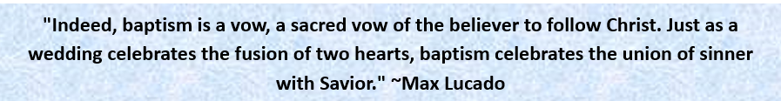

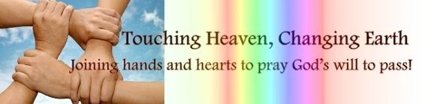

SERMON: Anticipate the Holy Spirit
Pray:
- For revelation that without the Holy Spirit, we can do nothing.
- Softening of hearts to be sensitive to the promptings of the Holy Spirit.
- We as Christians will be obedient to take water baptism and seek spirit baptism.
- Boldness among Christians to share Christ.
- Healthy church growth.
And if the Spirit of him who raised Jesus from the dead is living in you, he who raised Christ from the dead will also give life to your mortal bodies because of his Spirit who lives in you. (Romans 8:11)

MINISTRIES & EVENTS: Alpha Course
A new season of the Alpha Course is scheduled to commence on 22 May 2016.
Pray:
- Open minds to sign up for the course.
- Wisdom to the facilitators who will be serving.
- Steadfastness amongst participants to complete the course without wavering.
- Peace and joy to prevail during all sessions of the course.
- Participants to have an opportunity to ask burning questions and find out more about God.
For if, while we were God’s enemies, we were reconciled to him through the death of his Son, how much more, having been reconciled, shall we be saved through his life! (Romans 5:10)
MALAYSIA MY NATION: Mass Hysteria
Mass hysteria was reported to be taking place in some schools in the east coast of Peninsula Malaysia, resulting in schools shutting down.
Pray:
- Discernment amongst parents, teachers, students and authorities.
- To do away with superstitions and wrong beliefs.
- Revelation that Jesus is omnipotent, omnipresent and omniscient.
- For those affected to be open-minded to get to know Christ.
For with you is the fountain of life; in your light we see light. (Psalms 36:9)

- A TRANSFORMED WORLD: Presidential Elections in the United States of America
The USA will be expected to cast their votes for a new president come November 2016.
Pray:
- God-fearing candidates to be contesting in both the Democrat and Republican camps.
- Citizens to cast their votes with God’s wisdom without fear or favour.
- The USA to rise as a nation which is filled with the righteousness of God.
- Peace and harmony to prevail worldwide with positive influence from the USA.
Kings detest wrongdoing, for a throne is established through righteousness. (Proverbs 16:12)

