Desire the Holy Spirit
Senior Pastor Chris Kam
(Acts 2:1-13; 37-41)

The Holy Spirit Comes at Pentecost
When the day of Pentecost came, they were all together in one place. Suddenly a sound like the blowing of a violent wind came from heaven and filled the whole house where they were sitting. They saw what seemed to be tongues of fire that separated and came to rest on each of them. All of them were filled with the Holy Spirit and began to speak in other tongues as the Spirit enabled them. Now there were staying in Jerusalem God-fearing Jews from every nation under heaven. When they heard this sound, a crowd came together in bewilderment, because each one heard their own language being spoken. Utterly amazed, they asked: “Aren’t all these who are speaking Galileans? Then how is it that each of us hears them in our native language? Parthians, Medes and Elamites; residents of Mesopotamia, Judea and Cappadocia, Pontus and Asia, Phrygia and Pamphylia, Egypt and the parts of Libya near Cyrene; visitors from Rome (both Jews and converts to Judaism); Cretans and Arabs—we hear them declaring the wonders of God in our own tongues!” Amazed and perplexed, they asked one another, “What does this mean?” Some, however, made fun of them and said, “They have had too much wine.” (Acts 2:1-13)

When the people heard this, they were cut to the heart and said to Peter and the other apostles, “Brothers, what shall we do?” Peter replied, “Repent and be baptized, every one of you, in the name of Jesus Christ for the forgiveness of your sins. And you will receive the gift of the Holy Spirit. The promise is for you and your children and for all who are far off—for all whom the Lord our God will call.” With many other words he warned them; and he pleaded with them, “Save yourselves from this corrupt generation.” Those who accepted his message were baptized, and about three thousand were added to their number that day. (Acts 2:37-41)

Introduction
Continuing our series on Holy Spirit, the mystery of the 7 feasts in the Bible are taught this week, and what is it that we should desire following the three types of baptism: Salvation Baptism, Water Baptism and the significant outpouring of the Baptism in the Holy Spirit.

The 7 Feasts of Israel
- Feast of Passover (Pesach)- Represents salvation, crucifixion of Jesus.
Plague about the death of the first born in the family where God saved them.
- Feast of Unleavened Bread- Represents our holy walk with the Lord, Jesus was buried.
Yeast represents sins. God told the Israelites not to take the sins of Egypt with them.
- Feast of First-fruits- Represents the resurrection of the Lord, Jesus as our first fruit! Jesus was raised from dead!
The very first fruits (barley) they received in Promised Land, is to be presented to God.
- Feast of the Festival of Weeks or Pentecost (Shavuot)- Represents giving of the Holy Spirit. Now. Current.
50 days from Passover, during harvest of the week. Before the Israelites continue with the harvest, the first harvest should be presented to God first. This is similar to our tithe offering.
- Feast of Trumpets (Rosh HaShanah)- Represents the second coming of Christ, yet to be fulfilled.
When the priest blows the trumpet, everyone goes to the temple (leave their work for 10 days) and reflect on their life. A day when The Trumpet sounds in the whole world, it means Jesus is back!
- Feast of The Day of Atonement (Yom Kippur)- Day of confession/ Judgement Day
The day when the priests go in the Holy of Holies after sanctifying themselves in the Tabernacle.
- Feast of Tabernacles (Sukkot)- Represents the Lord’s shelter in the world to come.
The Israelites build huts outside their house, and celebrated as God had watched over them in the last 40 years. It represents new heaven and new earth.

God’s calendar is based on the phases of the moon, each month in a lunar calendar begins with a new moon. The first three feasts fall in March/April. The fourth one occurs in late May or early June. The last three happen in September and October. All these, in a series of “3-1-3", are the 3 main feasts that we celebrate as Christians. We must celebrate them joyfully, depicting DUMC’s weekly celebrations. In God’s presence, there is always joy.

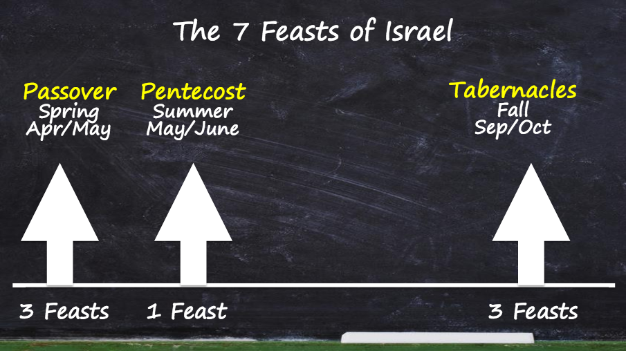
Holy spirit is with us as a church while waiting for Christ second coming. We must always come with a desire that is to desire the Holy Spirit!

BIG IDEA: Desire the Baptism of the Holy Spirit. Desire the gift of prayer tongues.

Pastor Chris asked God for a vision for DUMC 10 years from now. In answering his question, God showed him a revival that took place in our very own Dream Centre last week during altar call. For the first time in his life in DUMC, he witnessed the gallery seats were almost empty when many of the people came down to receive the prayer for the baptism of the Holy Spirit. It was also last week that some DUMC members saw visions in church of Angels dancing around, fires were sighted, gold leaves pouring down. There was even miraculous healings like healing of back pain, etc.

All these have been taking place in DUMC when the Holy Spirit came and visit us. This is the vision that Pastor Chris had from God, for us in DUMC in 10 years’ time - for revival to take place and for us to practice the gift of the Holy Spirit.
Peter replied, ‘Repent and be baptised, every one of you, in the name of Jesus Christ for the forgiveness of your sins. And you will receive the gift of the Holy Spirit. The promise is for you and your children and for all who are far off – for all whom the Lord our God will call.’ (Acts 2:38-39)
This is the vision that Pastor Chris has from God, for us in DUMC in 10 years’ time - for revival to take place and for us to practice the gift of the Holy Spirit.

The concern? Yes, we may have Holy Spirit with us, but we may not necessary to be FULL of the Holy Spirit. That is why we need the baptism of the Holy Spirit following salvation and water baptism. Although the second and third baptisms are not necessary for one to be saved and entitled for salvation, but they are beneficial, edifying and we need them to live a powerful Christian life.

Pattern for the early church:
Year 1 All of them were filled with the Holy Spirit and began to speak in other tongues as the Spirit enabled them. (Acts 2:4)
On Pentecost, a group of God-fearing Jews were filled with Holy Spirit and started speaking in other tongues, native language of every nation.

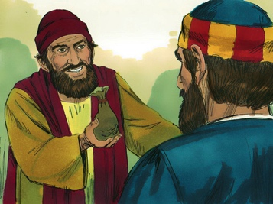
Year 5 Then Peter and John placed their hands on them, and they received the Holy Spirit. (Acts 8:17)
Simon the Sorcerer asked for what Peter and John had, something that was manifested out of them. Pastor Chris believed it was tongue that Simon was asking for. However, the apostles said that he was asking for the wrong reason.

Year 10 For they heard them speaking in tongues and praising God. (Acts 10:46)
Testimony of the first Gentile Christians who received the gift of the Holy Spirit.

Year 25 When Paul placed his hands on them, the Holy Spirit came on them, and they spoke in tongues and prophesied. (Acts 19:6)
The disciples whom Paul laid his hands on were full of the Holy Spirit and prophesied.

Christians should seek the baptism of the Holy Spirit and ask for the gift of tongue. It is not compulsory but definitely necessary to live a Christian life in a powerful way. If one cannot receive the gift of the Holy Spirit, it is always the mindset issue. Pastor Chris, in his career as a pastor for 22 years, had laid hands on over 2,000 believers for them to receive the gift of the Holy Spirit (tongue). Out of these more than 2,000 people, 99% received it. It is noted that, the leftover 1% are usually the old time Christians who have not unlearned what were taught and practice.

What about this gift of tongue?

It is biblical
Tongue is not to men but for God.
For anyone who speaks in a tongue does not speak to people but to God. Indeed, no one understands them; they utter mysteries by the Spirit. (1 Corinthians 14:2)

For if I pray in a tongue, my spirit prays, but my mind is unfruitful. So what shall I do? I will pray with my spirit, but I will also pray with my understanding; I will sing with my spirit, but I will also sing with my understanding. Otherwise when you are praising God in the Spirit, how can someone else, who is now put in the position of an inquirer, say “Amen” to your thanksgiving, since they do not know what you are saying? You are giving thanks well enough, but no one else is edified. (1 Corinthians 14:14-17)

A very good example to illustrate 1 Corinthians 14:17 is this; Imagine a group members, when praying and giving thanks to food, start praying in tongue follow by “Amen”. When that happens, no one on the dining table understands, therefore not edifying others.

In order to edify others, we should use a common language (understood by others) in our prayer. Public tongues have to come with interpretations and in proper context.

In DUMC, we rarely use public tongue, and Pastor Chris is hoping for a change. That is one of his visions in DUMC for the next 10 years. He believes that day will come when we live our Christian life powerfully.
Therefore, my brothers and sisters, be eager to prophesy, and do not forbid speaking in tongues. (1 Corinthians 14:39)

Do we prophesy? Do we speak in tongue? WHY?

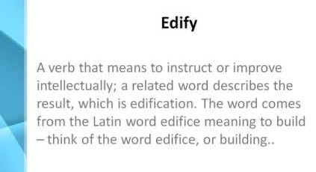
It is edifying
Edify means builds up and strengthen. Receiving private tongue is the only spiritual gift that builds ourselves up, as compared to over thirty spiritual gifts. Other spiritual gifts build up the Body of Christ (church).

Anyone who speaks in a tongue edifies themselves, but the one who prophesies edifies the church. (1 Corinthians 14:4)

The more we speak in tongue, we more strengthened we are. In DUMC, we should speak in private tongue regularly and allow God to build up our spirit.

Take the helmet of salvation and the sword of the Spirit, which is the word of God. (Ephesians 6:17)
… WAIT--- read the next verse!

Ephesians 6:18--- Don’t miss this out!
And pray in the Spirit on all occasions with all kinds of prayers and requests. (Ephesians 6:18)
When a Christian prays in tongue, his spirit prays… (1 Corinthians 14:14a)

But you, dear friends, by building yourselves up in your most holy faith and praying in the Holy Spirit. (Jude 20)
Praying in Holy Spirit helps to build ourselves up.

Therefore, put on Armour of God and speak in tongue! Anywhere, anytime! Be foolish for God.

It is a choice
God will not force anything upon us because He respects our freewill, the greatest gift given to mankind. As such, we always have a choice.
For if I pray in a tongue, my spirit prays, but my mind is unfruitful. So what shall I do? I will pray with my spirit, but I will also pray with my understanding; I will sing with my spirit, but I will also sing with my understanding. (1 Corinthians 14:14–15)

Follow the way of love and eagerly desire gifts of the Spirit, especially prophecy. (1 Corinthians 14:1)

“Which of you fathers, if your son asks for a fish, will give him a snake instead? Or if he asks for an egg, will give him a scorpion? If you then, though you are evil, know how to give good gifts to your children, how much more will your Father in heaven give the Holy Spirit to those who ask him!” (Luke 11:11–13)

The word “will” signifies a choice made. Similarly, receiving and practicing the gift of the Holy Spirit is also a choice. God does not “move” our tongues with His fingers, asking it to roll. For example, during hospital visitation, we must be willing to lay hands on the patient after offering our prayers. We can also ask from God the gift of encouragement or other spiritual gifts (Luke 11:11-13), as we need to cooperate closely with the Holy Spirit.

Conclusion
Baptism of the Holy Spirit and receiving the gift of the Holy Spirit, although not compulsory, is essential for Christians to live a powerful life with God-honouring testimony. Speaking in tongue, one gift of the Holy Spirit is biblical, edifying and a wise choice to be made by all obedient Christians.
The greatest stumbling block to our resistance towards the gift of the Holy Spirit is our mind. We can only learn new languages by speaking them. Pastor Chris shared with us his experience when he attempted to receive the Holy Spirit when he was told not to speak any language that he knows. Confused at the beginning, Pastor Chris obliged and started by imitating others. He acted in faith, and God blessed him with the gift of the Holy Spirit!
That’s it?
When Pastor Chris received the gift of the Holy Spirit, he was a little disappointed thinking that was it. Little did he know, that was only the “Starter Pack”. In time, and through faith and obedience, he asked and received the Word of Knowledge (“In-app purchase”) which had helped him tremendously in his counselling sessions with those who seek for spiritual guidance. When we act in faith, we will receive and practice the gift of the Holy Spirit, where God will train us to confront evil forces. But first get a Starter Pack.

“The next object of speaking in tongues is the edification of self”
(Sunday Adelaja)

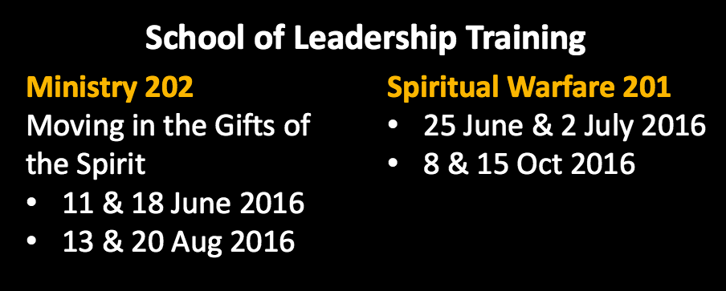
Want to know more? Have more to say (or ask)? Join us in our School of Leadership training on Ministry 202 and Spiritual Warfare 201 by registering at our info counter.

Sermon notes prepared by Chrisandra Wong.
Prayer pointers prepared by Michelle Wong.
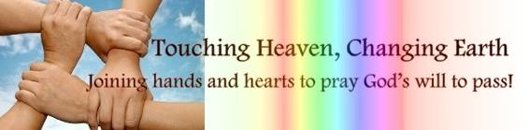

SERMON: THE HOLY SPIRIT AND YOU: Desire the Holy Spirit
Pray:
- Members of DUMC will desire the Baptism of the Holy Spirit and be enabled to speak and pray in tongues.
- We will be bold to ask for the gift of the Spirit like prophesy, praying in tongues and in understanding.
- We will step up by going for leadership training in moving in the gifts of the Spirit.
- We will constantly pray for our church Elders, Pastors and Leaders to constantly encourage all CG members in exercising the gift of the Spirit.
Anyone who speaks in a tongue edifies themselves, but the one who prophesies edifies the church. And pray in the Spirit on all occasions with all kinds of prayers and requests. (1 Corinthians14:4, 18)

MINISTRIES & EVENTS: Mission Trips
- SARAWAK IBAN/PENAN (6 – 13 JUNE 2016)
- A ROMPIN (10 – 13 JUNE 2016)
Pray:
- People of God will step up to equip themselves by attending MCPP 1 & 2.
- God’s hand of protection upon those going on the trips and for all the plans and events to be carried out well and timely.
- God will open the hearts of the local people to receive His Word and be convicted in their hearts.
- God will enable each volunteer to be sensitive to the people who come to be touched.
And we know that in all things God works for the good of those who love him, who have been called according to his purpose. (Romans 8: 28)

MALAYSIA MY NATION: MALAYSIAN GOVERNMENT
- Leaders in the Nation
Pray:
- Hand of God to be upon all leaders involved with fighting terrorism for the future good of Malaysia.
- God will convict the hearts of leaders in authority within the government to rise up against all corrupted and wrong practices which hinder the progress of the nation.
- God will raise up God fearing leaders with integrity to step up and transform the attitudes of the leaders.
- God will prevent the nomination and election of extremists in the area of religion and worship in the Federal government.
But we prayed to our God and posted a guard day and night to meet this threat. (Nehemiah 4:9)
Wherever you hear the sound of the trumpet, join us there. Our God will fight for us! (Nehemiah 4:20)

- A TRANSFORMED WORLD: EURASIAN ECONOMIC UNION - EEU
ASEAN – Free trade Agreement
Pray:
- Economic reforms that will benefit ASEAN.
- Non-political agreements to benefit all the countries concerned.
- The people of God to be able to take strategic positions in the EEU to ensure fairness in policies.
- For God’s Love, Grace and Mercy to convict the representatives in ASEAN to make the right decisions for the policies introduced.
And do not forget to do good and to share with others, for with such sacrifices God is pleased. (Hebrews 13:16)

