The Gifts of the Holy Spirit
(1 Corinthians 12:1, 4-11)
Pastor Mike Ngui

Now about the gifts of the Spirit, brothers and sisters, I do not want you to be uninformed. There are different kinds of gifts, but the same Spirit distributes them. There are different kinds of service, but the same Lord. There are different kinds of working, but in all of them and in everyone it is the same God at work. Now to each one the manifestation of the Spirit is given for the common good. To one there is given through the Spirit a message of wisdom, to another a message of knowledge by means of the same Spirit, to another faith by the same Spirit, to another gifts of healing by that one Spirit, to another miraculous powers, to another prophecy, to another distinguishing between spirits, to another speaking in different kinds of tongues, and to still another the interpretation of tongues. All these are the work of one and the same Spirit, and he distributes them to each one, just as he determines.
(1 Corinthians 12:1, 4-11)

What are spiritual gifts?

The Plain Truth about Spiritual Gifts
Spiritual gifts are special abilities given to the Christian by the Holy Spirit.

They need not be spectacular.
In those days when the number of disciples was increasing, the Hellenistic Jews among them complained against the Hebraic Jews because their widows were being overlooked in the daily distribution of food. (Acts 6:1)
They chose Stephen, a man full of faith and of the Holy Spirit; also Philip, Procorus, Nicanor, Timon, Parmenas, and Nicolas from Antioch, a convert to Judaism. (Acts 6:5)
So the word of God spread. The number of disciples in Jerusalem increased rapidly, and a large number of priests became obedient to the faith. (Acts 6:7)

… but they can be, too.
Now Stephen, a man full of God’s grace and power, performed great wonders and signs among the people. (Acts 6:8)
Philip went down to a city in Samaria and proclaimed the Messiah there. When the crowds heard Philip and saw the signs he performed, they all paid close attention to what he said. (Acts 8:5,6)

We have more than one gifts. The Holy Spirit decides who gets what gifts.

Gifts mentioned in the Bible
We have different gifts, according to the grace given to each of us. If your gift is prophesying, then prophesy in accordance with your faith; if it is serving, then serve; if it is teaching, then teach; if it is to encourage, then give encouragement; if it is giving, then give generously; if it is to lead, do it diligently; if it is to show mercy, do it cheerfully. (Romans 12:6-8)
To one there is given through the Spirit a message of wisdom, to another a message of knowledge by means of the same Spirit, to another faith by the same Spirit, to another gifts of healing by that one Spirit, to another miraculous powers, to another prophecy, to another distinguishing between spirits, to another speaking in different kinds of tongues, and to still another the interpretation of tongues. (1 Corinthians 12:8-10)

And God has placed in the church first of all apostles, second prophets, third teachers, then miracles, then gifts of healing, of helping, of guidance, and of different kinds of tongues. (1 Corinthians 12:28)
So Christ himself gave the apostles, the prophets, the evangelists, the pastors and teachers, (Ephesians 4:11)

If anyone speaks, they should do so as one who speaks the very words of God. If anyone serves, they should do so with the strength God provides, so that in all things God may be praised through Jesus Christ. To him be the glory and the power for ever and ever. Amen. (1 Peter 4:11)

Words of wisdom.
This is wisdom that is beyond our human comprehension and understanding.
But when they arrest you, do not worry about what to say or how to say it. At that time, you will be given what to say, for it will not be you speaking, but the Spirit of your Father speaking through you. (Matt 10:19, 20)

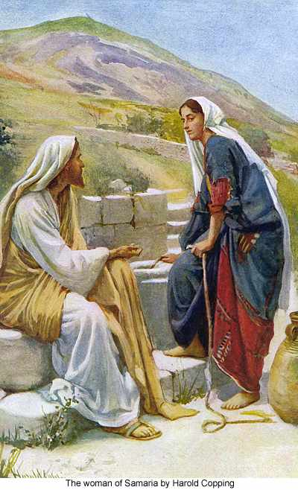
Words of knowledge
Information given to you which you cannot get naturally.
In John 4, we read about Jesus and the Samaritan woman. Jesus knew things about the Samaritan woman although he had never met her or anyone that she knew.

Discerning of spirits
You are able to know things of the spiritual realm.
Acts 16:16-18 - Paul and the slave-girl-groupie. The slave girl was following Paul and his friends around and declaring that “These men are servants of the Most High God, who are telling you the way to be saved.”(v17) Paul recognises and cast out the spirit that was in the slave girl.

Miracles and healings
We read of Jesus performing miracles in the bible but we too can do so in this day and age. Many people in DUMC can testify to receiving healing or praying for someone in need of healing and then seeing / hearing of the person receiving healing.
The following 3 bible verses are examples of miracles and healings performed by the Jesus’ followers.
Acts 13 - Blinding of Elymas
Acts 3 - Healing of the crippled man
Acts 28 - Paul and the viper

Prophecy
While they were worshiping the Lord and fasting, the Holy Spirit said, “Set apart for me Barnabas and Saul for the work to which I have called them.” (Acts 13:2)

Do not quench the Spirit. Do not treat prophecies with contempt but test them all; hold on to what is good, reject every kind of evil. (1 Thessalonians 5:19-22)

Don’t suppress the Spirit, and don’t stifle those who have a word from the Master. On the other hand, don’t be gullible. Check out everything, and keep only what’s good. Throw out anything tainted with evil. (1 Thessalonians 5:19-22, MSG)

Why are spiritual gifts important?
The Purpose of Spiritual Gifts

Build up the Church.
But to each one of us grace has been given as Christ apportioned it. … So Christ himself gave the apostles, the prophets, the evangelists, the pastors and teachers, to equip his people for works of service, so that the body of Christ may be built up until we all reach unity in the faith and in the knowledge of the Son of God and become mature, attaining to the whole measure of the fullness of Christ. (Ephesians 4:7, 11-13)

Now to each one the manifestation of the Spirit is given for the common good. (1 Corinthians 12:7)

Spiritual gifts are for the church. It's to be shared. There is no gift too small, as all gifts are to be used for the good of the church.

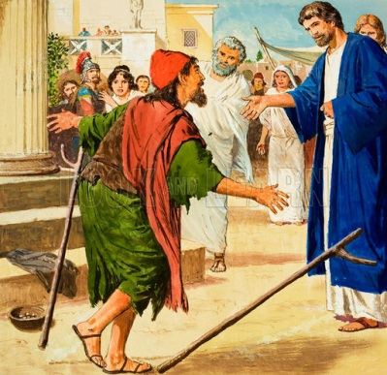
Open Hearts to The Gospel
When all the people saw him walking and praising God, they recognized him as the same man who used to sit begging at the temple gate called Beautiful, and they were filled with wonder and amazement at what had happened to him. While the man held on to Peter and John, all the people were astonished and came running to them in the place called Solomon’s Colonnade. (Acts 3:9, 10)
But many who heard the message believed; so the number of men who believed grew to about five thousand. (Acts 4:4)

Peter and John had the opportunity through the healing of the lame man to share the gospel. Although the priest, the captain of the temple guards and the Sadducees threw them into prison, many people believed in Jesus that day.

Glorify God
Each of you should use whatever gift you have received to serve others, as faithful stewards of God’s grace in its various forms. If anyone speaks, they should do so as one who speaks the very words of God. If anyone serves, they should do so with the strength God provides, so that in all things God may be praised through Jesus Christ. To him be the glory and the power for ever and ever. Amen.
(1 Pet 4:10-11)

How to Grow in Spiritual Gifts?
The Pursuit of Spiritual Gifts

Earnestly desire spiritual gifts
God will not force the gifts unto us. We must want it.
“Now eagerly desire the greater gifts.” (1 Corinthians 12:31)
“… eagerly desire gifts of the Spirit…” (1 Corinthians 14:1)

Follow the way of love.
The motivation has to be one of love.
“…the most excellent way.” (1 Corinthians 12:31)
“Follow the way of love and eagerly desire gifts of the Spirit” (1 Corinthians 14:1)

Share life with each other
Share our lives with each other. Have a better and deeper relationship with people.

Minister to hurting people.
Use our gifts to help people who are hurting and in need.

Sermon summary and Prayer Points by Prudence Tay

SERMON: The Gifts of the Holy Spirit
Pray:
- We will desire the Holy Spirit and the gifts of the Holy Spirit.
- We will exercise speaking in tongues for at least 10 minutes a day.
- May we be open minded and allow the Holy Spirit to work in and through us.
- We will use the gifts given to us by the Holy Spirit for the good of the church.
Each of you should use whatever gift you have received to serve others, as faithful stewards of God’s grace in its various forms. (1 Pete 4:10)

MINISTRIES & EVENTS: Truth16 Campus Camp
This camp is for University students and will be help on July 1 – 3 in Port Dickson.
Pray:
- The university students will attend this camp.
- God will touch the hearts of the camp participants and they will return home moved and empowered for the Kingdom of God.
- God’s anointing upon the speakers of the camp for a rhema word for this season of time.
- Wisdom and strength for the organising committee and everyone helping out in this camp.
- Journey mercies as they travel to and from Port Dickson.
These are the things that you shall do: Speak the truth to one another; render in your gates judgments that are true and make for peace; (Zechariah 8:16)

MALAYSIA MY NATION: Fasting Month
The month of Ramadan has started and our Muslim friends are observing a month of fasting. The end of the fasting month is celebrated with the Hari Raya Puasa holidays.
Pray:
- As our friends observe this time of fasting may we not be a hindrance to them.
- During this time where our friends spend more time seeking god, may the God reveal Himself to them.
- May we all be wise in our spending with the many Ramadhan bazaars going on and not waste food and money.
- Journey mercies for everyone as they travel back to their home towns during the Hari Raya Puasa holidays
For the earth will be filled with the knowledge of the glory of the Lord as the waters cover the sea. (Habakkuk 2:14)

- A TRANSFORMED WORLD: UEFA EURO 2016
This major football tournament is held in Paris this year from June 10 to July 10. Many people are there in Paris or will make their way there to watch the many matches that will be held. There has been a security concern will all the bombings that have taken place of late in Europe. Security is high and so far there have been no incidents of violence and terrorist attacks
Pray:
- People will keep their cool and not break out into fighting with their rival team supporters.
- Wisdom and alertness upon the security teams as they keep watch over the many matches that will take place.
- As the people pour into Paris, may God’s people take the opportunity to connect with non-believers and share with them God’s love.
- God’s hand and protection be over Paris during this time where many people will visit the city. May peace reign in Paris
Though the mountains be shaken and the hills be removed, yet my unfailing love for you will not be shaken nor my covenant of peace be removed,” says the LORD, who has compassion on you. (Isaiah 54:10)

