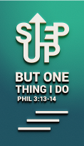
Enhancing the Culture / DNA of DUMC. (Acts 2:42-47)
Dr. Daniel Ho
Founding Senior Pastor

They devoted themselves to the apostles’ teaching and to fellowship, to the breaking of bread and to prayer. Everyone was filled with awe at the many wonders and signs performed by the apostles. All the believers were together and had everything in common. They sold property and possessions to give to anyone who had need. Every day they continued to meet together in the temple courts. They broke bread in their homes and ate together with glad and sincere hearts, praising God and enjoying the favour of all the people. And the Lord added to their number daily those who were being saved (Acts 2:42-47)

Introduction

What will Pastor Daniel be doing?
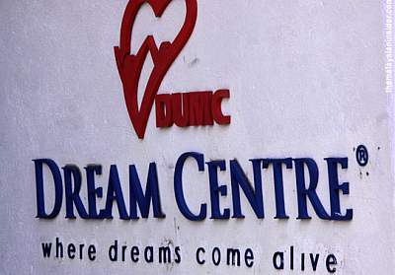
This week saw the commissioning of Pr. Chris Kam as Senior Pastor. During this time Pr. Daniel will be doing the following. He will be teaching and preaching in DUMC and outside of DUMC. Pr. Daniel also will be mentoring different groups of people; from young people to other groups of people. Pastor Daniel will be meeting Pr. Chris Kam on a monthly basis. He will be available for counselling and help for churches, NGO’s, other organizations Christian leaders and pastors. To continue to champion evangelism, church planting and issues related to nation-building. He will also pray and hopefully do some writing.

We reproduce our kind (Act 2:42-47)

Marks of the early Church:
- Learning fellowship.
- Worshipping fellowship.
- Loving, caring and serving fellowship.
- Evangelising fellowship.

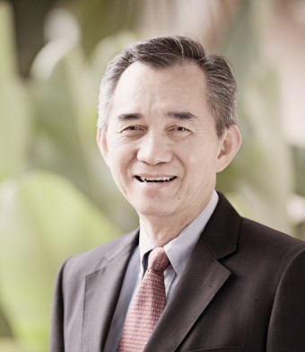
What are the marks of DUMC?
What I like about what I see in DUMC?
- People are warm, friendly and welcoming.
- People love God and love people.
- God-centred and Word-centred.
- Good environment and great spiritual and worship atmosphere.
- Great community and diversity.
- Humility and servanthood.
- Authenticity and generosity.
- Prayerfulness and courage.
- Kingdom-minded and Kingdom-hearted.
- Passion, energy, sense of urgency and takes God’s work seriously.
- Concerned to reach out to all peoples, engage society and issues of the nation.
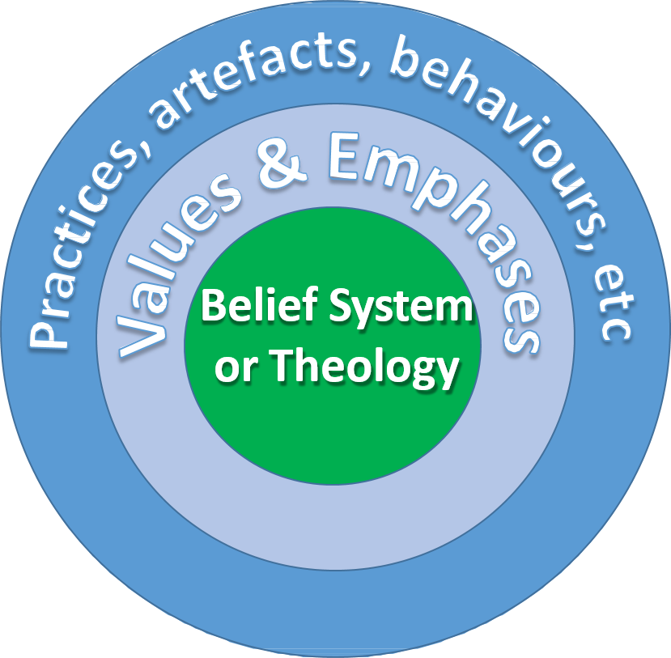
- A vision to transform the nation and the world.
- Great respect for elders, pastors and leaders.
- Great equipping centre, wonderful cell system and support structure.
- Safe and secure place and caters for all age groups.
- Confidence to bring friends, relatives, children and all kinds of professions where needs can be met.
- Café is pork-free, clean, pleasant, welcoming and serves good food at reasonable prices.
- What you see in church is always a reflection of the values and emphases of the senior pastor.

What Pastor Daniel wish to see in DUMC?
- A real 24/7 prayer centre.
- A counselling and healing centre.
- A pervasive evangelistic culture and lifestyle.
- Maximising Dream Centre facilities like having café operating till 10.30 pm, nightly life band, jazz festival, art festival, sports carnival, hobbies exhibition, etc.
- Sunday night specials.
- Dream Centre: KL / PJ Top 10 must visit places.
- Greater engagement with society and nation.
- More into missions and church planting.
- More risk-taking.

Let’s reinforce what we have built

Let us build strong together (Nehemiah 4:6)
So we rebuilt the wall till all of it reached half its height, for the people worked with all their heart. (Nehemiah 4:6)

Let us build strong around the Lord (Ephesians 2:19-22)
Consequently, you are no longer foreigners and aliens, but fellow citizens with God’s people and members of God's household, built on the foundation of the apostles and prophets, with Christ Jesus himself as the chief cornerstone. In him the whole building is joined together and rises to become a holy temple in the Lord. And in him you too are being built together to become a dwelling in which God lives by his Spirit. (Ephesians 2:19-22)

Let us guard what we build (2 Timothy 4:7)
I have fought the good fight, I have finished the race, I have kept the faith. (2 Timothy 4:7)
- Life is about a fight.
We need to fight for the right things, fight for the good fight.
- Life is about finishing.
It is important that we finish our life well.
- Life is about faith and keeping faith.
Above all we need to be consistent in our walk with God.

Let’s rally around Pastor Chris’ leadership (1 Timothy 4:14-16)
Do not neglect your gift, which was given you through a prophetic message when the body of elders laid their hands on you. Be diligent in these matters; give yourself wholly to them, so that everyone may see your progress. Watch your life and doctrine closely. Persevere in them, because if you do, you will save both yourself and your hearers. (1 Timothy 4:14-16)
- Commit to support him in his leadership
- Commit to pray for him, his family and all the ministries regularly
- Commit to partner him to advance God’s Kingdom and touch the world

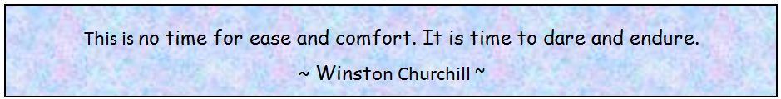

Sermon Summary contributed by Abbey Thangiah
Prayer points contributed by Michelle Chuah

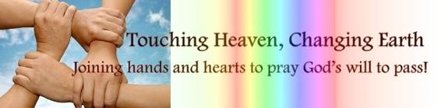

SERMON: THE HOLY SPIRIT & THE CHURCH: Enhancing DUMC’s Culture / DNA
Pray:
- People of DUMC will continue on the same culture of Love God, Love People as they serve together in the various ministries of the church.
- We will remember to be God centred and Word centred in our daily walk with God, with a spirit of humility and servanthood.
- We will be focused on being Kingdom minded and kingdom hearted when engaging with missions, church planting, evangelism and serving in the society we live in.
- We will constantly respect church Elders, Pastors and Leaders in carrying out the Great Commission.
Be devoted to one another in brotherly love. Honour one another above yourselves.
(Romans 12: 10)

MINISTRIES & EVENTS: LEAD2016
2 – 4 JUNE 2016
Pray:
- People of God will work together in unity and respect for each other in all aspects of preparation for Lead 2016
- God will make a way for all the plans and events to be carried out well and timely.
- All the audio and visual equipment will be in perfect working order throughout the service.
- God will enable each invited Speaker to be sensitive to the people who come to be touched.
And we know that in all things God works for the good of those who love him, who have been called according to his purpose. (Romans 8: 28)
MALAYSIA MY NATION: MALAYSIAN CONSTITUTION
Freedom of Religion and Worship in Malaysia
Pray:
- Fear of God to be upon all people involved with amendments to the Federal Constitution with transparency and honesty for the future good of the people.
- God’s people will step up in prayer in repentance and urgency for the freedom of religion and worship to be protected through the Federal Constitution.
- God will raise up God fearing leaders with integrity to guard over the rights for the marginalised group to be in the government.
- God will prevent the nomination and election of extremists in the area of religion and worship in the Federal government.
But we prayed to our God and posted a guard day and night to meet this threat. (Nehemiah 4:9)
Wherever you hear the sound of the trumpet, join us there. Our God will fight for us! (Nehemiah 4:20)
- A TRANSFORMED WORLD: ANTIQUA : Caribbean, Latin America
ABSAR (Antigua and Barbuda Search and Rescue) – a medical voluntary organization
Pray:
- Provision of funds for medical health care for the people by the local government.
- The voluntary organization to have more volunteers and medical supplies.
- For the people of God to be able to minister to the people through ABSAR.
- For God’s Love, Grace and Mercy to touch the people in Antiqua through God’s people who go forth to minister to them.
And do not forget to do good and to share with others, for with such sacrifices God is pleased. (Hebrews 13:16)

