Step Up (Philippians 3:13-14)
Deputy Senior Pastor Chris Kam

Brothers and sisters, I do not consider myself yet to have taken hold of it. But one thing I do: Forgetting what is behind and straining toward what is ahead, I press on toward the goal to win the prize for which God has called me heavenward in Christ Jesus. (Philippians 3:13-14)

Introduction
Have you ever tried something new? Have you ever done something you have never done before? How did it feel?
Depending on your personality and how you are wired as a person, you can either be excited, apprehensive, anxious or even paralyzed.
Pastor Chris shared his experience of his trip to the USA in September 2015, where he tried driving on the other side of the road for the first time, the ‘wrong’ side, which is the right lane in the US. His wife kept reminding him to keep to the right, especially when he was about to veer too close to the road shoulder.
The church is now undergoing a major leadership transition, whereby the Senior Pastoral leadership will be transferred from Pastor Daniel Ho to Pastor Chris Kam. Pastor Daniel is still the Senior Pastor until Pastor Chris is commissioned as the Senior Pastor on the 8th of May. Just like driving on the right side of the road in USA, this is also new experience for Pastor Chris.
Pastor Chris went away for three days to seek the Lord in June, as per the custom of the church leadership planning. It was a time of rediscovery for him, and he was reminded that in a similar way, a generation of Moses is now passing on the baton to the Joshua generation. The generation that came after Joshua forgot why they are God’s chosen people – to be a salt and light to the nations. They did not do well in the end.
“You are the salt of the earth. But if the salt loses its saltiness, how can it be made salty again? It is no longer good for anything, except to be thrown out and trampled underfoot. You are the light of the world. A town built on a hill cannot be hidden. Neither do people light a lamp and put it under a bowl. Instead they put it on its stand, and it gives light to everyone in the house. In the same way, let your light shine before others, that they may see your good deeds and glorify your Father in heaven.” (Matthew 5:13-14).

Brothers and sisters, I do not consider myself yet to have taken hold of it. But one thing I do: Forgetting what is behind and straining toward what is ahead, I press on toward the goal to win the prize for which God has called me heavenward in Christ Jesus. (Philippians 3:13-14)

We must not think that we have taken hold of it, that we have arrived.
There are three things that God wants to remind us of:
- Forgetting what is behind
- Focusing toward what is ahead
- Focusing on the Call

- Past (Forgetting what is behind)
It does not mean that we forget the contribution of our leaders and senior members, and forget what they have done for us in the past. We need to appreciate them. The founding members have been in DUMC for 28 years. DUMC started on the 6th of January 1980, with 22 adults and young children. Today in 2016, the church has grown to about 4500 worshippers with 6 language congregations – English, Chinese, Bahasa, Tamil, Burmese and Nepali. DUMC has moved four times, once in Damansara Uptown, to Taman Mayang (1993), to Sea Park (1998) and to Section 13. We are one church, with one Holy Spirit, who gives us unity. The Holy Spirit visited the church in a powerful way in 1996, which brought the church to a whole new level of faith and spirituality.
It is about getting out of our comfort zone.
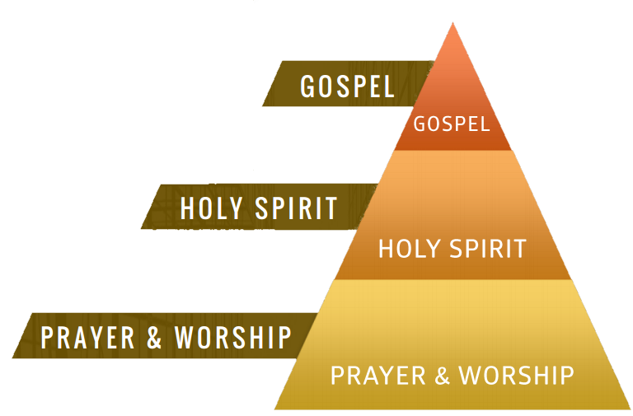
The Emphasis:
The legacy of the Christian life is people being touched, changed and transformed. The church exists for the Gospel. So far, there is a record of 40-50 salvations for the Christmas production. About 600 people gave their lives to Jesus during the Myanmar ministry Christmas outreach event.
- Present (Forging toward what is ahead)
The transition of leadership is like driving a car. It is the same car (DUMC) but the driver will be different. From Pastor Daniel to Pastor Chris Kam.
In the car there is a GPS (Global Positioning System) system. The same GPS system that Pastor Daniel used. When Pastor Chris takes a wrong turn onto another highway, the GPS will reroute and guide him back onto the right path leading to the right destination. Pastor Chris cannot drive like Pastor Daniel, but they have the same car, the same GPS system, heading in the same direction. DUMC will continue to head in the right direction with the same vision and mission. Building God’s community and making known His glory. Evangelism, discipleship and community services may change a little.
Pastor Daniel will be stepping out as the Senior Pastor of DUMC after 20 years, and as the senior elder for 36 years, he steps up more actively into a national and international role of a Christian statesman. His contribution to the larger Body of Christ is timely and most needed in a time such as this. DUMC has been blessed by his leadership in taking us to be where we are today. Pastor Chris will be stepping up to take that role with the utmost respect and honor to the legacy Pastor Daniel will be leaving behind under his leadership.
The theme for 2015 is Spread Out! Think Big!
The theme for 2016 is Step Up!
As Pastor Daniel steps out and up, and Pastor Chris steps up and in, it will bring about a cascading effect, causing many others to step up either to fill in the vacated positions or in the re-orientation or re-calibration of their ministries. There will be new opportunities for different ones to discover new capabilities and capacities.
This transition period reminds us to think of our successors and the need to intentionally disciple and mentor younger people. Thus the focus on #Twenty35.
- Future (Focusing on the call)
“The kingdom of heaven is like treasure hidden in a field. When a man found it, he hid it again, and then in his joy went and sold all he had and bought that field. (Matthew 13:44)
Even though I get older, what I do never gets old, and that's what I think keeps me hungry.
- Steven Spielberg
Jesus is saying that there is a treasure worth selling everything for, and that treasure is the Gospel. God was willing to give up His beloved Son so that everyone can be saved. This treasure is more valuable than all you have now and will ever have in the future.
Everyone becomes equal on their death beds, because they cannot take anything with them. The only thing we can take with us are souls of people. Everything else fades away in the light of eternity – wealth, possessions and status in life.
The question for us is this: What would we die for? Are the things we are dying for now, worth dying for?
The one thing that matters is Christlikeness and Eternal Salvation. Everything we do must have the goal of helping a person to be nearer to Christ. The call in this season of transition is to step up. We are called to step up in our homes, in the marketplace, and in church ministry.
2016 will be a year of major transitions. The strategy is to reach out to the younger generation. 59% of the population of Malaysia is under 30. We build our church not for us, but for the generations to come. We can begin by discipling the young people, starting with children and youth. Pastor Chris hopes to see more leaders rise up from the 20-35 category. We are not neglecting the older generation, the Moses generation. The truth is that the older generation is needed more than ever. They are needed to mentor, teach and share their wealth of experiences to the next generation.
Even when I am old and gray, do not forsake me, my God, till I declare your power to the next generation, your mighty acts to all who are to come. (Psalm 71:18)

When Pastor Chris asked God what he could expect in ten years’ time for the church, God gave him a number, which was 15,000 in satellite churches and church plants. Humanly speaking, it cannot be done, but with God it is possible. It is a season to go rather than to invite people to come. The population size in the city shows that there is never enough churches. There are 7.7 million in the Klang Valley, 600k in Petaling Jaya, 700k in Subang Jaya, 1.6 million in Kuala Lumpur, 750k in Klang and 800k in Kajang. There are thousands of foreign labours, with 2 million legal ones.
Conclusion
The Challenge: Will you dream and walk with Pastor Chris for the next 10 years to build the church for our children? Can we leave DUMC better than when we step in?
So what can we do? We can volunteer our time, and seek God’s call for our lives at work. Some are called to full-time ministry, which also means their professional skills are needed, to be excellent administrators, secretaries, IT personnel and social workers. We need to discover our mission call. You will never experience the thrill if you do not jump.
So how can you step up?
Sermon summary contributed by Anthea Tan
Prayer points contributed by Ngui Yuen Loong

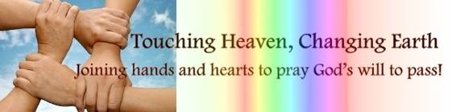

SERMON: FORWARD: Step Up
Pray:
- DUMC members will catch the vision to Step Up in their respective callings.
- The church as a whole will have a smooth transition, enduring the necessary adjustments and forge ahead together as one body.
- We will move forward together in the same vision.
- Elder folks and young adults will invest their lives into the #Twenty35 groups to develop future leaders.
- We will have the correct priorities in our lives, going for what is eternal instead of what is temporal.
- We will all find out the “one thing” we do.
Brothers and sisters, I do not consider myself yet to have taken hold of it. But one thing I do: Forgetting what is behind and straining toward what is ahead, I press on toward the goal to win the prize for which God has called me heavenward in Christ Jesus. (Philippians 3:13, 14)

MINISTRIES & EVENTS: 14-day Fast and Pray
05/01/2016 to 17/01/2016
Pray:
- Members will be challenged to come for prayer.
- Members will rest early to ensure they can get up early.
- The fasting and prayer time will allow us to draw close to God.
- Members will grow in desire to spend time with God, in worship and prayer.
- We will receive wisdom and strength from God.
Declare a holy fast; call a sacred assembly. Summon the elders and all who live in the land to the house of the Lord your God, and cry out to the Lord. (Joel 1:14)
MALAYSIA MY NATION: Economy
Pray:
- The administration will be compassionate of the people’s situation and takes measures to elevate the difficult situation many are in.
- Unnecessary spending will be eliminated and funding will be channelled to essential areas.
- Tax collected will be put to good use.
- The people will learn to live according to their means and exercise great financial disciplines to weather any storm.
- The poor and needy will receive the help they need.
- Christians will be good stewards and learn to depend on God.
I was young and now I am old, yet I have never seen the righteous forsaken or their children begging bread. (Psalm 37:25)

- A TRANSFORMED WORLD: High Speed Rail Connecting the Region
Pray:
- The construction of the Kuala Lumpur-Singapore High Speed Rail will proceed smoothly without much casualty.
- The construction work will not cause too much obstruction to the surrounding areas.
- There will be no corruption.
- The contractors will not cut corners.
- The completion of this project will allow convenient, fast and safe transport that improves lives of many.
- The connection of this railway will open up many opportunities for tour and travels in the region, especially new opportunities for the expansion of God’s kingdom.
A voice of one calling: “In the wilderness prepare the way for the Lord; make straight in the desert a highway for our God.” (Isaiah 40:3)

