Why are we a Cell Church (1 Peter 2:4-12)
Deputy Senior Pastor Chris Kam

As you come to him, the living Stone—rejected by humans but chosen by God and precious to him— you also, like living stones, are being built into a spiritual house to be a holy priesthood, offering spiritual sacrifices acceptable to God through Jesus Christ. For in Scripture it says: “See, I lay a stone in Zion, a chosen and precious cornerstone, and the one who trusts in him will never be put to shame.” Now to you who believe, this stone is precious. But to those who do not believe, “The stone the builders rejected has become the cornerstone,” and, “A stone that causes people to stumble and a rock that makes them fall.” They stumble because they disobey the message—which is also what they were destined for. But you are a chosen people, a royal priesthood, a holy nation, God’s special possession, that you may declare the praises of him who called you out of darkness into his wonderful light. Once you were not a people, but now you are the people of God; once you had not received mercy, but now you have received mercy. Dear friends, I urge you, as foreigners and exiles, to abstain from sinful desires, which wage war against your soul. Live such good lives among the pagans that, though they accuse you of doing wrong, they may see your good deeds and glorify God on the day he visits us. (1 Peter 2:4-12)

Introduction
Each of us have our own reasons and motivations to come to church. In Acts 2:43-47, we find that there are three reasons why people join church.
- They have an encounter with God (Acts 2:42-43)
The early church devoted themselves to the apostles’ teachings and to the fellowship with one another on a daily basis. As such, they witnessed many signs and wonders, thus knew that God was in their presence.
- They feel they belong (Acts 2: 44-46)
The believers help each other and gave unselfishly to address another believer’s need. This fostered a bond between them, which in turn gave each of them a sense of belonging.
- They find purpose for their life (Acts 2: 47)
The believers saw that their group was growing day by day. There was so much excitement about souls saved that they are excited to come to church on a daily basis. One thought that was continuously reinforced in them is that of their purpose here on earth was that their life was for the Gospel.
Moving on to the church itself, Pastor Chris sees the church as a two-winged bird. The first wing is the weekly celebrations. The second wing is the small groups. And just like a bird, the church will not be able to function well with only one wing.
There is a heaven and earth difference between a cell church and a church with cells.
A church with cells sees cell groups as an option, as just another ministry in the church; where as in a cell church, a person cannot join a ministry until they join a cell group.

The first important note for us is that DUMC is a cell church, and seeks to expand church growth by narrowing gaps. The more recent joiners will be encouraged to stay in the church by having a relationship with other Christians within a cell group, which leads them to feel like they belong in the body of the Church. The second important note is that cell group in itself is also a church, because the definition of church is “a gathering of God’s people”.
However, what is “church”?
The church is a spiritual house, a royal priesthood, and a holy nation.
- Spiritual House (1 Peter 2:4-5)
“As you come to him, the living Stone—rejected by humans but chosen by God and precious to him— you also, like living stones, are being built into a spiritual house to be a holy priesthood, offering spiritual sacrifices acceptable to God through Jesus Christ.” (1 Peter 2:4-5)
All of us are “living stones”. Therefore, everything that we do as a Christian must have the goal of helping a person to be nearer to Christ (Ephesians 4:11-13) with Christ as our cornerstone.
In this sermon, Pastor Chris illustrates the five-fold ministry, in which:
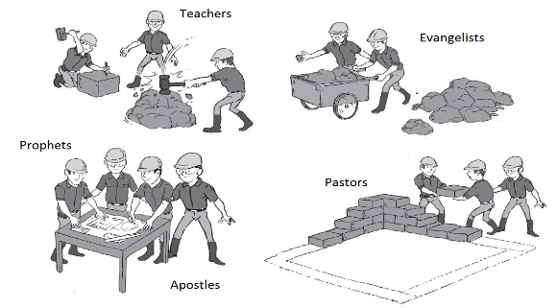
- Apostles who teach the Gospels are seen to be the ones with the blueprint/building plans.
- Prophets, who hear from God, are seen as the Quality Assurance Officers.
- Evangelists, who spread the Gospel, are seen as the gatherers of the living stones.
- Teachers, who teach the Word of God, are seen as stone cutters who shape the stone to be used in the House of God.
- Pastors, who bring the people together, are seen as the laborer who stacks the stones and builds according to the blueprint.
There are two observations arising from this:
i. Some Christians don't like to be stacked together, and
ii. When you are stacked together, it is quite uncomfortable because it is not easy to get along with people
Why are we averse to being stacked together?
It is because being with another person(s) brings out the worst in us, simply because they are not like us. In going through this difficult process of being in the presence of another person constantly, we learn to disagree with one another in order to accept and grow to love one another.

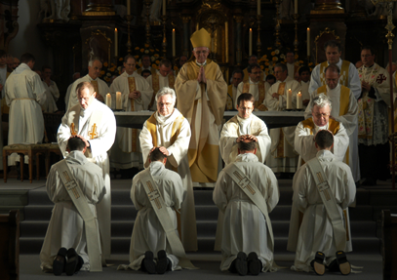
- Royal Priesthood (1 Peter 2:5)
We who put our trust in Christ are called to be a royal priesthood for the Lord. Cell groups trains us in our faith journey of becoming the priests of God by exercising spiritual gifts in the cell group and praying for the people with us and around us. It is crucial that we bear in mind that we have the same Holy Spirit in us, and there is no distinction in our roles, from one believer to another believer, as priests of the one God.
- Holy Nation (Exodus 19:5-6, 1 Peter 2:9-10)
“Now if you obey me fully and keep my covenant, then out of all nations you will be my treasured possession. Although the whole earth is mine, you will be for me a kingdom of priests and a holy nation.’ These are the words you are to speak to the Israelites.” (Exodus 19:5-6)

“But you are a chosen people, a royal priesthood, a holy nation, God’s special possession, that you may declare the praises of him who called you out of darkness into his wonderful light. Once you were not a people, but now you are the people of God; once you had not received mercy, but now you have received mercy.” (1 Peter 2:9-10)
The definition of being holy is “set apart”. This means that we are to be different from what the world tells us to be. Therefore, we have to testify to the world that we are indeed “set apart” by showing them that we as Christians:
- Think differently
- Live differently
- Love differently
- Talk differently

Conclusion
God’s primary objective is not to make us happy. His objective is to make us holy. Cell groups is the avenue for us to be made holy, and helps us understand what it means to be a Church.
The question is: Are you in one today? If you are not in a cell group, join one today.

Sermon summary contributed by Adeliyn Lim
Prayer points contributed by Ngui Yuen Loong

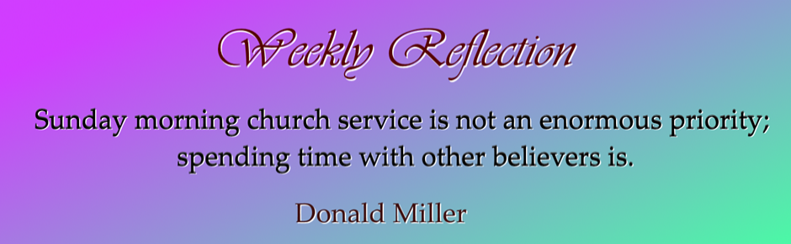
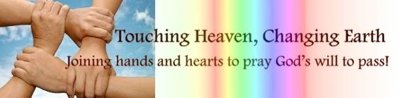

SERMON: FORWARD2016: Why are we a cell-church?
Pray:
- All church members will be assimilated into a CG.
- The CG will be “the other wing” to the weekend celebration to ensure the church continues to soar.
- Edification and evangelism will thrive in each CG.
- The CG leaders, interns and members will work together the CG ministry.
- The CG will be the platform where many leaders are discovered, equipped and launched into various ministries.
- Members will recognized their identity as members of the Body, the royal priesthood and being holy.
Therefore encourage one another and build each other up, just as in fact you are doing. (1 Thessalonians 5:11)
MINISTRIES & EVENTS: LEAD2016
LEAD2016 will take place in the Dream Centre from 02/06/2016 to 04/06/2016.
Pray:
- Many will sign up.
- The speakers will
- The organizing committee will plan and execute accordingly.
- DUMC will once again be a good host.
- Delegates will have a wonderful time of worship, learning and networking.
- Leaders will confirm their calling and step up.
Be shepherds of God’s flock that is under your care, watching over them—not because you must, but because you are willing, as God wants you to be; not pursuing dishonest gain, but eager to serve; not lording it over those entrusted to you, but being examples to the flock. (1 Peter 5:2-3)

MALAYSIA MY NATION: Terrorist Fear
Two bags left unattended in Pavilion, Kuala Lumpur caused a bomb scare. This comes at the heels of one minister’s warning about IS targeting several locations in Kuala Lumpur, which was later denied by the police.
Pray:
- The authority and the police will work together with the people as well as their counterpart in the region to prevent any untoward incidents.
- Security personnel everywhere will stay alert to any suspicious activities and be effective in their job.
- Citizens will be responsible when they share information, especially when they are not verified.
- Extremist groups with ulterior motives will not take this opportunity to spread fear in attempt to cause problems.
I keep my eyes always on the Lord. With him at my right hand, I will not be shaken. (Psalm 16:8)
- A TRANSFORMED WORLD: United Nation’s Sustainable Development Plan
At the United Nations Sustainable Development Summit on 25/09/2015, more than 150 world leaders including Malaysia Prime Minister, Datuk Seri Najib Tun Razak, adopted the new 2030 Agenda for Sustainable Development, including the Sustainable Development Goals (SDGs). The United Nations Development Programme (UNDP) will support governments around the world in tackling the new agenda and taking it forward over the next 15 years. The 169 targets of the 17 goals will be monitored through a set of global indicators. More details here.

Pray:
- The 17 Sustainable Development Goals or Global Goals which seek to end poverty, hunger, inequality, improve access to health and education and others will be carried out with the co-operation of all the nations.
- The world leaders will put aside personal or national interest to see that these goals are achieved by 2030.
- There will be transparency and accountability in the execution of the plans.
- Through these efforts, the nations will learn to understand one another better and will be able to work closer with one another.
The righteous care about justice for the poor, but the wicked have no such concern. (Proverbs 29:7)

