What Can We Do In Our Community? (Matthew 5:14-16)
Deputy Senior Pastor Chris Kam

“You are the light of the world. A city on a hill cannot be hidden. Neither do people light a lamp and put it under a bowl. Instead they put it on its stand, and it gives light to everyone in the house. In the same way, let your light shine before men, that they may see your good deeds and praise your Father in heaven.” (Matthew 5:14-16)

Introduction
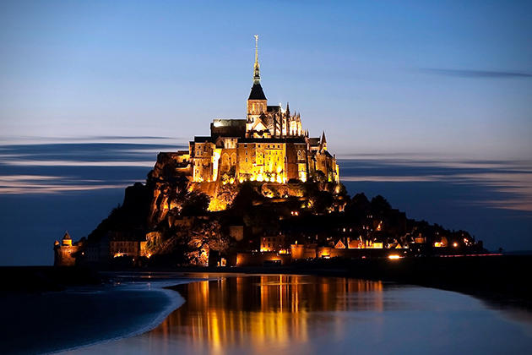
The purpose of the church is for the gospel. Everything we do is for the sake of the gospel, empowered by the Holy Spirit, in a spiritual environment, prayer and worship. The things that we do should not be based on our own agenda but from what we hear from the Holy Spirit.
Pastor Chris reminded us on his last week’s sermon that Cell Group is the basic building block of the church. Cell Group itself is a church because church simply means the gathering of God’s people where we learn to be living stones, royal priests and Holy people; so that we could be different among our communities, to be the city on a hill.
Pastor Chris explained further based on this simple Word from the Bible:
- You
- Are the Light
- Of the World

You
Yes, God is talking about YOU! A lot of times we feel that we are lacking of something or we are just not good enough. This is because we feel we are just ordinary people which is the fact. When we are very good at something like having a specific talent it is actually a grace gift from God.
Even Elijah whom performed many miracles was an ordinary man just like us. The apostles and Moses were ordinary men as well but God chose them and used them to do great and mighty things. And God can use us too. God is looking for ordinary people and because of that we all have hope.
Elijah was a human being, even as we are. He prayed earnestly that it would not rain, and it did not rain on the land for three and a half years. (James 5:17)

Are the Light
When we receive Jesus into our lives, we receive the light in us that is permanently on because Jesus is the Light.
When Jesus spoke again to the people, he said, “I am the light of the world. Whoever follows me will never walk in darkness, but will have the light of life.” (John 8:12)
So we have the light that is forever on but most of the time we are not using it but hiding it instead. The Bible says we are to bring salvation to the ends of the earth which means all that we do have to be for the gospel. We have to be the light.
For this is what the Lord has commanded us: “I have made you a light for the Gentiles, that you may bring salvation to the ends of the earth.” (Acts 13:47)
The purpose of the Light is to:
- Expel darkness
- Expose deeds of darkness
- Exalt God
When there is darkness, we would automatically turn on the lights and the darkness is gone. Hence God has created us to be the weapon of warfare we only need to turn on the light. We were placed where we are today to expel darkness. As the light, we also tend to speak out things that are unjust. Those who do not want to receive the light will definitely dislike us because they are fearful that their evil deeds will be exposed.
In all that we expel darkness and expose the deeds of darkness, it is not for ourselves but to exalt God. God holds us responsible if the society deteriorates because we are meant to preserve honour and truth and we are supposed to be the light.
When society deteriorates, the questions to ask are: ‘Where is the church? Why are the salt and light of Jesus Christ not permeating and changing our society?’ It is sheer hypocrisy on our part to raise our eyebrows, shrug our shoulders or wring our hands. The Lord Jesus told us to be the world’s salt and light. If, therefore, darkness and rottenness abound, it is our fault and we must accept the blame.
~John Stott

Of the World
Our “world” every day is the “world” that we go to such as our home, workplace, schools etc. God did not make a mistake to put us to live in the Klang Valley. There are 7.2 million of people in the Klang Valley; 600,000 in Petaling Jaya, 700,000 in Subang Jaya, 1.6 million in Kuala Lumpur, 750,000 in Klang and 800,000 in Kajang and 2 million documented foreigners. As the population and urbanisation continue to grow it is foreseen that the mission field of the future is in the cities.
Pastor Chris challenged each of us to reach out to just 2 persons in the next 10 years to fulfil the vision that God has given to DUMC to reach 15,000 members in 10 years. Is it possible? God says with you it is impossible but with God it is possible. It is actually not that difficult but the problem is in our mind because we often forget that we are the light. The harvest is there but there are no workers. We need to do something crazy for the Lord. We need to be the salt and light where we are. The members of the church is just a small number but the 7.2 million population is the number that should impress upon us. That is why Cell Groups are the key missionary because they can be planted everywhere in Klang Valley to be a blessing to the community.

Conclusion
If every one of us can do little things and random acts of kindness with no strings attached, we can certainly see the change of the atmosphere of Klang Valley. There are many things that we can do but most importantly is to listen to the Holy Spirit. For example Pastor Chris challenged his son to take out RM10 per day and look around whom he wanted to bless on that day. Or we could also walk up to a person and pray for him or her. As we do all these little things, we began to be more sensitive to the needs of people around us.
The Challenge: The greatest mission field is our 9-5 window because we all go to work every day. Ask the Holy Spirit if there is someone that we can do something for. God will lead us to places that we will be surprised.
Step Up to be the Light. Start SMALL with little acts of kindness, think BIG to see the community we are in being transformed.
Sermon summary contributed by Phoebe Wong
Prayer points contributed by Abbey Thangiah

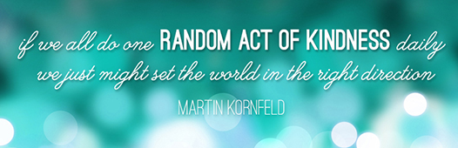

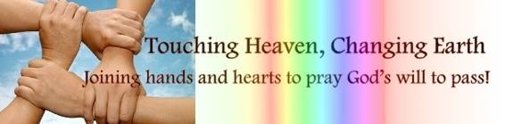

SERMON: Forward 2016: What can we do in our community?
Pray:
- That we, as believers will not hide our faith under a bowl.
- We display our faith with boldness for others to see.
- We may do good deeds and give all glory to the Father.
- The CG will be challenged to serve and be a light to the world by adopting a family, sponsor a child or in whatever way God moves the cell.
- That in blessing others, others may come to know him.
- That we may continue to be a testimony by doing small acts of kindness in wherever God has put us.
You are the light of the world. A town built on a hill cannot be hidden. (Matthew 5:14)
MINISTRIES & EVENTS: ASOL Classes
Hermeneutics and Basic Counselling.
Pray:
- God will raise leaders and members to attend.
- For the health of lecturers and the supporting team.
- God will instil the hunger to learn God’s word in a new perspective.
- Discipline of students to come continuously and do their assignment diligently.
- Lecturers to receive rhema word from the Lord.
Keep this Book of the Law always on your lips; meditate on it day and night, so that you may be careful to do everything written in it. Then you will be prosperous and successful. (Joshua 1:8)

MALAYSIA MY NATION: Terrorist Fear
KUALA LUMPUR: Seven Islamic State (IS) militants were detained in multiple swoops nationwide since Friday, says Tan Sri Khalid Abu Bakar (pic).The suspects, aged between 26 and 50, were detained in Kuala Lumpur, Johor, Kedah, Pahang and Selangor by the Bukit Aman Special Branch Counter-Terrorism Division. "They were arrested in special operations held since Friday. "The suspects were planning attacks on strategic locations in the country," (Thestar.com.my).
Pray:
- Praise God that action is being taken to maintain peace in the country.
- That the police will continue to work together locally and internationally.
- Malaysians will not live in fear but stand fast to the promises of God and live life boldly.
- We will take the hope that we have in Him and use it as a testimony to others.
I keep my eyes always on the Lord. With him at my right hand, I will not be shaken. (Psalm 16:8)
- A TRANSFORMED WORLD: Blizzards at New York and Washington
NEW YORK/WASHINGTON (Reuters) - Millions of residents, business owners and workers began digging out on Sunday from a massive blizzard that brought Washington, New York and other north eastern U.S. cities to a standstill, killing at least 19 people in several states
Pray:
- God will be merciful by protecting the lives of many in New York and Washington.
- The shift of the weather and its unpredictability will be an eye opener to the world to take climate change seriously.
- All parties will join together in making sure help reaches the needy and resources are wisely allocated.
- The church will continue praying for miracles and healing during this time of disaster.
Comfort, comfort my people, says your God. (Isaiah 40:1)

