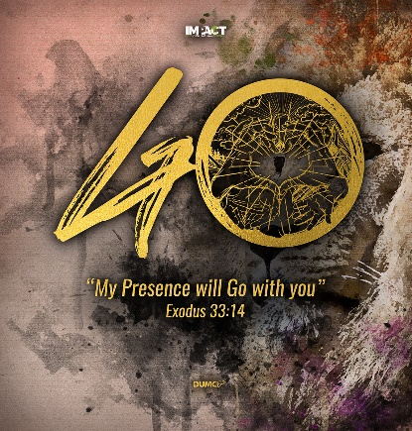
Live Another Day
(James 4:13-17)
Senior Pastor Chris Kam

Now listen, you who say, “Today or tomorrow we will go to this or that city, spend a year there, carry on business and make money.” Why, you do not even know what will happen tomorrow. What is your life? You are a mist that appears for a little while and then vanishes. Instead, you ought to say, “If it is the Lord’s will, we will live and do this or that.” As it is, you boast in your arrogant schemes. All such boasting is evil. If anyone, then, knows the good they ought to do and doesn’t do it, it is sin for them. (James 4:13-17)

Introduction

As Malaysia and the world is going through the covid-19 pandemic, the question for us is, “How are we going to live another day?”

After this pandemic, everything will not be the same. Economically and socially, things will be different. Humans are now facing a global crisis that will shape the many years to come. Everything from economics, politics and culture will be affected. The storm will eventually pass, but we will inherit a different world.

Right now, we are all moving out of our comfort zone.

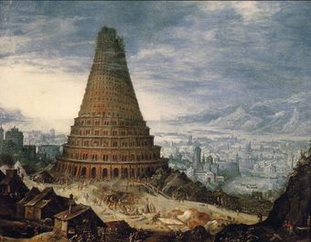
Then they said, “Come, let us build ourselves a city, with a tower that reaches to the heavens, so that we may make a name for ourselves; otherwise we will be scattered over the face of the whole earth.” (Genesis 11:4)

Man think that they are in control, but God came and took over. We look at the Tower of Babel as an example of this happening. Even powerful nations are at a loss as to how to control this tiny virus called coronavirus. God stopped the people from building the tower of Babel and creating a godless society. In the same way, the world will be changed after the covid-19 pandemic.

How will this change the church? And how will this change us?

In this season, God gave a word – recalibration.

The meaning of recalibration in the dictionary is to make small changes in an instrument so that it measures accurately, or to change the way you do or think about something.
BIG IDEA: Will you live your life differently after this?

Small sub-idea: What is God recalibrating in you?

During this time, God is recalibrating us before He sends us out for IMPACT. The MCO (Movement Control Order) has highlighted the fact that we are found to be wanting. God is telling us to be watchful and ready. God is going to begin the change that He wants to bring about in the world by starting with us.

3 Areas of Sin:

Presumption
Now listen, you who say, “Today or tomorrow we will go to this or that city, spend a year there, carry on business and make money.” (James 4:13)

Plan – Today or tomorrow we will go
Place – To this or that city
Period – Spend a year there
Purpose – Carry on business and make money

Due to the covid-19 pandemic, many plans of corporate businesses and private companies will be messed up. Many plans that people have made would have to be changed.

Some of us act like we will live forever. We expect tomorrow to come to us.

Why, you do not even know what will happen tomorrow. What is your life? You are a mist that appears for a little while and then vanishes. (James 4:14)

Life is short and unpredictable. Death is certain, it is not a probability. We need to learn to not be presumptuous about the gift of the days we have ahead of us.

Pride
It is not wrong to plan, but when we try to do things our way, to be our own god, that is when pride comes in. Sometimes we treat God like an ATM machine, going to Him only when we need something.

You may say to yourself, “My power and the strength of my hands have produced this wealth for me.” But remember the Lord your God, for it is he who gives you the ability to produce wealth, and so confirms his covenant, which he swore to your ancestors, as it is today. If you ever forget the Lord your God and follow other gods and worship and bow down to them, I testify against you today that you will surely be destroyed. (Deuteronomy 8:17-19)

God has given us the ability to produce wealth, so we should not be proud and think it all comes from us.

But he gives us more grace. That is why Scripture says: “God opposes the proud but shows favor to the humble.” (James 4:6)

We are not in control. God is.

He replied, “You give them something to eat.” They answered, “We have only five loaves of bread and two fish—unless we go and buy food for all this crowd.” (Luke 9:13)

Procrastination
If anyone, then, knows the good they ought to do and doesn’t do it, it is sin for them. (James 4:17)

When one of those at the table with him heard this, he said to Jesus, “Blessed is the one who will eat at the feast in the kingdom of God.” Jesus replied: “A certain man was preparing a great banquet and invited many guests. At the time of the banquet he sent his servant to tell those who had been invited, ‘Come, for everything is now ready.’ “But they all alike began to make excuses. The first said, ‘I have just bought a field, and I must go and see it. Please excuse me.’ “Another said, ‘I have just bought five yoke of oxen, and I’m on my way to try them out. Please excuse me.’ “Still another said, ‘I just got married, so I can’t come.’ “The servant came back and reported this to his master. Then the owner of the house became angry and ordered his servant, ‘Go out quickly into the streets and alleys of the town and bring in the poor, the crippled, the blind and the lame.’ “‘Sir,’ the servant said, ‘what you ordered has been done, but there is still room.’ “Then the master told his servant, ‘Go out to the roads and country lanes and compel them to come in, so that my house will be full. I tell you, not one of those who were invited will get a taste of my banquet.’” (Luke 14:15-24)

Many people were invited to a great banquet but they gave many excuses as to why they could not come. God says we cannot afford to delay or procrastinate. We cannot control what happens next.

An example of procrastination is in the area of serving God. We say that we will serve God when we have time, when the kids are grown up, when we retire and so on. The truth is, we never have enough time. The issue here is in our priorities.

The sin of commission is doing something wrong. Another sin is the sin of omission. It is knowing what you need to do but not doing it. Do not look back on your life with regret when you are on your deathbed.

Antidote to the three poisons of sins:

As we are reminded to wash our hands daily during the MCO, we also need to remember to wash our hearts regularly.

Presumption – Know the Lord’s Will

Instead, you ought to say, “If it is the Lord’s will, we will live and do this or that.” (James 4:15)

Teach us to number our days, that we may gain a heart of wisdom. (Psalm 90:12)

We need to ask God to give us wisdom. We need wisdom so we will not be presumptuous about our lives.

Pride – Humility

Every success of any person is a contribution of people around him, so there is no such thing as a self-made man.

We need to always acknowledge God in everything and depend on Him.

Procrastination – Walk by the Spirit in Obedience

Since we live by the Spirit, let us keep in step with the Spirit. (Galatians 5:25)

To overcome procrastination is to keep in step with the Spirit. We need to follow the Spirit’s leading and make the most of every opportunity.

Be very careful, then, how you live—not as unwise but as wise, making the most of every opportunity, because the days are evil. Therefore do not be foolish, but understand what the Lord’s will is. (Ephesians 5:15-17)

Conclusion

The covid-19 will change the world, it will change the way church is run, and it will change our lives. Is there anything in our lives we need to repent for, could we learn to be more compassionate? Could we draw closer to God and pray more? In the midst of the fear and uncertainty surrounding the covid-19 pandemic, what are the opportunities for us to reach out to those around us and share the Gospel with them?

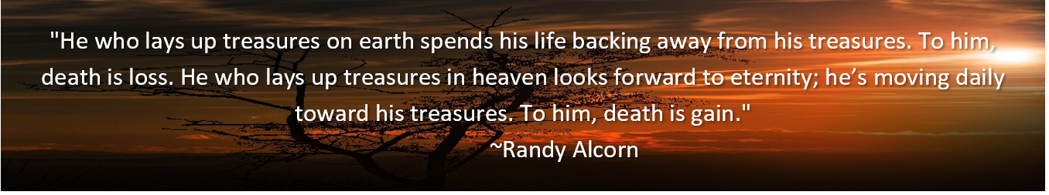

Sermon summary contributed by Anthea.

