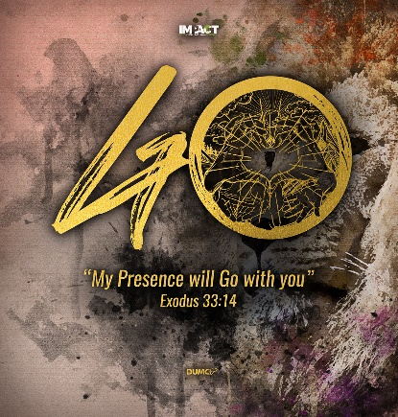
The Apostles’ Creed ll
God the Father Almighty, Creator of Heaven and Earth
(Mathew 3:16-17, Acts 17: 24-28)
Senior Pastor Chris Kam
As soon as Jesus was baptized, he went up out of the water. At that moment heaven was opened, and he saw the Spirit of God descending like a dove and alighting on him. And a voice from heaven said, “This is my Son whom I love; with him I am well pleased.” (Mathew 3:16-17)

“The God who made the world and everything in it is the Lord of heaven and earth and does not live in temples built by human hands. And he is not served by human hands, as if he needed anything. Rather, he himself gives everyone life and breath and everything else. From one man he made all the nations, that they should inhibit the whole earth; and he marked out their appointed times in history and the boundaries of their lands. God did this so that they would seek him and perhaps reach out for him and find him, though he is not far from anyone of us. For in him we live and move and have our being.” As some of your own poets have said, ‘We are his offspring.’ (Ac17:24-28)

Introduction
After recapping on the first in the series of The Apostles’ Creed – I believe In, in which he reminds us that we are what we believe in, Pastor Chris mentions that Man has always believed in ‘god’ as seen in history of the many Greek ‘gods’ that they worshipped during ancient times and God was named the Unknown God by Man. Yet today we are blessed to have the Apostles’ Creed as the sacramental liturgy for water baptism and to guide us. Even today in the current crisis the world is facing of the uncertainty of life, we are privileged to have the Apostles’ Creed as our Guide. Yet, today we can call God ‘Abba ’which means father or daddy as He want to have an intimate relationship with us. In the next nine sermons we will examine the object of our faith: Father, Son & Holy Spirit.

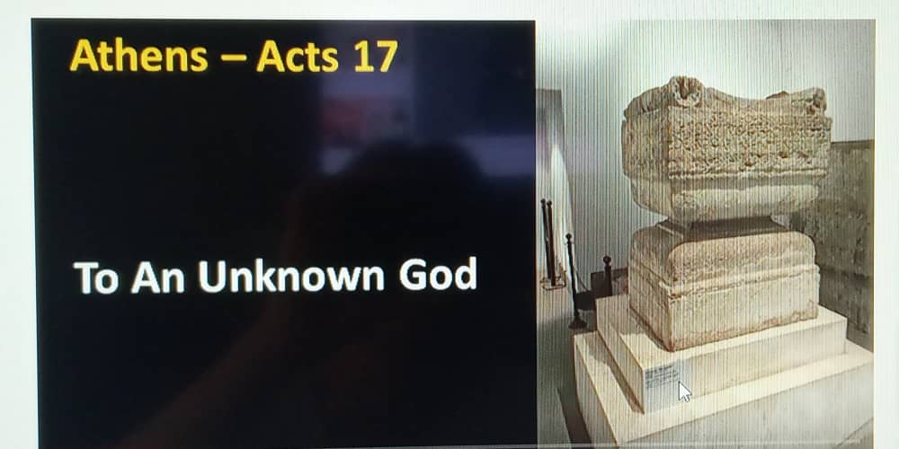

BIG IDEA
The Infinite God who invite me to Intimacy

Who is this God who is infinitely powerful yet intimately personal?

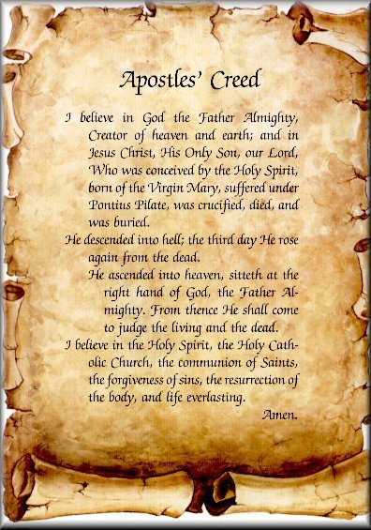
THE APOSTLES’ CREED

I Believe in God, the Father Almighty,
Creator of heaven and earth,

I Believe in Jesus Christ, His Only Son, our Lord,
who was conceived by the Holy Spirit,
born of the Virgin Mary,
suffered under Pontius Pilate,
was crucified, died, and was buried;
the third day He rose again from the dead.
He ascended into heaven,
is seated at the right hand of the Father,
and will come again to judge the living and the dead.

I Believe in The Holy Spirit,
the holy catholic* church,
the communion of saints,
the forgiveness of sins,
the resurrection of the body,
and the life everlasting.
Amen.
*universal

There are three aspects of God the Father Almighty

The Trinitarian God
God is One and yet Three. It is a mystery. God exists as Father, Son and Holy Spirit.

As the Father, he creates everything. As the Son he died for our sins. As the Holy Spirit, he lives in all who welcomes him into their lives and regenerates a new person in him. We worship a God who is constant and eternal. Love and community has already existed in the Trinity and we are made in His image and to relate to him.

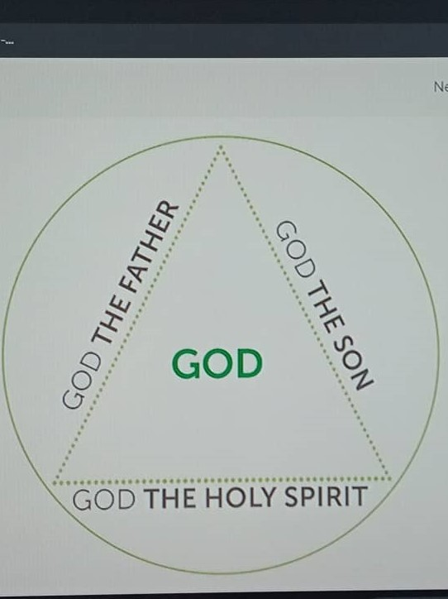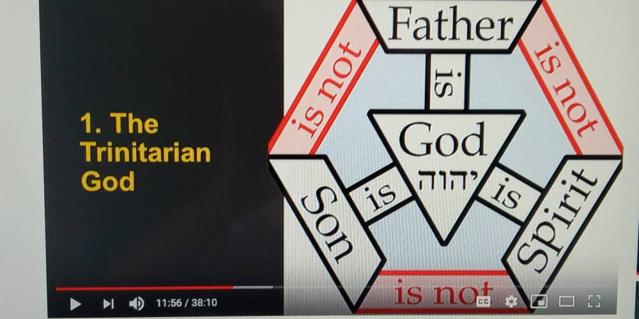

Therefore go and make disciples of all nations, baptizing them in the name of the Father and of the Son and of the Holy Spirit. (Mathew 28:19)

The Creator God

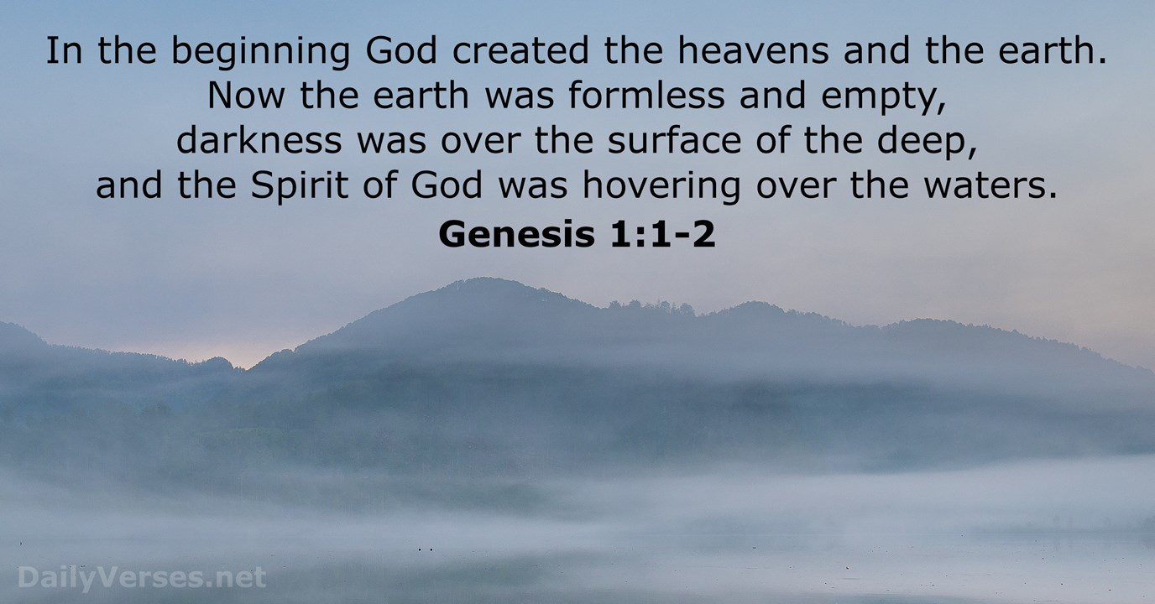
God made the entire Universe, the most complex to the most minute are made by him.

And he is not served by human hands, as if he needed anything. Rather he himself gives everyone life and breath and everything else. (Acts 17:25)

From one man he made entire nations. He is the Lord of history, we are here by his purpose. He is powerful and omnipresent. He is powerful yet restorative, redemptive, personal and passionate.
So worship Him.

From one man he made all the nations, that they should inhabit the whole earth; and he marked out their appointed times in history and the boundaries of their lands. (Acts 17:26)

Benevolent dictatorship comes from Him not only above us, but alongside us and within us. So, we must be concerned about Creation care to honour him. He is in Control.

‘For in him we move and live and have our being.’ (Acts 17:28)

The Father God
We have a big Father God who we can hold on to. Even though we may have disappointments about our own earthly Father, yet we have our Heavenly father who we can hold on to. He is the Intimate God.

We are adopted by our Heavenly Father, chosen and who loves us unconditionally.

For those who are led by the Spirit of God are the children of God…. the Spirit you received brought about your adoption to sonship. And by him we cry, “Abba Father.” (Romans 8:14-15)

We can turn to Him in all circumstances. We also have the Holy Spirit who will always be with us.

“Which of you fathers, if your son asks for a fish, will give him a snake instead? Or if he asks for an egg, will give him a scorpion? If you then, though you are evil, know how to give good gifts to your children, how much more will your Father in heaven give the Holy Spirit to those who ask him!” (Luke 11:11-13)

Conclusion
No matter what we go through in life, we have our Heavenly Father who is the Creator God, the all-powerful Infinite God, the Intimate God who wants us and loves us so deeply whom we can surrender it to Him and have His Peace.

Are we still like the ancient Greeks or do we want to have intimacy with our God the Creator?

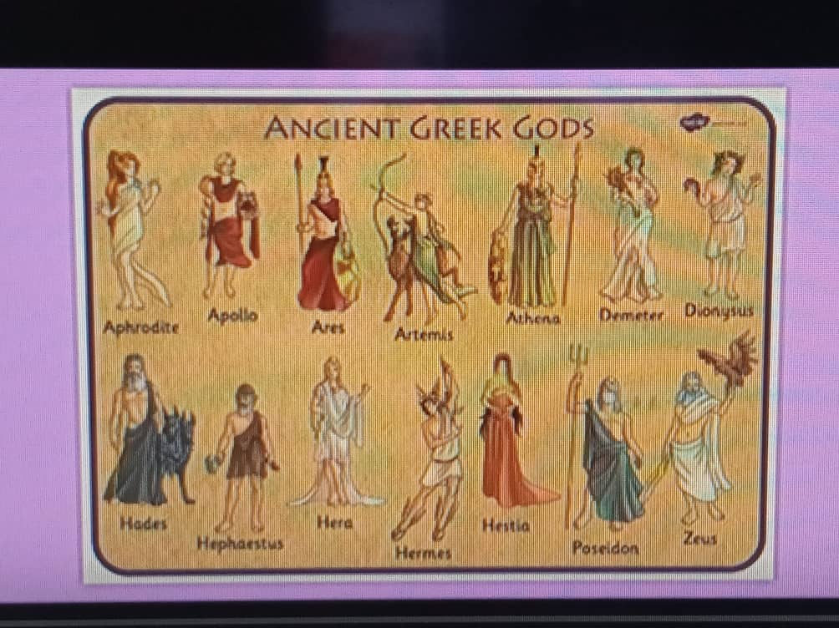

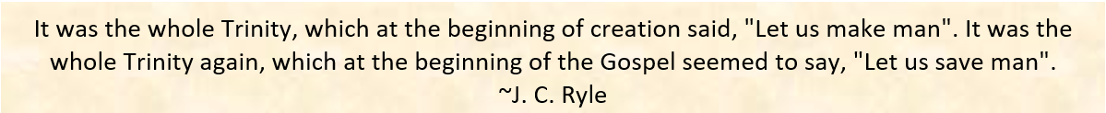

Sermon summary contributed by Michelle Chuah

