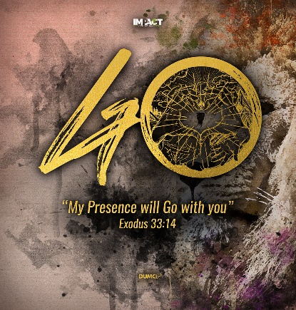
The Unexpected Transforming Encounter with Jesus
(Luke 24:13-35)
Senior Pastor Chris Kam

Now that same day two of them were going to a village called Emmaus, about seven miles from Jerusalem. They were talking with each other about everything that had happened. As they talked and discussed these things with each other, Jesus himself came up and walked along with them; but they were kept from recognizing him.
He asked them, “What are you discussing together as you walk along?”
They stood still, their faces downcast. One of them, named Cleopas, asked him, “Are you the only one visiting Jerusalem who does not know the things that have happened there in these days?”
“What things?” he asked.
“About Jesus of Nazareth,” they replied. “He was a prophet, powerful in word and deed before God and all the people. The chief priests and our rulers handed him over to be sentenced to death, and they crucified him; but we had hoped that he was the one who was going to redeem Israel. And what is more, it is the third day since all this took place. In addition, some of our women amazed us. They went to the tomb early this morning but didn’t find his body. They came and told us that they had seen a vision of angels, who said he was alive. Then some of our companions went to the tomb and found it just as the women had said, but they did not see Jesus.”
He said to them, “How foolish you are, and how slow to believe all that the prophets have spoken! Did not the Messiah have to suffer these things and then enter his glory?” And beginning with Moses and all the Prophets, he explained to them what was said in all the Scriptures concerning himself.
As they approached the village to which they were going, Jesus continued on as if he were going farther. But they urged him strongly, “Stay with us, for it is nearly evening; the day is almost over.” So he went in to stay with them.
When he was at the table with them, he took bread, gave thanks, broke it and began to give it to them. Then their eyes were opened and they recognized him, and he disappeared from their sight. They asked each other, “Were not our hearts burning within us while he talked with us on the road and opened the Scriptures to us?”
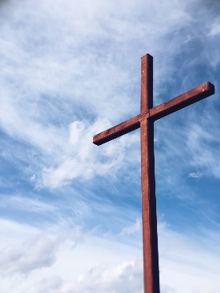
They got up and returned at once to Jerusalem. There they found the Eleven and those with them, assembled together and saying, “It is true! The Lord has risen and has appeared to Simon.” Then the two told what had happened on the way, and how Jesus was recognized by them when he broke the bread. ( Luke 24: 13-35)

Introduction

This is our first Easter at home. Pr. Chris encourages us to welcome the Holy Spirit to be with us in our homes. Millions have often experienced Jesus unexpectedly. The world after COVID 19 will be different. 2000 years ago, Jesus changed the world. The three simple truths of a Christian is “Christ has died. Christ has risen. Christ will come again.”

BIG IDEA: Christ has died. Christ has risen. Christ will come again.

Christ Has Died

Now that same day two of them were going to a village called Emmaus, about seven miles from Jerusalem. They were talking with each other about everything that had happened. (Luke 24:13-14)

He asked them, “What are you discussing together as you walk along?” They stood still, their faces downcast. One of them, named Cleopas, asked him, “Are you the only one visiting Jerusalem who does not know the things that have happened there in these days?” (Luke 24:17-18)

Two disciples were walking about 11km. This is the distance from PJ to Shah Alam. They were sure that Jesus was going to save them from the Romans. They felt hopeless because Jesus has died. And Jesus pretend to be a stranger and asked them

“What things?” he asked. “About Jesus of Nazareth,” they replied. “He was a prophet, powerful in word and deed before God and all the people. The chief priests and our rulers handed him over to be sentenced to death, and they crucified him; but we had hoped that he was the one who was going to redeem Israel.” (Luke 24:19-21)
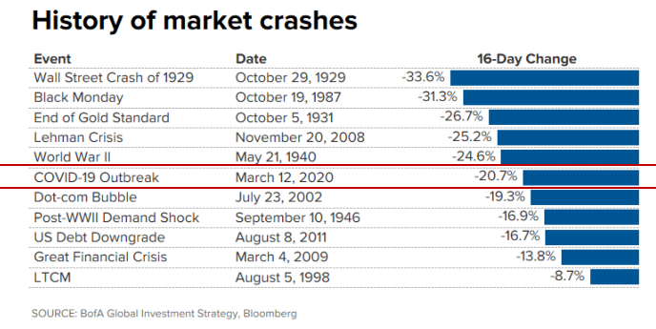

Are you confused and lacking hope? What are the changes as the going on? COVID 19 records one of the biggest market crashes of the country. Billions of dollars have been lost. Malaysia is one of the Top 15 economies affected. USA is expecting 6.65 million people who are unemployed. Nobody expected to live in such a situation for such a time as this.

Note: Post-COVID-19 Economic charts can be downloaded here: https://bit.ly/dumc-charts
we treat God like

He said to them, “How foolish you are, and how slow to believe all that the prophets have spoken! Did not the Messiah have to suffer these things and then enter his glory?” And beginning with Moses and all the Prophets, he explained to them what was said in all the Scriptures concerning himself. (Luke 24:25-27)

For what I received I passed on to you as of first importance: that Christ died for our sins according to the Scriptures (1 Cor 15:3)

Christ died for our sins. It is like a firefighter that broke into a fire, sacrifice himself to save the victims. Christ had to die to save us.

Christ Has Risen

Now that same day two of them were going to a village called Emmaus, about seven miles from Jerusalem. They were talking with each other about everything that had happened. As they talked and discussed these things with each other, Jesus himself came up and walked along with them; but they were kept from recognising him. (Luke 24:13-16)

The two disciples were together and was there for each other. They were walking, comforting and encouraging each other during this 11km journey. They didn’t event recognize Jesus he was walking with them. They only recognize him when he broke bread. Jesus appreared to more than 500 people when he was risen. When he is lifted up, he said that he will send the Holy spirit. He was both human and divine at this time.

“Christianity is in its essence a resurrection religion. The concept of resurrection lies at its heart. If you remove it, Christianity is destroyed” Dr John Stott

And if Christ has not been raised, your faith is futile; you are still in your sins. (1 Cor 15:17)

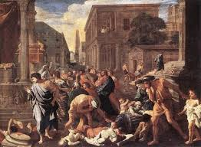
We have a privilege to see how the church has raise up in such a time as this. “The Rise of Christianity” by Rodney Stark highlights how the Church has rose to major events. During the Plague of Cyprian (249-262 AD), at the height of the plague, it was killing up to 5000 people a day in Rome. The Bishop of Alexandria, Dionysius wrote the following.

“Heedless of danger, they took charge of the sick, attending to their every need and ministering to them in Christ, and with them departed this life serenely happy; for they were infected by others with the disease, drawing on themselves the sickness of their neighbours and cheerfully accepting their pains.” - The Bishop of Alexandria, Dionysius:

The Bishop of Alexandria continued to write about those who were not believers:

“But with the heathen everything was quite otherwise. They deserted those who began to be sick, and fled from their dearest friends. They shunned any participation or fellowship with death; which yet, with all their precautions, it was not easy for them to escape.” -The Bishop of Alexandria, Dionysius

“Plagues intensify the natural course of life. They intensify our own sense of mortality and frailty. They also intensify opportunities to display counter-cultural, counter-conditional love. Plagues were a huge factor in growing the Christian faith from an obscure and marginal movement to representing around 6 million believers by AD300.” - The Bishop of Alexandria, Dionysius

We are not in control but God is.

Christ will come again

They got up and returned at once to Jerusalem. There they found the Eleven and those with them, assembled together and saying, “It is true! The Lord has risen and has appeared to Simon.” Then the two told what had happened on the way, and how Jesus was recognised by them when he broke the bread. (Luke 24:33-34)

Up to that point they didn’t recognize him until Jesus broke the bread. Jesus became a divine human. We will receive this body when we meet Him someday. There are countless stories from ppl of other faith and see a person in white.

A person in Malaysia has encountered transformation in Jesus. He was a gangster who was at his prime and making money smuggling people from China. When he came out of prison after 15 years, he had no life and direction. He then attended alpha when he met his cousin. He was impressed people were welcoming to him in church. He accepted Christ during the weekend away when an elder told him that God has forgiven him. He felt so light and his burden lifted. He is now determined to share God’s love with others.

Christians put their hope to the world that is to come.

They were looking intently up into the sky as he was going, when suddenly two men dressed in white stood beside them. “Men of Galilee,” they said, “why do you stand here looking into the sky? This same Jesus, who has been taken from you into heaven, will come back in the same way you have seen him go into heaven.” (Acts 1:10-11)

Sermon summary contributed by Abbey Thangiah.

