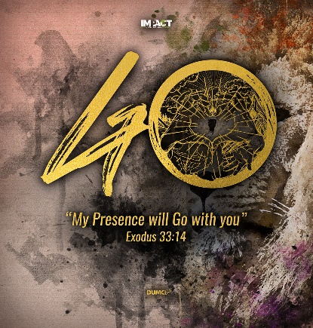
Apostles’ Creed III: I Believe in Jesus Christ, His Only Son, our Lord.
Matt 16:13-16, Hebrews 1:3, Romans 10:9)
Senior Pastor Chris Kam
When Jesus came to the region of Caesarea Philippi, he asked his disciples, “Who do people say the Son of Man is?” They replied, “Some say John the Baptist; others say Elijah; and still others, Jeremiah or one of the prophets.” “But what about you?” he asked. “Who do you say I am?” Simon Peter answered, “You are the Messiah, the Son of the living God.” (Matthew 16:13-16)
The Son is the radiance of God’s glory and the exact representation of his being, sustaining all things by his powerful word. After he had provided purification for sins, he sat down at the right hand of the Majesty in heaven. (Hebrews 1:3)
If you declare with your mouth, “Jesus is Lord,” and believe in your heart that God raised him from the dead, you will be saved. (Romans 10:9)

THE APOSTLES’ CREED

I Believe in God, the Father Almighty,
Creator of heaven and earth,
I Believe in Jesus Christ, His Only Son, our Lord,
who was conceived by the Holy Spirit,
born of the Virgin Mary,
suffered under Pontius Pilate,
was crucified, died, and was buried;
the third day He rose again from the dead.
He ascended into heaven,
is seated at the right hand of the Father,
and will come again to judge the living and the dead.
I Believe in The Holy Spirit,
the holy catholic* church,
the communion of saints,
the forgiveness of sins,
the resurrection of the body,
and the life everlasting.
Amen.
BIG IDEA: Jesus the Christ, the Son, Our Lord

Introduction
There are many different views on who Jesus Christ is – a religious teacher, a greatest man on Earth, and a historical figure. Jesus asked his disciples the same thing.
Now when Jesus came into the district of Caesarea Philippi, he asked his disciples, “Who do people say that the Son of Man is?” And they said, “Some say John the Baptist, others say Elijah, and others Jeremiah or one of the prophets.” He said to them, “But who do you say that I am?” Simon Peter replied, “You are the Christ, the Son of the living God.” (Matthew 16:13-16, ESV)
Are you confused with what people are claiming about Him? If Jesus were to ask you these questions, how would you answer him?
The second line of the Apostles’ Creed reads, “I Believe in Jesus Christ, His Only Son, our Lord,”
In it, are 3 attributes on who Jesus is:

Jesus the Christ
I Believe in Jesus Christ, His Only Son, our Lord.

“Jesus” was a human name given to his mother, Mary by angel, Gabriel. “Christ” is a title. Christ, or Christos in Greek, is the equivalent of a Hebrew term, “Messiah,” which means the anointed or chosen one. It signifies that Jesus was sent from God to be a king, a saviour and deliverer. It was mentioned more than 500 times in the New Testament.
In ancient Israel, when someone was given a position of authority (such as kings, priests and prophets), oil was normally poured on his head to indicate that he has been set apart for God’s service.
Oil symbolizes the Holy Spirit. In other words, Jesus, the anointed one, is divinely appointed, commissioned and accredited as the saviour of the world. Jesus was anointed by his Father during his water baptism by John the Baptist.
… how God anointed Jesus of Nazareth with the Holy Spirit and power, and how he went around doing good and healing all who were under the power of the devil, because God was with him. (Acts: 10:38)
There are many prophetic verses in the Old Testament that refers to the coming messiah who would deliver his people, but ancient Israel though their messiah would come with military might to deliver them from captivity and earthly powers. Jesus is the better deliverer who can saved us from the power and penalty of sin to live in true freedom and the eternal kingdom.
In other religions, man try to make peace with God. In Christianity, God took the initiative to make peace with man, through His Son. He came as human form to identify with us. He came as Christ to deliver us - mankind needed to be saved and rescued.
“I am the way and the truth and the life. No one comes to the Father except through me.” (John 14:6)

Today, there is a pandemic of sin which incurs the wrath of God and eternal punishment. Only Christ can save us from this pandemic of sin.
The Implications:
H has delivered us from the power of darkness – ‘we lost it all’.
Salvation is found by grace alone through faith in Christ and not by our works, meaning that we cannot save ourselves. The work of saving is completely accomplished by our Lord and Saviour. We are to live in freedom in Him and no longer under the slavery of sin. – ‘He did it all’.
We can see transformations in the lives of people. When filled with the Holy Spirit, people are able to overcome addictions like smoking, anger, anxiety, and illnesses. Spiritual changes led to physical changes in their lives. We can now say no, to sin. – ‘we gain it all’.

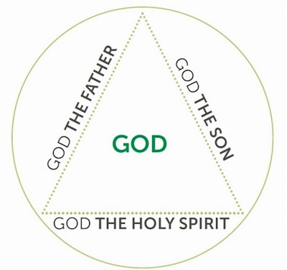
Jesus the Son
I Believe in Jesus Christ, His Only Son, our Lord.

Jesus is the only son of God. “Only” indicates that He has an exclusive and unique relationship with God, the Father. No other has such father-son relationship.
Jesus is God incarnate in human form in the virgin birth; and divine.
- Jesus is human because he can be tired, stressed and angry. He has cried. He was happy, and sad. He expressed a whole range of emotions. As a man, he was able to fully represent all of humanity to God. His lived a life of obedience to his Father by making an offering / sacrifice of his life (acceptable on behalf of all who trust in Him).
- Jesus is divine because he demonstrated the power of healing, deliverance, prophecy and acknowledged who God is but he limited himself and gave up his rights while on earth. He took on the role of a servant and was obedient to death on the cross.
To the Jews, Jesus claimed to be the son of God. It was tantamount to blasphemy. To blaspheme against God was to say that he has the same nature as God and can be put to death. In that sense, as Jesus revealed himself as the Father, he is the revelation of who God is. Knowing God is not a matter of self-discovery. We can only know God when God reveals himself through his Son, in Scripture.
… Anyone who has seen me has seen the Father… (John 14:9)
The Son is the radiance of God’s glory and the exact representation of his being, sustaining all things by his powerful word. After he had provided purification for sins, he sat down at the right hand of the Majesty in heaven. (Hebrews 1:3)

Because you are his sons, God sent the Spirit of his Son into our hearts, the Spirit who calls out, “Abba, Father.” So you are no longer a slave, but God’s child; and since you are his child, God has made you also an heir. (Galatians 4:6-7)

The Implications:
As children of God, we are adopted into his spiritual family. We are accepted and loved by God. We are not alone anymore. We can have an intimacy and relate to Him. He understands what it is to be human.
For we do not have a high priest who is unable to empathize with our weaknesses, but we have one who has been tempted in every way, just as we are—yet he did not sin. Let us then approach God’s throne of grace with confidence, so that we may receive mercy and find grace to help us in our time of need. (Hebrews 4:15-16)

(John 5:19) … “Very truly I tell you, the Son can do nothing by himself; he can do only what he sees his Father doing, because whatever the Father does the Son also does.

How well do we know our Father, his heart and his will for our lives? We need to pursue our Father as Jesus modelled to us on how he pursued his father.

Jesus the Lord
I Believe in Jesus Christ, His Only Son, our Lord.
“Our” = the corporation declaration by the church.
C.S. Lewis brought up an argument, a trilemma of who Jesus is – liar, lunatic, the Lord.
If Jesus is not God | - Liar  - Lunatic | - Lying deliberately to the world, making him a hypocrite and a fool for dying on the cross.  - Believing in something that he is not; sincerely deluded
If Jesus is God | - The Lord | - We have to accept everything that he said about himself.
There are only 2 choices – accept or reject Him.
Fundamental confession of the Christian faith in the New Testament, was not that Jesus is Saviour but that He is Lord.
If you declare with your mouth, “Jesus is Lord,” and believe in your heart that God raised him from the dead, you will be saved. (Romans 10:9)

In Jesus’ time, to be declared Lord is treason because only Caesar was both saviour and Lord. Those were the meaning carried by Caesar’s title. The Roman Empire was not opposed to Christianity as a religion, but the authorities could not accept that Jesus’ disciples declared him as their Lord. Jesus is Lord means that he is God, the Lord Supreme, the King of Kings, and the Lord of Lords.

The Supremacy of the Son of God
The Son is the image of the invisible God, the firstborn over all creation. For in him all things were created: things in heaven and on earth, visible and invisible, whether thrones or powers or rulers or authorities; all things have been created through him and for him. He is before all things, and in him all things hold together. And he is the head of the body, the church; he is the beginning and the firstborn from among the dead, so that in everything he might have the supremacy. For God was pleased to have all his fullness dwell in him, and through him to reconcile to himself all things, whether things on earth or things in heaven, by making peace through his blood, shed on the cross. (Colossians 1:15-20)

Whether people acknowledge it or not, He is Lord!

There is a phrase that goes: “The Bible says it. I believe it. That settles It.”
Where truth is concern, it is not whether you believe it or not.

A better phrase would be: “The Bible says it. That settles it.”
This Lord is coming back again as king and judge.

For we must all appear before the judgment seat of Christ, that each one may receive what is due him for the things done while in the body, whether good or bad. (2 Corinthians 5:10)
The Implications:
If Jesus is who he says he is, how will that change the way we live our lives?
- It will cost us
- It is not a mere convenient religion to get us into heaven. It may make us uncomfortable about our past and present. It may change our values, ethics, practices, ambition, lifestyle etc. We have to love Jesus more than any other.
Large crowds were traveling with Jesus, and turning to them he said: “If anyone comes to me and does not hate father and mother, wife and children, brothers and sisters—yes, even their own life—such a person cannot be my disciple. And whoever does not carry their cross and follow me cannot be my disciple. (Luke 14:25-27)

- It will question our allegiance
- If Jesus is not Lord of all, he is not Lord at all. There are no in-betweens, no other in our lives. Christ has paid the price for our sins with his life, wouldn’t we remain loyal to him?
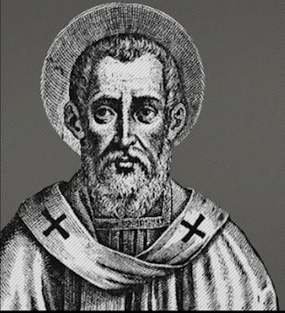
- Saint Polycarp (69-156 AD), a bishop of Smyrna, was persecuted to death by the church of the Roman Empire. At 86, he was arrested for refusing to submit to Caesar. At his trial, he was required to place a pinch of incense into a bowl before the statue of Caesar. Polycarp said, “Eighty and six years have I served Christ, and he never did me any injury: how then can I blaspheme my King and my Saviour?” Polycarp was then tortured. When they wanted to nail him to a stake to avoid him from running away. Polycarp stopped them and said, “Leave me as I am. For he who grants me to endure the fire will enable me also to remain on the pyre unmoved, without the security you desire from nails.” He then burned to death. He was willing to die for the sake of Christ.

- It will compel us to submission
- “Why do you call me, ‘Lord, Lord,’ and do not do what I say?” (Luke 6:46)
- It is not whether the call to discipleship fits our convenience, but rather that we submit to his will. We come with open palms. Everything we have belongs to God. We come with nothing and we leave with nothing.

- It will release us into joy
- Believing in Jesus is marked by joy, even in the midst of suffering and persecution. In Christ, we can see beyond the world’s brokenness to the eternal spiritual reality. We have hope for today. Our joy is made complete in Him.

Conclusion
How do we apply these truths in the Covid-19 pandemic? We are not alone in the fears, anxieties, stresses and concerns of these uncertain days. We have been denied our means to support and strength to live ordinarily and of the ability to have regular fellowship and encouragement.
May you, in these uncertainties, turn your eyes with certainty to Jesus and proclaim, “I believe in Jesus Christ, His Only Son, our Lord.”

If we live, we live for the Lord; and if we die, we die for the Lord. So, whether we live or die, we belong to the Lord. For this very reason, Christ died and returned to life so that he might be the Lord of both the dead and the living. (Romans 14:8-9)
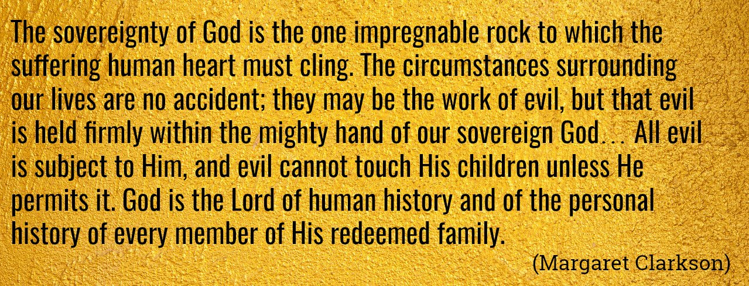
Sermon summary contributed by Wendy ML Tan

