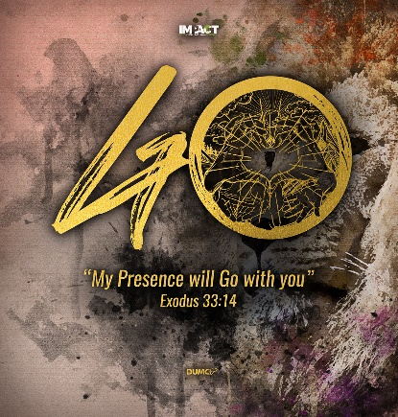
Jesus: From Cradle to Grave (Philippians 2:6-8)
Pastor Mike Ngui
Who, being in very nature God, did not consider equality with God something to be used to his own advantage; rather, he made himself nothing by taking the very nature of a servant, being made in human likeness. And being found in appearance as a man, he humbled himself by becoming obedient to death – even death on a cross! (Philippians 2:6-8, NIV)

THE APOSTLES’ CREED

I Believe in God, the Father Almighty,
Creator of heaven and earth,
I Believe in Jesus Christ, His Only Son, our Lord,
who was conceived by the Holy Spirit,
born of the Virgin Mary,
suffered under Pontius Pilate,
was crucified, died, and was buried;
the third day He rose again from the dead.
He ascended into heaven,
is seated at the right hand of the Father,
and will come again to judge the living and the dead.
I Believe in The Holy Spirit,
the holy catholic* church,
the communion of saints,
the forgiveness of sins,
the resurrection of the body,
and the life everlasting.
Amen.

BIG IDEA: Jesus lived and died in obedience to the Father, for our sake.

Introduction
The Apostles’ Creed has been around since 4th century AD. Old does not mean obsolete but rather a testament of its lasting value.

What is the Apostles’ Creed?
It is a corporate confession of ancient faith passed down through the ages that unites all Christians past and present. It is
- A basic testament and test of what a Christian believes; irrespective of denomination and background.
- A teaching framework or the disciples teaching as described in Acts 2.
- Basic truths that shape our world views and behaviours when living out its implications.
Why should Jesus Christ be our Lord and Saviour?
Jesus is the price, the waited Messiah, and He is Lord and Saviour above all else. Jesus’ disciples pledged ultimate allegiance to Jesus.

For Christians of today, there are 2 main reasons why He is worthy to be called our Lord and Saviour:

Jesus the son of God came to live as a man

If one denies the virgin birth, because it is a miracle, then we would also have to deny His resurrection. Without the virgin birth at Christmas, there is no resurrection at Easter.
We do not get to pick and choose which part of Christianity to accept.

All Joseph and Mary could do was to surrender and submit to God’s redemptive plan set in motion by the conception and birth of Jesus.

And Mary said, “Behold, I am the servant of the LORD; let it be to me according to your word.” And the angel departed from her. (Luke 1:38, ESVUK)

The implication:
Our challenge is to embrace both his divinity and humanity. He is more like us than we like to admit. Coming into humanity, he took on all the limitations of human experience.

Jesus conception was supernatural

who was conceived by the Holy Spirit,
born of the Virgin Mary,
suffered under Pontius Pilate,
was crucified, died, and was buried;

Jesus’ origin is divine. His conception was supernatural by the power of the Holy Spirit. It is not resulting from sexual union, human actions or choices.

“How will this be,” Mary asked the angel, “since I am a virgin?”. The angel answered, “The Holy Spirit will come to you, and the power of the Most High will overshadow you. So the holy one to be born will be called the Son of God. (Luke 1: 34,35).

In the Gospel according to Matthew, the writer stressed that Joseph had nothing to do with the birth of Jesus. Joseph thought to quietly divorce Mary and it took an angel of the LORD to convince him to do otherwise.

This is how the birth of Jesus the Messiah came about: His mother Mary was pledged to be married to Joseph, but before they came together, she was found to be pregnant through the Holy Spirit. (Matt 1:18)

Jesus birth was natural

who was conceived by the Holy Spirit,
born of the Virgin Mary,
suffered under Pontius Pilate,
was crucified, died, and was buried;

Both Matthew and Luke underscored that Jesus was given birth to by Mary.

This is how the birth of Jesus the Messiah came about: His mother Mary was pledged to be married to Joseph, but before they came together, she was found to be pregnant through the Holy Spirit…But he did not consummate their marriage until she gave birth to a son. And he gave him the name Jesus. (Matthew 1:18,25)
While they were there, the time came for the baby to be born, and she gave birth to her firstborn, a son… (Luke 2:6,7a)

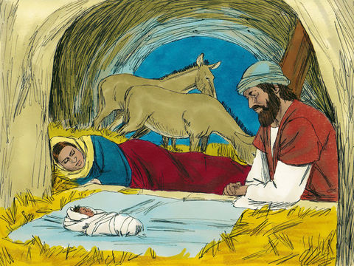
Contrary to the extravagant images portrayed at Easter, Jesus’ birth was uneventful except for the fact that he was born in a manger. He was born into the world crying just like millions of babies before and billions after.

He did not come into this world to live in a bubble - quarantined from human experience. He came into this world like us, with all the limitations of hunger, thirst, tiredness, plagues, epidemics and all other real human experiences.

Jesus the son of God came to die as a man

who was conceived by the Holy Spirit,
born of the Virgin Mary,
suffered under Pontius Pilate,
was crucified, died, and was buried;

The creed highlights not just the death, but also the breadth of Jesus’ human experience – from cradle to grave. He was born human even though of divine conception, suffered and died.

The church, throughout history, has maintained the historical fact of Jesus trial, crucifixion, death and burial. The Creed reaffirms by the Gospel accounts that Jesus was tortured, crucified and verified dead by Roman officials (cross reference Matt 27, Mark 15, Luke 23, John 18,19).

The implication:
We celebrate the depth of God’s love for the world by the Good Friday sacrifice of His son on the cross. The cross, the instrument of Jesus’ death has become the symbol of our salvation!

Jesus lived and died as a man in history

Jesus is a real historical figure. There are historical accounts in the Gospel that state the events of Jesus’ ministry and his death especially referencing Pilate. The writers were not writing a fictional story or mythology but reporting historical events with verifiable facts!

In the fifteenth year of the reign of Tiberius Caesar – when Pontius Pilate was governor of Judea, Herod tetrarch of Galilee, his brother Philip tetrarch of Iturea and Traconitis, and Lysanias tetrarch of Abilene – during the priesthood of Annas and Caiaphas.. (Luke 3:1,2a)

Finally Pilate handed him over to them to be crucified. (John 19:16)

It is not a romanticized story, it happened in history. It happened on a hill in Jerusalem on a wooden cross where Jesus died. He was tortured, crucified and died. Roman soldiers pierced His side to verify He was dead. Anyone found still alive would have had their legs broken to accelerate the asphyxiation cause of death on the crucifix.

Jesus lived and then died on a cross; and it offends man

The Greeks think it utter foolishness that an all-powerful God should condescend as a man (a weak one at that) and then unjustly killed. That is a rather poor God as far as they were concerned.
Some are offended by the seemingly abusive theology that God would allow His only son to suffer abuse. Still others, having a sentimental view of God, feel that He should love and cuddle us but not take definitive steps to bring divine justice into the world.

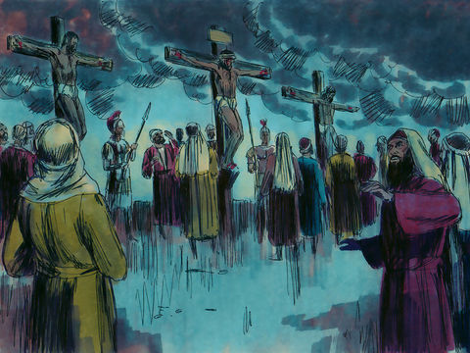
The Christian view is that Jesus was cursed and crucified that God’s justice against humanity’s sin would be dispensed. Jesus was there in our place, making atonement for our sins and displacing God’s wrath from us.

“The Son of God…loved me and gave himself for me”; (so) “God forbid that I should glory, save in the cross of our Lord Jesus Christ”. (Galatians 2:20; 6:14)

May I never boast except in the cross of our Lord Jesus Christ, through which the world has been crucified to me, and I to the world. (Galatians 6:14)

Jesus died, He really died! That He was buried is a statement of finality of human death. As those who have lost loved ones know that death feels final when the casket is covered by dirt or when it disappears behind the doors of a crematorium fire.

But we do see Jesus, who was made lower than the angels for a little while, now crowned with glory and honor because he suffered death, so that by the grace of God he might taste death for everyone. (Hebrews 2:9)

He lived as for 33 years as a human being, going through the human passages of puberty, adolescents and adulthood. He knew the hunger of physical tiredness, hunger, thirst, bitter disappointments, material life and social unrest of an oppressed populace. He also suffered injustice and finally death.

He can sympathize with our weaknesses because he lived a human life and died a human death and yet, he did not sin even when tempted in every way.

For we do not have a high priest who is unable to feel sympathy for our weakness, but we have one who has been tempted in every way, just as we are – yet he did not sin. (Hebrews 4:15)

He did not yield to temptation but chose to obey the Father in everything.

Jesus gave them this answer: “Very truly I tell you, the Son can do nothing by himself; he can do only what he sees his Father doing, because whatever the Father does the Son also does. (John 5:19)

Son though he was, he learned obedience from what he suffered. (Hebrews 5:8)

Conclusion

Why was it necessary for Jesus to live a human life of obedience to God?
It is so that he can be our victorious saviour, not just by account of His divine nature but also on account of his human life of 33 years. Living every single day in total obedience to God.

The implication:
We, as people saved and born again, are to live in obedience to God through Jesus Christ, His only son and our LORD. Whenever we recite the creed, it reminds us that we are saved by grace through faith, to live a new life of obedience to God, just like Jesus did.

The challenge for Christians today is to live each day in active obedience to God. This active obedience requires that we know our God and His ways. We are encouraged to read, study and reflect on God and His Word for it is through knowing His Word that we know God. There are many ways to do that, for example, joining Equip class to study with others, signing up for RightNowMedia to make use of the wealth of available study videos or by setting up a Zoom bible study.

Jesus has given us the power to live in obedience to God. We are called to live a life of obedience, submission and yieldedness to God so that we may be able to say like Mary - “Be unto me according to your will”.

God knows, through Christ, what it is like to be tempted and tested in trials of human experience. He also knows what is like to suffer. When we pray, we can be confident that God understands our situation because Jesus lived and died as a human being. Jesus has been through it all and experienced it first-hand. So we know that we have a God who we can approach and trust because He knows and understands our weaknesses.

Let us then approach God’s throne of grace with confidence, so that we may receive mercy and find grace to help us in our time of need. (Hebrews 4:16)

Sermon summary contributed by Darren Lim.

