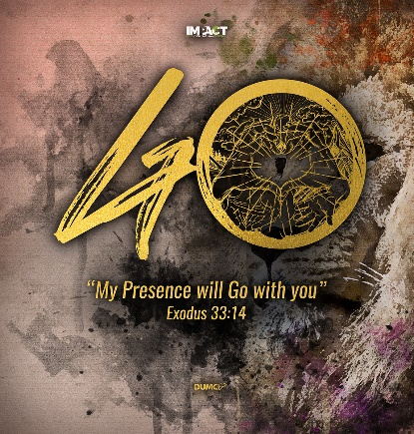
Church Gathered & Scattered: IMPACT Here and Now
Luke 24:46-49
Pastor Kelvin Yong

He told them, “This is what is written: The Messiah will suffer and rise from the dead on the third day, and repentance for the forgiveness of sins will be preached in his name to all nations, beginning at Jerusalem. You are witnesses of these things. I am going to send you what my Father has promised; but stay in the city until you have been clothed with power from on high.” (Luke 24:44-49)

BIG IDEA: IMPACT is a call to go, but it starts where we are.

Introduction
This year is the year of IMPACT. The goal of IMPACT is to mobilise the cell groups for community outreach.

Despite our current situation in light of the MCO and the covid-19 pandemic, the goal of IMPACT has not changed. We can still chase the lion. We can still do something that we have not done before, such as gathering as a church online; and if the situation permits, we can go somewhere where we have not gone before.

God is a big God who is in control and has a plan and purpose in all that is happening. We are to align ourselves to what He wants to do in us and through us.

IMPACT is a missional call, a reflection of the Great Commission. It reflects who we are (our identity) and what we are called to (our purpose) as a church.

THREE ASPECTS OF THE CHURCH
- The Church Founded
- The Church Gathered
- The Church Scattered

The Church Founded

Jesus is the founder of His church
Jesus Himself said that He will build His church. He is the builder and founder of the church, and the church belongs to Him.

And I tell you that you are Peter, and on this rock I will build my church... (Matthew 16:18)

Christ is also the head of the church, which is his body. (Colossians 1:18a NLT)

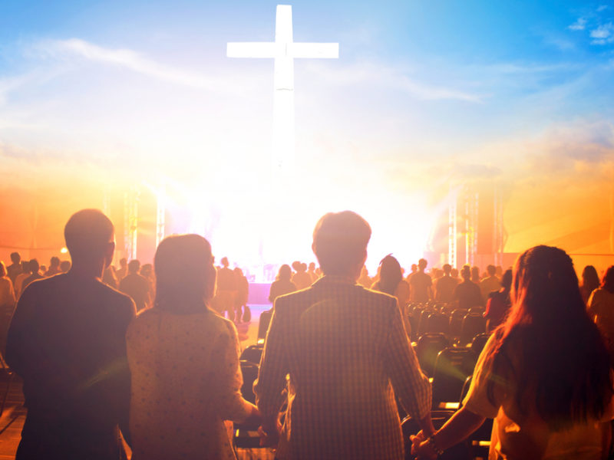
He is the head of the church, which is His body. Only Jesus is the head of the church, and He builds the church through the process of redeeming sinners like you and me by His sacrifice on the cross and the atonement of their sins.

He told them, “This is what is written: The Messiah will suffer and rise from the dead on the third day, and repentance for the forgiveness of sins will be preached in his name... (Luke 24:46-47)

Jesus took our place on the cross so that we can take our place in the church that He founded.

Jesus is the foundation of His church
And I tell you that you are Peter, and on this rock I will build my church... (Matthew 16:18)

The rock that Jesus was referring to can be understood when we go back a few verses to when Jesus asked his disciples, “Who do people say the Son of Man is?”, and they replied, “Some say John the Baptist, others say Elijah; and still others, Jeremiah or one of the prophets.”
Then Jesus asked, “But what about you? Who do you say I am?” and Simon Peter answered, “You are the Messiah, the Son of the living God.” (Matthew 16:16)

It was on the basis on Peter’s acknowledgement of Jesus as the Messiah that Jesus said that on this rock He will build His church. Jesus is the rightful foundation of the church. Jesus is the rock of salvation and anchor of the church. He holds both the church and our lives together. Why is this important? It is because it has to do with our identity.
For no one can lay any foundation other than the one already laid, which is Jesus Christ. (1 Corinthians 3:11)

The mission of IMPACT is to touch lives. When we do that, we are representing Jesus, not ourselves.

The Church Founded is about who we are and who we represent – Jesus Christ

The Church Gathered

We gather to worship Christ
God wants all those who respond to His call for salvation to worship Him as a community. He is to take centre stage in all our gatherings.

“For where two or three gather in my name, there am I with them.” (Matthew 18:20)

Jesus’ presence is assured in all our gatherings. We are to acknowledge, celebrate and worship Him. He is to be the object and focus of our worship and gatherings.

“The church is often more about the people and the institutions that gather in the name of Jesus than it is about the reality of the risen Jesus, alive and active with His people.” - Neil Cole (Church Multiplication Associates)

Hopefully this is not the case for us. It is time for us to reflect upon this and to realign our focus back to Jesus.

We are to exalt Jesus, give Him our fullest attention, and worship Him when we gather.

We gather to edify one another
Therefore encourage one another and build each other up, just as in fact you are doing. (1 Thessalonians 5:11)

We have a responsibility towards one another, to strengthen and edify one another. We are to do that through the spiritual gifts deposited in us, made possible by the outpouring of the Holy Spirit.
You are witnesses of these things. I am going to send you what my Father has promised; but stay in the city until you have been clothed with power from on high. (Luke 24:48-49)

The disciples obediently stayed back in Jerusalem to be clothed with power from on high. The Holy Spirit came upon them, and Peter was empowered to speak boldly, and 3000 came to Christ that day. More importantly, that was also when the New Testament church was born.
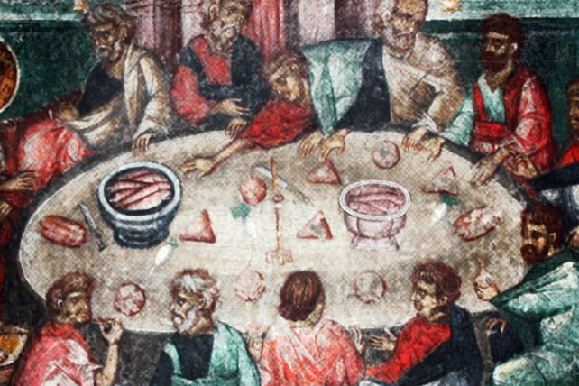
They committed themselves to the teaching of the apostles, the life together, the common meal, and the prayers. (Acts 2:42 MSG)

The believers of the early church were committed to doing life together. That is also expected of us today, as we grow together like living stones in God’s house. That is easier said than done, for we are all imperfect people, flawed, works in progress.
Here is an interesting analogy to describe us. We are like durians and Jesus is the durian farmer. He picks us up and put us in a basket to bring us to the market, and along the way, one durian was agitated and said to another durian, “Your thorns are very sharp, you are poking me!” The other durian replied, “So are you friend. Your thorns are very sharp, and you are poking me too!”
We are like the durians, and we all have thorns. We each have our own blind spots and shortcomings, and when we come together, we rub each other the wrong way, causing friction.
Doing life together means we need to be more gracious and forgiving towards one another. When Jesus comes again, when the durians arrive at the store to be consumed, the fragrance, the aroma, the tenderness of the durian flesh will be something to look forward to! Look beyond the thorns each other has.
IMPACT is about giving life!

We cannot give life to others without having first done life with each other.

The Church Scattered

We are called to the nations
The call to the nations is a missional call. This is the mandate given by Jesus. The call to the nations is about connecting with the world.
...and repentance for the forgiveness of sins will be preached in his name to all nations... (Luke 24:47)

Reaching the nations is the key purpose of Jesus’ mission. This represents the heart, character, and purpose of God. We as God’s people are given the same mission and mandate to preach to the nations.
“But you will receive power when the Holy Spirit comes on you; and you will be my witnesses in Jerusalem, and in all Judea and Samaria, and to the ends of the earth.” (Acts 1:8)

We are all called to be human instruments of Christ, to preach the Gospel to the nations. However, without the power of the Holy Spirit, we will not be equipped to do that.
When we are infused by the Holy Spirit, it will ignite in us a passion for incredible impact – in places where God wants to use us.

We are to start where we are
IMPACT is a call to go to the nations, but we are to start where we are. Despite the current situation, we are not to abandon our mission. God is redirecting and repositioning us.

...and repentance for the forgiveness of sins will be preached in his name to all nations, beginning at Jerusalem. (Luke 24:47)

The verse above is a Rhema word of God for us in these times. We are to start where we are, in our Jerusalem. This does not mean that we are to serve in comfort. In fact, serving in our Jerusalem might be more challenging for us. Jerusalem was probably the last place the disciples wanted to be in, because that was where their dreams were crushed. It was the place where Jesus, their master and perceived political saviour was hung on the cross to die. Jerusalem was a hostile place, for it was there where the religious leaders were after them.

With where we are now, it is not easy to start as well.

Conclusion

Let us start right here and right now – as reflected by the rebranded IMPACT logo:

Right here and right now, we are to…

- Represent Christ, the founder and the foundation of His church
- Gather to do life together and glorify Christ (Even if it is done online)
- Reach the nations represented by the refugees, asylum seekers and migrants (Empowered by the Holy Spirit)
- Impact the lives of the people in our communities, workplaces and spheres of influence.

We can start where we are, by seeking opportunities to help. We need to be agile and adaptable, creative and innovative, proactive and resourceful. There are many examples of ways we can help. For example, we who are technologically savvy can help those who are technologically challenged. If we have a vehicle, we can use it to deliver food packs to the needy. If we have a sustainable business, we can consider hiring migrants and refugees, those who are out of jobs. Our cell group can follow up on the migrant communities that have been helped by our Social Concerns Project and check on them to see how they are doing. We can make connections with no strings attached. MCO does not need to be Movement Control Order. It can be an opportunity for Missional Community Outreach. Ask God to use us right here, right now, as we commit ourselves to Him.

Sermon summary contributed by Anthea.

