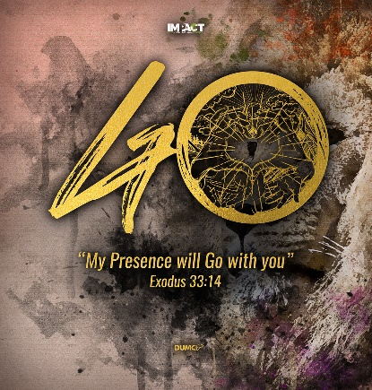
Resurrection of the Body (1 Corinthians 15:20-23, 51-52)
Pastor Mike Ngui

But Christ has indeed been raised from the dead, the firstfruits of those who have fallen asleep. For since death came through a man, the resurrection of the dead comes also through a man. For as in Adam all die, so in Christ all will be made alive. But each in turn: Christ, the firstfruits; then, when he comes, those who belong to him. I declare to you, brothers and sisters, that flesh and blood cannot inherit the kingdom of God, nor does the perishable inherit the imperishable. Listen, I tell you a mystery: We will not all sleep, but we will all be changed—in a flash, in the twinkling of an eye, at the last trumpet. For the trumpet will sound, the dead will be raised imperishable, and we will be changed. (1 Corinthians 15:20-23,51-52)

THE APOSTLES’ CREED

I Believe in God, the Father Almighty,
Creator of heaven and earth,
I Believe in Jesus Christ, His Only Son, our Lord,
who was conceived by the Holy Spirit,
born of the Virgin Mary,
suffered under Pontius Pilate,
was crucified, died, and was buried;
the third day He rose again from the dead.
He ascended into heaven,
is seated at the right hand of the Father,
and will come again to judge the living and the dead.
I Believe in The Holy Spirit,
the holy catholic* church,
the communion of saints,
the forgiveness of sins,
the resurrection of the body,
and the life everlasting.
Amen.

BIG IDEA: The future in Christ is better than you can imagine!

Introduction
The Apostle’s Creed is a corporate communal declaration of our Christian faith. In the ninth and final part of this series, Pastor Mike explores how Jesus’ rising from the dead and the promise of eternal life must transform our world views, values and the way we live our lives. Everything before has led up to this – what past we, as followers of Jesus, are leaving behind and what we are living towards.
“I believe in…the resurrection of the body, and the life everlasting. Amen”
As disciples of Christ, we live the present, sandwiched between the past of Christ’s life, death, resurrection, ascension and exaltation and the future of His return, when we will be resurrected and glorified with Him. Our life and eternal life are rooted in the past work of Christ at the cross on Calvary. The life of the God man who lived a similar life to us except that He was sinless. He died for us and when He rose from the dead, our sins were forgiven. He ascended into heaven to intercede for us and will return again as king and judge where we will rise to everlasting life.

Why is this in the Creed? It reminds us to lift our heads up from miseries and hardships of this life. In Christ, we can gaze at the most certain future even when faced with the loss of a loved one or situations of certain hopelessness.

Jesus the son of God came to live as a man
Just as people are destined to die once, and after that to face judgment (Hebrews 9:27)
For the wages of sin is death, (Romans 6:23a)

For the perishable must clothe itself with the imperishable, and the mortal with immortality. When the perishable has been clothed with imperishable, and the mortal with immortality, then the saying that is written will come true: “Death has been swallowed up in victory”. “Where, O death, is your victory? Where, O death, is your sting?” The sting of death is sin, and the power of sin is the law. But thanks be to God! He gives us the victory through our Lord Jesus Christ. (1 Corinthians 15: 53-57)

We will surely die despite great advances in healthcare that help prolong life and stave off diseases. Death is mankind’s mortal enemy in our pursuit of immortality.

Why do we have to die? It is the consequence of mankind’s’ sin of removing ourselves from God’s rule and jurisdiction and rebelling against Him. We have unplugged from the very source of life, much like our cell phone (Hebrews 9:7, Romans 6:23a). That is why we die but death is not the end for the redeemed. After death, those in Christ will rise, like Jesus, with a body at His return (1 Corinthians 15:20-23,50-57).

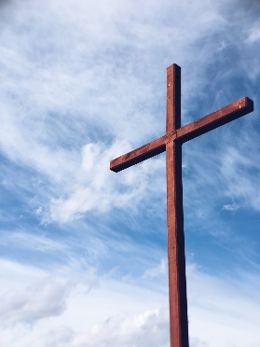
We have victory over sin and eventually over death in Christ because of the finished work at the cross, not because of ourselves. If death is not the end, then what comes after?
What is certain is that there is judgement for all – believers and those outside of Christ.

The implication:
There is judgement and second death (Hebrews 9:27). This has no power over a follower of Christ since death itself was destroyed Him. There is something more and much better.

Everlasting life will be incredibly, unimaginably glorious!
For to me, to live is Christ and to die is gain. If I am to go on living in the body, this will mean fruitful labor for me. Yet what shall I choose? I do not know! I am torn between the two; I desire to depart and be with Christ, which is better by far; (Philippians 1:21-23)

However, as it is written; “What no eye has seen, what no ear has heard, and what no human mind has conceived” – the things God has prepared for those who love him (1 Corinthians 2:9)

No one’s ever seen or heard anything like this, Never so much as imagined anything quite like it – What God has arranged for those who love him. (1 Corinthians 2:9 MSG)

But as we wait, we trust in God’s royal proclamation to be fulfilled. There are coming heavens new in quality, and an earth new in quality, where righteousness will be fully at home. (2 Peter 3:13 TPT)

And I heard a loud voice from the throne saying, “Look! God’s dwelling place is now among the people, and he will dwell with them. They will be his people, and God himself will be with them and be their God. ‘He will wipe every tear from their eyes. There will be no more death’ or mourning or crying or pain, for the old order of things has passed away.” (Revelations 21:3,4)

Everlasting life is inconceivable, unimaginable and incredible! The apostle Paul expresses his preference for dying because being with Christ is by far better! (Philippians 1:21-23).

It is unimaginable but the Bible does give us some glimpses. Peter wrote about a new heaven and a new earth where righteousness will be the norm (2 Peter 3:13 TPT). In the book of Revelation, John tries to describe the beautiful and glorious new heaven and eternity using limited human vocabulary. He describes a new city with foundations made from precious jewel and streets paved with pure gold. When the everlasting life begins, we will be on a new earth where there will be no more tears, sorrows and pain (Revelations 21:3,4).

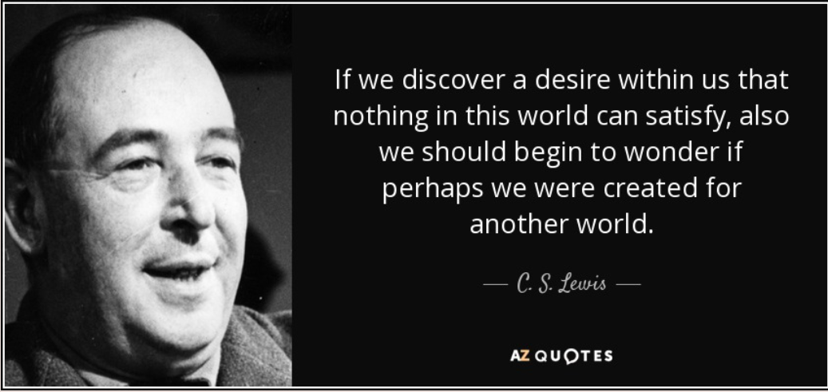
Perhaps the longings that we cannot seem to hold on to in this world, gives us an indication of what that this glorious eternity may be like (for examples, moments with loved ones that we wish could last forever such as with a child or the wonderful breath-taking moments to savour like a sunset, waterfall, and so on). We despair because life does not turn out the way we expect. But we have been created for something more than this life - a new world to be with God who is our source of life. Eternity is so much more.

The Implication:
We are called to look beyond death and the grave to eternity with Christ. Jesus taught us to store up treasures in heaven because when we do, our hearts turn upwards and we become heavenly minded (Matthew 6:19-21).

We can live differently in this life, in view of eternity
..I have learned to be content whatever the circumstances. I know what it is to be in need, and I know what it is to have plenty. I have learned the secret of being content in any and every situation, whether well fed or hungry, whether living in plenty or in want. (Philippians 4: 11b-12)

[God] has said, “I will never leave you and I will never abandon you. So we can say with confidence, “The Lord is my helper, and I will not be afraid. What can people do to me?” (Hebrews 13:5b-6)
..let us run with perseverance the race market out for us, fixing our eyes on Jesus, the pioneer and perfecter of faith. For the joy set before him he endured the cross, scorning its shame, and sat down at the right hand of the throne of God. Consider him who endured such opposition from sinners, so that you will not grow weary and lose heart. (Hebrews 12:1b-3)
You suffered along with those in prison and joyfully accepted the confiscation of your property, because you knew that you yourselves had better and lasting possessions (Hebrews 10:34)

The thief comes only to steal and kill and destroy; I have come that they may have life, and have it to the full. (John 10:10)
How does this part of the Creed translate to life in the present? We can live life differently in view of the glorious eternity. Rick Warren (author of Purpose Driven Life) adequately sums it up - “When you live in the light of eternity, your values change”.

Photo credit
Senjuti Kundu@Unsplash

It should affect our lives in that we can:
- Live life CONTENTED – learning to be contented whatever the circumstances. We can persevere in light of eternity (Philippians 4:11b-12).
- Live COURAGEOUSLY – faithful in this life by walking, following and obeying Christ, knowing that our glorious eternity is safety bound up in Him. We are not fearful even when tested or persecuted for our faith (Hebrews 13:5b-6).
- Live JOYFULLY – anticipation of joy as better and lasting possessions are in eternity. Losing stuff in this world is OK. We can share what little we may have with others. We, like Jesus, can see beyond this life and the grave (Hebrews 12:1b-3, Hebrews 10:34).
- Live FULLY – we have a foretaste of the eternal life right now. We can live a life fully in anticipation of our glorious eternity (John 10:10).
The Implication:
If you want to live fully and make a difference in this life, think more about eternity. It will give you courage, certainty about the things you do. Give you joy as you plough through hardships of serving the kingdom of God.
BIG IDEA: The future in Christ is better than you can imagine!
Sermon summary contributed by Darren.

