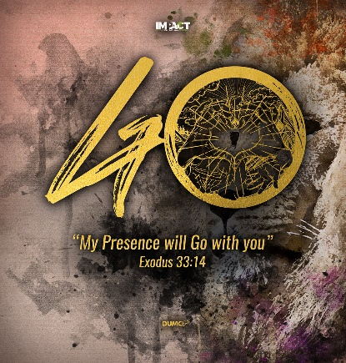
From a Superficial Faith to an Authentic Faith: Me, Myself and I
Philippians 2:1-4; Galatians 2:20
Senior Pastor Chris Kam

Therefore if you have any encouragement from being united with Christ, if any comfort from his love, if any common sharing in the Spirit, if any tenderness and compassion, then make my joy complete by being like-minded, having the same love, being one in spirit and of one mind. Do nothing out of selfish ambition or vain conceit. Rather, in humility value others above yourselves, not looking to your own interests but each of you to the interests of the others. (Philippians 2:1-4)
I have been crucified with Christ and I no longer live, but Christ lives in me. The life I now live in the body, I live by faith in the Son of God, who loved me and gave himself for me. (Galatians 2:20)

Introduction

We have just concluded a 9-week sermon on the Apostles’ Creed, which lasted throughout the MCO period. It helped us to anchor on the fundamentals of our Christian beliefs, and to put our focus on the basic truths of the Trinitarian God, even when things around us are being shaken.

We are now doing a 2-week series on shifting from a superficial faith to an authentic faith, which is one of the key things Pastor Chris highlighted that God will do in DUMC during this MCO period. Hopefully this season would have given us a new perspective on what is important and what is not important about life. Hopefully it would have encouraged us to take our faith seriously and deepen our devotion to God, with a desire to obey and follow Him.

What does it mean to shift from a superficial faith to an authentic faith? As a pastor, Chris Kam’s desire is to see us moving from outward good Christian religiosity, to a real inner lasting change of heart. It means to grow in maturity and Christlikeness; moving from drinking milk, to eating meat; moving from being spoon-fed, to learning to feed yourself; moving from self-centeredness, to other-centeredness; saying no to ungodliness, and pursuing godliness.

Growing in maturity and Christlikeness is for our good and His glory. One day, when we meet the Lord, we will long to hear Him say, “Well done, good and faithful servant.” We did a Gospel sermon series last year, entitled: The Gospel Grows and Matures You to be More Christ-like.

* You have been saved – Justification
You have been justified, you have been saved from the wrath and judgement of God. This is only the first step of the process.

* You are being saved – Sanctification
It means being saved from something to being saved for something. You are cleansed, sorted, and transformed. This is a daily thing as we continue to grow in our discipleship, helping us to say no to sin and ungodliness.

* You will be saved – Glorification
You are being saved for something eternal. One day, you will have a new and glorious body on the new earth.
BIG IDEA: God is not finished with me yet. He wants to save me from myself.

Selfie Mode
One of the most difficult people to confront in life is ourselves. This is because we love ourselves too much. One phenomenon that proliferated in the last 10 years is that of the selfie phenomenon. We live in the world of the selfie mode, where people are taking selfies everywhere that they go.
The selfie phenomenon, which has transformed our social culture, is commonly understood to be a photograph that has been taken by oneself, usually with a smart phone or webcam and shared on social media. Today, people post millions of selfies each day to social media sites, such as Facebook, Instagram and Twitter. - Christine M. Kowalczyk, East Carolina University, USA

When you look at a group photo, who do you look for first? You look at yourself first. If you do not look good in it, then the whole photo is bad. It does not matter even if other people look good in it. The selfie mode is all about ourselves, making ourselves the centre of God’s creation. It is about self-promotion, self-exaltation, and self-exaggeration. The selfie mode focuses on me, myself and I. It is the unholy trinity. It is about what I eat, where I go, and what I do.

The Bible warns us that the last days, this is going to creep into the church. The Apostle Paul talked about it 2000 years ago.
But mark this: There will be terrible times in the last days. People will be lovers of themselves, lovers of money, boastful, proud, abusive, disobedient to their parents, ungrateful, unholy, without love, unforgiving, slanderous, without self-control, brutal, not lovers of the good, treacherous, rash, conceited, lovers of pleasure rather than lovers of God— having a form of godliness but denying its power. Have nothing to do with such people. (2 Timothy 3:1-5)
In this passage, Apostle Paul is not just referring to the pagans, but also to the church. It is not that Facebook and Instagram is bad. It is just a social media tool and platform. We need to watch out that we do not become too obsessed with ourselves. This is really difficult because the default mode of our sinful nature is self-centredness. We want people to take notice of us, and to take notice of our problems. The most miserable people are those who cannot get out of selfie mode for a long time. They cannot be pleased or happy no matter what we do for them.

Selfless Mode
We need to find the reverse camera button on our mobile phone and push it, taking us off selfie mode. After this, we cannot see ourselves anymore on the camera. It is about moving from a selfie mode to a selfless mode, from a self-centred life to an other-centred life. This mode is counter intuitive because, all our lives, we have been told to get ahead of everyone else.
We ask, “Why am I not mentioned or featured after putting in so much effort? Nobody thanked me or appreciated me.” Hence, in the process of sanctification, God has to deal with our self-centredness. The best thing you can do for yourself is to get over yourself and learn to look at the needs of others.
Do nothing out of selfish ambition or vain conceit. Rather, in humility value others above yourselves, not looking to your own interests but each of you to the interests of the others. (Philippians 2:3-4)
Don’t push your way to the front; don’t sweet-talk your way to the top. Put yourself aside, and help others get ahead. Don’t be obsessed with getting your own advantage. Forget yourselves long enough to lend a helping hand. (Philippians 2:3-4(The Message))
Becoming Christ-like is about turning off the selfie mode, and turning on the selfless mode, by looking at others and serving them.
Now to each one the manifestation of the Spirit is given for the common good. (1 Corinthians 12:7)
God has given us unique spiritual gifts to serve the body of Christ. These are called spiritual gifts of grace, which are given to us not because we deserve it, but so we can use them to build up one another. We are given these gifts to bless others. It is not for ourselves, but it is for the common good. The reason why we have not been receiving these gifts is because we have not been thinking about the common good of the body. Gifts cannot flow through you when you are in a selfie mode. Turning on the selfless mode is to start each day by praying, “Holy Spirit, please use me to bless someone else.” We are encouraged to serve in ministry for it is by serving where we learn to take our eyes off ourselves and onto the needs of others.
We need the Holy Spirit to reveal to us the posture of our hearts, because we cannot see how self-centred we are. Most modern day counselling is about focusing on ourselves, to look deeper, to look inwards, to go back to our childhood. Dealing with them is not wrong where inner hurts are concerned. However, if you continue to focus on yourself, you will just be caught up in an unending cycle.
God has given us a new life and a new spirit. The Bible exalts us to put off the old sinful nature and to put on the new self by serving others. Jesus Christ came not to be served, but to serve and to give His life as a ransom for many. If He is our role model, then being like Him is going to give us life.

Saviour Mode
From a selfie mode, we switch to a selfless mode, which then turns on the Saviour mode.
I have been crucified with Christ and I no longer live, but Christ lives in me. The life I now live in the body, I live by faith in the Son of God, who loved me and gave himself for me. (Galatians 2:20)
What does it mean to be crucified with Christ? Our fleshly self is always leading us into misery and destruction, always focusing on how we feel, how we were offended, how dissatisfied we were. How about we put ourselves to death? This is what it means to be baptised. It is to get rid of ourselves. When we come out of the water, we are no longer our own, but His. That is what it means to be a disciple of Jesus. We no longer exist in ourselves, but in Christ. We need to put the old self to death, so that the Holy Spirit can have more of the new self.
This passage of scripture depicts a picture of heaven:
Then I looked and heard the voice of many angels, numbering thousands upon thousands, and ten thousand times ten thousand. They encircled the throne and the living creatures and the elders. In a loud voice they were saying: “Worthy is the Lamb, who was slain, to receive power and wealth and wisdom and strength and honour and glory and praise!” (Revelation 5:11–12)
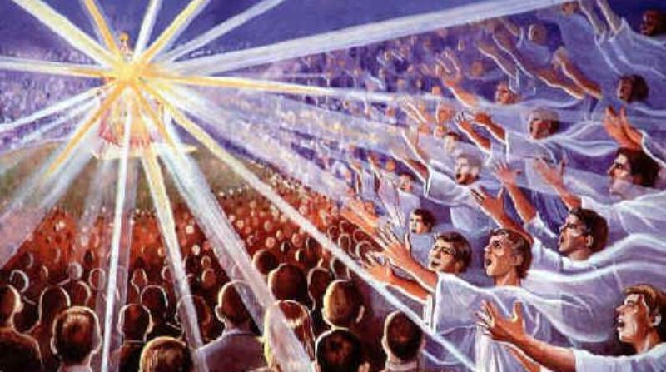
Millions and millions of angels are gathered to worship God, and one day, when all the people are gathered to worship God, no one will be taking selfies, crying out for attention to “Look at me!” Everyone will be focused on God, giving Him the attention that He alone deserves. No one will be looking at themselves.
The key to be in the selfless and saviour mode is to grow in love with Jesus and His Word, and to serve His people. The book of Hebrews describes some Christians who are still drinking milk, whereas others are eating solid food.
In fact, though by this time you ought to be teachers, you need someone to teach you the elementary truths of God’s word all over again. You need milk, not solid food! (Hebrews 5:12)
The writer of Hebrews is saying that some should have been teachers by now, but they are still drinking from the milk bottle. They do not know how to feed themselves. Stop expecting the church to be the only platform to feed you with the Word of God. Learn to feed yourself. Spend daily time with God. Read and meditate on His Word, and let Him speak to you.

The growing up years of a child is to teach him how to feed himself when he is hungry. Do not resort to eating only buffets, which is terribly unhealthy. Eat regular and routine meals. You grow healthy not through eating buffets, but through the daily feeding on the Word of God. There is no shortcut. Stop hopping from church to church, from sermon to sermon, or from preacher to preacher looking for buffet meals, and complain that the church never feeds you enough. The church will never be enough in that sense. Only Christ is enough for us. No one can meet our expectations except for Christ.

Jesus says, “I am the living water, and whoever drinks of me will never go thirsty; and when you eat of this bread, you will never go hungry.” King David says in Psalm 23:5, “My cup overflows.” That can only happen when you learn to feed on the Lord every day. When we are empty people, we suck other people dry. That is what causes conflicts in relationships and divorces to happen. Empty people are in selfie mode.

God sacrificed His one and only Son so that you and I can be saved, and He calls us His children. No one has ever loved us like this. We live in this perpetual love relationship first and foremost with God, and then with each other. When we focus on Jesus and let Him fill us, we can come to our relationships overflowing and not spiritually dry.

Conclusion
The devil hands us a mirror, telling us to look at ourselves, but Jesus says to look at Him. Some of us need to repent from looking at ourselves too much. This is not to say that our hurts, needs and wounds are not important. However, there must come a time when you need to stop looking at yourself. There is a difference between self-care and self-centredness. By all means, take care of yourselves and seek help when needed. Keep in mind that the greatest remedy to your problems is to let God work powerfully through you, by focusing on Him first, and then on others. You will be pleasantly surprised to find that when you begin to do that, your own problems begin to fade away.

If you are hurting, come to Jesus. Do not dwell on it any longer, for you have been forgiven and delivered. Live out the truth. If you are consumed with yourself, it is a good time to repent and to pray, “Jesus, help me to be useful for the Kingdom of God.” Commit yourself to spending daily time with God, and serving others. Be committed to your church and your cell group. It is not about what you can get out of them, but it is about what you can give.
Life is an exciting business, and most exciting when it is lived for others.
~ Helen Keller ~

Sermon summary contributed by Anthea.

