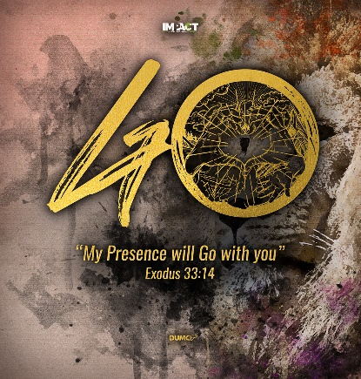
From Superficial Faith to Authentic Faith: It Is So Easy for Leaders to Fake It (Revelation 2:1-7)
Senior Pastor Chris Kam
“To the angel of the church in Ephesus write: These are the words of him who holds the seven stars in his right hand and walks among the seven golden lampstands. I know your deeds, your hard work and your perseverance. I know that you cannot tolerate wicked people, that you have tested those who claim to be apostles but are not, and have found them false. You have persevered and have endured hardships for my name, and have not grown weary. Yet I hold this against you: You have forsaken the love you had at first. Consider how far you have fallen! Repent and do the things you did at first. If you do not repent, I will come to you and remove your lampstand from its place. But you have this in your favor: You hate the practices of the Nicolaitans, which I also hate. Whoever has ears, let them hear what the Spirit says to the churches. To the one who is victorious, I will give the right to eat from the tree of life, which is in the paradise of God. (Revelation 2:1-7)

Introduction
The Covid-19 pandemic and MCOs have been instrumental in moving us towards a new normal, hopefully a Christlike normal. With time to reflect on our spiritual state, perhaps we have taken our faith more seriously and live a life more devoted to Christ and have a greater desire to obey and follow Him wholeheartedly. As we aim to have a true and firm anchor in Christ, be careful that it is possible to have “a form of godliness but denying its power.” (2 Timothy 3:5)
We can look spiritually okay on the outside but be empty inside; void of experiences with God who is not in the business of making us happy, but holy. God is interested in our spiritual transformation to become effective witnesses for Him and the Gospel. Jesus himself never preached easy messages. His messages put people off as much as it draws some to Him as well.
On hearing it, many of his disciples said, “This is a hard teaching. Who can accept it?” Aware that his disciples were grumbling about this, Jesus said to them, “Does this offend you? (John 6:60-61)
Do we get offended with Jesus’ teachings? Do we pick and choose only what we like to hear or do? Does Jesus fit into the idea of what we hope He will be like? Do we take a stand against sin and talk about repentance or hell and judgment? Will you stay or leave church and cell groups, if such hard topics are preached on? During Jesus’ time, many turned away.
From this time many of his disciples turned back and no longer followed him. (John 6:66)
Jesus demanded everything out of His disciples, challenging them on the cost of following Him. While He loved the people deeply, He was not afraid to offend and confront them. Sin is subtle and can lead us down a life of deception through a life of hypocrisy.
I know your deeds, your hard work and your perseverance. I know that you cannot tolerate wicked people, that you have tested those who claim to be apostles but are not, and have found them false. You have persevered and have endured hardships for my name, and have not grown weary. Yet I hold this against you: You have forsaken the love you had at first. Consider how far you have fallen! Repent and do the things you did at first. If you do not repent, I will come to you and remove your lampstand from its place. (Revelation 2:2-5)
We are all leaders wherever we are as a disciple of Jesus Christ. We are called to influence and make a difference with those around us, whether at home as a parent, at work with people, or in our schools and universities. Yet, it is so easy for leaders to fake it. What does it mean? Well, Jesus calls it hypocrisy. It is basically about trying or pretending to be someone you are not.
Pastor Chris made a statement of himself: I can lead a “successful” church without being in love with Jesus.
We can blame many things for that problem – culture, position, or busy schedule, for his lack of intimacy. The point is - sin and hypocrisy are a result of himself and no one else. He would need to take a personal responsibility for it.
Hypocrisy is so compelling because we want to look good outside as we love ourselves too much to be otherwise. We love to give the impression that we are better than we really are. We make ourselves the centre with self-promotion, self-exaltation, and self-exaggeration.
Trappings of Hypocrisy

I Forget to Love God
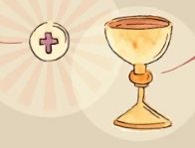
There are moments in our lives when we are filled with intense moments of adoration for God. That everything else matters less. It is just that at times, we forget to love Him, not that we do not want to
That is why Jesus instituted the Holy Communion and commanded us to do it as often as we can. “Remember Me,” He said.
We can argue about our busy schedule – how we love God by our ministry. In Rev 2:2 we read, “I know your deeds, your hard work and your perseverance. I know that you cannot tolerate wicked people, that you have tested those who claim to be apostles but are not, and have found them false. You have persevered and have endured hardships for my name, and have not grown weary.”
God recognised the Ephesians church for their wonderful ministry but He also made it clear that “ I hold this against you: You have forsaken the love you had at first. Consider how far you have fallen! Repent and do the things you did at first. If you do not repent, I will come to you and remove your lampstand from its place.”
God tells the hardworking, sin-hating, doctrine-loving and persecuted church that He doesn’t want them around unless they truly love Him. He has always been interested not so much in what we do, but how we love Him.
Love the Lord your God with all your heart and with all your soul and with all your mind. (Matthew 22:37)
Love is and must be the reason for all our godly actions and ministry.
Question: When was the last time you were alone with your Heavenly Father and just enjoy Him?
Do not take God for granted. He is your first love. As you partake in the next Holy Communionn, do not treat it as another ritual, rather that as a remembrance feast.

I fake passion well
Leaders like us can make the greatest hypocrites because of our ability to persuade and deceive. Rarely is there a leader whose character exceeds his reputation.
We live three kinds of life:
Public Life
Private Life
Secret Life

•

We can portray a vibrant life in public. We are there by position, our persuasiveness and leadership ability. But we may all lie to a certain degree, exaggerating even, justifying it with white lie as opposed to a black outright lie so that we sound and look better than we really are.
Really, we are all the same, equally sinful, and prone to sin. There are no one holier than another. We may have similar struggles in area of pride, arrogance and lust.
From your public life, when you return home, you enter your private life. How does your family, or even your domestic helper, view you? When you enter another world, your secret world with no one around, what do you do?
Questions: If I were to ask those closest to you about your relationship with God, what would they say? If I were to ask God the same question, what would He say?
To the Church in Sardis, this is what Jesus said: “I know your deeds; you have a reputation of being alive, but you are dead.” (Revelation 3:1b)
We are not perfect, but we are called to be real (DUMC’s 3rd core habit). Why then do we need to fake it when we can have the genuine thing? Why do we struggle in deception when the full life is already promised to us? “…so that they may take hold of the life that is truly life.” (1 Timothy 6:19b)
A Christian leader once said, “I refuse to let my public passion exceed my private devotion.”
What about you? How is your private devotion or secret life? Is there a point here for repentance?

I follow the people I lead
We all love to be loved. We do not like to be rejected so we learn how to fit in and position ourselves to be loved by people. We tend to please them, and not God.
God has called us to give people what they need, and not what they want. We need to lead in accordance to His Word, whether people stick around or not.
Question: If Jesus has a church in PJ, would DUMC be a bigger church because we call for easier commitment?
There is sometimes a stronger pull to keep people rather than to truly lead those who are faithful and are prepared to count the cost. We often neglect the truly faithful and spend our energy on making the bystanders stay. We must be careful not to build a consumeristic culture that attracts people by what they like rather than the beauty of Jesus that attracts them through the Gospel.
Programs and events do not make strong disciples. Strong disciples make other strong disciples.
Question: What kind of disciple are you? Who is leading who?
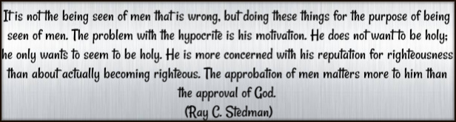

Sermon summary contributed by Wendy ML Tan

