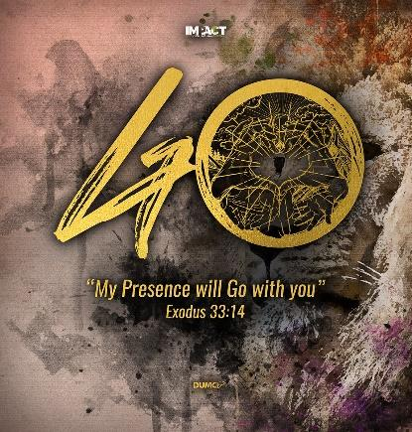
What is Life?
(Psalm 90: 1, 2, 10, 12, 14, 17)
Founding Senior Pastor Dato’ Dr Daniel Ho

Lord, you have been our dwelling place throughout all generations. Before the mountains were born or you brought forth the whole world, from everlasting to everlasting you are God. (Psalm 90: 1-2)

Our days may come to seventy years, or eighty, if our strength endures; yet the best of them are but trouble and sorrow, for they quickly pass, and we fly away. (Psalm 90: 10)
Teach us to number our days, that we may gain a heart of wisdom. (Psalm 90: 12)

Satisfy us in the morning with your unfailing love, that we may sing for joy and be glad all our days. (Psalm 90: 14)

May the favour of the Lord our God rest on us; establish the work of our hands for us—yes, establish the work of our hands. (Psalm 90: 17)

Introduction
In this trying period of MCO, when we are overwhelmed with the feeling of insecurities, uncertainties, and isolation; many of us reflect on “What Life is about?” We ponder on the simplicity of life, the centrality of life (Psalm 27:4), the value of relationships and of others. We search for the meaning of Life. The best person to learn what life is all about is from Moses, who has lived till 120 years old. Moses teaches us the lessons in living a meaningful and fruitful life (Psalm 90). Life, in a nutshell, is a gift, is gain and is gladness.

Life is a gift (Psalm 90:10a, Psalm 27:4)
A man typically lives to 70-80 years of age, or much longer now, due to the advent in medical breakthroughs. But, it is not the length of time (in this case, years) that matters, but the way we live our lives. The time that we have is a gift, given by God.

Therefore, we need to ask ourselves, how do we want to use this gift? Do we live a meaningful life, blessing others through our works and attitude? Do we intentionally use our life to honour God and for His glory? Or do we squander this life away? Whatever length of time given, we must consciously steward it towards God, so that on the day when we look back, we will have no regrets. Instead, it will be filled with gratitude to God.

Life is gain (Psalm 90:12, James 1:5, James 3:13, James 3:14-16, Galatians 5:22,23)
Our life is gain when we gain the heart of wisdom. And this wisdom from God is the Heavenly wisdom that we have the privilege to ask from God. God’s wisdom teaches us to know what we know, and also how to use it in our lives so that our lives are transformed to become more attractive and winsome. Heavenly wisdom is set apart from the Earthly wisdom, where Heavenly wisdom guides us to live a sincere, impartial, gracious and kind life; but the Earthly wisdom (unspiritual wisdom) leads us to disorder and evil practices. Ultimately, the wisdom from God will guide us to live our lives, increasing in kindness and thoughtfulness, demonstrating the fruits of the Spirit.

Life is gladness (Psalm 90: 14, 15)
The mark of gladness is joy, thankfulness and gratefulness. Gladness is an attitude that we can choose to adopt. When something bad happens, do we get upset with it or do we say that God has something to teach us? The attitude that we adopt then dictates the posture of our response to God, in the midst of challenges and affliction. Do we blame God, or do we continue to praise God and be thankful for what He is doing in our lives?

Christians are not free from troubles and challenges. But as Christians, we can choose to respond with the grace from God, so that we can grow and mature even more. God teaches us love, care, concern, patience and of serving others through challenging times. We mature through difficult times, not in the good times. We can choose to become a bitter or a better person; and to look at things as a burden or a blessing. As we grow, mature and increase in our lives, we should also increasingly demonstrate gladness in our lives and see burdens as blessings.

Conclusion
We are given a precious gift from God - Life. Therefore, choose to live a life that is meaningful, that will bless others. Let God’s wisdom guide us towards living a life of sincerity, gracious and kind, and one that is at peace and at rest in the face of troubles. Choose gladness, so that the posture of our response to challenges is one that allows us to grow and mature to become more Christlike.

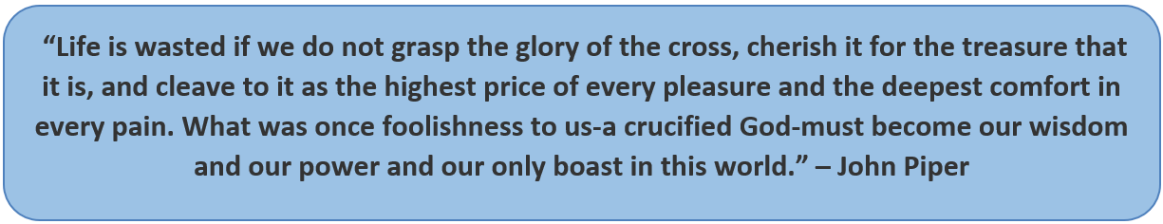

Sermon summary contributed by Adeline Ting.

