LEAD2017 Saturday: Leading Towards God’s Agenda: WHY SHOULD I?
Pastor Jose Carol

Introduction

Corruption has always been an issue in Indonesia. According to the Good Country Index (GCI), where research was done on a total of 167 countries, Indonesia was ranked 88th (Malaysia ranked 54th and Singapore 8th) on the corruption perception index. Corruption had even penetrated into the country’s education system. People bribe to get into good universities, to get good results, to get through exams, etc. Sadly, this could also be the case in our church. God has a specified purpose for us to bring an impact to our church and our nation.

A TEACHING ON GENEROSITY
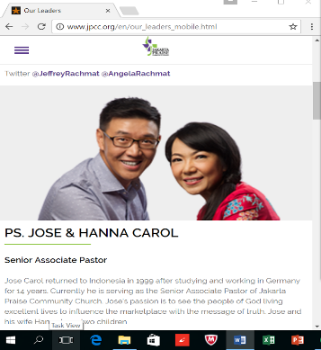
Pastor Jose grew up in an environment where he placed little trust in Christian leadership. He had doubts and questions of God’s work in his life and what he deems as fair. As he struggled to pursue his studies in Germany, he avoided church due to his disappointment and lack of trust, failing to see the trustworthiness representative in the leadership of the church. After residing in Germany for 14 years, he obediently returned to Jakarta, became the pioneer of Jakarta Praise Community Church (JPCC), and is now serving as the Senior Associate Pastor.
When the church was founded on 4th July 1999, there were issues on punctuality, cleanliness, generosity and financial stability. It was purely reflecting the state of the country where trust, cleanliness and generosity are very subtle and difficult to testify. Trust was a big issue in JPCC (and Indonesia!). However, today, JPCC is of an entirely different church altogether.
How did it start in JPCC?
It allowed members to make free will offering and people can give offering if they wanted to and if they trust God. People started questioning on JPCC's sustainability, they needed the money to pay for the rented hall. Ever since, God had shown Himself faithful to the church. There was never a time when they were not able to pay the rent.
WHY SHOULD I?
JPCC started with young people. A typical response from these young people when they were asked to serve, was, “Why should I?” Over time, a tweak in the culture of the church has taken place. Punctuality is perfect now. People are generous. There is trust. It is clean. It took some time for this culture to be built.

WHY GENEROSITY?

Why do we need generosity? What goodness does it bring forth to the society, nation and generations?

Enlargement
Enlarge the place of your tent, and let the curtains of your habitations be stretched out; spare not; lengthen your cords and strengthen your stakes, For you will spread abroad to the right hand and to the left; and your offspring will possess the nations and make the desolate cities to be inhabited.
(Isaiah 54:2-3, AMPC)

It takes generosity to enlarge your life.
Stinginess or bare minded thinking will not help us to enlarge. It hinders God from enlarging and stretching out our tent. Pastor Jose shared a testimony he witnessed a few months ago when he went to Chinatown to change the batteries of his watches. While waiting, he was observing the bargaining skills of customers. A lady managed to bargain to a quarter of the offered price, not only that, her child who tried on two toy watches refused to take them off. The mother was reluctant to buy them, and surprisingly, the shop owner gave them to her for free.

Pastor Jose was shocked at her generosity. One thing for sure, he knew that the customer would definitely return again whenever she thinks of buying a watch. The business will get larger.

The world of the generous gets larger and larger; the world of the stingy gets smaller and smaller.
The one who blesses others is abundantly blessed; those who help others are helped.
(Proverbs 11:24-25, MSG)

In the NIV version of the Bible, it says in verse 25 that “A generous person will prosper…”. To become generous, we cannot always be counting. We cannot be picky either.

GOD IS INTERESTED IN ENLARGING YOUR BEING, HE IS NOT GOING AFTER YOUR GIVING.

If you have never been generous in little, you will never be generous in much.

God wants to prosper us. He is not after our giving. In order to give us, He first challenge us to give.

LACK | PROSPER
Little | Much  Have

One will never move to prosperity by lacking in giving and reluctance in being generous in little.

Prosperity comes from the state of our hearts, not the condition of our pockets. When God anoint us with stewardship to prosperity, He gives us the anointing that enables us to prosper in building His kingdom. Be generous, then you will prosper.

ENTRUSTMENT
This most generous God who gives seed to the farmer that becomes bread for your meals is more than extravagant with you. He gives you something you can then give away, which grows into full-formed lives, robust in God, wealthy in every way, so that you can be generous in every way, producing with us great praise to God. (2 Corinthians 9:10, MSG)
God gives us bread and seed- bread to consume and seed to sow (Yes, He trusts us with seeds to sow!). In other words, He gives us something that we can give away. In real life, things do not come in such a form. But the same concept applies.

For example, Pastor Jose has a favourite T-shirt brand. It is very expensive, costing about SGD 300-500 per T-shirt. One day, he received a gift, it was the T-shirt that he always wanted. However, it was two inches too big, but he can always change the size since he was given the receipt. But, suddenly, he thought this may be the seed and not a bread. A seed for him to give away. He was really struggling, and eventually it was given away. His wife later, went to Hong Kong and came across stock clearance of the said brand at hugely discounted price. She ended coming back with a whole bag of the brand’s merchandise, all at a very low price. This can be an example of sowing one, reaping many!
Prior to this, any extra time was a “Me time” to Pastor Jose. But ever since he learned about this principle—he would think of how should he sow the seeds given to him during his free time.

ENJOYMENT
You will be far happier giving than receiving
“In everything I’ve done, I have demonstrated to you how necessary it is to work on behalf of the weak and not exploit them. You’ll not likely go wrong here if you keep remembering that our Master said, ‘You’re far happier giving than getting.’” (Acts 20:35, MSG)

It is well with the man who deals generously and lends, who conducts his affairs with justice. (Psalms 112:5, AMP)

Conclusion
Generosity allows God to enlarge our lives, for Him to entrusts us with seeds to sow and to bring forth the enjoyment of giving than to receive. If you have everything but not happy, you may start to give and serve. You will be joyfully enlarged and entrusted with seeds to sow.
No matter how little we have in our hand, we live generously because we have a big heart within us.

LEAD2017 Sunday: Following Christ = Making Disciples: The Deceit of Willpower (Appropriating God’s Power)
Pastor Randy Pope

What shall we say, then? Shall we go on sinning so that grace may increase? By no means! We are those who have died to sin; how can we live in it any longer? Or don’t you know that all of us who were baptized into Christ Jesus were baptized into his death? We were therefore buried with him through baptism into death in order that, just as Christ was raised from the dead through the glory of the Father, we too may live a new life. For if we have been united with him in a death like his, we will certainly also be united with him in a resurrection like his. For we know that our old self was crucified with him so that the body ruled by sin might be done away with, that we should no longer be slaves to sin - because anyone who has died has been set free from sin. Now if we died with Christ, we believe that we will also live with him. For we know that since Christ was raised from the dead, he cannot die again; death no longer has mastery over him. The death he died, he died to sin once for all; but the life he lives, he lives to God. In the same way, count yourselves dead to sin but alive to God in Christ Jesus. Therefore do not let sin reign in your mortal body so that you obey its evil desires. Do not offer any part of yourself to sin as an instrument of wickedness, but rather offer yourselves to God as those who have been brought from death to life; and offer every part of yourself to him as an instrument of righteousness. (Romans 6:1-13)

Introduction
There are two (and only two!) kinds of people in the world - the natural man in the likeness of Adam, who possesses only one nature, a sinful nature; and the spiritual man in the likeness of Christ, who possesses two natures.

There are two certainties true of every spiritual person. Firstly, they are sealed by the Holy Spirit (Ephesians 1:13) – once they have become a true Christian they will always be a true Christian. Secondly, they are capable of being filled with the Holy Spirit (Ephesians 5:18). However, it is not a sure thing that every Christian is filled with the Holy Spirit. We need to walk by the Spirit (Galatians 5:16) and not be consumed by fleshly desires like worry, despair and addiction.

The Big Idea: Consciously appropriate the power of the Spirit!

It is of critical importance that we understand that the answer to every issue is to walk in the Spirit and to appropriate God’s power consciously. Is it possible to walk in the Spirit without consciously using it? Yes, it is! Apostle Paul in 1 Thessalonians 5:17 exhorts us to pray unceasingly – meaning that we can go through the day in prayer, without making a conscious effort and display of praying.

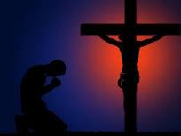
Many Christians, when confronted with a trial or temptation, choose to fight using only their human strength. After repeated tries and exhausting the limits of their capabilities, they give up and declare, “I cannot do it”. The mistake here is that they have tried to overcome their trial by their own power, rather than calling on the Spirit for the godly power that will enable them to overcome that trial. As a true Christian, one should not say, “I cannot”; but admit that “I will not” or “I do not know how”. As Paul says in 1 Corinthians 10:13: “No temptation has overtaken you except what is common to mankind. And God is faithful; he will not let you be tempted beyond what you can bear. But when you are tempted, he will also provide a way out so that you can endure it.”

The Three Keys to Unlock the Secret to being Filled with the Holy Spirit

Know
Or don’t you know that all of us who were baptized into Christ Jesus were baptized into his death? (Romans 6:3)
For we know that our old self was crucified with him so that the body ruled by sin might be rendered powerless, that we should no longer be slaves to sin. (Romans 6:6)
For we know that since Christ was raised from the dead, he cannot die again; death no longer has mastery over him. (Romans 6:9)
To walk in the Spirit, one must have an informed mind and act accordingly. When we say that we put our faith in Christ, we are separating ourselves from our old ways. We stop taking orders from our old life (which is familiar but abusive to our own selves) despite its screaming and shouting; rather we take on the yoke with Jesus and know that God is in control, come what may.

Consider
So you also must consider yourselves dead to sin and alive to God in Christ Jesus. (Romans 6:11, ESV)
Being dead to sin means to be separated from our sinful nature. At conception, man is born conjoined to his sinful nature. When a man is reborn as a Christian, the man and his sinful nature are separated, and man is in turn is joined with the Spirit.

Paul reminds us to consider our rebirth as Christians, and to recall what we have already learned and know. It is human nature to go back to what is familiar, and not put into action what we already know and learned.

Present
Do not present your members to sin as instruments for unrighteousness, but present yourselves to God as those who have been brought from death to life, and your members to God as instruments for righteousness. (Romans 6:13, ESV)

We are to present our situations to God in a pose of surrender. As long as we think that we can do it with our own willpower, we cannot and will not see God’s power because we have yet to surrender to His will.

The Deceit of Willpower
There are two truths in regards to the deceit of willpower:

Presenting without Knowing
Willpower will deceive Christians into believing they can experience God’s power without embracing the truth. You can surrender your life to Christ, but if you continue to cling on to false beliefs, you continue to be trapped in a cage you were made free from. We need to acknowledge the truth, for the truth will set us free (John 8:32).

Knowing without Presenting
Willpower will deceive non-Christians into believing they are Christians if they sincerely believe the truth. They do not realise that by only saying the prayer to Christ and sincerely (at that time) believing in Christ does not change a person into a Christian. To become a true Christian, you must present your now-born-to-Christ-self to Christ as an instrument for His glory.
For those of us who profess to be Christians, we must admit God’s truth into our lives and live out the faith of Him whom we call our Saviour; no longer tricked by our old selves, but truly live in Him.

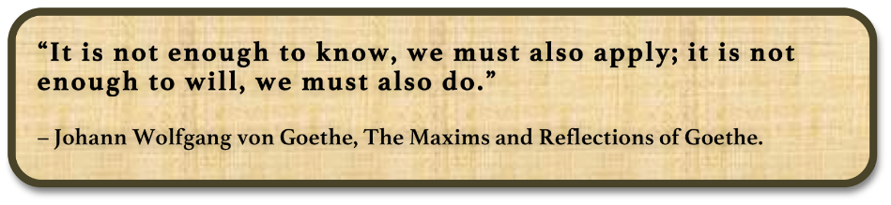
Sermons summary contributed by Chrisandra and Adeliyn.

