LEAD2017 Sunday: Following Christ = Making Disciples: The Deceit of Willpower (Appropriating God’s Power)
Pastor Randy Pope

What shall we say, then? Shall we go on sinning so that grace may increase? By no means! We are those who have died to sin; how can we live in it any longer? Or don’t you know that all of us who were baptized into Christ Jesus were baptized into his death? We were therefore buried with him through baptism into death in order that, just as Christ was raised from the dead through the glory of the Father, we too may live a new life. For if we have been united with him in a death like his, we will certainly also be united with him in a resurrection like his. For we know that our old self was crucified with him so that the body ruled by sin might be done away with, that we should no longer be slaves to sin - because anyone who has died has been set free from sin. Now if we died with Christ, we believe that we will also live with him. For we know that since Christ was raised from the dead, he cannot die again; death no longer has mastery over him. The death he died, he died to sin once for all; but the life he lives, he lives to God. In the same way, count yourselves dead to sin but alive to God in Christ Jesus. Therefore do not let sin reign in your mortal body so that you obey its evil desires. Do not offer any part of yourself to sin as an instrument of wickedness, but rather offer yourselves to God as those who have been brought from death to life; and offer every part of yourself to him as an instrument of righteousness. (Romans 6:1-13)

Introduction
There are two (and only two!) kinds of people in the world - the natural man in the likeness of Adam, who possesses only one nature, a sinful nature; and the spiritual man in the likeness of Christ, who possesses two natures.

There are two certainties true of every spiritual person. Firstly, they are sealed by the Holy Spirit (Ephesians 1:13) – once they have become a true Christian they will always be a true Christian. Secondly, they are capable of being filled with the Holy Spirit (Ephesians 5:18). However, it is not a sure thing that every Christian is filled with the Holy Spirit. We need to walk by the Spirit (Galatians 5:16) and not be consumed by fleshly desires like worry, despair and addiction.

The Big Idea: Consciously appropriate the power of the Spirit!

It is of critical importance that we understand that the answer to every issue is to walk in the Spirit and to appropriate God’s power consciously. Is it possible to walk in the Spirit without consciously using it? Yes, it is! Apostle Paul in 1 Thessalonians 5:17 exhorts us to pray unceasingly – meaning that we can go through the day in prayer, without making a conscious effort and display of praying.

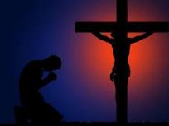
Many Christians, when confronted with a trial or temptation, choose to fight using only their human strength. After repeated tries and exhausting the limits of their capabilities, they give up and declare, “I cannot do it”. The mistake here is that they have tried to overcome their trial by their own power, rather than calling on the Spirit for the godly power that will enable them to overcome that trial. As a true Christian, one should not say, “I cannot”; but admit that “I will not” or “I do not know how”. As Paul says in 1 Corinthians 10:13: “No temptation has overtaken you except what is common to mankind. And God is faithful; he will not let you be tempted beyond what you can bear. But when you are tempted, he will also provide a way out so that you can endure it.”

The Three Keys to Unlock the Secret to being Filled with the Holy Spirit

Know
Or don’t you know that all of us who were baptized into Christ Jesus were baptized into his death? (Romans 6:3)
For we know that our old self was crucified with him so that the body ruled by sin might be rendered powerless, that we should no longer be slaves to sin. (Romans 6:6)
For we know that since Christ was raised from the dead, he cannot die again; death no longer has mastery over him. (Romans 6:9)
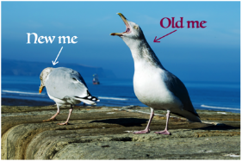
To walk in the Spirit, one must have an informed mind and act accordingly. When we say that we put our faith in Christ, we are separating ourselves from our old ways. We stop taking orders from our old life (which is familiar but abusive to our own selves) despite its screaming and shouting; rather we take on the yoke with Jesus and know that God is in control, come what may.

Consider
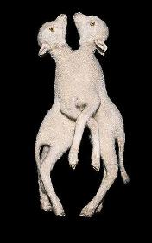
So you also must consider yourselves dead to sin and alive to God in Christ Jesus. (Romans 6:11, ESV)
Being dead to sin means to be separated from our sinful nature. At conception, man is born conjoined to his sinful nature. When a man is reborn as a Christian, the man and his sinful nature are separated, and man is in turn is joined with the Spirit.

Paul reminds us to consider our rebirth as Christians, and to recall what we have already learned and know. It is human nature to go back to what is familiar, and not put into action what we already know and learned.

Present
Do not present your members to sin as instruments for unrighteousness, but present yourselves to God as those who have been brought from death to life, and your members to God as instruments for righteousness. (Romans 6:13, ESV)

We are to present our situations to God in a pose of surrender. As long as we think that we can do it with our own willpower, we cannot and will not see God’s power because we have yet to surrender to His will.

The Deceit of Willpower
There are two truths in regards to the deceit of willpower:

Presenting without Knowing
Willpower will deceive Christians into believing they can experience God’s power without embracing the truth. You can surrender your life to Christ, but if you continue to cling on to false beliefs, you continue to be trapped in a cage you were made free from. We need to acknowledge the truth, for the truth will set us free (John 8:32).

Knowing without Presenting
Willpower will deceive non-Christians into believing they are Christians if they sincerely believe the truth. They do not realise that by only saying the prayer to Christ and sincerely (at that time) believing in Christ does not change a person into a Christian. To become a true Christian, you must present your now-born-to-Christ-self to Christ as an instrument for His glory.
For those of us who profess to be Christians, we must admit God’s truth into our lives and live out the faith of Him whom we call our Saviour; no longer tricked by our old selves, but truly live in Him.

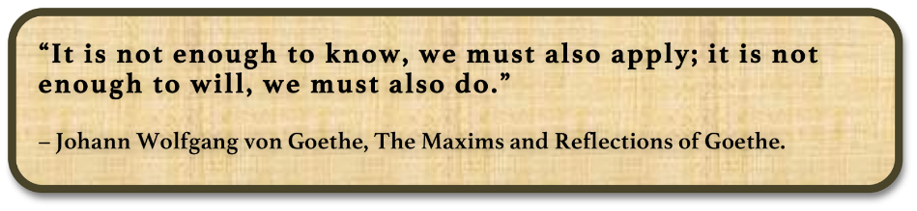
Sermons summary contributed by Chrisandra and Adeliyn.

