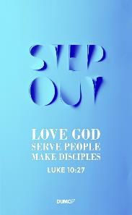
Love One Another: Putting Off Your Old Self
Pastor Tan Moy How

Since, then, you have been raised with Christ, set your hearts on things above, where Christ is, seated at the right hand of God. Set your minds on things above, not on earthly things. For you died, and your life is now hidden with Christ in God. When Christ, who is your life, appears, then you also will appear with him in glory. Put to death, therefore, whatever belongs to your earthly nature: sexual immorality, impurity, lust, evil desires and greed, which is idolatry. Because of these, the wrath of God is coming. You used to walk in these ways, in the life you once lived. But now you must also rid yourselves of all such things as these: anger, rage, malice, slander, and filthy language from your lips. Do not lie to each other, since you have taken off your old self with its practices. (Colossians 3:1-9)

Introduction
The scripture above is put in the context of the period in which the Colossian church was increasing in size and the number of people who came to know the Lord was also rising quickly. However, the Christians of the church began engaging in a pagan society, turning away from the ways of the Lord and living polytheistic lives – they worshipped and prayed to many different gods though they were strictly told not to do so by God. When Paul paid a visit to Colossae – the Colossians’ home, he felt the burden of their sins and thus, wrote this letter to them, imploring them to put their old ways to death, and to turn back to the Lord and His righteousness.

Pastor Moy How continues this series of loving one another with a sermon imploring us to put away our old ways and turn over a new leaf in our lives. If we do not kill off our old self, our old self will kill us. We must learn to let go of ourselves and allow God to prune away our old habits, before we can accept and be open to new habits that can help us to grow better as a person. He uses the analogy of walking into a clothes shop and trying some new outfits in the fitting room. If we don’t take off the old clothes that we are wearing, we simply cannot get a perfect fit of the new clothes we are going to put on.

“You were taught, with regard to your former way of life, to put off your old self, which is being corrupted by its deceitful desires; to be made new in the attitude of your minds; and to put on the new self, created to be like God in true righteousness and holiness.” (Ephesians 4:22-24)

“There is a way that appears to be right, but in the end it leads to death.” (Proverbs 14:12)

THE BIG IDEA:
You must take off the old before you can put on the new!

So then, how can we take off the old, put our old ways to death, so that we can put on the new?

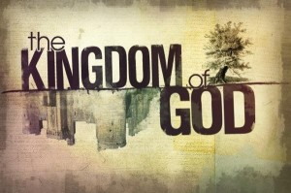
Set your eyes on The HEAVENLY (vs 1-4)
Pastor Moy How reminds us of the Kingdom mind and that we are to set our eyes not on the life that we are given here on Earth, but on the great rewards of Heaven and the goodness that Jesus Christ has to offer when we rid of our old ways. There are three truths to set our eyes on The Heavenly:

We are RAISED with Christ (Colossians 3: 1, 2)
“Do not conform to the pattern of this world, but be transformed by the renewing of your mind. Then you will be able to test and approve what God’s will is—his good, pleasing and perfect will.” (Romans 12:2)

“Finally, brothers and sisters, whatever is true, whatever is noble, whatever is right, whatever is pure, whatever is lovely, whatever is admirable—if anything is excellent or praiseworthy—think about such things.” (Philippians 4:8)

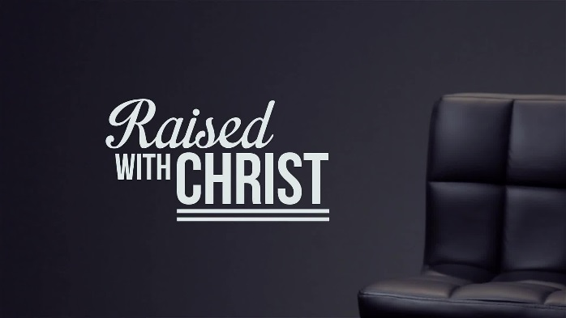
Paul implores us to set our mind on the things above, NOT on earthly things. He urges us to refocus our thought life. Do we focus on the things of this earth that are luxurious, pleasurable but temporal? Or do we focus on the permanent pleasures of Christ? Paul tells us to let God transform and renew us through changing the way we think; to let Him be in control of every part of us, including our minds, and to allow Him to guide us into righteousness and the way of Christ through the way we think – because it has the power to determine the person we are, and the posture we carry as a person through the many encounters we face in life. WHERE and WHO are you setting your eyes on today? Is it on the earthly, or The Heavenly?
“Sow a thought, reap a habit;
Sow an action, reap a habit;
Sow a habit, reap a life.”

We DIED with Christ (Colossians 3: 3)
“because anyone who has died has been set free from sin.” (Romans 6:7)

“But thanks be to God! He gives us the victory through our Lord Jesus Christ.” (1 Corinthians 15:57)
“For I am convinced that neither death nor life, neither angels nor demons, neither the present nor the future, nor any powers, neither height nor depth, nor anything else in all creation, will be able to separate us from the love of God that is in Christ Jesus our Lord.” (Romans 8:38-39)

We are ONE with Christ. He was planned to die for our sins even before we knew Him as our Saviour. There is nothing we can or cannot do that will ever make Him love us any less.

We are GLORIFIED with Christ (Colossians 3: 4)
“Dear friends, now we are children of God, and what we will be has not yet been made known. But we know that when Christ appears, we shall be like him, for we shall see him as he is.” (1 John 3:2)

Put to DEATH the earthly (vs 5-6)
As we look upward to Christ and move forward in His ways and prepare ourselves for His return, we put to death our old ways of living. We rid ourselves of our old habits and behaviours, and look to God for guidance as He walks this new life with us hand in hand.
“Whoever claims to live in him must live as Jesus did.” (1 John 2:6)

Putting away our ‘old habits’ also includes us ridding ourselves of any form of sexual sins in our lives.
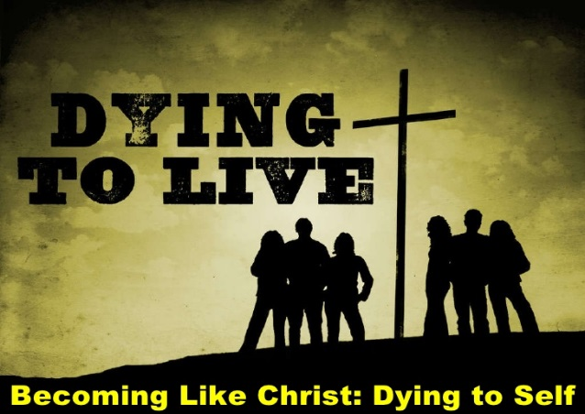
Sexual sins:
- Sexual immorality
- Impurity
- Lust
- Evil desires
- Greed / Covetousness
“Do you not know that your bodies are temples of the Holy Spirit, who is in you, whom you have received from God? You are not your own; you were bought at a price. Therefore honor God with your bodies.” (1 Corinthians 6:19-20)

“But among you there must not be even a hint of sexual immorality, or of any kind of impurity, or of greed, because these are improper for God’s holy people.” (Ephesians 5:3)

Rid of the Old ‘Selfy’ (vs 7-9)
Scripture tells us to rid ourselves of our fleshly sins, such as:
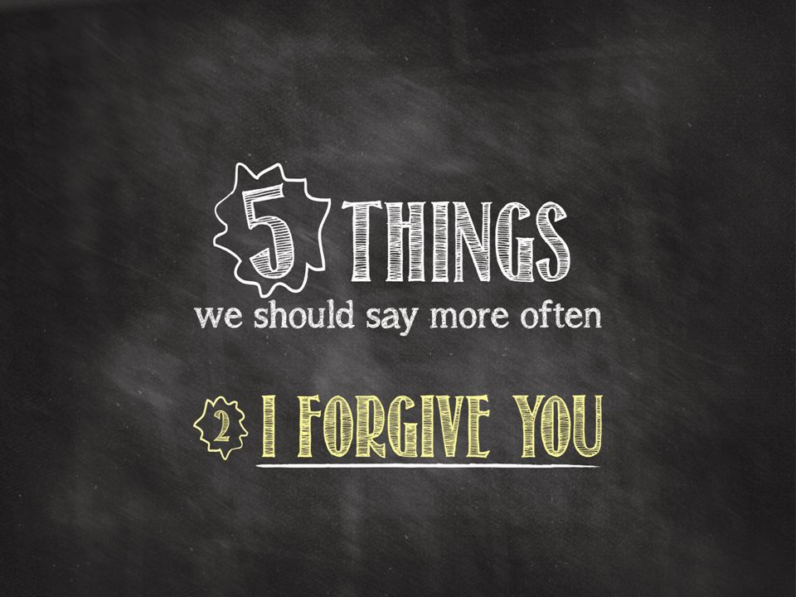
“Emotion” sins
- Anger
“and do not give a foothold to the devil.” (Ephesians 4:27)

- Rage
“Stop being angry! Turn from your rage! Do not lose your temper – it only leads to harm.” (Psalm 37:8)

- Malice
“rid yourselves of all malice” (1 Peter 2:1)
“Tongues” sins – spoken words intended to hurt and cut
- Slander
“A troublemaker plants seeds of strife; gossip separates the best of friends.” (Proverbs 16:28)

- Filthy Language
“Do not let any unwholesome talk come out of your mouths, but only what is helpful for building others up according to their needs, that it may benefit those who listen.” (Ephesians 4:29)

- Lying
“A half truth is a whole lie”
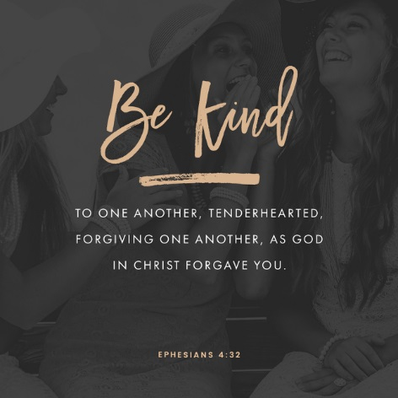
“You belong to your father, the devil, and you want to carry out your father’s desires. He was a murderer from the beginning, not holding to the truth, for there is no truth in him. When he lies, he speaks his native language, for he is a liar and the father of lies.” (John 8:44)

“Whoever of you loves life and desires to see many good days, you’re your tongue from evil and your lips from telling lies.” (Psalms 34:12-13)

Conclusion
“God wants you to wear the grace-clothes, not the grave-clothes!” ~Warren Wiersbe
Sermon summary contributed by Phoebe Leong
Prayer Points contributed by Loong
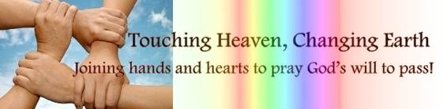

SERMON: Love One Another – Put off Your Old Self
Pray:
- As Christians, we will remember God gave us new life and we must not allow our past to haunt us.
- We will allow the old carnal self to die and will not give any opportunity for it to come back.
- We will allow ourselves to be set free by God to walk with Him.
- We will find strength from God to resist and flee from impure thoughts.
- We will be mindful of our emotions and not commit any sins.
- We will be transformed by the renewal of our minds by the Holy Spirit by seeking Him and obeying Him every day.
Therefore, if anyone is in Christ, the new creation has come. The old has gone, the new is here! (2 Corinthians 5:17)

MINISTRIES & EVENTS: Prayer as a Lifestyle
Max Lucado said, “"Our prayers may be awkward. Our attempts may be feeble. But since the power of prayer is in the one who hears it and not in the one who says it, our prayers do make a difference." Martin Luther observed that “"To be a Christian without prayer is no more possible than to be alive without breathing."
Pray:
- We will set time to pray, in the weekly prayer meetings, zone prayer meetings, during celebration, Cell Group meetings, family prayer altars, at work, etc.
- We will recognize the importance of prayer in the life as a Christian and treasure the time we spend with God and one another.
- We will come to God in the right posture and attitude, with thanksgiving, with clean hands and a pure heart.
- We will not rush past our precious prayer time with God, instead we will choose to linger in His presence and wait on Him. We will understand that “time spend in prayer is never wasted.” (Francis Fenelon)
- We will come with expectation when we approach the throne of grace and place our trust in God.
Do not be anxious about anything, but in every situation, by prayer and petition, with thanksgiving, present your requests to God. And the peace of God, which transcends all understanding, will guard your hearts and your minds in Christ Jesus. (Philippians 4:6, 7)
MALAYSIA MY NATION: Kuala Lumpur 2017
Kuala Lumpur 2017 (KL2017) is the brand name of the 29th Southeast Asian Games and the 9th ASEAN Para Games. The Southeast Asian Games will take place between 19th and 30th August 2017. The ASEAN Para Games will be held from September 17th to 23rd, 2017. The Games will coincide with the celebration of Malaysia's 60th Independence Day as well as Malaysia Day. It will be the sixth time that Malaysia hosts the biennial games.
Pray:
- The SEA Games and ASEAN Para Games will be a platform for the nations to foster even better relationship.
- The athletes will compete fairly with emphasis on sportsmanship.
- The games will be carried out smoothly and fairly. Volunteers will give a great impression to visitors.
- Tourists and local citizens will enjoy the events.
- The events in conjunction with the Merdeka Day and Malaysia Day will generate much fanfare and interest that benefits the local tourism industry and related businesses.
Do you not know that in a race all the runners run, but only one gets the prize? Run in such a way as to get the prize. (1 Corinthians 9:24)

- A TRANSFORMED WORLD: Elections
Elections were just concluded in the African nations of Senegal and Rwanda, with an important election in Kenya on the horizon. The opposition led by the former president will contest the election result in Senegal. Violence and even murders were reported prior to the elections in both Senegal and Kenya.
Pray:
- The elections will be conducted in a free and fair manner so the people can choose who to form the government.
- The ruling coalition and the opposition will focus on what they can offer the nation and the people instead of resorting to force, intimidation, rhetoric and empty promises.
- The elected will choose to use their position to make their nations a better place.
- The government elect will understand they need to be accountable and responsible.
- Politicians who practice corruption and dirty tactics will be exposed and rejected.
for dominion belongs to the Lord and he rules over the nations. (Psalm 22:28)

