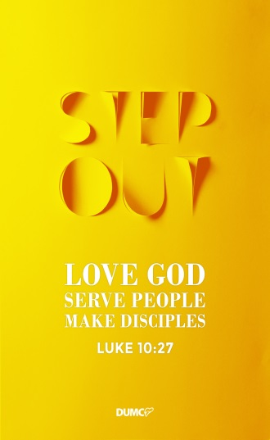
Love One Another: Putting on Your New Self
Senior Pastor Chris Kam

Do not lie to each other, since you have taken off your old self with its practices and have put on the new self, which is being renewed in knowledge in the image of its Creator. Here there is no Gentile or Jew, circumcised or uncircumcised, barbarian, Scythian, slave or free, but Christ is all, and is in all. Therefore, as God’s chosen people, holy and dearly loved, clothe yourselves with compassion, kindness, humility, gentleness and patience. Bear with each other and forgive one another if any of you has a grievance against someone. Forgive as the Lord forgave you. And over all these virtues put on love, which binds them all together in perfect unity. Let the peace of Christ rule in your hearts, since as members of one body you were called to peace. And be thankful. Let the message of Christ dwell among you richly as you teach and admonish one another with all wisdom through psalms, hymns, and songs from the Spirit, singing to God with gratitude in your hearts. And whatever you do, whether in word or deed, do it all in the name of the Lord Jesus, giving thanks to God the Father through him. (Colossians 3:9-17)

Introduction
Last week, we learned about how to rid our old self, in preparation for a brand new self in Christ. Both the old and the new self in us are affecting people around us. The question is, how does it affect others? The answers to this question depends entirely on something that we need to work on.

BIG IDEA: Putting on your new self is a choice.

V10 …and have put on the new self, which is being renewed in knowledge in the image of its Creator.
V12 … clothe yourselves with compassion, kindness, humility, gentleness and patience.

Put on and Clothe yourself In Greek, it is called “enduo” which describes the idea of putting on clothes. It is like the superhero figures in the comic world, such as Dr. Strange and Superman, they “enduo” themselves with an outfit that brings out the super sides in them, in a positive way.

Such an analogy leads to the comparison between a carnal man and spiritual man, where we can consciously make a choice to be spiritual. By end of this sermon message, we should come to the realization that the way we live our Christian life depends on the choices we make. To take off our old self and put on a new self, is entirely our choice to make. Let us explore together on ways to make the right choices in our life.

Put OFF
Put to death, therefore, whatever belongs to your earthly nature: sexual immorality, impurity, lust, evil desires and greed, which is idolatry… But now you must also rid yourselves of all such things as these: anger, rage, malice, slander, and filthy language from your lips. Do not lie to each other, since you have taken off your old self with its practices (Colossians 3:5,8,9)

The heart is deceitful above all things and beyond cure. Who can understand it? (Jeremiah 17:9)
In real life, we are constantly struggling, and the only time we stop struggling is when we die. Some people are too comfortable staying in their old self, and made the choice to not follow Godly advice. It is pleasurable in the short term, but destructible in the long term. It points to the analogy where people (especially men) refuse to throw away the old and disgusting looking clothes in their closet because it is “too comfortable”.

Many will follow their depraved conduct and will bring the way of truth into disrepute. (2 Peter 2:2)

On the other hand, it is also possible for people to form Godliness on the outside but have yet to deal with their inner self. For example, anyone who wears a Superman outfit does not grant him (or her) superpowers. It only contributes to outward appearance, but no superpowers (for example “You cannot fly”).

having a form of godliness but denying its power. Have nothing to do with such people. (2 Timothy 3:5)

For people who constantly wear a mask, his/her old self will come out sooner or later. In due time, people will see through you. As such, we must die to self and put off conflict through throwing out the old self in us. Otherwise, it will only make yourself and others miserable. PUT ON NEW SELF!

Put ON (Colossians 3:10-12)
After putting off the old self, we need to put on the new! But how do we do that, and what do we put in it?
…and have put on the new self, which is being renewed in knowledge in the image of its Creator. Here there is no Gentile or Jew, circumcised or uncircumcised, barbarian, Scythian, slave or free, but Christ is all, and is in all. Therefore, as God’s chosen people, holy and dearly loved, clothe yourselves with compassion, kindness, humility, gentleness and patience. (Colossians 3:10-12)

How do you put on?
…and have put on the new self, which is being renewed in knowledge in the image of its Creator. (Colossians 3:10);

Since, then, you have been raised with Christ, set your hearts on things above, where Christ is, seated at the right hand of God. Set your minds on things above, not on earthly things. (Colossians 3:1-2);
Do not conform to the pattern of this world, but be transformed by the renewing of your mind. Then you will be able to test and approve what God’s will is—his good, pleasing and perfect will. (Romans 12:2)

The most undisciplined part of ourselves is our mind, which causes us to do many things in life that we do not want to do. When the scripture says “Do not conform”, it is referring to the choices we make through setting our hearts and minds not on earthly things but on God’s perfect will.

As some might be visualizing spiritual warfare to be a physical battle between the devil and our own flesh, well, we do not fight with the devil “that” way, literally. It is usually the case where the devil runs havoc in our mind; that is when spiritual warfare takes place. That is why our mind must be conformed to God, and not the world. We need to put new mind to fight spiritual battle.

Different people see one same situation differently through different mindsets. So many in our midst are struggling because we have not renewed our minds.

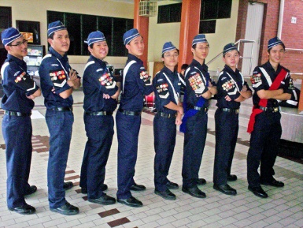
It is interesting how by putting on the new self, it helps us form new a mind. For example, one may find it perplexing when a woman looks into her wardrobe filled with clothes, yet still comments, “I have nothing to wear!” We like to wear new clothes; we want to wear something that makes us look good. Why? Because we want to feel good and draw people to us. An example that we see in church would be the Tamil congregation where there are many broken families who are constantly struggling with issues of gangsterism. The church started something called the “Boys Brigade” for the children (that recruits girls too!), which requires them to put on a uniform. Interestingly, the moment they put on their uniform, they follow orders!

When we find our new self in Christ, we change. It is done consciously by choice that we make every single day.

What do you put on?
…clothe yourselves with compassion, kindness, humility, gentleness and patience. (Colossians 3:12b)

We need to put on the fruits of the spirit. After which we have done so, we do not earn a road to immortality and we will still die one day. But, the greatest miracle in life is the changed of life in us, for it is VERY hard to change the heart of a human’s life.

When we change, everything changes. A non-believer father disapproved the baptism of his son, but once he witnessed the change in his son, he had a change of mind. This is how our new self affects others around us.

If anyone, then, knows the good they ought to do and doesn’t do it, it is sin for them. (James 4:17)

Put RIGHT (Colossians 3:13-17)
The Bible also talks about putting RIGHT, especially in terms of relationship:

Bear with each other and forgive one another if any of you has a grievance against someone. Forgive as the Lord forgave you. And over all these virtues put on love, which binds them all together in perfect unity. Let the peace of Christ rule in your hearts, since as members of one body you were called to peace. And be thankful. Let the message of Christ dwell among you richly as you teach and admonish one another with all wisdom through psalms, hymns, and songs from the Spirit, singing to God with gratitude in your hearts. And whatever you do, whether in word or deed, do it all in the name of the Lord Jesus, giving thanks to God the Father through him. (Colossians 3:13-17)

Flee from sexual immorality. All other sins a person commits are outside the body, but whoever sins sexually, sins against their own body. (1 Corinthians 6:18)

Formerly he was useless to you, but now he has become useful both to you and to me. (Philemon 11)

Traits that leads to a holy life
From Colossians 3:13-15, Bible teaches us the following traits that leads to a Holy Life:

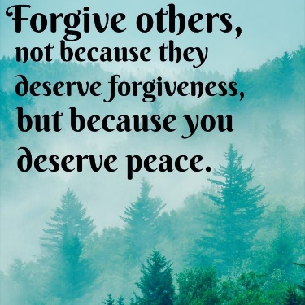
A. Forgiveness
Bear with each other and forgive one another if any of you has a grievance against someone. Forgive as the Lord forgave you. (Colossians 3:13)

Is the above verse speaking right to your heart? Put it on right now! God is speaking to you!

Love
And over all these virtues put on love, which binds them all together in perfect unity. (Colossians 3:14)
Putting on love is a choice, and not depending on how you feel. Interestingly, you can love a person without liking a person. Because it is a CHOICE that we make! An example for the married couples would be hearing from a man’s mind, “I don’t FEEL like I love my wife, but I CHOOSE to love her”— the outcome is determined by how one chooses in life.

Peace with one another
Let the peace of Christ rule in your hearts, since as members of one body you were called to peace. And be thankful. (Colossians 3:15)
In midst of our congregation, we often greet one another with the word “Shalom”— which means “The peace of God be with you.” Imagine you are seated near someone that you do not like! Well, we may not instantly like that person just because we are in church, but we can choose to love him/her through the love Christ has for us. Always remember that while Christ died for us, we are still sinners. God really hated the sins in us, but He loves us.

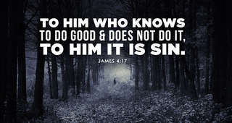
Having understood that love and hate can go hand in hand, it is imperative to know that it is (now) okay not to be okay. But it is NOT okay to REMAIN that way. We must go beyond and make it right. While it is the sins of commission when we do something wrong, it is also the sin of omission when there is something we ought to do but do not do it.

If anyone, then, knows the good they ought to do and doesn’t do it, it is sin for them. (James 4:17)

In short, when we put on the new self, this church becomes a healing community.

How are we to acquire these traits (Forgiveness, Love & Peace)?

A. God’s WORD
We acquire traits that lead to a Holy Life through obedience to God’s Word.

Let the message of Christ dwell among you richly as you teach and admonish one another with all wisdom through psalms, hymns, and songs from the Spirit, singing to God with gratitude in your hearts. (Colossians 3:16)

B. Christ’s BODY
It is through the message from Christ’s body on the cross that we learn about His love and forgiveness for us sinners.

C. Holy Spirit’s ENABLING
And whatever you do, whether in word or deed, do it all in the name of the Lord Jesus, giving thanks to God the Father through him (Colossians 3:17)

The motto for life should be “Active life of service to please God”.

Boundaries
- When we truly want to put right with God, we would want to get rid of the old self in us.
- When we want to rid the old self, we repent.
- When we repent, the mind gets it the body does it.

The concern of today’s church, especially for those aged 20 to 35, or anyone susceptible to the boundaries and certain choices in life, is when Christians put themselves in a situation where they “think Christianly” (spirit is willing) but flesh is too weak (that is when the body does not act according to the mind!). A scenario that is so real and tempting in the real world would be heavily discounted air fares and a non-married couple planning to go on a trip together with sleeping arrangement that may ultimately lead to bondage in life.

Remembering the message preached by Brother Terry two weeks ago, boundaries are closely linked to how one chooses life. The three ultimate questions that are helpful to assist us in aligning our way back to Christ are:

- Will it (our CHOICE) cause obedience or disobedience to God?
- How does it (our CHOICE) affect people around me?
- Will it (CHOICE) ultimately lead me to freedom or bondage?

Remember, some decisions may seem like a good idea (since everyone else is doing it) - but that does not mean it is God’s idea! Sometimes, the old self in us is too strong that the renewal of the mind is too difficult.

If leaders in our midst make a decision that reflects DISOBEDIENCE to God, it casts doubts in us about them (AFFECTING us). The Bible taught us to flee from sexual immorality. If our mind is renewed, we will make the right choice, and the right choice will lead us into FREEDOM.

But among you there must not be even a hint of sexual immorality, or of any kind of impurity, or of greed, because these are improper for God’s holy people. (Ephesians 5:3)

When we begin to read the word of God, our mind will be renewed powerfully. The standard God has for us if to be in our new self. When we do that, something powerful is going to happen. A powerful example in the Bible is when Paul pleads for Onesimus, who has put off his old self and put on a new one:

Formerly he was useless to you, but now he has become useful both to you and to me. (Philemon 11)

“He” was a runaway slave. “You can take him back” because he is a new man. God is changing from useless to useful—the only way to be useful, no matter who we are and what our status in life is, it is so clear that God can turn us from old to new!

Testimony:
Pastor Chris once shared a story about power blackout in a restaurant where he and his family were dining in. The family continued with their meal and conversation in the dark and in midst of all other complaining customers. When they were done and asked for the bill, to their surprise, the bill as waived. The manager thanked the family as they are the only table who made no fuss about the power blackout.

Recently, Pastor Chris received a message from a church member who shared his own experience in a restaurant. A server had accidentally spilled two dishes right in front of him - the tofu and vegetables were all over the table and on him. The first thing that came across his mind was Pastor Chris’ testimony, and in reaction, he was calm and merciful.

The testimony above tells that the man has put on his new self. If it was his old self, he would have reacted very differently by screaming and shouting at the server and all others that come into the picture. But instead, he said “It is okay”. This is compassion, kindness, humility, gentleness and patience (Colossians 3:12). It is Shalom, for the peace of God was with him!

CONCLUSION
In summary to all that is mentioned in this sermon, putting on new self is a choice. It is constantly crucial for us to make the right choice, such as choice to be in a cell group where we admonish one another and pointing out the old self to rid. Always remember the 5 core habits of DUMC:

- Honour
- Humility- remain humble!
- Be real
- Pass it on
- Have fun

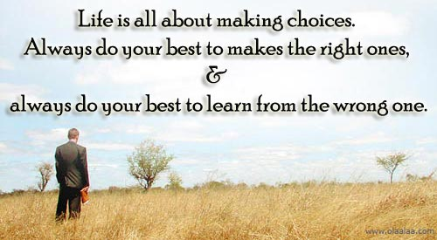

Sermon summary contributed Chrisandra Wong
Prayer Points by May Ng
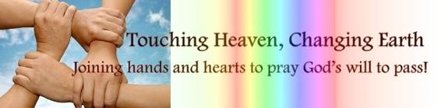

SERMON: Love One Another – Put on Your New Self
Pray:
- Awareness that the Christian’s battle is in the spiritual realm.
- Christians to arm themselves with the armour of God, in fighting against spiritual warfare.
- Christians no longer are prisoners of their past; now they are in Christ, they are a new creation.
- Christians to heed the promptings of the inner voice of the Holy Spirit guiding them.
- Freedom from any bondage that the truth can only be found in Jesus.
Put on the full armour of God, so that you can take your stand against the devil’s schemes. (Ephesians 6:11)

MINISTRIES & EVENTS: The Marriage Course
The Marriage Course is a series of seven sessions, designed to help couples invest in their relationship and build a strong marriage.DUMC is hosting this instalment of The Marriage Course.
Pray:
- Awareness that a strong marriage is the foundation of an exemplary society.
- Spouses to honour one another.
- Marriages be Christ-centred.
- Participants in the course will commit to attending the entire duration, and to encourage their friends to attend.
- Wisdom and honesty to prevail in the sessions.
The Lord God said, “It is not good for the man to be alone. I will make a helper suitable for him.” (Genesis 2:18)
MALAYSIA MY NATION: Sexual abuse of children
Of late, there has been an increase in reports in the sexual abuse of children.
Pray:
- Awareness that children are a gift from the Lord to be nurtured and treasured.
- True agape love to prevail in families.
- Strong family units, in order to raise godly, healthy, children.
- Undue media influences to be eradicated completely.
- Wisdom to do the correct thing.
- Holy Spirit to flood all the households in Malaysia.
Children are a heritage from the Lord, offspring a reward from him. (Psalm 127:3)

- A TRANSFORMED WORLD: Exchange of Threats between the US and North Korea
US President Donald Trump appeared to have threatened nuclear war on North Korea, saying he would unleash "fire and fury like the world has never seen" if Pyongyang continued to threaten the US or its allies.
Pray:
- Heads of countries will focus on bilateral relations.
- Amicable and warm relationships among heads of countries.
- Realisation that war is not a solution to any problems.
- Wisdom and diplomacy to deal with any potential conflicts between countries.
- God to be glorified.
"Even before you begin your attack, while your plans are ripening like grapes, the Lord will cut off your new growth with pruning shears. He will snip off and discard your spreading branches." (Isaiah 18:5)

