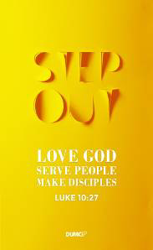
Looking Back to Look Forward: Christ in Leviticus
Pastor Alex Tan

Then Aaron lifted his hands toward the people and blessed them. And having sacrificed the sin offering, the burnt offering and the fellowship offering, he stepped down. Moses and Aaron then went into the tent of meeting. When they came out, they blessed the people; and the glory of the Lord appeared to all the people. Fire came out from the presence of the Lord and consumed the burnt offering and the fat portions on the altar. And when all the people saw it, they shouted for joy and fell facedown. (Leviticus 9:22-24)

The law is only a shadow of the good things that are coming—not the realities themselves. For this reason it can never, by the same sacrifices repeated endlessly year after year, make perfect those who draw near to worship. (Hebrews 10:1)

Then he said, “Here I am, I have come to do your will.” He sets aside the first to establish the second. And by that will, we have been made holy through the sacrifice of the body of Jesus Christ once for all. Day after day every priest stands and performs his religious duties; again and again he offers the same sacrifices, which can never take away sins. But when this priest had offered for all time one sacrifice for sins, he sat down at the right hand of God, and since that time he waits for his enemies to be made his footstool. For by one sacrifice he has made perfect forever those who are being made holy. (Hebrews 10:9-14)

Introduction
Let’s face it. Most of us have never truly read and understand the terms and conditions of every (if any) application or update we downloaded. We would just hunt for the “Agree” button to click and be done with it!

Unfortunately we treat many books in the Old Testament (like Leviticus) the same like the modern day terms and conditions. It is important for us to recognize and understand the old books in order to fully understand and appreciate what Christ has done and is continuing to do for those who profess the Christian faith.
The Big Idea:
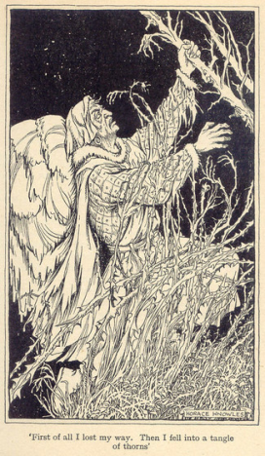
CHRIST is Enough.

The Weight of Sin
“Leviticus” literally means the Book of Law. It was basically God (through Moses) giving the Israelites basic instructions on how to live with one another as God’s redeemed people. It presented that God is Holy – like a lava pit that is magnificent from a distance, but extremely dangerous when near. The people could not approach Him, yet He dwelled with them in the wilderness. Leviticus allows all to see where we stand against the holiness of God – that our lives are literal minefields since we could offend God is various ways, with or without intending to.
For the life of a creature is in the blood, and I have given it to you to make atonement for yourselves on the altar; it is the blood that makes atonement for one’s life. (Leviticus 17:11)

The book also provides the Israelites restitution for everything through sacrifice (Leviticus 1-7): a messy, costly and tedious affair.
- Messy, because of the animal’s blood and organs.
- Costly, because cows, sheep and goats are not cheap even in those days.
- Tedious, because the animal cannot have ANY blemish or weakness – imagine going through an entire flock for one animal!
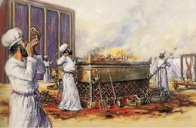
Just to give you a taste of how many animals you would have needed to sacrifice since the day you were born, go to http://crossward.org/bullsandgoats
Thank God that we are no longer required to do these when He sent Jesus to be the Perfect Sacrifice, as the last sacrifice require as atonement for the sins of the world! (Hebrews 10: 1, 11-14)

We ourselves are blemished from birth as the curse of Adam and Eve’s sin. God gave us His best. What then can we bring to Him? It is in serving one another in love, and giving our best – not giving God our leftover time and efforts.

The Way of the Priest
You also, like living stones, are being built into a spiritual house to be a holy priesthood, offering spiritual sacrifices acceptable to God through Jesus Christ. (1 Peter 2:5)
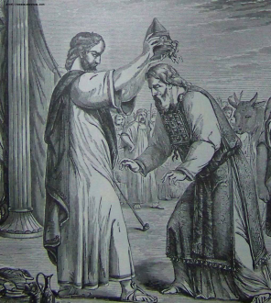
He then presented the other ram, the ram for the ordination, and Aaron and his sons laid their hands on its head. Moses slaughtered the ram and took some of its blood and put it on the lobe of Aaron’s right ear, on the thumb of his right hand and on the big toe of his right foot. (Leviticus 8: 22-23)
When we profess faith in Christ, we are then ordained into the holy priesthood. Moses had ordained Aaron and his sons by putting blood on the ear, thumb and big toe on the right side of the body. These parts of the body are significant as:
- Ear = Words : Talk less, listen more to God and people. Do our words encourage and bless?
- Thumb = Action : Do it for God, not for people’s affirmation. Do our actions glorify God?
- Big Toe = Walk : Live our lives as God’s ordained priests. How is our walk with God?

Jesus is our Great High Priest. His sacrifice has given us a direct access to God.
For there is one God and one mediator between God and mankind, the man Christ Jesus, (1 Timothy 2:5)

He, who was tempted in every way while in the flesh but was without sin, is able to empathize with our weaknesses. This gives us the assurance and confidence to approach God. (Hebrew 4:14-16)

The Wonder of Christ
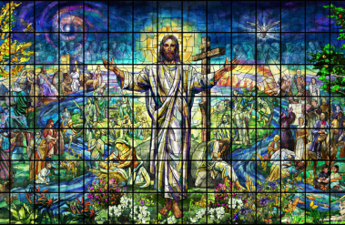
Very truly I tell you, a time is coming and has now come when the dead will hear the voice of the Son of God and those who hear will live. (John 5:35)

Jesus is the Pioneer and Perfecter of faith (Hebrews 12:1-2). Look to Him and know that He is the Perfect Sacrifice, the Great High Priest and the Author and Perfecter of Faith.

Conclusion
The end cannot be understood without the beginning. We will not be able to appreciate or understand the sacrifice God made for us while we were yet sinners, as we do not know what we are saved from.

Our challenges as we look at the wonder of Christ are:
- Take stock of our Words, Action and Talk
- Recognize that God takes care of it all, and to be sanctified daily
- Go to Him daily, as He has paid it all.

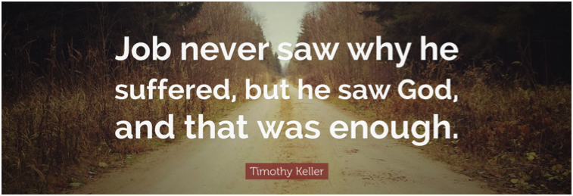

Sermon summary contributed by Adeliyn.
Prayer points contributed by Michelle.

SERMON: Discovering Christ In Leviticus
- God's people will repent of their sinful ways by turning away from their sinful ways and look to Christ, the pioneer and Perfect One sent by God.
- We will intentionally set aside ourselves to meet the needs of others by giving our best to serve Christ.
- People of God will follow the Way of Christ, our Great High Priest in serving others through His spiritual gifts.
- We will allow the Holy Spirit to use us in spreading God’s revelation by taking stock of our Words, Actions and Walk daily.
"Then he opened their minds so they could understand the Scriptures. He told them, ‘This is what is written. The Messiah will suffer and rise from the dead on the third day, and repentance for the forgiveness of sins will be preached in His name to all nations, beginning at Jerusalem. You are witnesses of these things.” (Luke 24:45 - 48)

MINISTRIES & EVENTS: MISSIONS VOLUNTEERS: MCPP1
7 & 8 October 2017
Pray:
- God will convict the hearts of all believers to answer the call to sign up for MCPP1.
- God will inspire more mission workers to step up and avail themselves for this ministry.
- God will enable His people to be united and build up one another through his calling for this ministry.
- God will bless the leaders in charge with wisdom, knowledge and understanding to do His Will.
For the Lord gives wisdom; from his mouth come knowledge and understanding.
(Proverbs 2:6)

MALAYSIA MY NATION : Future of Malaysia - 40 Days Fast & Prayer for Kensiu Tribe in Kg Lubok ,
Pray:
- More people of God in Kedah will step out to reach out to the Kensiu Tribe to minister to them.
- State Government will step up to provide basic amenities such as tap water & electricity for the tribal people in Baling & Kubang Pasu districts.
- God’s protection and deliverance upon the Kensiu tribe from alcoholism and glue sniffing through new life in Christ.
- God’s peace, authority and protection on all and we are thankful for all His grace and mercies.
I urge, then, first of all, that petitions, prayers, intercession and thanksgiving be made for all people- for kings and all those in authority, that we may live peaceful and quiet lives in all godliness and holiness.(1 Timothy2 :1-2)

- A TRANSFORMED WORLD: China – Hong Kong
Calamities- Typhoon Hato & Cyclone Pakkhar
Pray:
- God's wisdom on Christian leaders who are involved in rescue missions from the aftermath of typhoon Hato.
- God’s strength, comfort and protection upon the victims and their families as they face the tragedy.
- Wisdom and providence for the people of God providing comfort, financial support and manpower during this tragedy.
- God to give wisdom to the authorities to prepare for the next impending calamity.
But you Lord, are a shield around me, my glory the One who lifts my head high. (Psalm 3:3)

