Living Christ Out in Community: Act Justly
Sister Margaret Loy

Then they came to Jericho. As Jesus and his disciples, together with a large crowd, were leaving the city, a blind man, Bartimaeus (which means “son of Timaeus”), was sitting by the roadside begging. When he heard that it was Jesus of Nazareth, he began to shout, “Jesus, Son of David, have mercy on me!”
Many rebuked him and told him to be quiet, but he shouted all the more, “Son of David, have mercy on me!”
Jesus stopped and said, “Call him.”
So they called to the blind man, “Cheer up! On your feet! He’s calling you.” Throwing his cloak aside, he jumped to his feet and came to Jesus.
“What do you want me to do for you?” Jesus asked him.
The blind man said, “Rabbi, I want to see.”
“Go,” said Jesus, “your faith has healed you.” Immediately he received his sight and followed Jesus along the road. (Mark 10:46-52)

Introduction
Here’s a brief account of the story:
Jesus was leaving Jericho with his disciples, and Bartimaeus was sitting at the roadside, begging. There was a crowd following Jesus. This happened after the transfiguration, and Jesus had performed many miracles before this. In the same chapter, Jesus had predicted His arrest and death a third time. The disciples quarreled about who was the greatest. Jesus said He had come to serve and not to be served, and to give His life as a ransom for many.
Who are the people who are unseen and unheard?
- Those with special needs
- Those with physical disabilities
- Refugees
- Migrants
- Children at risk
- Beggars
- Homeless
- People in pain – not necessarily obvious

BIG IDEA: Jesus cares for the vulnerable and the marginalized and restores them with compassion and dignity.

Four Categories of People

Jesus
- Son of God who came to give His life as a ransom for many. He is full of mercy and grace.
- Jesus was leaving the city of Jericho (i.e. busy and on the way to something else) but He stopped when He heard the cry of Bartimaeus.
- Jesus asked the crowd to call Bartimaeus.
- Jesus spoke to Bartimaeus directly and personally.
- Jesus valued Bartimaeus.

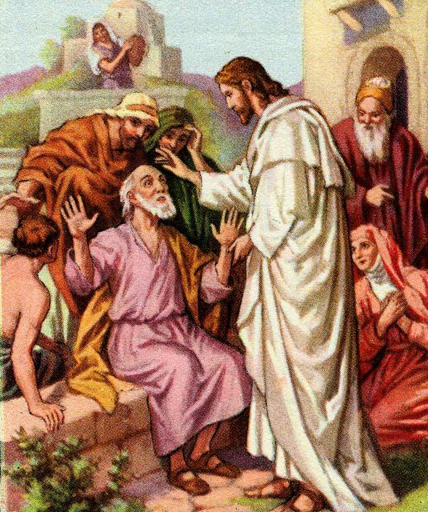
Bartimaeus
- In need of mercy
- He knew the identity of Jesus. He heard that He was Jesus of Nazareth, a miracle worker, the Son of David.
- Bartimaeus acted in faith! He cried out to Him, “Jesus, Son of David, have mercy on me”.
- Hindrances are only obstacles to be overcome. (We need to build an inner resilience to whatever is against our reaching out in faith to God.)
- He was sensitive to the voice of God. When called by Jesus he responded.
- He threw aside his cloak (his only protection from the elements), showing his faith. In reaching out to God, and in trusting God, it may require us to let go of our security blanket.

Disciples
- Lacked compassion
- They followed Jesus but did nothing. We can be next to Jesus but blind to His compassion and power. We can be dulled in our senses and paralysed into inaction by our emotions or our indecisiveness.
- The disciples were fearful because Jesus predicted His death a third time and had told them that He would be delivered to the chief priests and the teachers of the law and would be condemned to death. He would be mocked, flogged and killed. He predicted His resurrection after 3 days.

The Crowd
- Did not treat Bartimaeus with dignity and respect.
- The crowd rebuked Bartimaeus.
- The crowd went from ignoring and despising Bartimaeus to acknowledging him as a person. In chasing the sensational and the latest fad, the crowd missed the heart of Jesus, until Jesus showed them how to treat blind Bartimaeus.

How can we apply this in our context?
The crowd regards someone with disability as unimportant, as a nuisance. This is also the common cultural and societal response towards people with disabilities. People tend to shun those with disabilities and push them out of sight. They are embarrassed to be seen with them. These people with disabilities are considered as less important. They are despised and ignored.
The disciples did nothing when they heard Bartimaeus shouting. They were preoccupied with their own problems, which dulled their senses to the needs of others. They were fearful, bickering and fighting for position and power amongst themselves. They were the closest to Jesus and have witnessed countless miracles, yet they missed the point of Jesus’ compassion and power.
Bartimaeus recognised Jesus as a supernatural healer, the Son of David, the one with the Messianic title. He acknowledged Jesus’ Lordship. He cried out to God and was healed, despite the rebuke and discouragement from the crowd.
Jesus responded in compassion towards Bartimaeus. He healed him. Jesus practiced a different value system. He looked at the faith of the individual. He loved the children, the widows, the sick and the vulnerable. He touched even the lepers. He restored them socially to society. He honoured their simple faith.

Conclusion
Jesus cares for those in pain (the vulnerable and the needy) and restores them with compassion and dignity. When we reach out to others and care for them, we do not need to worry about the results. Just leave that to God.
Many people are in pain, so we should help one another. Let us stop and listen, be empathetic. Let us hear and respond in human kindness, to reflect and decide what to do. Let us be a channel of God’s blessing. It takes leadership, strategizing and the investment of resources, such as time and money.
There are two spheres of consideration in reaching out to others: The personal sphere of influence, such as family, friends and workplace; and the corporate sphere of influence, such as organisations, church, network, state and the nation.
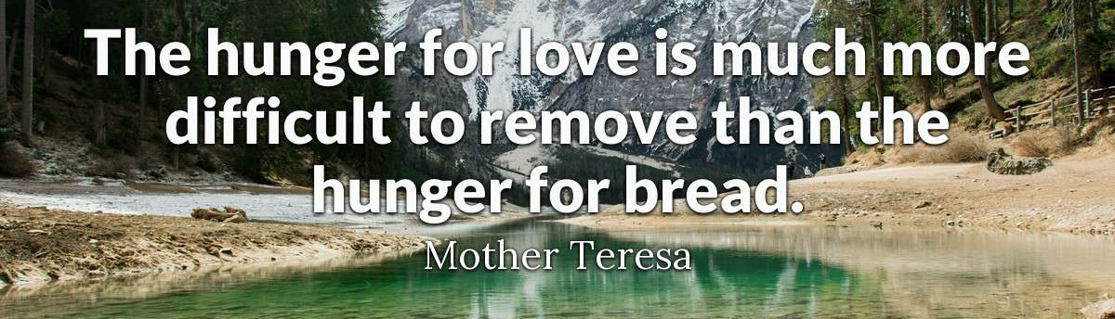
Sermon summary contributed by Anthea Tan
Prayer points contributed by Wendy ML

SERMON: Love Mercy
- God's people will repent of their sinful ways by turning away from their sinful ways and look to Christ, the pioneer and Perfect One sent by God.
- We will intentionally set aside ourselves to meet the needs of others by giving our best to serve Christ.
- People of God will follow the Way of Christ, our Great High Priest in serving others through His spiritual gifts.
- We will allow the Holy Spirit to use us in spreading God’s revelation by taking stock of our Words, Actions and Walk daily.
"Then he opened their minds so they could understand the Scriptures. He told them, ‘This is what is written. The Messiah will suffer and rise from the dead on the third day, and repentance for the forgiveness of sins will be preached in His name to all nations, beginning at Jerusalem. You are witnesses of these things.” (Luke 24:45 - 48)

MINISTRIES & EVENTS: MISSIONS VOLUNTEERS: MCPP1
7 & 8 OCTOBER 2017
Pray:
- God will convict the hearts of all believers to answer the call to sign up for MCPP1.
- God will inspire more mission workers to step up and avail themselves for this ministry.
- God will enable His people to be united and build up one another through His calling for this ministry.
- God will bless the leaders in charge with wisdom, knowledge and understanding to do His Will.
For the Lord gives wisdom; from his mouth come knowledge and understanding. (Proverbs2:6)

MALAYSIA MY NATION: Future of Malaysia -40 Days. Fast & Prayer for Kedah
Kensiu Tribe in Kg Lubok, Baling
Pray:
- More people of God in Kedah will step out to reach out to the Kensiu Tribe to minister to them.
- State Government will step up to provide basic amenities such as tap water and electricity for the tribal people in Baling and Kubang Pasu districts.
- God’s protection and deliverance upon the Kensiu tribe from alcoholism and glue sniffing through new life in Christ.
- God’s peace, authority and protection on all and we are thankful for all His grace and mercies.
I urge, then, first of all, that petitions, prayers, intercession and thanksgiving be made for all people- for kings and all those in authority, that we may live peaceful and quiet lives in all godliness and holiness.(1 Timothy2 :1-2)

- A TRANSFORMED WORLD: China – Hong Kong
Calamities - Typhoon Hato & Cyclone Pakkhar
Pray:
- God's wisdom on Christian leaders who are involved in rescue missions from the aftermath of typhoon Hato.
- God’s strength, comfort and protection upon the victims and their families as they face the tragedy.
- Wisdom and providence for the people of God providing comfort, financial support and manpower during this tragedy.
- God to give wisdom to the authorities to prepare for the next impending calamity.
But you Lord, are a shield around me, my glory the One who lifts my head high. (Psalm 3:3)

