Living Free - Time: Your Time for Your Life
Senior Pastor Chris Kam

Now listen, you who say, “Today or tomorrow we will go to this or that city, spend a year there, carry on business and make money.” Why, you do not even know what will happen tomorrow. What is your life? You are a mist that appears for a little while and then vanishes. Instead, you ought to say, “If it is the Lord’s will, we will live and do this or that.” As it is, you boast in your arrogant schemes. All such boasting is evil. If anyone, then, knows the good they ought to do and doesn’t do it, it is sin for them. (James 4:13-17)

Introduction
In general, people’s pursuit in life is to get more money. We were brought up to think that money will bring happiness. So, we end up putting in more time to make money. Yet, we are never satisfied and are not happy enough. So, we end up asking ourselves, what is purpose we doing all this? Many people feel emptiness after all these years. That is why we need to learn how to live freely. What is our attitude towards time, career or money? Are we living free or are we slaves to these three things?

At the end of the day, many people are looking for a meaning in life but in the pursuit of money, they probably have the thought that they somehow not gotten it all together. As we grow older, we would begin to see (the fruits) and understand the meaning of what we have been doing (planting seeds) years before and the time that we have spent with people.
“I have come that they may have life, and have it to the full.” (John 10:10)
This verse does not just speak about our eternal salvation, but also our present lives on earth, that we can live a full life.

A common complaint that we tend to give are, “I have no time” or “I don’t have enough time.” All of us struggle with the time that we have.

We all have 24 hours - we will make time for what is important.
We tend to make it on time for a movie, but why are we late for church? We tend to spend time on our hobbies, holiday trips, business, etc. but do we spend time on church activities? No, there is no such thing as not enough time.

What does it mean to be Christlike with how we spend our time?
During Jesus’ time, there were so many people that needed healing, many that He could have visited but He did not. One example is in John 11, the story of Mary, Martha and Lazarus. Even after Jesus heard the news that Lazarus was very ill, He waited for two more days saying, “it is for God’s glory so that God’s Son may be glorified through it.” (John 11:4b)

Ask yourselves: “How do I become more Christlike?” That we may know the heart of our heavenly Father and so that the way we use our time is in accordance to the heart of God. Stay rested in God and ask, “What do I need to do and who should I meet? What is Your will in my life?”

Big Idea: The challenges in life are not about managing time, but purpose and priorities.

Do not waste your time and money for a time management seminar, if you have not sorted out your purpose and priorities in life. Turn to God and seek His will and purpose for your life.

In the “I Love My Church” series, “The local church is not just about me, it is for a purpose bigger than myself.” It is not just about living for ourselves but for the purpose of God.

Wrong Assumptions / Attitudes We Have Towards Time

Presumption
- We will not live forever. As we get much older, we begin to realize that time is ticking away and that life is short. Only then do we tend to our live life more purposefully.
- Discover that early in life and do not regret it down the road, nor repeat the mistakes that others have done before.
Now listen, you who say, “Today or tomorrow we will go to this or that city, spend a year there, carry on business and make money.” (James 4:13)
This is like a good plan. There is:
- A plan – today or tomorrow we will go.
- A place – to this or that city.
- A period – spend a year there.
- A purpose – to carry on business and make money.
Why, you do not even know what will happen tomorrow. What is your life? You are a mist that appears for a little while and then vanishes. (James 4:14)
This is a very solemn thought. Time seems to go by faster as you grow older.

Often, people use this verse in obituaries:
I have fought the good fight, I have finished the race, I have kept the faith. (2 Timothy 4:7)
As Christians, we know that death has lost its sting. We know where we’re heading or what happens after we die.

On a tombstone, there is an indication of a person’s name and the duration that he / she has lived. In between the years of birth and death, there is a “dash”. Observations:
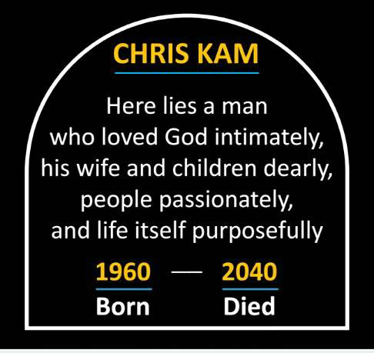
- The dash is short. Life is short.
- It is that century / unique moment that we are born in. God wants us to be where we are right now. He did not make a mistake. It is His prerogative.
- One day, we will die. So, we should invest in life wisely, and not waste time.
- We cannot rewind time. The good news is, we can redeem it.

What would happen after we die? Are we certain that we have a new place to go to someday? Do we have the wrong attitude towards time? What would be written on our tombstone or what would people say at our funeral? Do people think about Jesus when they see you?

Pride
Instead, you ought to say, “If it is the Lord’s will, we will live and do this or that.” (James 4:15)
As it is, you boast in your arrogant schemes. All such boasting is evil. (James 4:16)
Boasting about tomorrow = doing things my way.
It is important to ask ourselves, “Is this the Lord’s will? What are the fruits of the things that we do?”

If anyone builds on this foundation using gold, silver, costly stones, wood, hay or straw, their work will be shown for what it is, because the Day will bring it to light. It will be revealed with fire, and the fire will test the quality of each person’s work. If what has been built survives, the builder will receive a reward. If it is burned up, the builder will suffer loss but yet will be saved—even though only as one escaping through the flames. (1 Corinthians 3:12-15)

The “Day” refers to Judgement Day, there are 2 judgments:
- Our Salvation - when God looks into the “Book of Life” to see if your name is there. We are saved if we have accepted Jesus as our Saviour.
- Our works - what we build. We may be rewarded.
As Christians, Jesus is our foundation. There are many ways to build a foundation - it is an analogy of the things we do - gold, silver, costly stones, wood, hay or straw. What we do matters to God, and to us, for our sake. It is not how many things we do, but about doing the things that God is asking us to do. Not just in church, but out there, in the workplace.

We have many life issues and decisions to make about our family, work, money or the thought of migration. An open door does not mean it is God’s door. Sometimes, a closed door is God’s door. So, it is important to ask, what will burn up and what will survive the fire?

People often go to God when things go wrong in life. Why don’t we go to God when things are going right so we can be even better? No matter how good the sermon was or how many bible studies we attend, if we are not changed by them, they are useless. Do we really allow the bible to “instruct our behaviours.”? We have to learn to take steps of obedience - make time for God every day of your life. Start by being obedient, with the small things.

POSTPONEMENT - do it tomorrow / procrastination.
If anyone, then, knows the good they ought to do and doesn’t do it, it is sin for them. (James 4:13-17)
How many sermons, bible studies or daily devotions have changed you? Are we better disciples of Christ? God does not demand perfection, but He desires progress in our lives - sanctification - that we will become more and more Holy. We will only be perfect when we have died.

Sin is not just about the sin we do, but also about what we do not do.
Are we still postponing doing the right things?

Then Jesus came to them and said, “All authority in heaven and on earth has been given to me. Therefore go and make disciples of all nations...” (Matthew 28: 18-20)
The BIG call is so clear but there is a specific call out of that BIG call. If you understand the call, you will understand the purpose in your life. It is powerful when we realize our purposes. What is God telling you to do in life, not just in church, but out there?

Conclusion
If you sort out the purpose and priorities in your life, time will take care of itself. You will know what you ought to do or not to do.

At the end of your life, you should be able to say, “I have fought the good fight, I have finished the race, I have kept the faith.” (2 Timothy 4:7)

If you know how to die well, you will know how to live well.

It is not about how long we live, but how well we live. Jesus only lived up to 33 years old. At the end of His life, He said, “I have completed what God has asked me to.”

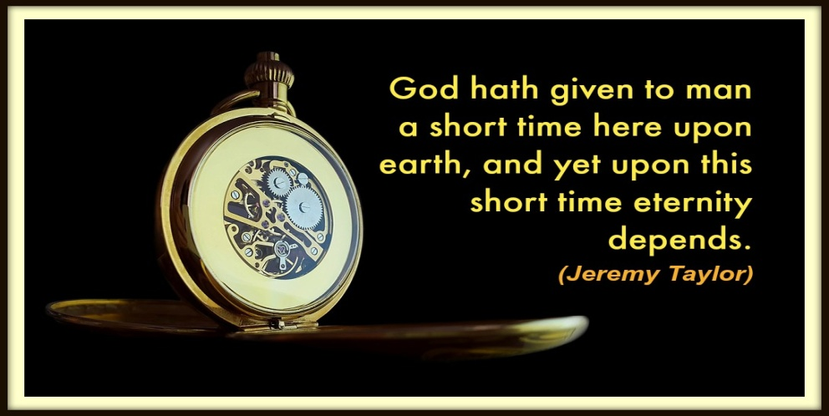

Sermon summary contributed Wendy ML.
Prayer pointers contributed by Chrisandra.

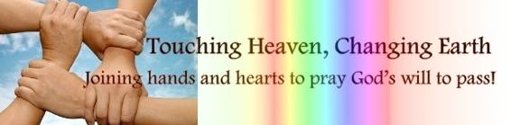

SERMON: TIME: Your Time for Your Life
Pray:
- All Christians to have a purpose in life and know how to place priorities.
- God fearing people to not possess wrong attitudes in life such as the below:
  - Presumption: People do not presume that they are going to live forever.
  - Pride: People do not do things their way and always remember God in all things that they do.
  - Postponement: People to not procrastinate but live life well and purposeful.
- All Christians to go through a reflective journey of walking with Christ.
We demolish arguments and every pretension that sets itself up against the knowledge of God, and we take captive every thought to make it obedient to Christ. (2 Corinthians 10:5)

MINISTRIES & EVENTS: Vacation Bible School (VBS)
30 November – 2 December 2017
Pray:
- Leaders’ and volunteers’ hearts to be prepared in ministering and discipling the little ones during the 3-days programme.
- Wisdom, discernment and empowerment upon the organizers and programme coordinators for a fruitful programme.
- Children who attend the programme to be blessed and touched.
- Salvation upon the non-believers children who attend.
- Unity, understanding and togetherness in between all organizing committees and members part of VBS.
But Jesus said, “Let the children come to me. Don’t stop them! For the Kingdom of Heaven belongs to those who are like these children. (Matthew 19:14)

MALAYSIA MY NATION: Flood
Even before the clean-up of Penang's floods is completed, Malaysia is bracing for more floods in the coming days. The north-east monsoon is likely to arrive in less than a week, bringing heavy rains until January to areas like Kelantan, Terengganu, Pahang, east Johor and west Sarawak. The Malaysian Meteorological Department (MetMalaysia) has warned that low-lying or flood-prone areas in these states are at risk in the event of continuous rain lasting several days. The country is expected to enter the north-east monsoon from the middle of November to March next year. (Straitstimes.com, 10 Nov 2017)
Pray:
- Thank God for armed forces as well as volunteers who rendered assistance and humanitarian support to flood victims during this period of hardship.
- Safety for volunteers and those who are directly involved in humanitarian work bringing relief to the residents of flood areas.
- Situation in all flood-hit areas to return to normal; and flood-prone areas to be well-prepared for the worst scenario.
- Capable and willing team leaders to lead clean-up operations.
- Good weather to resume as soon as possible.
Share each other’s burdens, and in this way obey the law of Christ. (Galatians 6:2)

- A TRANSFORMED WORLD: Israel Defence Forces (IDF)
The IDF values human life and helps those in need, regardless of their location. No matter the disaster, time and time again these humanitarian missions have been carried out quickly and effectively, saving thousands of lives.
Pray:
- God’s protection to be upon the IDF soldiers, alliances and volunteers against terrorist organizations and other threats and/ or attacks.
- Cooperative potential and peaceful agreements to be maintained with moderate regional elements.
- God’s people to reach out to those in need through cooperation and partnership with IDF.
- Wisdom, discernment and protection upon all who risk their lives protecting the civilians of the world during wartime and/or emergencies.
- Elimination of conflict and violence in all nations.
- God’s favour to be upon the peacemakers.
- Improvement and God’s intervention in international security.
- High quality intelligence in the formulation of defence strategy towards peace and harmony.
Unless the Lord builds a house, the work of the builders is wasted. Unless the Lord protects a city, guarding it with sentries will do no good. (Psalm 127:1)

