Beautiful King: From Humility to Servanthood (Mark 10:45; 11:1-10)
Pr Tan Moy How

“For even the Son of Man did not come to be served, but to serve, and to give his life as a ransom for many.” (Mark 10:45)

As they approached Jerusalem and came to Bethphage and Bethany at the Mount of Olives, Jesus sent two of his disciples, saying to them, “Go to the village ahead of you, and just as you enter it, you will find a colt tied there, which no one has ever ridden. Untie it and bring it here. If anyone asks you, ‘Why are you doing this?’ say, ‘The Lord needs it and will send it back here shortly.’”
They went and found a colt outside in the street, tied at a doorway. As they untied it, some people standing there asked, “What are you doing, untying that colt?” They answered as Jesus had told them to, and the people let them go. When they brought the colt to Jesus and threw their cloaks over it, he sat on it. Many people spread their cloaks on the road, while others spread branches they had cut in the fields. Those who went ahead and those who followed shouted,
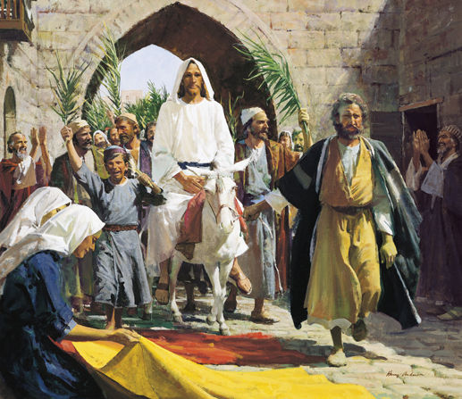
“Hosanna!”
“Blessed is he who comes in the name of the Lord!”
“Blessed is the coming kingdom of our father David!”
“Hosanna in the highest heaven!”
(Mark 11:1-10)

Introduction
Jesus’ most humbling statement is in Mark 10:45, where he says “For the Son of Man did not come to be served, but to serve, and to give his life as a ransom for many.”
Jesus, the King of kings comes in gentleness and humility, riding on a young donkey. This is a beautiful image of the beautiful King, a picture of His humility and gentleness to the people.

BIG IDEA: “Even though Christ is the King of kings, He came to serve. Let us imitate His servant heart.”

3 Descriptions of Why Christ the Humble King Came

Save

Prearrangement
As they approached Jerusalem and came to Bethphage and Bethany at the Mount of Olives, Jesus sent two of his disciples, saying to them, “Go to the village ahead of you, and just as you enter it, you will find a colt tied there, which no one has ever ridden. Untie it and bring it here. If anyone asks you, ‘Why are you doing this?’ say, ‘The Lord needs it and will send it back here shortly.’” (Mark 11:1-3)
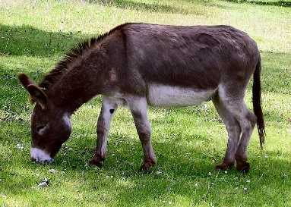
Jesus never rode on an animal during His ministry up to this point. He uses boats to traverse back and forth on the Sea of Galilee, and He walked from town to town in Israel. Bethphage is only 3 kilometres from Jerusalem. Why does He need to ride on a donkey? He made a divine prearrangement to use this colt ahead of time. With this specific instructions, He says to the two disciples, “You will find a colt there, no one has ever ridden.”
What happens when you try to ride an animal that has never been ridden before? The animal will react wildly and madly, kicking around until the rider falls off. However, that is not what happened when Jesus sat on the colt. It was a beautiful picture of the gentleness, tenderness and humility of Christ, as the Saviour to His people.

Prophecy
Jesus rode on a colt to Jerusalem to fulfil a prophecy. 550 years earlier, Zechariah had prophesied that Jesus will come to Jerusalem on a colt.
“Rejoice greatly, Daughter Zion! Shout, Daughter Jerusalem! See, your king comes to you, righteous and having salvation, gentle and riding on a donkey, on a colt, the foal of a donkey.” (Zechariah 9:9)

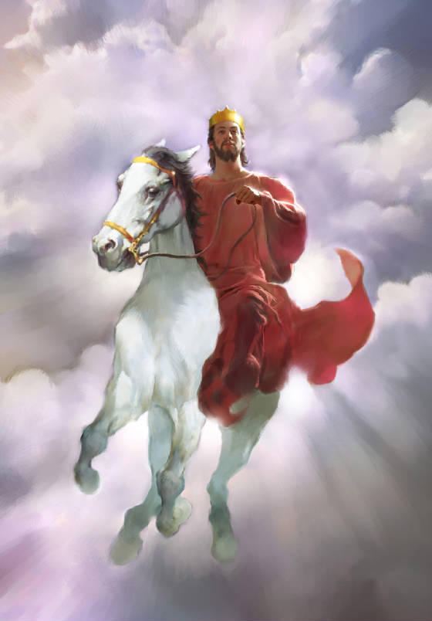
Jesus rode on a colt so that the people of the city will be reminded of this prophecy, and to show that Jesus is the true King. It is not the grandest and most glorious of all entrances, and yet it is a unique way of showing that Jesus is the prophesied Messiah that was to come. The people’s expectation was for the king to come in power and splendour, riding on a horse, with a sword in his hand, as described in Revelation 19:11-16, where the king comes with his armies, striking the nations with a sharp sword, and ruling with a rod of iron. However, it was not time for that yet.

The Jews were acquainted with many prophesies about the Messiah, which means the chosen or the anointed one. They firmly believed that Jesus the Messiah would be a strong and powerful earthly king who would deliver them from their Roman oppressors, and once again, form a great and independent Jewish kingdom. When the people awaited for the appearance of the son of David, they were hoping for the prophesied one, who would restore the kingdom of Israel under the divine lineage. Instead of coming with a sword in hand, Jesus came riding on a donkey, for He came to bring salvation and deliverance to the people who would believe in Him.

Substitute
Jesus came to be a substitute.
“For even the Son of Man did not come to be served, but to serve, and to give his life as a ransom for many.” (Mark 10:45)
Take note of the underlined word in the verse, ‘ransom’. The Greek word for ransom is λύτρα, pronounced as ‘lutron’. It refers to a payment to release someone from some kind of bondage. It is an image of someone caught in a huge, seemingly unpayable debt, a prisoner of war, a person ensnared in slavery. It is used in the New Testament of the ultimate "liberty-price" – the blood of Christ which purchases (ransoms) believers, freeing them from all slavery (bondage) to sin.

Jesus sees His death as a ransom to release many from bondage. He is paying what they cannot pay so they can go free. He is substituting himself, so that at the cost of His life, they are set free from bondage. Jesus is substituting Himself in the place of many. We should have died for our sins and wrongdoings, instead, Jesus died on our behalf, paying the price for our release from eternal death.

Exchange
Jesus came in exchange. He paid the price, in exchange for us, for our freedom. He exchanged our brokenness for His righteousness. He came to set people free from the stronghold of deep seated rejection, the prison of offense, the bondage of unforgiveness, past hurts of failed relationships, and many other bondages that ensnare people in sin and darkness.

“He himself bore our sins” in his body on the cross, so that we might die to sins and live for righteousness; “by his wounds you have been healed.” (1 Peter 2:24)

Everyone
Jesus came for everyone. He came for you and I. Jesus took the bullet for us. We deserved to die because of our sins, but Jesus came to take our place. He died on our behalf.

For there is one God and one mediator between God and mankind, the man Christ Jesus, who gave himself as a ransom for all people. This has now been witnessed to at the proper time. (1 Timothy 2:5-6)
For God so loved the world that he gave his one and only Son, that whoever believes in him shall not perish but have eternal life. (John 3:16)

God loved the world, which means everyone. The true substitute was God’s only son, Jesus, who came and died for the world.

Serve
The humble King came to serve.

One Who Waits On
“For even the Son of Man did not come to be served, but to serve, and to give his life as a ransom for many.” (Mark 10:45)
The Son of Man came to serve. Imagine the king of Kings coming to serve the people. This is the kind of humility we should emulate as His disciples.

Others First
Do nothing out of selfish ambition or vain conceit. Rather, in humility consider others better than yourselves, not looking to your own interests but each of you to the interests of the others. Your attitude should be the same as that of Christ Jesus: Who, being in very nature God, did not consider equality with God something to be used to his own advantage; rather, he made himself nothing by taking the very nature of a servant, being made in human likeness. (Philippians 2:3-7)

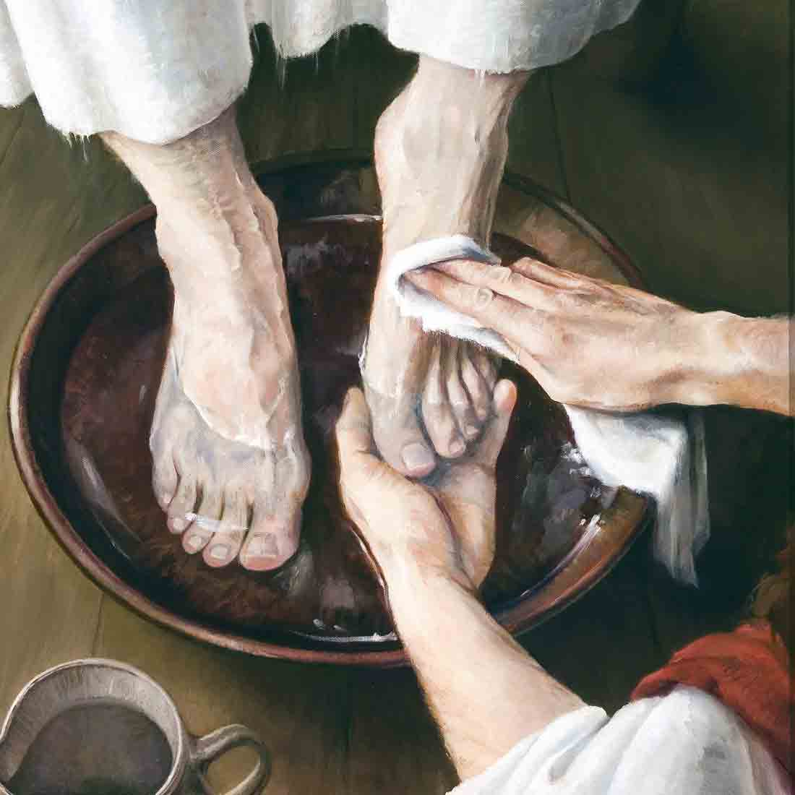
This is a wonderful account of what it means to put others first, which is exemplified by Christ the King. Serve whenever you can, wherever you can, and whoever you can. Jesus’s two disciples, James and John, the sons of thunder, were trying to hustle each other for the power of position, but Jesus lovingly instructed them to think of others first.
Jesus called them together and said, “You know that those who are regarded as rulers of the Gentiles lord it over them, and their high officials exercise authority over them. Not so with you. Instead, whoever wants to become great among you must be your servant, and whoever wants to be first must be slave of all. (Mark 10:42-44)
Conclusion
“For even the Son of Man did not come to be served, but to serve, and to give his life as a ransom for many.” (Mark 10:45)

This verse is the summary of the Gospel of Mark.
Jesus is Saviour, Substitute and Servant. He served the needs of others, and demonstrated the ultimate act of servanthood when He gave His life as a substitute for the payment of our sins so that we can be set free.

God is not unjust; he will not forget your work and the love you have shown him as you have helped his people and continue to help them. (Hebrews 6:10)

The measure of a man’s greatness is not in the number of servants he has, but in the number of people he serves.
~ John Hagee ~

Sermon summary contributed by Anthea Tan
Prayer points contributed by Abbey Thangiah

SERMON: From Humility to Servanthood
Pray:
- We will accept Jesus as the King of Kings.
- We will recognize that Jesus came to earth to fulfill the prophecy.
- We will be thankful that He became our substitute for our sins.
- We will serve others just as He served us.
- We will have the servant heart of Jesus and be humble.
For even the Son of Man did not come to be served, but to serve, and to give his life as a ransom for many. (Mark 10:45)

MINISTRIES & EVENTS: Christmas Season
Pray:
- God to prepare our hearts to invite pre-believers to attend the celebration.
- God's protection upon all who are preparing for the Christmas Celebration.
- Journey mercy for those who are travelling out of the city during the holidays.
- God will bless all cell groups which are preparing for their Christmas events within the cell or zone.
- We will remember it is Jesus' birthday we are celebrating during this Christmas season and not be focused on parties and celebration.
"For God so loved the world, that He gave His only begotten Son, that whoever believes in Him shall not perish, but have eternal life. (John 3:16)
MALAYSIA MY NATION: Malaysia Agreement
Sarawak is unwavering in its efforts to reclaim its rights under the Malaysia Agreement 1963 (MA63). Sarawak Chief Minister Datuk Patinggi Abang Johari Tun Openg said Najib had publicly declared that the state's rights under the agreement would be returned and stressed the negotiations should be based on facts. "I do not want to be emotional in this and it should not be a popularity game," he told reporters after opening the Parti Pesaka Bumiputera Bersatu (PBB) Zon 8 branch delegates meeting here Sunday.
Pray:
- For fair politics in this nation.
- Malaysia will honour its agreement with Sarawak based on the Malaysia Agreement 1963.
- Equal allocation of resources to Sarawak and Sabah.
- Development of rural areas regardless of political affiliation.
- The media will be more mature and fair in reporting news without any biases.
- God will raise more Christians in politics.
Remind them to be submissive to rulers and authorities, to be obedient, to be ready for every good work, to speak evil of no one, to avoid quarreling, to be gentle, and to show perfect courtesy toward all people. (Titus 3:1-2)

- A TRANSFORMED WORLD: ISIS
Beirut: The Syrian Kurdish forces and their Arab allies fully captured the eastern Deir al-Zor countryside from Islamic State, with the help of both the US-led coalition and Russia, the Kurdish YPG militia said on Sunday. YPG said the US-led coalition and Russian forces in Syria had provided "air and logistical support, advice and coordination on the ground" and that it hoped this support would increase. (Reuters)
Pray:
- Thank God that world allies are joining forces to eliminate the threat of ISIS.
- God will comfort the war victims and fallen soldiers.
- God will intervene as the church prays for Syria.
- Media will be wise to separate rumours from the truth and report accordingly.
Comfort, comfort my people, says your God (Isaiah 40:1)

