Following Jesus
Senior Pastor Chris Kam

As Jesus walked beside the Sea of Galilee, he saw Simon and his brother Andrew casting a net into the lake, for they were fishermen. “Come, follow me,” Jesus said, “and I will send you out to fish for people.” At once they left their nets and followed him. When he had gone a little farther, he saw James son of Zebedee and his brother John in a boat, preparing their nets. Without delay he called them, and they left their father Zebedee in the boat with the hired men and followed him. (Mark 1:16-20)

Introduction

As time goes by, years get more and more exciting. Beginning of this year, the church preached on the Parable of the Good Samaritan, with the theme “Step Out” (Luke 10:25-37).

Not forgetting The Great Commandment (Luke 10:27):

“‘Love the Lord your God with all your heart and with all your soul and with all your strength and with all your mind’; and, ‘Love your neighbor as yourself.’”

… and The Great Commission (Matthew 28:18-20):

Then Jesus came to them and said, “All authority in heaven and on earth has been given to me. Therefore go and make disciples of all nations, baptizing them in the name of the Father and of the Son and of the Holy Spirit, and teaching them to obey everything I have commanded you. And surely I am with you always, to the very end of the age.”

All the above symbolise the purpose and existence of all churches. The reason why we do church is for people outside. As our tagline goes, we are to Love God, Serve People, Make Disciples toward Christlikeness. How do we cultivate all that was said? Through the five core habits of DUMC: Honour, Humility, Be Real, Pass It On and Fun.

As we come to the end of the year, we often are tempted to measure the number of things we have done for God. For instance, we might take pride in the numbers of people we have brought to church or to Christ, taking credit for the growth in CG/church, etc. However, sometimes, we tend to forget that God is the one who caused the growth. The most important question for us to ask ourselves is, “Have we grown from the inside?” Reflecting on year 2017, have we…

- Love God more?
- Serve more?
- Disciple others?
- Grown to be more Christ-like?

BIG IDEA: Following Jesus demands our ALL
Yes, all. When it comes to serving God, it is either 0% or 100%. If we are neither here nor there, we are lukewarm and God will spit out the lukewarm. Does it take an extraordinary person to serve God and follow him? Is it only the best of the best who can give all and serve him?

Jesus chooses ordinary people like you and me
When God invited Simon, Andrew, James and John, they were all fishermen. Fisherman is by far the lowest ranking of jobs of all times. Jesus also invited Matthew the tax collector, where tax collectors were reviled by the Jews during Jesus’ days. As we can see, Jesus did not look for best men in town to be his disciples. He chose the less than ordinary people, with some being perceived as “the enemy.”
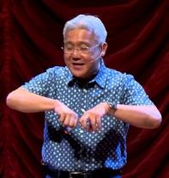
Our senior pastor Chris Kam is also an ordinary person. He grew up ordinarily in an ordinary small town, seized opportunities like others kids as he was growing up, and who went to schools like everyone else. And, God chose him, the ordinary man, to be our senior pastor. It is not what we want to do for God, but more to what God wants us to do!

Jesus invites ordinary people to follow Him

“Come, follow me,” Jesus said, “and I will send you out to fish for people.” At once they left their nets and followed him. When he had gone a little farther, he saw James son of Zebedee and his brother John in a boat, preparing their nets. Without delay he called them, and they left their father Zebedee in the boat with the hired men and followed him. (V17-20)

If someone invites you to go along with him, you have to accept the invitation before you follow him. If you are not a Christian today, the invitation is opened to you now. Jesus gave us an invitation (the greatest invitation of all)— and it is up to us whether to accept it or not. We have a choice, and it is the same thing with marriage where the essence of love is a choice. If accepted, the starting of a marriage begins with wedding vows: For better or worse, for richer or poorer, in sickness and in health, until death do us part.

If anyone wakes up one day and feel that you are not married, remember the vow you have made. It is not about how we feel, but the commitment that we made in front of so many witnesses. Likewise,
God invited us to follow him, and we accepted the invitation. It is a lifelong commitment.

When we leave our parents for Jesus, that does not mean we love our parents less. We just love Jesus more. Jesus tells us to love our parents.
The fact that Simon and Andrew dropped their nets at once (v18) and James and John left their father with some hired men and their tasks of mending their nets without delay (v20) to follow Jesus had clearly showed their enormous commitment and sacrifice in following him. They did not doubt, did not have to do a budget sheet, and did not have to worry how life would sustain. They just followed Jesus.

When we follow Jesus, are we willing to give up something that we love? This is the last sermon of the year, and instead of preaching about hope or something more uplifting, Pastor Chris sensed so much of this challenge in his heart. He felt the need to preach about following Jesus in which would demand all in us. Through reflection, Pastor Chris concluded that he actually loves Jesus less, as he is more concern about his comfort and needs. He did not think that he can fully trust God, and that something else is more precious than Jesus in his life.

God is not condemning us but instead, he is tutoring our hearts. He demands not perfection but progression.

Then he called the crowd to him along with his disciples and said: “Whoever wants to be my disciple must deny themselves and take up their cross and follow me. (Mark 8:34)
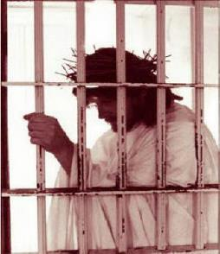
It is never about how we feel (God does care about our feeling). We must know the cost about taking up the Cross and follow him.

Four questions added to the list for people of certain faith baptising into Christianity are as follow:

- Are you willing to go to jail for your faith?
- Are you willing to lose your job for your faith?
- Are you willing to be kicked out by your family for your faith?
- Are you willing to go to rehabilitation camp for your faith?
While questioning himself with the above list, Pastor Chris concluded that he actually loved Jesus less than his desire. We all have to come to repentance. We need a church that is on fire for Jesus. Are we willing to the above questions?

Jesus gave us His invitation. When we accept it, Jesus does not need our permission anymore. In other words, we would be a born slave, like how Apostle Paul addressed himself.

This is a difficulty message to preach, but if Pastor Chris does not preach it, he is not preaching to the Gospel, the Gospel that we can have only one God in our lives.
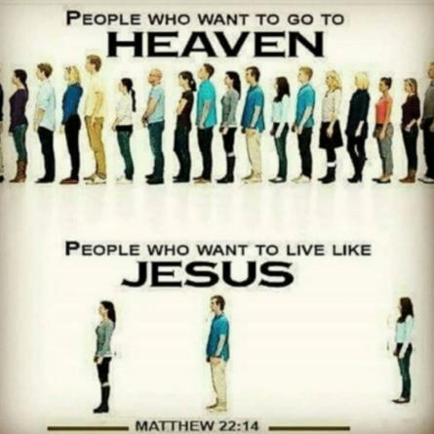
“For many are invited, but few are chosen.” (Matthew 22:14)

If we are to call for two lines in church today:
Line A: Let me live the way I like (“Don’t-disturb-me life”

and

Line B: I will follow Jesus

Which line do you think would be the longest? Pastor Chris’s guess would be neither, but a brand new line in between, which means “Lukewarm”.

Jesus transforms them into fishers of men

“Come, follow me,” Jesus said, “and I will send you out to fish for people.” (v17)

Pastor Chris tells us about how he shared Jesus with contractors who worked at the renovation of his house. He is aware that these are people whom we meet every day outside, and all we have to do is to share! It is really about us recognising that we are ordinary people who God wants to use, and that God had given is his invitation to be part of the great scheme he had. After all, God is more interested in our inner life. Pastor Chris’ prayer is for us to give our lives to God, as God’s plan is by far a lot more better for us than what we may have planned without God in the picture.

John Wesley cared about the holiness kept by Christians, to the extent that he expelled 64 members from the community of Newcastle Society. For what reasons? See the below list:
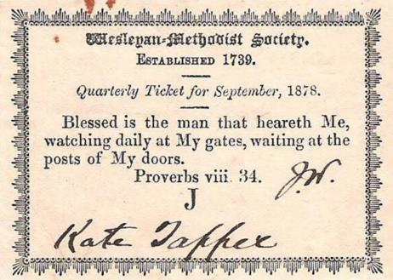
- Two for cursing and swearing.
- Two for habitual Sabbath-breaking.
- Seventeen for drunkenness.
- Two for retailing spiritous liquors.
- Three for quarrelling and brawling.
- One for beating his wife.
- Three for habitual, wilful lying.
- Four for railing and evil-speaking.
- One for idleness and laziness. And,
- Nine-and-twenty for lightness and carelessness.

John Wesley would, every three months, sit down with every member of the church and question on their spiritual life? Every week, the leaders would ask, “In the last seven days, what sins have you committed?” They will then issue a ticket, and that ticket is the ticket to enter church. No one is perfect, but soul is well when we are willing to walk the journey of Christ.

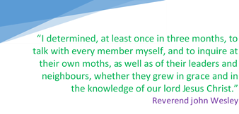
Can you imagine Wesley coming our congregation and start expelling people because of their habits? You and I probably would be expelled too. Holiness is demanded in church, as a church is tempered when we are not holy.

Conclusion

Following Jesus demands our all. Reflecting on 2017’s theme, we are to step out in obedience to The Great Commandment and The Great Commission through loving God, serving people and making disciples toward Christlikeness while cultivating the habits of giving honour, being humble and real, passing it on to others and having fun throughout! At the end, one question to ask ourselves is whether we have grown from the inside? To let God use us, we must acknowledge that
1) Jesus chooses ordinary people like you and me;
2) Jesus invites ordinary people to follow Him; and
3) Jesus transforms ordinary people into his disciples that reach out to souls outside of church.

Watchnight celebration for 2017-2018 will be a special one. Upon the completion of countdown, the church would renew our covenant with God, as follows:

Methodist Covenant Renewal Prayer

I am no longer my own but yours.
Put me to what you will, rank me with whom you will.
Put me to doing, put me to suffering.
Let me be employed for you or laid aside for you, exalted for you or brought low for you.
Let me be full, let me be empty.
Let me have all things, let me have nothing.
I freely and wholeheartedly yield all things to your pleasure and disposal.
And now, glorious and blessed God, Father, Son, and Holy Spirit, you are mine and I am yours.
So be it. And the covenant now made on earth, let it be ratified in heaven. Amen.

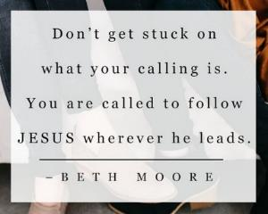

Sermon summary contributed Chrisandra.
Prayer pointers contributed by Abbey.

SERMON: I am no longer my own but yours.

Pray:
- We will surrender all to Jesus.
- We will continue to serve God more just as Christ loves us.
- We will not stay lukewarm but we are willing to die for our faith.
- We will be more committed to God as we proclaim 2018.
“Come, follow me,” Jesus said, “and I will send you out to fish for people.” At once they left their nets and followed him. (Mark 1:17-18)

MINISTRIES & EVENTS: Equip 2018
EQUIP have classes to help you grow your faith in all areas of your life—covering theology, Scripture, ministry, and personal growth. In this way, we help new believers grow into maturity and mature believers into a people of influence.
Pray:
- Members will push themselves to complete more courses in 2018.
- Trainers will receive the Word of God as they prepare relevant material for the participants.
- Members will see God move as they attend and equip themselves for 2018.
- For good time of fellowship and renewed passion for Christ during the training.
“To the Jews who had believed him, Jesus said, “If you hold to my teaching, you are really my disciples. Then you will know the truth, and the truth will set you free.” John 8:31,32

MALAYSIA MY NATION: 2018
Pray:
- Political and economic stability.
- Cost of living will not continue to go up.
- Politicians from both political divide will have the people’s interest at heart.
- Public policies will benefit and take care of the people.
- Malaysia will truly shine as a nation where her people live harmoniously together in the spirit of Muhibbah.
"How good and pleasant it is when God’s people live together in unity!" (Psalm 133:1)

A TRANSFORMED WORLD: Firing on the Coptic Church in Egypt
HONG KONG (Reuters) -The gunman fired at the church and a neighbouring Christian-owned shop on Friday, killing at least 11 people, security and church sources said. The attack was later claimed by Islamic State militants via their news agency Amaq. Islamist militants have claimed several attacks on Egypt's large Christian minority in recent years, including two bombings on Palm Sunday in April and a blast at Cairo's largest Coptic cathedral in December 2016 that killed 28 people. (thestar.com.my)

Pray:
- Freedom of worship in Egypt will be respected by all.
- Churches of the world to stand with Egypt at this difficult time.
- For the Christians in Egypt to believe that God is more supreme than ISIS
- For the churches in Egypt to stand, pray and come together during this time of crisis.
Follow justice and justice alone, so that you may live and possess the land the LORD your God is giving you. (Deuteronomy 16:20)

