Forward 2018: Running with Horses & Chasing the Lion
Senior Pastor Chris Kam
“If you have raced with men on foot
and they have worn you out,
how can you compete with horses?
If you stumble in safe country,
how will you manage in the thickets by the Jordan?
(Jeremiah 12:5)

Benaiah son of Jehoiada, a valiant fighter from Kabzeel, performed great exploits. He struck down Moab’s two mightiest warriors. He also went down into a pit on a snowy day and killed a lion. And he struck down a huge Egyptian. Although the Egyptian had a spear in his hand, Benaiah went against him with a club. He snatched the spear from the Egyptian’s hand and killed him with his own spear. Such were the exploits of Benaiah son of Jehoiada; he too was as famous as the three mighty warriors. He was held in greater honor than any of the Thirty, but he was not included among the Three. And David put him in charge of his bodyguard. (2 Samuel 23:20-23)

Forward 2018
* Sermon 1: Big Idea – Be very careful, be wise and be mindful of every opportunity
* Sermon 2: Big Idea – The Presence of God is the Blessed Life
* Sermon 3: Big Idea – Don’t be like the Dead Sea. Be a Blessing and Serve People
* Sermon 4: Big Idea – It’s not about the things we can pass on to our children, but the time we can be with them.

Introduction
Jeremiah was known as “the weeping prophet”. He served in the Southern nation of Judah, prophesying during the reign of 5 kings. He was a doomsayer, telling the people that God will judge them and they may be exiled. He cried over the task that God had given to him. He was a man of compassion and courage. He was branded a traitor but continued to prophesy. He was also very human. At times, he was very discouraged as he was an obedient prophet of God but things did not go smoothly for him.
One day, Jeremiah had a prayer meeting with God. As humans, we love to complain when things do not go our way. This is what Jeremiah did. Note the tone of sarcasm as he spoke to God. God allows us to be who we are. We do not have to hide. When we go to God, it is alright to complain but not to remain complaining.
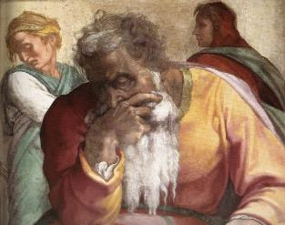
You are always righteous, Lord, when I bring a case before you. Yet I would speak with you about your justice: Why does the way of the wicked prosper? Why do all the faithless live at ease? (Jeremiah 12:1)

This was God’s answer:
“If you have raced with men on foot and they have worn you out, how can you compete with horses? If you stumble in safe country, how will you manage in the thickets by the Jordan?
(Jeremiah 12:5)
Jeremiah had a great and impossible task ahead of him, namely to be a doomsayer and warning the nation that they will be exiled and calling on them to repent of their sins.
BIG IDEA: Have a dream so big that unless God is in there, we are bound to fail

We tend to think that dreams are about the niceties of life. However, this is about a dream God is going to purpose in your heart. When the dream happens, we know that it is God and not us. God will challenge us to run with horses. We are in the defensive mode. God is going to challenge us in the years to come – not only to run with horses, but also to chase the lion.

There are two parts to the life of a Christian:
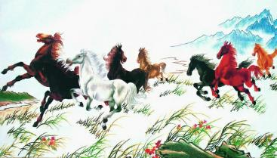

Preparation - Running with horses
“If you have raced with men on foot
and they have worn you out,
how can you compete with horses?
If you stumble in safe country,
how will you manage in the thickets by the Jordan?
(Jeremiah 12:5)

Basic Training (Defensive)

God is always in the business of preparing us and building our character. Therefore be careful how we live our lives. We live in a relatively safe country and we have easy lives. We are racing with men on foot right now. It is easy to be a Christian here right now.
Thickets are bush-like plants. You do not know what wild animals (such as lions) are hiding in the thickets and can pounce on you.

We have not been called to suffer yet for our faith. Coming to church and serving God is easy. Bibles are easily accessible. For people who live where the Bible is not freely available, they memorise Scriptures in their minds. If you hardly read the Bible or serve God in a comfortable environment, how will you manage in the “thickets by the Jordan”?

How are we living our lives in a safe country like Malaysia?

Sometimes God allows certain things to happen in our lives and in the church. Churches always grow in times of persecution. Human nature makes us take things easy in safe environments. God is training us how to compete with horses. Some of us need to rise up and some of us need to be stretched. God will develop our character through difficult times so we can “compete with horses”. Ask instead what we can learn through difficulties so one day, we will be ready to “compete with horses”. Times may increasingly get more difficult and if we are not ready, the church of Jesus Christ will fall away. This is a prophetic message for the church.

Passion – Chasing the Lion
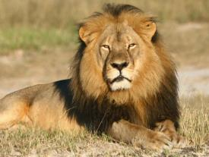
Benaiah son of Jehoiada, a valiant fighter from Kabzeel, performed great exploits. He struck down Moab’s two mightiest warriors. He also went down into a pit on a snowy day and killed a lion. And he struck down a huge Egyptian. Although the Egyptian had a spear in his hand, Benaiah went against him with a club. He snatched the spear from the Egyptian’s hand and killed him with his own spear. Such were the exploits of Benaiah son of Jehoiada; he too was as famous as the three mighty warriors. He was held in greater honor than any of the Thirty, but he was not included among the Three. And David put him in charge of his bodyguard. (2 Samuel 23:20-23)

Advanced Mission (Offensive)

Benaiah was a fighter. Instead of running away from the lion, he ran after it. Although the lion would be faster, he kept chase. Finally when the lion went into a pit, he jumped in after it and killed the lion. In the other episode, even though the Egyptian had a spear in his hand, Benaiah went after him. As we can see, he was not listed in the who’s who. He was one of the people God picked but he later became the commander of the army.

We need to have the spirit of Benaiah. When we see a lion, we do not run. Instead we chase the lion. The devil is like a roaring lion but he is a toothless lion. When we see the devil roar, we often run the other way in fear. If we know and truly understand our identity in Christ, God reminds us that our role is to chase after the lion. In fact, we are not to be in the defensive mode. We ought to be on the offensive mode.

“….fill the earth and subdue it…” (Genesis 1:28)

Because of sin, we have been on the defensive mode. However we are now not in the kingdom of darkness but we are in the kingdom of light. As we chase after the lion in our life, we are to be a blessing like the Sea of Galilee.

Conclusion
“In every dream journey there comes a moment when you have to quit living as if the purpose of life is to arrive safely at death.” Mark Batterson – Chase the Lion

Most of us plan our lives to arrive safely at death. We do not take risks. We only want to break even. You could do nothing wrong, and still do nothing right. The prophetic call to us is a call to repentance of our small dreams and our small God, and living only for ourselves. Go after something bigger than ourselves. The presence of God must be there as we continue to grow a God-sized dream.

Do you have a dream that scares you? Or is it so small that you can do it on your own?

If you do not have a dream that scares you, you can coast by and not need God. When the younger generation comes to us and asks us about God, do we have a story to tell? Do we have a story of an encounter with God to inspire the next generation to live life? Are our stories mediocre? We fail the next generation when we do not have a faith story to tell.
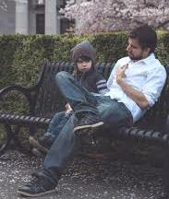
We are the Joshua generation. What lions are we chasing that we can tell the next generation that this is what God did in the life of the church? We are challenged to compete with horses and chase the lion.

We thank God for the previous generation who have a faith story to tell. But that is their story. What is our story? We need to pray and seek God because God has a purpose for this church.

There are 3 groups of people;
- Those who are running with men and have become tired.
These are people who are not even tithing.
- Those whom God is calling to run with horses.
God is asking these people to give even more or to do even more then what they are currently doing.
- Those God is calling to chase the lion
God is asking these people to give an impossible amount or to do an impossible task.

Where are you now? Are you still running with men? How many are competing with horses? How many of us are chasing the lion? For those who are still running with men and already feeling exhausted – do you have a breakthrough? Do we have a vision? Some of us are running with men as far as finances are concerned; we do not even tithe. We need to learn how to compete with horses; even as we give our all. God builds faith into us as we learn to give. We need to learn to move in faith and stretch ourselves. Ask God to show what “the lion” is in our lives so we can stretch our faith. Make sure we have a story to tell in the days to come – the story of chasing the lion.

Sermon summary contributed by Zhenli

