Discipleship: A Fully-Devoted Senior Citizen
(Psalms 92:12-5, Titus:1-5)
Elder Datuk Kee Sue Sing
Doing Good for the Sake of the Gospel - Older Christians
You, however, must teach what is appropriate to sound doctrine. Teach the older men to be temperate, worthy of respect, self-controlled, and sound in faith, in love and in endurance. Likewise, teach the older women to be reverent in the way they live, not to be slanderers or addicted to much wine, but to teach what is good. Then they can urge the younger women to love their husbands, so that no one will malign the word of God. (Titus 2:1-5)

A Psalm of Declaration for the Fully-Devoted Senior Citizen:
The righteous will flourish like a palm tree, they will grow like a cedar of Lebanon; planted in the house of the Lord, they will flourish in the courts of our God. They will still bear fruit in old age, they will stay fresh and green, proclaiming, “The Lord is upright; he is my Rock, and there is no wickedness in him.” (Psalm92:12-15)

Introduction
Elder Datuk Kee spoke of:
- 4 stages of life (Ecclesiastes 12)
- Children
- Youth
- Adulthood
- Senior Citizen
- Being old is not a curse but should be a great thing. Aging is not for the weak and cowardly. It includes lots of things like the loss of strength, weaker sight and hearing, loss of memory and mental faculty, etc. Many associate aging with decline and decay. Being old is not a curse. It is not necessarily bad. It can be a good thing.
- we are the gold mines
- it does not exclude us from Discipleship
- Christian Discipleship
- lifelong journey of obedience to Christ, knowing Him and becoming Christlike
- spiritually transforms a person’s values and behavior
- results in ministry in one’s home, church and the world
in short: Love God, Serve People, Make Disciples.
BIG IDEA: God is not done with older Christians so neither should the Church be.

3 Main Areas of Christian Discipleship especially for the Senior citizens:

An Unyielding Pursuit (2 Timothy 4:7, Galatians 5:7-8)
- Commitment to Christ for whole life, all our life.
- Be a True believer
  - use our life to finish well,
  - not to waste time on trivial things
- Be found walking with God personally in the end, close to God
- Beware not to be cut off, disqualified from God because of temptations from the adversary and sin = failed -> become an old fool
- We are to press on towards the finish line.

4 kinds of finishes in the Bible.
- Cut off early in life or ministry, like Samson or Ahab. There are godly people who got cut off early. But by and large, this is the worst kind of finish.
- Finishing poorly, like Saul and Solomon.
- Finishing so so or above average, like David, Hezekiah
- Well - Abraham, Joshua, Caleb, Joseph, Peter, Paul. Finishing strong means keeping our faith and walking with God personally right until the very end. This is not a given.
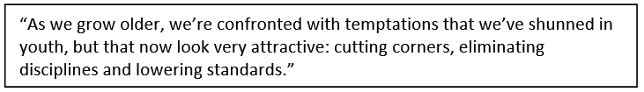

J.I. Packer suggested a three-pronged approach to finishing well:

- To live for God one day at a time – carefully planning and reviewing to assess whether we have achieved that we set out to do for God each day
- To live in the present moment – to be able to see God in everything on a daily basis an intimacy with God in everything on a daily basis
- To live ready to go when Christ comes for us – make sure we are right with God until our last breath

An Ongoing Transformation
- Be spiritually responsible to demonstrate godly character
- No value in being old if not a model to the younger generation
- Godly character such as:
- For OLDER MEN
“Teach the older men to be temperate, worthy of respect, self-controlled, and sound in faith, in love and in perseverance.” (Titus2:2)
Senior = one advanced in life
- Temperate
  - Someone who is moderate
  - A person who isn’t into excess, non-indulgent, non-extravagant
- Worthy of Respect
  - Semnos - serious, dignified
  - A person who is serious in life, who is responsible
- Self-controlled
  - sophron – sensible
  - one who has discretion and discernment
- Sound in faith, in love and in endurance:
  - In FAITH – a faith that is whole and solid faith and unwavering trusting God more
  - In LOVE – towards God and others
  - In ENDURANCE – patience in learning and growing in God
- For OLDER WOMEN
“Likewise, teach the older women to be reverent in the way they live, not to be slanderers or addicted to much wine, but to teach what is good.” (Titus 2:3)

- Be Holy
  - reverent in the way you live – Christlike
  - priestess who can enter into the presence of God
- Be not slanderers
  - Slanderers in Greek is diabolos, a name for Satan
  - guard your tongues
- Be teachers
  - mentor what is Holy to the younger women
  - always be ready to be spiritual mothers

An Unending Fruitfulness
“The righteous will flourish like a palm tree, they will grow like a cedar of Lebanon; planted in the house of the LORD, they will flourish in the courts of our God. They will still bear fruit in old age, they will stay fresh and green, proclaiming, “The LORD is upright; he is my Rock, and there is no wickedness in him.” (Psalm92:12-15)

The Aged Righteous are:
- Like a date palm – provider for a Man and cedar -evergreen, full of spiritual life
- Still bear fruit
- Their fruitages
  - to declare the character of God
    - stays fresh and green
    - proclaiming /expounding His Word
    - your life is an exposition of the Love, Grace
    - Glory of God, His Promises and Power
  - Able to Freely avail hospitality and benevolence
  - Ready for Edification and evangelism
  - Available for Prayer and fasting
  - A source of great blessing – sending messages or make calls to be the palm and cedar trees for Mankind

CONCLUSION
Let us all who are in Christ work out our life to be like the date palm and the cedar.
God can use us to be forever green in our spiritual walk like the cedar tree and fruitful like the date palm irrespective of our age. For God has a purpose for each and every one according to their maturity and experiences to touch lives.
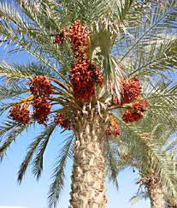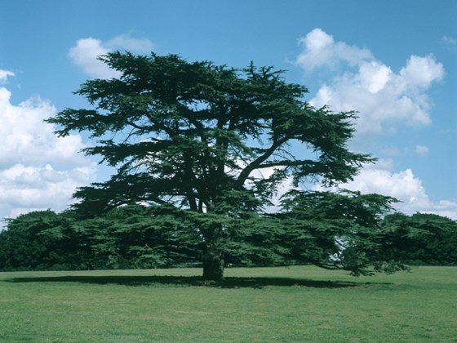

Sermon summary by Michelle Chuah

