A Fully-Devoted NextGen
(Acts 16:1-5; 1 Tim 4:11-16)
Senior Pastor Chris Kam

Paul came to Derbe and then to Lystra, where a disciple named Timothy lived, whose mother was Jewish and a believer but whose father was a Greek. The believers at Lystra and Iconium spoke well of him. Paul wanted to take him along on the journey, so he circumcised him because of the Jews who lived in that area, for they all knew that his father was a Greek. As they traveled from town to town, they delivered the decisions reached by the apostles and elders in Jerusalem for the people to obey. So the churches were strengthened in the faith and grew daily in numbers. (Acts 16:1-5)

Command and teach these things. Don’t let anyone look down on you because you are young, but set an example for the believers in speech, in conduct, in love, in faith and in purity. Until I come, devote yourself to the public reading of Scripture, to preaching and to teaching. Do not neglect your gift, which was given you through prophecy when the body of elders laid their hands on you. Be diligent in these matters; give yourself wholly to them, so that everyone may see your progress. Watch your life and doctrine closely. Persevere in them, because if you do, you will save both yourself and your hearers. (1 Timothy 4:11-16)

Introduction

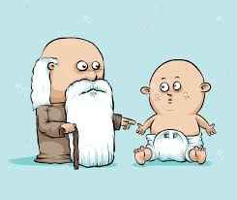
The Bible says, if you are young do not let anyone look down upon you.

Paul came to Derbe and then to Lystra, where a disciple named Timothy lived, whose mother was Jewish and a believer but whose father was a Greek. The believers at Lystra and Iconium spoke well of him. (Acts 16:1-2)

Timothy was about 16 years old at that time and was already a believer of Jesus. The letter 1 Timothy was written 14 years later. During these 14 years, Timothy grew under the discipleship / mentorship of Paul. In DUMC, NextGen is a term used to describe the group of people between the ages of college-going years and below 25 years.

‘Timothy’ means one who honours God. Paul mentored and discipled Timothy and became his spiritual father. Timothy is an introverted person.

When Timothy comes, see to it that he has nothing to fear while he is with you, for he is carrying on the work of the Lord, just as I am. No one, then, should treat him with contempt. (1 Corinthians 16:10-11)

For the Spirit God gave us does not make us timid, but gives us power, love and self-discipline. (2 Timothy 1:7)

Never look down upon yourself and say I cannot do this. God wants to develop you from young.

Parents want their children to do better than them.

When we are younger, when we want knowledge, we go to the Encyclopaedia Britannica. These days, we have Google. Wisdom is not finding the answer but asking the question.

BIG IDEA
Don’t go places where your talents or gifting take you but your character cannot sustain you.

We need to remind our young people that character is important, in order to be more Christ-like.

- I Can’t by Myself

To Timothy, my dear son:
Grace, mercy and peace from God the Father and Christ Jesus our Lord. (2 Timothy 1:2)

(For this reason I have sent to you Timothy, my son whom I love, who is faithful in the Lord. He will remind you of my way of life in Christ Jesus, which agrees with what I teach everywhere in every church. (1 Corinthians 4:17))

I am reminded of your sincere faith, which first lived in your grandmother Lois and in your mother Eunice and, I am persuaded, now lives in you also. (2 Timothy 1:5)

There is a close relationship between Apostle Paul and Timothy. Timothy did not have a Christian father. Over time, Timothy grew up to be godly under the influence of a godly mother and a godly grandmother. Timothy became who he is today, not because of himself, but because of his mother, grandmother and Apostle Paul.

God gave us a spiritual family. The Christian faith is about being born in a spiritual family, where there are brothers and sisters around us to help us in our growth as Christians.

Boys’ Brigade is successful because there are spiritual fathers and spiritual mothers to the kids who come from broken family background. When they do things right, they begin to grow because of the spiritual fathering and mothering. Young people these days have many friends on social media, but there are only a few that they can be real with. They hop from church to church and miss building relationships with the older uncles and aunties in church. They cannot by themselves. Never look down on our forefathers; it is because of them that we are here. Honour them with humility. Do not despise old people.

Old people should also not give young people ‘the look’, because they might run away. If we do not disciple our young people, the world will disciple them. There is no competition, but a collaboration with them.

- I Can with Christ
Don’t let anyone look down on you because you are young, but set an example for the believers in speech, in conduct, in love, in faith and in purity. Until I come, devote yourself to the public reading of Scripture, to preaching and to teaching. Do not neglect your gift, which was given you through prophecy when the body of elders laid their hands on you. (1 Timothy 4:12-14)

There are five things Apostle Paul told Timothy. These are the areas that young people can grow in.

- Speech (What we say)
The tongue has the power of life and death, and those who love it will eat its fruit. (Proverbs 18:21)

Our tongue can kill. Our words can cripple. The words that we say are very important.

- Conduct (What we do)
Is the way we walk our lives consistent with the way we talk? Our conduct is a trumpet to the world. If our conduct does not match what we say, people will never believe Christ.

- Love (How we feel)
The kind of love Jesus talks about is love without condition. Love is something that we experience and embrace in our hearts. Nothing affects the world more than love.

- Faith (What we aspire)
Learn to walk and step out in faith. God is always faithful. God is spiritual father who takes care of us.

- Purity (How we relate)
We need purity in the way we think and relate to one another. There is a principle behind modesty which can be difficult. How would the young people know if we do not tell them? We are always modelling our lives to someone. More is caught than taught. Do you have an older person to go to? We need to develop inter-generational relationships in our lives.

- I Must for the Sake of the Gospel
Be diligent in these matters; give yourself wholly to them, so that everyone may see your progress. Watch your life and doctrine closely. Persevere in them, because if you do, you will save both yourself and your hearers. (1 Timothy 4:15-16)

For this reason I remind you to fan into flame the gift of God, which is in you through the laying on of my hands. (2 Timothy 1:6)
Have a dream so big that if God is not there, it will fail.

If we have dreams so big, we will have stories to tell our children.

We need to build up our young people to be strong in the Lord. Young people need us to cheer them on.

We believe in a big God Who can do big things. Be a fully devoted NextGen-er. For the older ones, let’s help them.

What is the Holy Spirit saying to you?

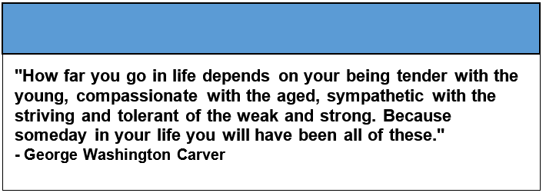

Sermon summary by May

