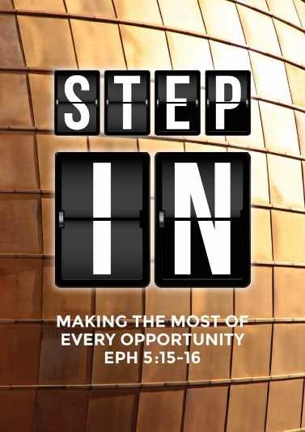
What is Life? Part 2.
(Judges 4:1-10)
Dato' Dr Daniel Ho, Founding Senior Pastor

Again the Israelites did evil in the eyes of the Lord, now that Ehud was dead. So the Lord sold them into the hands of Jabin king of Canaan, who reigned in Hazor. Sisera, the commander of his army, was based in Harosheth Haggoyim. Because he had nine hundred chariots fitted with iron and had cruelly oppressed the Israelites for twenty years, they cried to the Lord for help.
Now Deborah, a prophet, the wife of Lappidoth, was leading Israel at that time. She held court under the Palm of Deborah between Ramah and Bethel in the hill country of Ephraim, and the Israelites went up to her to have their disputes decided. She sent for Barak son of Abinoam from Kedesh in Naphtali and said to him, “The Lord, the God of Israel, commands you: ‘Go, take with you ten thousand men of Naphtali and Zebulun and lead them up to Mount Tabor. I will lead Sisera, the commander of Jabin’s army, with his chariots and his troops to the Kishon River and give him into your hands.’” Barak said to her, “If you go with me, I will go; but if you don’t go with me, I won’t go.”
“Certainly I will go with you,” said Deborah. “But because of the course you are taking, the honor will not be yours, for the Lord will deliver Sisera into the hands of a woman.” So Deborah went with Barak to Kedesh. There Barak summoned Zebulun and Naphtali, and ten thousand men went up under his command. Deborah also went up with him. (Judges 4:1-10)

Introduction
The people of Israel are not learning from the past. They are not learning from history.
Again the Israelites did evil in the eyes of the Lord, now that Ehud was dead. So the Lord sold them into the hands of Jabin king of Canaan, who reigned in Hazor. Sisera, the commander of his army, was based in Harosheth Haggoyim. Because he had nine hundred chariots fitted with iron and had cruelly oppressed the Israelites for twenty years, they cried to the Lord for help. (Kings 4: 1-3)

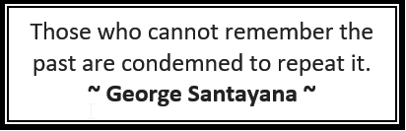
The Israelites, constantly failed to learn from their past.
What we learn from the past, it can take us into the right projector into the future.

Life is about engagement with God’s mission on earth. (Kings 4: 3-4)
Now Deborah, a prophet, the wife of Lappidoth, was leading Israel at that time. She held court under the Palm of Deborah between Ramah and Bethel in the hill country of Ephraim, and the Israelites went up to her to have their disputes decided. (Kings 4: 3-4)

The Bible has many women who have risen up to lead. We thank God for these women and we need to bring women into leadership.

It involves a willingness to want to get engaged. (Kings 4:6-8; Judges 5:1-2, 9)
She sent for Barak son of Abinoam from Kedesh in Naphtali and said to him, “The Lord, the God of Israel, commands you: ‘Go, take with you ten thousand men of Naphtali and Zebulun and lead them up to Mount Tabor. I will lead Sisera, the commander of Jabin’s army, with his chariots and his troops to the Kishon River and give him into your hands.’” Barak said to her, “If you go with me, I will go; but if you don’t go with me, I won’t go.” (Kings 4: 6-8)

On that day Deborah and Barak son of Abinoam sang this song: “When the princes in Israel take the lead, when the people willingly offer themselves— praise the Lord!
My heart is with Israel’s princes, with the willing volunteers among the people. Praise the Lord! (Judges 5: 1, 2, 9)
It is a willingness to response to God's call. Here we see that Barak was willing to go only if Deborah went with him.
- God will never force/compel us or cajole us to get engaged.
God always let us decide what to do. It is our choice, our decision to respond to Him. He wants a willing respond from us.

- He leaves us to make the choice but in that choice we reap the consequences.
If we do not response, we will miss out on what God has for us.
While serving in Asia (Turkey), Paul had a vision of a man calling him to come to them (Acts 16). Paul responded to the vision and went to Philippi, which is in Greece. That was the first time the Gospel went into Europe. At that time, Europeans were known as barbarians. After receiving the gospel, they changed and they are known for their advancement in engineering, technology and many other fields. All because one man responded to a call to go and share the Gospel, the whole of the world benefits.

In our willingness to respond we will reap the blessings.

Of course there are risks involved when we get engaged. (Kings 4:9; Judges. 5:15a, 18)
“Certainly I will go with you,” said Deborah. “But because of the course you are taking, the honor will not be yours, for the Lord will deliver Sisera into the hands of a woman.” So Deborah went with Barak to Kedesh. (Kings 4: 9)
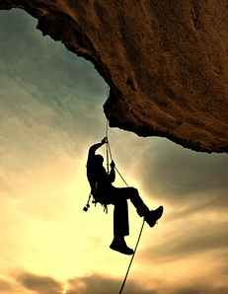
- Only through risks and difficulties are we stretched and truly made to depend upon the Lord.
When we face these risk and difficulties we see God taking us through it. We learn to trust and rely on Him.

- Only through challenges and difficulties do we mature and are built up strong.
We can be hurt and wounded when we go through challenges. When this happens, we must not walk out, we must not let it cripple us. We have to forgive and to let go. Only then do we walk in freedom. We have to live a life of humility, submission and trust in God.

We will miss out the privilege and its fruit when we don’t get engaged. (Judges 5:15b-17)
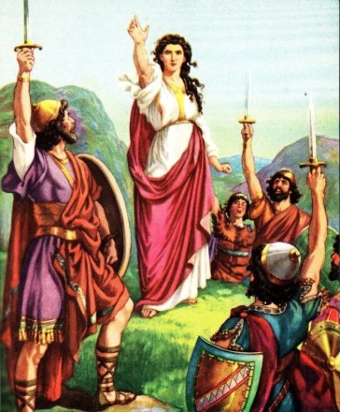
In the districts of Reuben there was much searching of heart. Why did you stay among the sheep pens to hear the whistling for the flocks? In the districts of Reuben there was much searching of heart. Gilead stayed beyond the Jordan. And Dan, why did he linger by the ships? Asher remained on the coast and stayed in his coves. (Judges 5:15b-17)
- When we are engaged we have a story to tell.
- When we are engaged we have a legacy to leave behind.
Some tribes did not response to Barak's call. They missed out on the story to tell and legacy.
We must get involved. Start small but think big. Move step by step. DUMC started with 22 people and have grown to what it is today.

How can we keep our engagement fervent for the long haul? How can we keep our faith strong and passionate to the end?

Worship to centre us. (Psalms. 27:4)
One thing I ask from the Lord, this only do I seek: that I may dwell in the house of the Lord all the days of my life, to gaze on the beauty of the Lord and to seek him in his temple. (Psalms. 27:4)
David desired to put God first. We have to keep worship at the centre of our lives. In so doing God is in the centre of our lives. This will give us clarity in our lives.

Word to feed and guide us. (Luke. 10:42)
but few things are needed—or indeed only one. Mary has chosen what is better, and it will not be taken away from her.” (Luke. 10:42)
Mary chose to take in the word of God. The Bible has wisdom to lead and guide us. It is the most important thing.

Witness to fire and inspire us. (John. 9:25)
He replied, “Whether he is a sinner or not, I don’t know. One thing I do know. I was blind but now I see!” (John. 9:25)
If we are excited about something, we will tell people about it. We must be like this blind man. Tell everyone about what Jesus did for him.
Does our faith have something to offer?
Is it the most exciting thing that has happen to us?

Sermon summary by Prudence.

