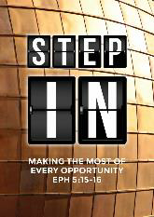
The Voice of One Crying – Sunday: Time to Forget and Remember (Isaiah 43:25; Joshua 4:6,7)
Rachel Hickson

“I, even I, am he who blots out your transgressions, for my own sake, and remembers your sins no more.” (Isaiah 43:25)

“…to serve as a sign among you. In the future, when your children ask you, ‘What do these stones mean?’ tell them that the flow of the Jordan was cut off before the ark of the covenant of the Lord. When it crossed the Jordan, the waters of the Jordan were cut off. These stones are to be a memorial to the people of Israel forever.” (Joshua 4:6,7)

Introduction

The key to this season is to remember to forget, but to not forget to remember. In transition times, we can often get sentimental. We hold on to the wrong things, and we let go of the wrong things. This is a critical time, and God is saying that it is important to set our attitude correctly.

A key to living life with an inner peace and joy is learning this grace of forgetting correctly and the art of remembering completely. What are the memories that haunt you? What are the things that stir in your mind? God is telling you to forget correctly. There could be certain things that are important keys, and God is saying not to forget those things, for they are critical in the season of your life.

BIG IDEA
Forget and remember.

Remember to Forget

“I, I am he who blots out (forgets) your transgressions for my own names sake, and I will not remember your sins.” (Isaiah 43:25 - ESV)

In this verse of Scripture, God says that he will blot out our transgressions, not for our names’ sake, but for His. Why would God need to blot out our sins for His name’s sake? Surely God would not need to do anything on our behalf for His own sake. There is an important principle here of remembering to forget, for if we do not remember to forget the right things, it positions us wrongly for moving forward in our relationships and in our seasons. God, in the incredible beauty of who He is, says that for His name’s sake, He forgets our sins.
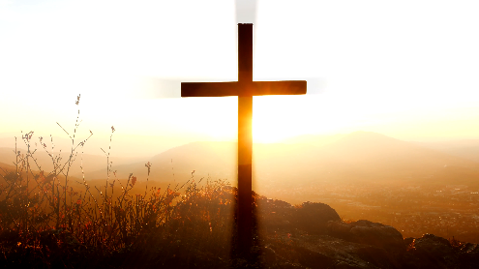
To do something for one’s name sake has two meanings. The first is for the integrity of a name. For God’s name to be upheld, and for there to be no conflict of attitude, God has to forgive sin. The other meaning is for the wellbeing of a person. God is essentially saying that He will forgive our sins so that the integrity of His name will be maintained, and the wellbeing of His function is maintained.
Now, the challenge is to replace God’s name with ours in the verse above.
“_____ will forget your transgressions (your betrayal of me, your sins against me), so that _____’s integrity will be maintained, and _____ can experience wellbeing of life. For _____ to live well, she/he needs to not remember people’s sins against her/him.

For us to step into the new season for the nation, there has to be a forgetting and a blotting out of sins, for the integrity of the name of the church, of our own selves, our families, and for the wellbeing of our souls.

God requires us to forget. Will we generously let go?

Historical people usually become hysterical! The enemy makes you feel as though forgetting will make you lose your power. The enemy always presses the power button, but Jesus always presses the generosity button. God calls us to let go. God is a perfect judge, but He is not always fair. If we just let go and trust God, God will do what is right, even if it does not appear to make sense. If we lean into that trust, God will upgrade us, make us stand upright, and open doors for us.

Most of us need to upgrade our emotional intelligence! We need to grow up, we need to say sorry, and we need to let go. It does not feel nice, but it is the right thing to do. We love to be let free, but we are not so generous about letting others go free. God is asking us to let people go free, to break the chains of history. Even if people do not understand or realise what they have done to us, even if it does not seem fair; however, for our name’s sake and God’s name sake, for our own integrity and wellbeing, we have to let it go. We cannot do it on our own. That is why we need the cross, and the model of unconditional love and generous forgiveness.

Removing the Contaminants

Unforgiveness is a luxury we cannot afford. Unforgiveness will pollute and contaminate the very essence of our lives. When we hold onto unforgiveness, it harms and hurts us most.

Sometimes, the person we need to forgive the most, is ourselves. We tend to relive histories of our past mistakes, and harbour regret and guilt over them. God wants us to forget our own mistakes, for when we brought them before the cross, God has already forgiven us our sins and lifted our burdens. We need to forget our mistakes – we cannot carry regret.

For the kind of sorrow God wants us to experience leads us away from sin and results in salvation. There is no regret with that kind of sorrow. (2 Corinthians 7:10 – NLT)

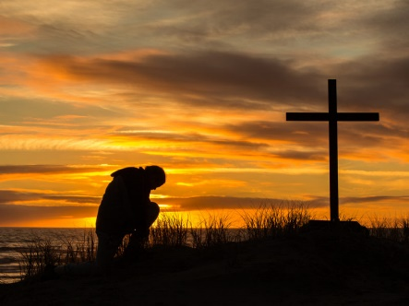
The devil likes to make us pay double for our trouble. He tells us that if we truly feel sorry for our sins, we will take responsibility for them, and feel sorry about what we have done for the rest of our lives. Regret is a heavy burden.

True repentance is a change of mind and attitude. It means to turn from the way you normally walk, realising that you cannot walk or behave the same anymore. It is a 180 degrees turn around.

There is a kind of sorrow that will make you turn from your instinctive behaviour and turn towards God. As you turn towards God, that sorrow will lead you away from your attitude to the presence of God, and it results in salvation. When you make the decision to turn around, the Bible says that there is no regret after true repentance!

Unless you let go, you cannot move forward into the new season with a healed mentality. God wants you to let go of the hysteria of your history so that instead of reacting, you are responding. Do not dwell in the past. God wants to break every chain of regret in your life.

Forgiveness does not mean you agree with the actions committed against you – forgiveness just means you will not hold these actions against them or yourself!

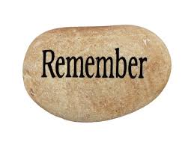
Just as it is hard for us to forget, it is also hard for us to remember. Our memories can become skewed.

Remember correctly! Or else we will put the wrong priorities in the wrong place. No government or leader can fulfil the promises of God for us. We can mistakenly put our trust and hope in the wrong things. We need more than a politician. We need God and the Word of God spoken over us.

But remember the Lord your God, for it is he who gives you the ability to produce wealth, and so confirms his covenant, which he swore to your ancestors, as it is today. (Deuteronomy 8:18)

Remember God. When we read in the headlines the fallout of the economy and the debt of the nation, we need to remember the God who gives us the ability to produce wealth, who can turn around every economic forecast. We need to remember not to have the wrong attitude towards certain people.

When life gets easier, we start to get comfortable and familiar, and we start to settle down. However, this is not the time to settle down, but this is the time to dig in and work like you have not worked before, to the glory of God. This is the time in Israel when people began to buy houses, children began to get married, and the land began to produce its harvest. During this time of ease and comfort, a cry came from the prophet Moses, a reminder to remember that it is God who gives us the ability to produce wealth.

Now is not a good time to be sleeping, but to be awake and to remember your God. Do not grow familiar with precious things. Do not forget the times when God encountered you, or when breakthrough came upon your life or upon the nation.

Time to Create Memories

It is time to create memories. Do not just dream about them, for God is giving us a legacy to leave stepping stones. Don’t just dream about history; write it and plant it.

We are part of a big story. God is the God of Abraham, Isaac and Jacob. God is the God of grandparents, parents, and children. God stretches, and He expects us to reflect the same. The story we are writing is a signpost to generations. Do not just dream it; write it down, build it, and leave it as marking stones. We are in a new season, moving into the season of the year 2020. God is preparing the church in Malaysia to wake up and to see clearly the gift of God in this precious land. It is preparation time.
We will use these stones to build a memorial. In the future your children will ask you, ‘What do these stones mean?’ 7 Then you can tell them, ‘They remind us that the Jordan River stopped flowing when the Ark of the Lord’s Covenant went across.’ These stones will stand as a memorial among the people of Israel forever.” (Joshua 4:6-7 - NLT)

The stones are stones that mark the miracles that have happened. We tend to forget the times of healing, times of answered prayers, times of reconciliation, the shifts in the nation which allow us to contribute to the forward momentum of the nation. We need to remember, to rehearse our God story.

Conclusion

I am reminded of your sincere faith, a faith that dwelt first in your grandmother Lois and your mother Eunice and now, I am sure, dwells in you as well. For this reason I remind you to fan into flame the gift of God, which is in you through the laying on of my hands, for God gave us a spirit not of fear but of power and love and self-control. (2 Timothy 1:5-7 – ESV)

It is time to remember who you are, it is time to stir up the prophetic dreams, to not just dream them but to write them in the stepping stones of history, for the generations to come. Remember to forget, but do not forget to remember the Lord your God. Remember to forget the transgressions of others, and remember to forget even your own transgressions. As you step forward into this season of 2020, the season of opportunity, remember the Lord your God. Remember every Word given to you; stir it up, write it down, run with it without fear and without apology.

Sermon summary contributed by Anthea.

