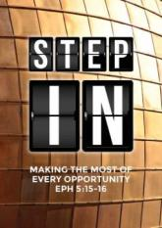
Armour of God 2: Breastplate of Righteousness & Shoes of Peace
(Ephesians 6:12-15, Zechariah 3:1-5)
Pr Chris Kam

For our struggle is not against flesh and blood, but against the rulers, against the authorities, against the powers of this dark world and against the spiritual forces of evil in the heavenly realms. Therefore put on the full armour of God, so that when the day of evil comes, you may be able to stand your ground, and after you have done everything, to stand. Stand firm then, with the belt of truth buckled around your waist, with the breastplate of righteousness in place, and with your feet fitted with the readiness that comes from the gospel of peace. (Ephesians 6:12-15)

Then he showed me Joshua the high priest standing before the angel of the Lord, and Satan standing at his right side to accuse him. The Lord said to Satan, “The Lord rebuke you, Satan! The Lord, who has chosen Jerusalem, rebuke you! Is not this man a burning stick snatched from the fire?” Now Joshua was dressed in filthy clothes as he stood before the angel. The angel said to those who were standing before him, “Take off his filthy clothes.” Then he said to Joshua, “See, I have taken away your sin, and I will put fine garments on you.” Then I said, “Put a clean turban on his head.” So they put a clean turban on his head and clothed him, while the angel of the Lord stood by. (Zechariah 3:1-5)
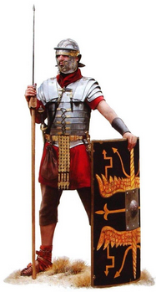
As a Roman soldier, having the breastplate and fitted shoes are important as they provide protection to the body. The breastplate protects the upper torso where vital organs such as the heart and lungs are. The shoes protect the feet and gives the soldier confidence to walk into the battlefield.

Stand firm then, with the belt of truth buckled around your waist, with the breastplate of righteousness in place, and with your feet fitted with the readiness that comes from the gospel of peace. (Ephesians 6:14-15 (NIV))

As shoes for your feet put on whatever will make you ready to proclaim the gospel of peace. (Ephesians 6:15 (NRSV))

Good shoes make us ready to proclaim the gospel of peace wherever we go. However as Christians, we are to be aware that warfare between the flesh and the Spirit is happening all the time. If we have the Belt of Truth, our mind can be firmly anchored in His Word and know that we are saved be grace through faith in Christ, not by performance. The devil seeks to render us ineffective in the Great Commission. It is his great strategy to create discord in the mind and oppose Christians into not sharing the Good News.

BIG IDEA:
If we want to live in victory, we must counter corruption by living out the Truth, and counter opposition by advancing the Truth.

The enemy creates doubt about our righteousness. (Rom 7:7)
“Righteousness” is doing what is right in God’s eyes. To be “righteous” is to live by God’s standards, but humanly speaking we can never be up to His standards because God is Holy. Holiness is a standard too high for us! We can try, but all will fall short. As we see in Zechariah 3:1-5, we can count on Satan to stand beside us, ready to accuse us in front of God.

What shall we say, then? Is the law sinful? Certainly not! Nevertheless, I would not have known what sin was had it not been for the law. For I would not have known what coveting really was if the law had not said, “You shall not covet.” (Romans 7:7)

Reading the Word help us to understand what sin is, and help us realise that humans cannot meet God’s standard because we are prone to sin. The bible sets the stage of 4 epic scenes. First is the Creation (Genesis 1-2), second is the Fall (Genesis 3), and fourth is Glory (Revelations 21-22).

The third scene is Redemption (Genesis 4 – Revelations 20). The bible tells of God’s pursuit after us. It details God’s plan of salvation of humanity. We are now living in the age of Redemption. However, like our ancestors Adam and Eve who sewed fig leaves to cover their nakedness, we like to “wear” designer fig leaves such as pride, materialism or religion to cover our shame and seem righteous. Let’s discuss the types of “righteousness”.

Ordinary human righteousness
We try to achieve righteousness by compensating wrong with right. We try to pay penance in wanting to be right. Some are driven to do charity to appease and seem right in the eyes of others, and not because of compassion.

In psychology, “gunny sacking’ is described as 'an alienating fight tactic in which a person saves up, or gunnysacks, grievances until the sack gets too heavy and bursts, and old hostilities pour out'. The devil has a gunny sack, each in our name. Whenever he wants to trip us up, all he needs to do is reach into the gunny sack and remind us of something we did in the past, and cause us to fall.

Religious self-righteousness (Romans 3:10-12; Romans 3:23; Genesis 3:21)
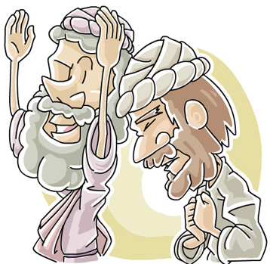
Like the fig leaves Adam and Eve wore when they suddenly realised they were naked, religious self-righteousness makes us look and feel good. We must understand that religious self-righteousness is like the Pharisees: a hypocrite. It is simply behaviour modification without the power of God. There is no change in the heart. Being righteous is not only about doing the right thing, it is doing things because it is right.

As it is written: “There is no one righteous, not even one; there is no one who understands; there is no one who seeks God. All have turned away, they have together become worthless; there is no one who does good, not even one.” (Romans 3:10-12)

No one seeks God on their own. It is God who seeks us, and draws us to Him. When we use religion to cover ourselves to seem righteous, it is not enough. In Genesis 3:21, God killed and skinned animals to cover the nakedness of Adam and Eve – this means for shame to be covered, something must die. Even at the beginning, God was already hinting at the death of Christ to cover our shame.

Imputed righteousness (Zechariah 3:1-5; Isaiah 64:6; Philemon 3:9; Romans 3:22; 2 Corinthians 5:21)

Imputed righteousness means that upon repentance and belief in Christ, individuals are forensically declared righteous. This righteousness is not the believer's own, rather it is Christ's own righteousness given to the believer.

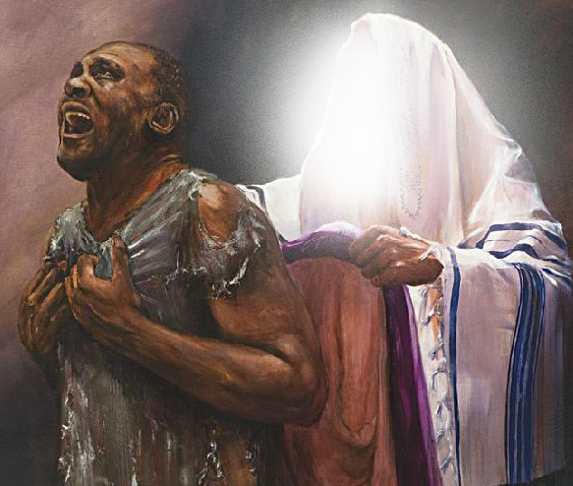
In Zechariah 3:1-5, the prophet saw Joshua, who was the High Priest of Zechariah’s day, standing before the Angel of the Lord and Satan on the right side of Joshua ready to accuse him (The Angel of the Lord in the Old Testament is the theophany of Christ). The prophet saw that Joshua the High Priest (reflection of all humankind) was in filthy rags. In this vision, the angel of the Lord ordered for Joshua’s sins to be taken away and be clothed in fine garments. A clean turban was placed on his head to signify that Joshua was restored as the High Priest. Joshua did nothing to deserve such treatment, yet God did so.

All of us have become like one who is unclean, and all our righteous acts are like filthy rags; we all shrivel up like a leaf, and like the wind our sins sweep us away. (Isaiah 64:6)

There is nothing we need to do, but believe in Christ Jesus. It is He who imputes and makes us righteous. The Breastplate of Righteous is not something you put on, rather it is God who has put it on you. All you need to do, is to believe in Him.

Day-to-day righteousness (Proverbs 4:23)
Above all else, guard your heart, for everything you do flows from it. (Proverbs 4:23)
Knowing that faith in Christ makes you righteous does not mean that we can live however we like. It is learning how to live in righteousness. If we are truly saved, we want to show righteousness in our lives. When we read the Word of God, we are to do C.P. R.:
- Confession - 1 John 1:9
Living in Christ does not stop you from sinning. But when we confess our sins to Him, it stops Satan from having a foothold in our lives
- Purification - James 4:8
There are times we do not even know we have sinned because of some deep-rooted beliefs we are not aware of. Allow God to renew the mind, and be cleansed from the inside out.
- Repentance - Luke 15
Repenting is walking away from a habit. It is changing your heart and mind and returning to God, not go on living in sin.

The enemy creates confusion about our salvation.
And with your feet fitted with the readiness that comes from the gospel of peace. (Ephesians 6:15)
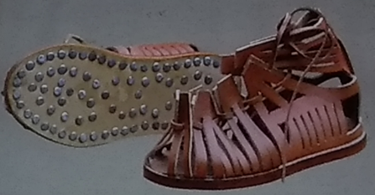
Just as a soldier cannot run if he did not properly secure his clothes with the Belt, he is not ready to run into battle without being fitted with proper shoes. The Romans soldiers shoes not only has laces to fasten the shoes to the feet, it is fitted with spikes on the soles so that the soldier is sure footed and will not slip during the battle.

Christians are to be fitted with the Shoes of Peace to spread:
- Gospel of the Kingdom
Jesus went throughout Galilee, teaching in their synagogues, proclaiming the good news of the kingdom, and healing every disease and sickness among the people. (Matthew 4:23)
- Gospel of Jesus Christ
The beginning of the good news about Jesus the Messiah, the Son of God, as it is written in Isaiah the prophet: “I will send my messenger ahead of you, who will prepare your way” (Mark 1:1)
- Gospel of the Kingdom of God
After John was put in prison, Jesus went into Galilee, proclaiming the good news of God. (Mark 1:14)
- Gospel of the grace of God
However, I consider my life worth nothing to me; my only aim is to finish the race and complete the task the Lord Jesus has given me—the task of testifying to the good news of God’s grace. (Acts 20:24)
- Gospel of peace
And how can anyone preach unless they are sent? As it is written: “How beautiful are the feet of those who bring good news!” (Romans 10:15)
“Euaggelion” simply means "good news." As Christians are called sent to spread the Good News, with beautiful feet firmly grounded in the Gospel. If we are surefooted in Him, the enemy cannot to sway us (Romans 10:15). Know the Gospel in your heart, and know how to tell the gospel to others. If you do not know how, get yourself equip and learn how to do so.

The enemy is defeated when we stand on the righteousness and salvation of Christ.
Do not let Satan steal your evangelistic zeal. Be dressed in the armour of God and march out in faith.

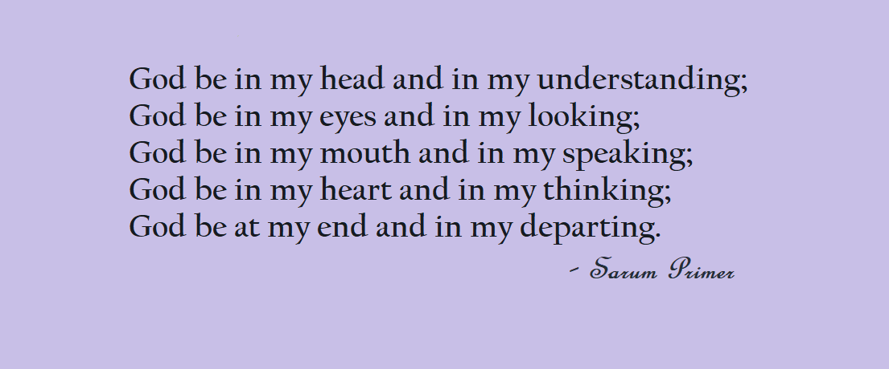

Sermon summary by Adeliyn.

