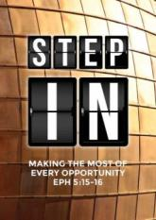
Armour of God 3: Shield of Faith & Helmet of Salvation
(Ephesians 6:14-17, John 6:5-13)
Pr Chris Kam

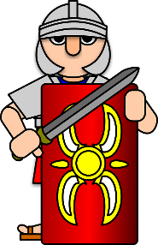
Stand firm then, with the belt of truth buckled around your waist, with the breastplate of righteousness in place, and with your feet fitted with the readiness that comes from the gospel of peace. In addition to all this, take up the shield of faith, with which you can extinguish all the flaming arrows of the evil one. Take the helmet of salvation and the sword of the Spirit, which is the word of God. (Ephesians 6:14-17)

When Jesus looked up and saw a great crowd coming toward him, he said to Philip, “Where shall we buy bread for these people to eat?” He asked this only to test him, for he already had in mind what he was going to do. Philip answered him, “It would take more than half a year’s wages to buy enough bread for each one to have a bite!” Another of his disciples, Andrew, Simon Peter’s brother, spoke up, “Here is a boy with five small barley loaves and two small fish, but how far will they go among so many?” Jesus said, “Have the people sit down.” There was plenty of grass in that place, and they sat down (about five thousand men were there). Jesus then took the loaves, gave thanks, and distributed to those who were seated as much as they wanted. He did the same with the fish. When they had all had enough to eat, he said to his disciples, “Gather the pieces that are left over. Let nothing be wasted.” So they gathered them and filled twelve baskets with the pieces of the five barley loaves left over by those who had eaten. (John 6:5-13)

We need to put on the armour of God. When Paul was under house arrest for about two years, there was a Roman guard with him and Paul may have had conversations with the guard; hence providing ideas to Paul. We are reminded that we live in the evil state of the world. The evil one will cause havoc. We can be set free from the bondage of the evil one.
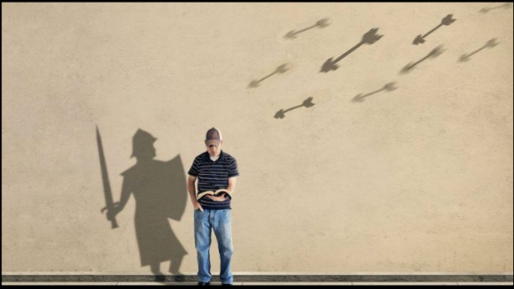
In this passage, Paul is talking about a spiritual armour. We need to stand firm in a spiritual battle when fiery arrows are being shot at us because we are wearing the armour of God. The evil one will come and ambush us with the fiery arrows of intimidation so we need to be prepared. The evil one wants to shake our faith so we need to take up the shield of faith even as the devil discourages us about our salvation.

BIG IDEA:
If we want to live in victory, we must be certain that we are saved by Grace through Faith in Christ.

The enemy intimidates us through our five senses
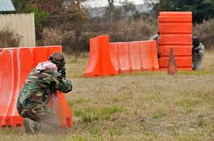
The five senses are sight, hearing, touch, smell and taste. The devil can get to us through these entry points into our lives. If we do not guard these five senses, we allow the devil to influence and mess us up. During a game of paintball, players hide behind obstacles to avoid getting shot. The strategy to win is to know where to hide. Similarly, we need to find something bigger than ourselves to hide behind – the shield.

The Romans had two kinds of shields – the parma (a smaller round shield for hand combat) and the scutum (higher rectangular shield which is used for advancing in open fields). This larger shield will be the first line of defence. The soldier can hide behind it. The shields can also be interlocked to form a huge shield and becomes an impenetrable defence against spears and arrows. We do not need to be afraid of flaming arrows as we hold up the shield of faith. As Christians, we are given a shield. God is our shield.

Every word of God is flawless; he is a shield to those who take refuge in him. (Proverbs 30:5)

The Lord is my strength and my shield; my heart trusts in him, and he helps me. My heart leaps for joy, and with my song I praise him. (Psalm 28:7)

Find something bigger than yourself. God is our refuge and our hiding place. We hide behind Someone who is reliable and trustworthy. Jesus is our shield and so we need Jesus in our lives to protect against the arrows of the evil one.

All of us exercise faith in something or someone whether we are Christians or not. In spiritual warfare, who do we put our faith in? What are these flaming arrows? These flaming arrows come through our five senses. Examples include voices in our heads which tell us something cannot be done or that we are not good/holy/gifted enough.

Feeding of 5 thousand (John 6:5-13)

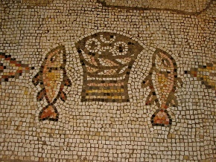
Verse 5 – Problem
When Jesus looked up and saw a great crowd coming toward him, he said to Philip, “Where shall we buy bread for these people to eat?” (John 6:5)

Verse 6 – Challenge
He asked this only to test him, for he already had in mind what he was going to do. (John 6:6)

Verses 7-9 – The Doubt
Philip answered him, “It would take more than half a year’s wages to buy enough bread for each one to have a bite!” Another of his disciples, Andrew, Simon Peter’s brother, spoke up, “Here is a boy with five small barley loaves and two small fish, but how far will they go among so many?” (John 6:7-9)

We are often frozen and hang on to the problem. Andrew, however at least, took initiative to find the boy but he had still no idea what to do with the boy and the food.

Verses 10-13 – The Miracle
Jesus said, “Have the people sit down.” There was plenty of grass in that place, and they sat down (about five thousand men were there). Jesus then took the loaves, gave thanks, and distributed to those who were seated as much as they wanted. He did the same with the fish. When they had all had enough to eat, he said to his disciples, “Gather the pieces that are left over. Let nothing be wasted.” So they gathered them and filled twelve baskets with the pieces of the five barley loaves left over by those who had eaten. (John 6:10-13)

Observation:
* 1st Response – It cannot be done. It is too big. It is too difficult.

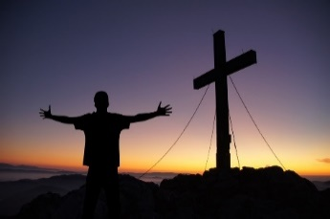
This is our normal human response based on our five senses

* 2nd Response – In your doubt (5 senses), start with what you have – give it to Jesus.

* 3rd Response – Surrender it to Jesus and trust that He will do what He needs to do.

Application:
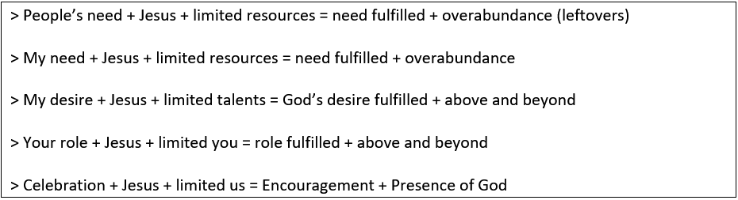

The common factor in all these equations is Jesus. This is why Jesus is our shield of faith. When we exclude Jesus and the Holy Spirit in our lives and church, something is wrong. We need to know why we come to church. These 5000 men were there because Jesus was there. We cannot by our own strength engineer anything that only God alone can engineer. We should come because Jesus is here. We want to win people to Jesus – to cross-carrying, self-denial, crucifixion of the flesh, nobility of character, to despise what the world has to offer, to self-discipline, making disciples and commitment to Christ. We are not winning people to the church or celebrations or events, or even to the worship or preaching. Our shield of faith should be Jesus and not in faith itself.

We can be a church which only practices religion without Jesus and the Holy Spirit:

having a form of godliness but denying its power. Have nothing to do with such people. (2 Timothy 3:5)

See to it that no one takes you captive through hollow and deceptive philosophy, which depends on human tradition and the elemental spiritual forces of this world rather than on Christ. (Colossians 2:8)

We need to have the right kind of faith, in Jesus and not in religion. We can plan our lives so well that we plan God out of our lives. God can allow troubles in our lives because we can plan so well that we do not have dependence on God. We become independent and come out, only to find the flaming arrows coming at us.

Therefore, since we have a great high priest who has ascended into heaven, Jesus the Son of God, let us hold firmly to the faith we profess. (Hebrews 4:14)

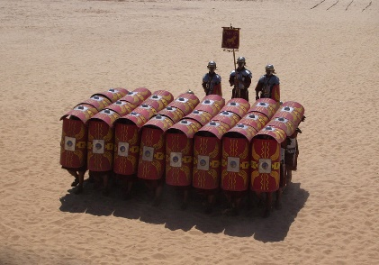
Christ is this faith. Hold on to Christ firmly like a child holding on firmly to his / her father’s hand. The shield of faith is not only for personal protection, but also to interlock their shields to prevent spears and arrows from getting through to the soldiers’ bodies. We have the entire church to hold up the shield of faith (Christ) together and interlock the shields so we are protected on all sides. However in this scenario, there is no protection at the back so there needs to be great trust in the soldiers behind them. You do not need armour behind because you trust the soldier behind you. We need to stay in formation to be kept safe. Even as the evil one intimidates us through our five senses, we need to lift up the shield of faith together with the entire church. Jesus should be the centre of our lives to protect us from the blows of the evil one.

The enemy confused us about our salvation.
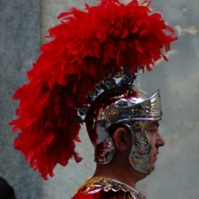
The head is also well protected from the sides and back using this helmet. A single blow to the head can cripple the person. The helmet of salvation is crucial for our spiritual life.

He put on righteousness as his breastplate, and the helmet of salvation on his head; (Isaiah 59:17)

In rugby, there is no protection as compared to American football which is more violent. However, rugby is actually more dangerous because there is no helmet. American football players are more confident because of the helmet and protective gear that they wear.

The Bible uses different tenses for our salvation:

* Past – We have been saved
For he has rescued us from the dominion of darkness and brought us into the kingdom of the Son he loves, in whom we have redemption, the forgiveness of sins. (Colossians 1:13-14)

* Present – We are being saved
Therefore, my dear friends, as you have always obeyed—not only in my presence, but now much more in my absence—continue to work out your salvation with fear and trembling (Philippians 2:12)

This is why there is a spiritual battle going on every day. We say yes to the devil and give in to our sinful nature. This present salvation is the sanctifying work of the Holy Spirit in our lives; hence the conflict between our old nature and new nature.

* Future – One day we will be entirely saved – our glorification.
Listen, I tell you a mystery: We will not all sleep, but we will all be changed— in a flash, in the twinkling of an eye, at the last trumpet. For the trumpet will sound, the dead will be raised imperishable, and we will be changed. For the perishable must clothe itself with the imperishable, and the mortal with immortality. When the perishable has been clothed with the imperishable, and the mortal with immortality, then the saying that is written will come true: “Death has been swallowed up in victory.” (1 Corinthians 15:51-54)

Even if we have doubt in our minds about ourselves, we have hope in the future. Our future bodies will be imperishable and immortal.

As we work out our salvation, allow the Holy Spirit to renew us in our lives. The body may grow older but the spirit will grow younger. Which tense does Paul refer to – past, present or future?

But since we belong to the day, let us be sober, putting on faith and love as a breastplate, and the hope of salvation as a helmet. (1 Thessalonians 5:8)

The helmet of salvation is referring to the future. As we put on the helmet of salvation, we are walking towards the certainty that one day, we will be entirely saved. Many of us struggle with this understanding. We do not understand that salvation is a gift of God. We are saved by grace through faith. The devil comes and plays with our minds to render us ineffective if we are not firmly on the ground as we fight the battle. Therefore, we doubt our salvation based on what we have done in our lives. We need to recognise the lies in our head. Once we are truly saved, our salvation is secure. If we believe in Jesus and what He did on the cross for our sins, it is good enough and God will help us work through our salvation in our daily lives so our lives will be cleaned up. The person who is truly saved will exhibit the fruit in his life – a holy life. We need to be eternally secure about our eternal salvation.

Conclusion
We will not enjoy our Christian lives if we keep wondering about our salvation. We need to be certain that we are saved by grace through faith in Christ if we are to live in victory. The helmet of salvation is the last line of defense. Hold on to the shield of faith tightly to protect against the fiery arrows from getting to your head.

For it is by grace you have been saved, through faith—and this is not from yourselves, it is the gift of God— not by works, so that no one can boast. (Ephesians 2:8-9)

One day we will be entirely saved in the new body. We put on the hope of salvation as we are eternally saved. We need to be sure of our salvation. If we are already saved, sins will not “unsave” us. What we need to do if we sin is to confess and repent to renew our lives to God. Allow the Holy Spirit to help us work through our salvation so we can live holy lives.

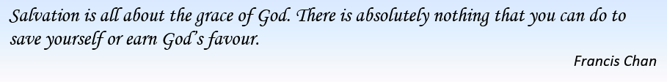

Sermon summary by Zhenli.

