ADVENT IV: God is Life. A Sacred Christmas
(John 1: 1-19, John 10:10)
Pastor Alex Tan
The Word became flesh and made his dwelling among us. We have seen his glory, the glory of the one and only Son, who came from the Father, full of grace and truth. (John 1:14)

Out of his fullness we have all received grace in place of grace already given. (John 1: 16)

Jesus, the Son of God came into this world to be like us. God’s creation
He came as a helpless baby, born in humble and challenging conditions. Yet His birth was prophesied by John the Baptist.

Introduction
Pastor Alex Tan spoke of:
- Christmas is not Christmas until it happens in your heart – have we allowed Christ into our hearts?
- Life is like a long journey with trials and having to go through difficult circumstances like Joseph and Mary’s journey to Bethlehem.
- Life has its humbling moments and anticipated results are disappointing when unexpected situations arise.
- Christmas reminds us how Jesus had come into the world in times of controversies, disappointments, diminishing privileges and acceptance.

BIG IDEA: Life is not always Perfect but Life in the Son is always full life.

“Who among us will celebrate Christmas correctly? Whoever finally lays down all power, all honor, all reputation, all vanity, all arrogance, all individualism beside the manger; whoever remains lowly and lets God alone be high; whoever looks at the child in the manger and sees the glory of God precisely in his lowliness.” ~Dietrich Bonhoeffer

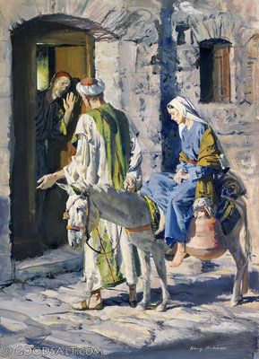
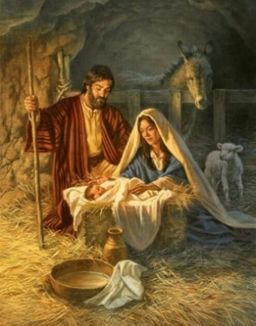
Jesus said:

“..I have come….
- during danger, controversy, as a helpless babe born in a manger.
- living in discomfort, inconvenience and challenges.
- we learn to live life in the midst of encumbrances and sufferings.
Example: Joseph and Mary his betrothed, had to leave Nazareth on a long journey because of Caesars decree to register themselves in Bethlehem despite Mary’s condition.

“…..that they may have life, ….”
- trust God to provide for our needs completely and receive the providence humbly like
Mary & Joseph had; to find accommodation in a manger to bear her son.
- be spiritually alive in the midst of our sufferings and disappointments. There is abundant life in Christ.
An example is our late sister Sharon who despite of having lost two legs due to sickness, still ministered to patients in the hospital while she herself was a patient there. Nurses at the hospital testified at her eulogy that she was like a mother to them, sharing the love to our neighbours.

Jesus said to her,” I am the resurrection and the life. The one who believes in me will live, even though they die;” (John 11:25)

“…….and have it to the full.”
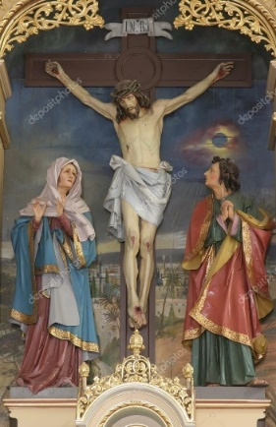
- Are we living life to the fullest?
- despite our challenges and disappointments, we can still have a full life which can only be found in Jesus.
- God’s will for us is found in our limitations: do not settle for a sub-par Christian life
- let us reflect on what Jesus has done for Mankind
- born a helpless babe (humility)
- suffered persecutions (perseverance)
- was crucified so that we may have Eternal Life (great Love)

I ask him to strengthen you by his Spirit—not a brute strength but a glorious inner strength—that Christ will live in you as you open the door and invite him in. And I ask him that with both feet planted firmly on love, you’ll be able to take in with all followers of Jesus the extravagant dimensions of Christ’s love. Reach out and experience the breadth! Test its length! Plumb the depths! Rise to the heights! Live full lives, full in the fullness of God.
God can do anything, you know—far more than you could ever imagine or guess or request in your wildest dreams! He does it not by pushing us around but by working within us, his Spirit deeply and gently within us.
Glory to God in the church!
Glory to God in the Messiah, in Jesus!
Glory down all the generations!
Glory through all millennia! Oh, yes! (Ephesians 3:16-21, MSG)

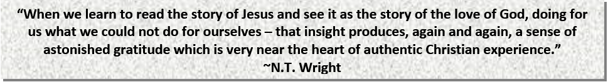

CONCLUSION :
When we encounter Jesus, we can overcome all things & have life to the full.
Sermon summary by Michelle Chuah

