He Must Become Greater; I Must Become Less
(John 3:22-30)
Senior Pastor Chris Kam

After this, Jesus and his disciples went out into the Judean countryside, where he spent some time with them, and baptized. Now John also was baptizing at Aenon near Salim, because there was plenty of water, and people were coming and being baptized. (This was before John was put in prison.) An argument developed between some of John’s disciples and a certain Jew over the matter of ceremonial washing. They came to John and said to him, “Rabbi, that man who was with you on the other side of the Jordan—the one you testified about—look, he is baptizing, and everyone is going to him.” To this John replied, “A person can receive only what is given them from heaven. You yourselves can testify that I said, ‘I am not the Messiah but am sent ahead of him.’ The bride belongs to the bridegroom. The friend who attends the bridegroom waits and listens for him, and is full of joy when he hears the bridegroom’s voice. That joy is mine, and it is now complete. He must become greater; I must become less.” (John 3:22-30)

For our struggle is not against flesh and blood, but against the rulers, against the authorities, against the powers of this dark world and against the spiritual forces of evil in the heavenly realms. Therefore put on the full armor of God, so that when the day of evil comes, you may be able to stand your ground, and after you have done everything, to stand. (Ephesians 6:12-13)

Be very careful, then, how you live—not as unwise but as wise, making the most of every opportunity, because the days are evil. (Ephesians 5:15-16)

John 3:30 (NIV) He must become greater; I must become less.
John 3:30 (ESV) He must increase, but I must decrease.

BIG IDEA:
“I must become less” is a process of dying to self, yielding and surrendering to Jesus more and more each day, so that people can see more of Him in me.

As we enter the new year, we must be mindful of these 3 things;

Competition in the Mind
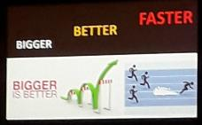
An argument developed between some of John’s disciples and a certain Jew over the matter of ceremonial washing. They came to John and said to him, “Rabbi, that man who was with you on the other side of the Jordan—the one you testified about—look, he is baptizing, and everyone is going to him.” (John 3:25-26)

John's disciples were jealous that people were going to Jesus’ disciples. There was a competitive spirit in them. We are the same. This can be seen especially when we play sports or get behind the wheel of a car. This competitiveness, is inculcated in us when we are young.

Being competitive is not wrong in itself, but it must not be taken to extreme. It will lead us to become performance oriented. Even in ministry we do this. We want to do better than the other person, for our own significance and self-esteem. We must constantly check our motives. We think we must do things to earn God's love.

The whole Judean countryside and all the people of Jerusalem went out to him. Confessing their sins, they were baptized by him in the Jordan River. (Mark 1:5)

2. Concern of the Soul
They came to John and said to him, “Rabbi, that man who was with you on the other side of the Jordan—the one you testified about—look, he is baptizing, and everyone is going to him.” (John 3:26)

ME
Getting smaller and lesser is a real fear to many people. It reveals the fear in our hearts. We want to look good in front of other people. To become less takes courage.
It is easy for God to take us out of the world but it is very hard for God to take the world out of us. We need to die daily to the world. This is what Paul says, “I die every day”.

I face death every day—yes, just as surely as I boast about you in Christ Jesus our Lord. (1 Cor 15:31)

Then he said to them all: “Whoever wants to be my disciple must deny themselves and take up their cross daily and follow me. (Luke 9:23)

Die every day to our rights, self-esteem and the recognition we get for what we do. We are now slaves, and slaves have no rights. Jesus must increase and I must decrease. Jesus must become everything. That is spiritual maturity.

3. Clarity in the Spirit
To this John replied, “A person can receive only what is given them from heaven. You yourselves can testify that I said, ‘I am not the Messiah but am sent ahead of him.’ The bride belongs to the bridegroom. The friend who attends the bridegroom waits and listens for him, and is full of joy when he hears the bridegroom’s voice. That joy is mine, and it is now complete. He must become greater; I must become less.” (John 3:27-30)

The joy becomes complete when I fade away and Jesus become greater. Jesus must increase and I must decrease. We must not take centre stage as it is all about Jesus Christ. We must point to Him.
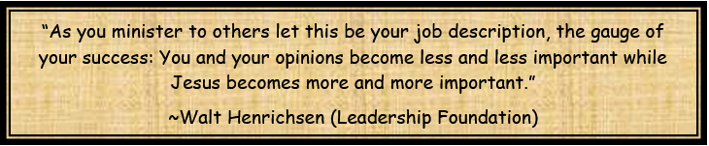

How do we decrease and Jesus increase?
The only way is through the power of the Holy Spirit. We have to be obedient, through yielding and surrendering to God which allows the Holy Spirit to fill us.

Do not get drunk on wine, which leads to debauchery. Instead, be filled with the Spirit, (Ephesians 5:18)

Conclusion
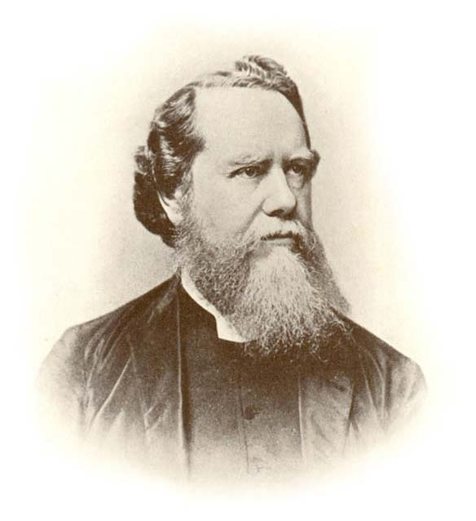
There were 2 brothers born in England. One brother became very prominent and great in the eyes of man. The other brother, Hudson Taylor went to China to reach the people there. He founded the China Inland Mission (CIM, now known as OMF International). He allowed Jesus to increase, as he himself decreased. His legacy far out shines that of his brother and even until today his children are involved in the work of the Gospel.

In some parts of the world, believers are asked several questions before they are baptised;
1. Are you willing to die for your faith?
2. Are you willing to go to jail for your faith?
3. Are you willing to lose your job for your faith?
4. Are you willing to be disowned by your family for your faith?

In the comfort and freedom that we have, are we willing to lose everything for Jesus?
To become less and less, so that people can see Jesus in your life.
Are we willing to follow through and say, Jesus must increase and I must decrease?

Sermon summary by Prudence.

