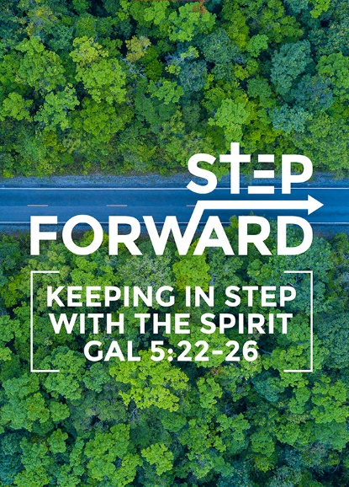
Stepping forward with the Spirit
(Galatians 5:22-26)
Senior Pastor Chris Kam

But the fruit of the Spirit is love, joy, peace, forbearance, kindness, goodness, faithfulness, gentleness and self-control. Against such things there is no law. Those who belong to Christ Jesus have crucified the flesh with its passions and desires. Since we live by the Spirit, let us keep in step with the Spirit. Let us not become conceited, provoking and envying each other. (Galatians 5:22-26)

Introduction

Our tagline is to “Love God, Serve People, Make Disciples towards Christlikeness.”
We should learn to love God more and serve people more.

Our 5 core habits:
- Honour
- Humility
- Be Real
- Pass It On
- Fun

This year, our theme will be “Stepping Forward”. Stepping forward is an exciting proposition in our lives. As we step forward, there are things happening around the world.

There are 5 global shifts that are happening, especially in this nation
- Rise in racism and xenophobia
  - Rise in nationalism and right-wing politics
    - We are called to be patriotic not nationalistic as all people are created equal in Christ.
  - The refugee opportunity
    - There are 2.7 million documented migrants in our nation and possibly just as many undocumented migrants.
    - Hence, we have an opportunity to reach out and disciple them so that when they return to their nations, they will be missionaries.
    - Refugees and migrants in our nation are our mission field.
- Urbanisation and social issues
  - Greater Kuala Lumpur: Population in 2018 is 7.5 million while this is projected to rise to 9 million in 2025. In 2010, there were only 4.3% Christians in Greater Kuala Lumpur. Hence there is immense opportunity for the gospel.
  - The Malaysian Education Blueprint forecasts 250 000 international students and this is also an opportunity for outreach.
  - The church also has opportunities to minister to the urban poor.
  - DUMC has a plan to do multi-site church and this will become a reality this year.
- Climate change
  - Environment-related challenges
  - Biblical theology of Creation Care
  - Stewardship
The use of plastics is reducing. The church is learning to be environmentally-friendly by reducing printing of bulletins. We need to get used to this lifestyle.

- Digitisation
  - Ubiquity of smartphones, apps, social media
  - Danger of Christianity “disincarnated”
We have an opportunity to reach out to people through mobile phones. Many of us look at the smartphone the first thing in the morning. Our lives have become impersonal. The challenge to the church is how to make life more personal for one another

- Changing demographics
  - Median age in 2018 is 28.6 years and by 2035 this is projected to be 37.0 years
  - In 2018, the proportion of the population more than 65 years old is 6% and this is projected to increase in 2035 to 12.6%
We are an aging population. As much as we have a strategy to reach out to young people, we must also have a strategy to reach out to older people. The church must be inclusive of people of all ages.

The world is moving at an incredible speed. The church must move in tandem with what is happening in the world and be relevant to the world. No matter what we do, one thing must remain constant – Jesus must remain in the centre of all that we do.

BIG IDEA:
Stepping Forward in preparation for something bigger than yourself

What is God leading us to? Many of us are living for ourselves, our careers and our families. When we come to know Jesus, our lives are beyond ourselves. Hence stepping forward is in preparation for something bigger than ourselves. When we look back ten years from now, we will be amazed at what God has done in our lives.

There are 3 ways that we can step forward:

Stepping forward with Jesus
Jesus must be present wherever we go. A new believer once testified that Jesus brought peace into her life. When someone comes to know Jesus, there is forgiveness, victory over temptation, power to good, influence and healing. Life in Jesus as we move forwards is bigger than ourselves. When we look back, we will be amazed.

Joseph in the Bible was also amazed. He was the youngest in the family. He was a spoilt brat. God took a spoilt brat and changed him into something else. In the life of Joseph, he affected Potiphar’s home, influenced a prison and eventually he influenced a whole nation. He went from a spoilt brat to the second most important person in the nation. Only God can do that.
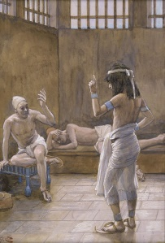
“Because the patriarchs were jealous of Joseph, they sold him as a slave into Egypt. But God was with him and rescued him from all his troubles. He gave Joseph wisdom and enabled him to gain the goodwill of Pharaoh king of Egypt. So Pharaoh made him ruler over Egypt and all his palace. (Acts 7:9-10)

The Lord was with Joseph so that he prospered, and he lived in the house of his Egyptian master. (Genesis 39:2)

Joseph’s master took him and put him in prison, the place where the king’s prisoners were confined. But while Joseph was there in the prison, the Lord was with him; he showed him kindness and granted him favor in the eyes of the prison warden. (Genesis 39:20, 21)

The principle is that you do not want to end up in any place where God is not with you. We can do many things without God’s presence. Even if one is clever, successful or accomplished, all this is in vain without the Lord. How can we ensure Jesus is present in our lives? The key is simple – the Holy Spirit. The Holy Spirit enables us to keep the presence of Christ. Jesus said that He needs to go to the Father so that the Holy Spirit can be with you always.

Since we live by the Spirit, let us keep in step with the Spirit. (Galatians 5:25)

Keeping in step means that the Holy Spirit has gone ahead and we need to keep in step with the Spirit. What is the role of the Holy Spirit?

He will glorify me because it is from me that he will receive what he will make known to you. (John 16:14)

When the Holy Spirit is present, He will glorify Jesus.

The essence of the Holy Spirit’s ministry is, at this or any time in the Christian era, to mediate the presence of our Lord Jesus Christ (J.I. Packer – “Keep in Step with the Spirit”)

When we honour Jesus in our midst, the Spirit will be present to glorify Him. We need to continue to honour Jesus in our midst.

When apostle Peter was preaching in Acts 10, he was speaking to Cornelius the centurion and his family. Peter preached about Jesus and the good news of Jesus, the anointing of Jesus by the Holy Spirit and His power, Jesus doing good and healing people, Jesus’ death and resurrection, and that anyone who believes in Jesus will be forgiven. When Peter was lifting up the name of Jesus, the Holy Spirit came on all who heard the message.

While Peter was still speaking these words, the Holy Spirit came on all who heard the message.(Acts 10:44)

The acknowledgment of Jesus is important. At His name, every knee shall bow and every mouth shall confess that He is Lord. When Jesus is present, we will have fullness of life.

The thief comes only to steal and kill and destroy; I have come that they may have life, and have it to the full. (John 10:10)

Stepping forward with your heart
So many Christians do not live the full life because our hearts prevent us. We are meant to live the full life when we step forward with Jesus. We must step forward with our hearts.

But the fruit of the Spirit is love, joy, peace, forbearance, kindness, goodness, faithfulness, gentleness and self-control. Against such things there is no law. Those who belong to Christ Jesus have crucified the flesh with its passions and desires. (Galatians 5:22-24)

We need to crucify the flesh with its passions and desires in order to have the fullness of life. We begin to realise what is hindering us from the fullness of Christ is actually ourselves and our hearts. In our lives, we allow God to have certain things but we also do not want God to touch certain other things. If we want to move forward with our hearts, we must surrender everything to God. Therefore, Apostle Paul says he dies every day, referring to dying to the things that he keeps for himself and gives these things to God.

I face death every day—yes, just as surely as I boast about you in Christ Jesus our Lord. (1 Corinthians 15:31)

He must become greater; I must become less. (John 3:30 NIV)

When Jesus came into the picture, John the Baptist knew he needed to fade away. He needed to allow Jesus to take centre stage.

He must increase, but I must decrease. (John 3:30 ESV)

When we pray, we often ask for more of God and we ask for more. That is a wrong prayer because God has already given His all for us, even His Son to die for us. The problem is we have not given more of ourselves to Him.

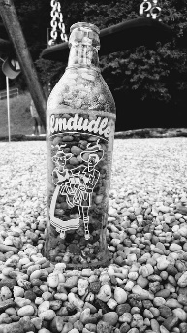
Imagine your life is like a 1 litre bottle, God wants to pour 1 litre of water into your life but many of us have stones in the bottle. No matter how God pours into your life, it will never be 1 litre. Therefore, our lives are full of stones. We need to remove these stones so that more of us are given to God and we can have all that God has given to us. As we move forward with our hearts, God will deal with many of us and this process can be painful. The stones in our lives stand in the way of God using us powerfully. We need to step forward with our hearts, wholly surrendered to God.

Above all else, guard your heart, for everything you do flows from it. (Proverbs 4:23)

Guard your heart because from your heart comes life. We need to examine our hearts for stones.

Stepping forward with someone
The Christian life is never lived alone. God gave us a community to live in.

Since we live by the Spirit, let us keep in step with the Spirit. Let us not become conceited, provoking and envying each other. (Galatians 5:25, 26)
God shapes our hearts by the community of people we live with. For instance, marriage is a place to truly love someone. Love is a choice. Therefore, God gave us a community, namely the church. The Bible did not ask us to like people, but to love people. We are to love even our enemies. In the church, God teaches us how to love. If we are Christians surrendered to Jesus, we celebrate even when there are people we do not like in our midst because this is an opportunity to learn how to love. God teaches us about love in a Christian community.

God also wants us to step forward with unbelievers. The church must never forget that our role is to share the gospel with people. As we step forward, we should bring the unbelievers into the Christian church. During Christmas, we had more than 95 outreach events in our church for all congregations except for the Myanmar congregations who had 110 events. We reached out to more than 4,100 people and saw 220 salvations while the Myanmar congregations reached out to 11,200 people and saw 3,279 salvations. We need to evangelise throughout the entire year.

Our church will also start DUMC@Puchong as a multi-site church this year with multiple language congregations. As we step forward, we bring the church to where the people are.

We can also move forward via our Anniversary and Gift Weekend (AGW). God gave us more than what we asked for last year. More than 130 organisations will benefit from the generosity during AGW. These funds will go where we cannot go.

Conclusion
DUMC will celebrate its 40th anniversary in 2020. We can expect God to do something powerful in 2020 and 2019 will be a year of preparation for us to move forward with Jesus, stepping forward with our hearts and with each other, united as one. In 2020, we will embark on Impact 2020. We need to ask God in our cell groups about what He wants us to do to step forward across the Klang Valley, across our nation and across boundaries. We need to all prepare our hearts as 2019 is the year for God to help us dream. When we look back after 10 years in the future, we will all be amazed at what God has done in our church because Jesus is present. We need to surrender our lives to God and ask God to use us and do something through us. We need to pray to learn to hear God’s voice and live in a cell community that hears the voice of God. As we submit our spiritual ears to God, He will speak to us through our daily devotions so that Jesus will be present in everything that we do in our lives.

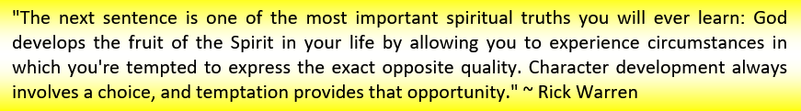

Sermon summary by Zhenli.

