A Personal Relationship With God (John 15:4)
Pastor Victor Gee
Remain in me, as I also remain in you. No branch can bear fruit by itself; it must remain in the vine. Neither can you bear fruit unless you remain in me. (John 15:4)

A Personal relationship with God means:
-He is our Abba Father who loves us that He gave us His beloved Son Jesus (our Saviour) that we have been saved by Grace (Galations 4:4)
-imperative that we carry out His commands as we are saved to do His Good works – go and share the Good News to the ends of the Earth
-disciple others mature in the Spirit and be a contributor instead of being a consumer

BIG IDEA
A 24/7 relationship with God : The desire for a Holy relationship which creates memories which are life’s testimonies, worshipping Him and
communing with Him
Pastor Victor Gee

The Nature of the Relationship

When we are In love, just listening to the one we love and feeling their presence was the best relationship so we must desire to spend time with our Holy Father.

Render unto God respect where it is due, desire to spend time with God develops a relationship

Abiding in Christ who is our Saviour is a 24/7 relationship It is not a 2-hour session on Saturday or Sunday. We can be with God anytime and anywhere.

Establishing a personal relationship requires spending time with our God to create memories - the moments we spend gives us the testimonies to share

God is in charge of our lives, He is IN CONTROL of every situation in our life if we allow Him.

Be closely connected to God, engage in a healthy relationship with Him – If you Love Jesus do as He commands (John 15:10, 1 John 2:3)

To Worship God is to hear from Him and to be always connected to Him.

Communing corporately in church enables the body of Christ to uphold one another in prayer
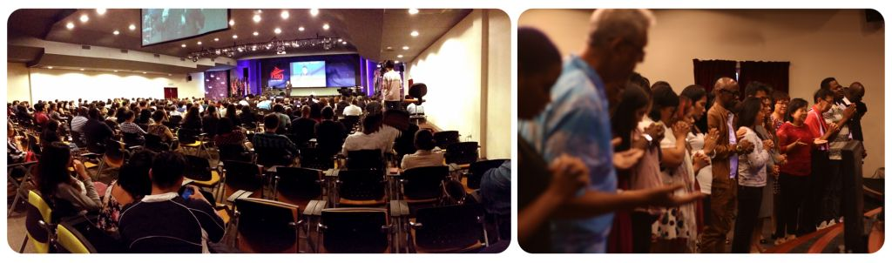

Responsibility of the Relationship

Therefore, as we have opportunity, let us do good to all people, especially to those who belong to the family of believers. (Galatians 6:10)

All people include believers and non-believers. Share Jesus Christ to strangers or people we meet daily.

If you keep my commands, you will remain in my love, just as I have kept my Father’s commands and remain in His love. (John 15:10)

Love all people as Christ has told us to by discipleship and contributing into the lives of people of God and also people of the world by blessing them and praying for them.

My command is this: Love each other as I have loved you. (John 15:12)

The imperative command – The Great Commission, a mandate to every believer, not just to a selected few.

Therefore go and make disciples of all nations, baptizing them in the name of the Father and of the Son and of the Holy Spirit, and teaching them to obey everything I have commanded you. And surely I am with you always, to the very end of the age. (Mathew 28:19-20)

Rewards/ blessings of the Relationship

A galore of blessings awaits you who receives Jesus as your personal Lord and Saviour:
- Joy of the Lord , a divine Joy will fill even in times of trials and tribulations
I have told you this so that my joy may be in you and that your joy may be complete
(John 15:11)
- Perseverance and contentment even during times of need as the Joy of the Lord is our strength.
‘…for I have learned to be content whatever the circumstances.’ (Philippians 4:11)
- Every single day we get to walk together with you and place our trust in Jesus will be saved
‘for, Everyone who calls on the name of the Lord will be saved.’(Romans 10:13)

IMPORTANT THINGS to keep in our daily walk with the Lord :
- TRUTH
- DISCIPLINE
- COMMITMENT

Conclusion
In God’s Presence there is overflowing Joy and we can sing in the midst of the Storm.

Sermon summary by Michelle Chuah

