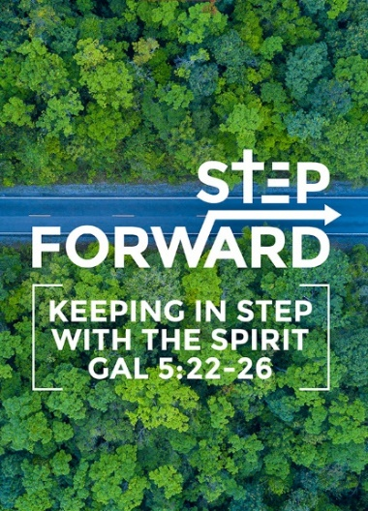
Easter Message – Repentance that leads to Salvation (Colossians 2: 13-15; Luke 24: 45-49)
Senior Pastor Chris Kam
When you were dead in your sins and in the uncircumcision of your flesh, God made you alive with Christ. He forgave us all our sins, having cancelled the charge of our legal indebtedness, which stood against us and condemned us; he has taken it away, nailing it to the cross. And having disarmed the powers and authorities, he made a public spectacle of them, triumphing over them by the cross. (Colossians 2: 13-15)

Then he opened their minds so they could understand the Scriptures. He told them, “This is what is written: The Messiah will suffer and rise from the dead on the third day, and repentance for the forgiveness of sins will be preached in his name to all nations, beginning at Jerusalem. You are witnesses of these things. I am going to send you what my Father has promised; but stay in the city until you have been clothed with power from on high.” (Luke 24: 25-29)

In 1 Corinthians 15:17 Paul says, “And if Christ has not been raised, your faith is futile; you are still in your sins.” This is an important statement and especially so during Easter as we reflected on Christ’s sacrifice on the Cross. If He did not rise from the dead, then the Christian’s faith in Jesus is useless. The pinnacle of the faith is not that Christ died. It is that He is risen.

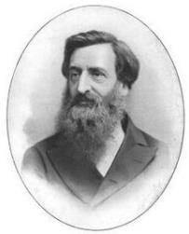
General William Booth, founder of the Salvation Army 154 years ago, said:
“I consider that the chief dangers which will confront the twentieth century will be:
- Religion without the Holy Spirit
- Christianity without Christ
- Forgiveness without Repentance
- Salvation without Regeneration
- Politics without God
- Heaven without Hell
The message this weekend focusses on Forgiveness without Repentance. Here, repentance means to turn away and change your ways. Pastor Chris illustrates with the power of the one-degree shift. The success of a commercial airline flight to get from one location to another is dependent on the aircraft’s ability to stay on a carefully plotted course. If a pilot makes the slightest error of just one degree in his aircraft’s flight path, after traveling 1.6 kilometres he will be off course by 28 metres. That error adds up the further it goes on. Example: an aircraft from Kuala Lumpur on one degree error will cause it to be off course by 4 kilometres if destination is Singapore, and 110 kilometres if Australia. To arrive at the correct destination, the pilot must correct the error while inflight to be on course to the correct destination.

Likewise, in Christian life we do not wake up one day and find ourselves far away from God. Rather, it is the little compromises we make once here, another there that we find ourselves drifted far away from God. To correct our trajectory and shift back to God, it is through repentance: turning away from what holds us back from God, be it sin, addiction, lifestyle or habit. Seeking forgiveness is easy, but without repentance there is no change in us, and therefore no returning to God.

BIG IDEA
In seeking forgiveness, there must be repentance.

The Cause for Repentance
(Romans 8:22; Colossians 2:13; Romans 3:23; Romans 6:23; Jeremiah 17:9; Psalm 51:1-2; Colossians 2:13-14; Romans 2:4; Luke 24:45-47)
Wanting to be good is something anyone can say as what they aspire to be. But what does it mean to be good? The dilemma we have is the gap of the Bible’s standards. That gap was described by apostle Paul as “groaning” in Romans 8:22. Our desire to be good will never be achieved by ourselves as we can never meet the standards for the simple reason is that we live in a sinful world while being in the flesh. Apostle Paul states that he too struggles to be a good person in Romans 7:15-20 as he desires to do what is good, but cannot carry it out but the evil he does not want to do, he keeps on doing.

When you were dead in your sins and in the uncircumcision of your flesh, God made you alive with Christ. He forgave us all our sins. (Colossians 2:13)

For all have sinned and fall short of the glory of God (Romans 3:23)

For the wages of sin is death, but the gift of God is eternal life in Christ Jesus our Lord. (Romans 6:23)

The wages of sin is death. Jesus talked about it. The problem of our age is that there is no fear of God. We cheat ourselves by telling ourselves that “I’m not that bad” but the reality is we have the potential to be worse that we are, it is just that we did not have the opportunity to be the worst versions of our current selves. As such we allow ourselves to continue to be self-centred, be indulgent and narcissistic.

The heart is deceitful above all things and beyond cure. Who can understand it? (Jeremiah 17:9)

A shocking statement in today’s world is that people go to Hell not primarily because they reject Jesus. They go to Hell because of the wrath of God. What is often forgotten is that if God had not sent Jesus, all of us only have a one-way ticket to Hell – that is God’s justice. It is in God’s Mercy, that HE sent His Son as the Lamb to redeem the world bound for Hell.

Mercy in Malaysia’s context is like royal pardon from the Yang Dipertuan Agong. His Majesty can consider a number of recommended convicts for royal pardon and free the selected convicts from their sentences. These people do not deserve to be let out but it is by the Agong’s mercy that they receive royal pardon and are let go.

In the same way, those who believe in Christ receive God’s royal pardon (mercy) from God’s holy wrath because of our sins. The Greek word for repentance is ‘metanoia’ meaning ‘the mind afterwards’ (meta = after, noia = mind). It is about having a transformative change of heart, a spiritual conversion. Upon receiving royal pardon from the King of Kings we are to honour Him by turning from our ways into His ways. The cause of repentance is God’s mercy to we who are undeserving.

Have mercy on me, O God, according to your unfailing love; according to your great compassion blot out my transgressions. Wash away all my iniquity and cleanse me from my sin. (Psalm 51: 1-2)

When you were dead in your sins and in the uncircumcision of your flesh, God made you alive with Christ. He forgave us all our sins, having cancelled the charge of our legal indebtedness, which stood against us and condemned us; he has taken it away, nailing it to the cross. (Colossians 2:13)

Or do you show contempt for the riches of his kindness, forbearance and patience, not realizing that God’s kindness is intended to lead you to repentance? (Romans 2:4)

Then he opened their minds so they could understand the Scriptures. He told them, “This is what is written: The Messiah will suffer and rise from the dead on the third day, and repentance for the forgiveness of sins will be preached in his name to all nations, beginning at Jerusalem. (Luke 24: 25-27)

The word “repentance” occurs in Acts 11 times, yet “Love” is never brought up. The crucial message of the Gospel is of repentance.

The Cost of Repentance
(Luke 15:7,10; 2 Corinthians 7:10; Psalm 51:17)
The cost of repentance is of change to Christlikeness. In the parable of the lost sheep, Jesus concluded the parable “I tell you that in the same way there will be more rejoicing in heaven over one sinner who repents than over ninety-nine righteous persons who do not need to repent” (Luke 15:7). Jesus continued with the parable of the lost coin and concluded the parable saying, “In the same way, I tell you, there is rejoicing in the presence of the angels of God over one sinner who repents” (Luke 15:10).

Will we become perfect when we repent? The short answer is never while we are still in the world. We will stray and need to repent repeatedly as it happens. All we need is to stray by just one degree and we will miss the mark. With the help of the Holy Spirit and repenting regularly, we who can never be perfect by God’s standards, can grow more Christ-like.

Godly sorrow brings repentance that leads to salvation and leaves no regret, but worldly sorrow brings death. (2 Corinthians 7:10)

My sacrifice, O God, is a broken spirit; a broken and contrite heart you, God, will not despise. (Psalm 51:17)

The Christ in Repentance
(Luke 24:49; Matthew 3:8; Luke 17:3-4; 2 Chronicles 7:14)

I am going to send you what my Father has promised; but stay in the city until you have been clothed with power from on high.” (Luke 24:49)

We will struggle as God expects repentance, but God knowing that we are weak, did not leave us to figure out by ourselves. He sent to us the Holy Spirit to dwell in us: to lead, to guide in His ways, and to convict us when we compromise and shift one degree away from God.

Produce fruit in keeping with repentance. (Matthew 3:8)

So watch yourselves. “If your brother or sister sins against you, rebuke them; and if they repent, forgive them. Even if they sin against you seven times in a day and seven times come back to you saying ‘I repent,’ you must forgive them.” (Luke 17:3-4)

if my people, who are called by my name, will humble themselves and pray and seek my face and turn from their wicked ways, then I will hear from heaven, and I will forgive their sin and will heal their land. (2 Chronicles 7:14)

When we say we repent, we must show that we have repented. We may be born into the sinful nature, but we can master over the sinful nature by the guidance of the Holy Spirit and grow in Christlikeness.

Ending Thoughts
Pastor Chris closed by sharing the success rates of drug centres in Malaysia from Pastor Sam who heads ministry through Breakthrough Drug Rehabilitation Centre:
- Government organization: 0%
- Secular organization: 30%
- Christian-based organizations: 60%-70%
Why is it that Christian-based organizations have higher success rates? Pastor Chris believes that it is the work of the Holy Spirit in the addicts’ lives that enables them to turn away from their old lives and habits when they repent.

This Easter, we are to have a heart of repentance as we seek God’s forgiveness over our lives. Let it not be lip service, but in true understanding of what the Holy and Loving God has done in order made a way for us to freely go to Him.

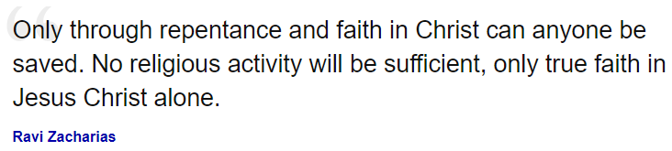

Sermon summary by Adeliyn

